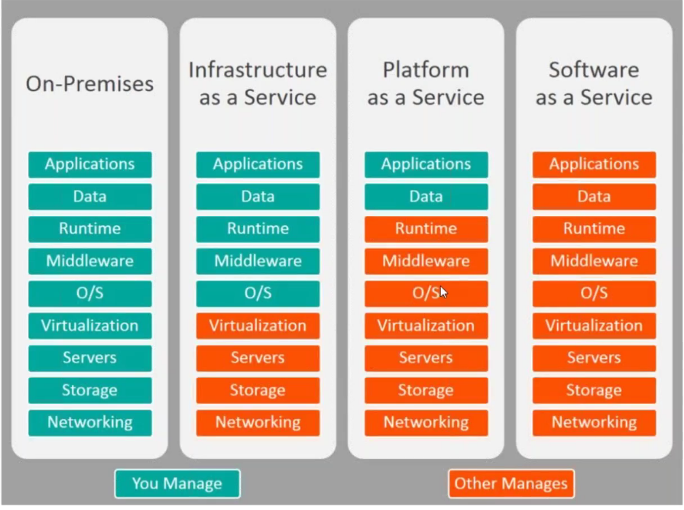

**EC2 RDS S3**

**Useful Websites:**

https://www.tooplate.com → You can take a template from here to launch your website.

<https://github.com/devopshydclub/vprofile-repo.git> --> Vprofile repo

https://www.cloudping.info → This URL help you find nearest region near you. For example if your region is Africa and we actually don’t have that region in the list – So you go to the above link (if you are not in Africa – you should ask someone in Africa to do a ping) and click on ping – it will display the latency and choose the one which is low and that’s the one near you as a region).

<https://www.amazon.com/free> → To check amazon free services details

git clone -b vp-docker <https://github.com/devopshydclub/vprofile-repo.git>

<https://docs.docker.com/engine/reference/builder/> - when building mages using docker this link is useful

What ever values we use in the lab to define any settings is just the hypothetical values. In real time you should use per your project requirement and this comes from:

* Capacity planning
* Capacity planning comes from performance testing
* If you want right values, first of all it will take time to get adjusted with your project
* This value comes from your experience with your own project because every project will have diff env and different resources diff load and so on.
* You need to work with the performance testing team – they put lot of load on the system then you monitor it , see the graph what is happening and decide.

**Versions of all I am using here:**

**Jenkins –**

**Java/Jdk – 1.8**

**Maven – 3.6.0**

**Nexus – 3.16 and latest 3.18 we have**

**Apache Tomcat- 8.5.37 (8.5.45 is latest)**

**Python – 2.7**

**Ansible - 2.8.5**

**Commands:**

Ss -tunlp → to check all open ports

curl http://localhost or URL to check the httpd service

In Linux - yum update -y to update the yum repos

Systemctl start/status/enable httpd

In Solaris - apt update && apt install apache2 wget unzip -y

Systemctl start/status → In ubuntu when you install a service its started and enabled automatically.

Systemctl is-enabled apache2 – to enable the service

yum install epel-release -y – epel repo install

yum install stress -y - tool to stress your CPU

/etc/ssh/sshd_config → you can enable or disable password based login options

**#stress -c 10 -t 500 -v** command to stress your system CPU

#– while installing or staring or stopping any service you get errors and it is not getting started, then you run this command and it will show you the latest log.

#sudo apt purge Jenkins – This command will cleanly uninstall any attempted installation and it got failed.

**Notes:**

1. Always run top command after you login to any instance to engage the service or the session will get hang
2. **Naming Conventions are very important while you name anything anywhere.**
3. To host your website – files will be kept under /var/www/html
4. You need to use the private key for SSH login and if the key matches with the public key you get ssh login
5. The public key gets injected into the instance
6. Never lose your private key – If you lose then there is no chance of regenerating it
7. Public Key is like a lock and the Private Key is like the Key to unlock it – So never lose the private key
8. Never select ICMP rule in security group as this will open up a new threat like d dos attack, ping of death and lots more if you enable ping – people can lots of ping request and Jam you complete instance network
9. **You cannot copy/move existing EBS volumes.**
10. You can make your snapshot public by using the option “permission”
11. **You can share the snapshot across world**
12. you cannot unmount if you are in the same directory
13. All the process should be shut down in the directory
14. There are some tools which can tell you what are the process that are accessing the particular directory – lsof or fuser
15. Lsof <path of the directory> and you can kill the processes.
16. **ELB can route the requests to multiple zones and not regions. Different instances on different zones**
17. **Sudo apt update (ubuntu) – run this before you install anything**
18. Sudo yum update (Linux)
19. Sudo apt install “service name to install any service” apache2 wget unzip
20. **AMI’s are region specific**
21. **If the status of the instances in the Load Balancer target group is unhealthy, Lb cannot route the request to its instances**.
22. 503 Gateway Error – is a routing error from the server side
23. **How to move an EBS volume from one zone to other zone -** You can create a snapshot of EBS volume and from that snapshot you create a volume and while creating you select the zone where you want to create.
24. **How to move an EBS volume from one region to other** – Create a snapshot of EBS volume and copy the snapshot to different zone.
25. **How to move an Instance from one region to another region** – Create an image of the instance (AMI) and copy AMI and select the region to copy the AMI. Now go that region and create an instance with that AMI
26. AMI sharing – modify image permissions and select public option. Once you selct public this will come in your community AMI section. Or If you select Private then you can add recipients account ID to share to them –

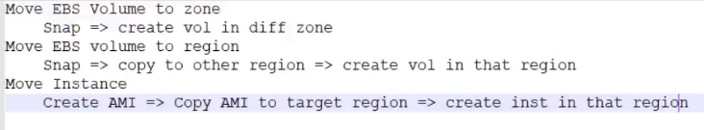

1. To create a launch template, we need to have an AMI
2. Cloud watch uses **SNS** service to send notifications
3. Check interval by default for EC2 is 5 min and when you enable detail monitoring – it checks for every 1 min
4. Check interval for ELB is 30 sec
5. 10 Alarm and 10 Custom metrics is free
6. CPU utilization and load average are 2 different things. Load average is CPU wait time. This load average has 3 values current value, last 5 min value and last 15 min value
7. Maximum size of launching instance in scale out is 10 instances.
8. Never do any changes directly on instances which are part of ASG. Instead launch a new from AMI and then do changes – Always recommended
9. You cannot change the name of the LC after it is created- so make sure you give a proper naming
10. In linux to run any command in the background → nohup cp src dest & . nohup will detach it from shell and & will make to run the command in background
11. How to identify a git repository – go to directory and do ls -a and you see “.git” directory and also you see master
12. On ubuntu machine – GIT comes by default
13. In linux the first process is init and in latest systems its system
14. Refer hard way to learn python book for python exercises.
15. Search codecademy python and you can take up exercises

**Being a devops engineer – how to start taking up a project to setup your Infrastructure:**

Being a DevOps engineer it is very important to understand different services like platform as a service, Infrastructure as a service, Software as a service and on premises as a service. Because being devops you would be in-charge of doing automation and setting up infrastructure. So, if you are consuming any services, you should know what kind of automation you would be doing over there. Or is it required to do any automation like software as a service (here nothing you need to do or just minimal automation). Platform as a service (less automation). Infrastructure as a service (lot of automation). On-premises as a service (you can do automation, but you can’t automate infrastructure).

**Initial Step of your project is to choose a region:**

Which region you would select depends on 2 parameters. This is the initial setup – If customer recommends you use any particular region then fine if not you need to decide based on below 2 parameters.

1. **User Proximality** - (Let’s say you hosted a website and your users are in Asia region then I can choose Asia and Mumbai could be the closest one) Always select region based on users
2. **Cost** (US region is cheap, Mumbai is costly)

**EC2 setup– This is a service to create virtual machines:**

Get the requirement – This is very important – Any task you do get the right requirement

You make all this in a excel sheet in real time – Always ask the requirement in writing.

Don’t do any changes without any email.

* OS?

Centos 7

* Size? (RAM, CPU, Disk and Speed)

1GB RAM, 1 CPU, min Disk, normal speed

* Services? (What service you going to host like http, database or just scripts)

HTTP, HTTPS and SSH

* Env? (What environment)

QA

* Project? (What project)

Avengers

* Owner? (Who is going to own it) – Vey Important

Tony Stark

1. Set up the Key pair (it’s a login key to your instance) you can use one key pair to all your instances. One Key pair for one env (Dev, QA , Staging and PROD)
2. Security Group – (SG separate for separate services) – This is firewall

**Now Let’s launch as per steps above:**

1. Create a Key pair (Key pair = public key and private key)

Name – Aven-QA-Ohio and click create – This will automatically save a file or ask you to save a file and that’s you private key. Public key you can see on the AWS console. You need to provide the private key.

You need to use the private key for SSH login and if the key matches with the public key you get ssh login

The public key gets injected into the instance

Never lose your private key – If you lose then there is no chance of regenerating it

Public Key is like a lock and the Private Key is like the Key to unlock it – So never lose the private key

1. Security Groups

Click on create security group – Name = Aven-QA-web-sg

Now Firewall has 2 rules

-Inbound = when traffic/packets are coming towards it, its inbound → Very important

- Outbound = when packets are going out of firewall/instances its outbound

Click on Add rule - By default SG disallows all the rules

In our case we need HTTP HTTPS and SSH – lets first do it for ssh

Type ssh ; protocol TCP ; Port 22 ; Source MY IP

Source ( so port 22 is allowed from where ? you can give a custom IP or give your public IP (search google “what is my IP and this is your public IP- this is for internet. ” your laptop IP is private IP given by router) or you can choose anywhere – which is not recommended – This means any packet from anywhere can come on port SSH which is very dangerous )

Note; Never select ICMP rule in security group as this will open up a new threat like d dos attack, ping of death

And lots more if you enable ping – people can lots of ping request and Jam you complete

instance network

Security group is also created and now finally we are ready to launch the instance.

EC2 service – Launch instance

EC2 cost comes from

1. AMI
2. Instance type CPU RAM …
3. EBS storage - Connected storage

In vagrant we create instance from vagrant box and in AWS could we create instance from AMI

→

In AWS market place - Search for centos 7 and select the free tier

Instance type – select the free one

Configure Instance – let it be default – Let amazon decide for now and will learn about it later

Storage – put a check mark on delete storage upon termination (not in real time); under device in this section is the virtual hard disk (virtual hard disk – EBS root volume)

Tags – not mandatory but are very important – here

Key = Name ; value = web01

Key = Project ; value = Avengers

Key = Environment ; value = QA

Key = Owner ; Value = Tony Stark

Under Security groups – select an existing one which we created for SSH

Click on launch and select your key pair you already created and click launch

Click on connect and it will show how to do a ssh

Open GIT bash and make a directory in C drive by name KEYS and place all your keys here – just to be safe and not to lose

To login: ssh -i “path of the Key” user@PublicIP

**EBS – Elastic block storage (Virtual Hard disk)**

We have root volume comes with AMI and it stores your OS files

Sometimes you may need more storage – so you create a new volume and attach it to the instance

EBS volume is zone specific

If we want to take a backup of entire volume – we have a technology called snapshot

Snapshot backup and restore:

1. Unmount partition
2. Detach volume
3. Create new volume from snapshot
4. Attach the volume created from snapshot
5. Mount it back

Requirement is – create a 50GB volume for /opt/devdata

Login to your instance and run fdisk -l command which will list you attached hard disk

[root@ip-172-31-38-255 ~]# fdisk -l

Disk /dev/xvda: 8589 MB, 8589934592 bytes, 16777216 sectors

Units = sectors of 1 * 512 = 512 bytes

Sector size (logical/physical): 512 bytes / 512 bytes

I/O size (minimum/optimal): 512 bytes / 512 bytes

Disk label type: dos

Disk identifier: 0x000b956b

Device Boot Start End Blocks Id System

/dev/xvda1 * 2048 16777215 8387584 83 Linux

**/dev/xvda – This is the path of the hard disk**

[root@ip-172-31-38-255 ~]# ls -l /dev/xvda

brw-rw----. 1 root disk 202, 0 Aug 6 13:33 /dev/xvda

So, this is the hard disk

[root@ip-172-31-38-255 ~]# file /dev/xvda

/dev/xvda: block special

Linux Disk naming convention: (Kernel that decides the naming)

/dev/ → This is the path where you will have all your hard disk

There are different kinds of hard disk

/dev/hda → Previously we use to have this called IDE/pata disk

/dev/hdb

/dev/hdc If you have multiple disk and the naming goes this way

/dev/sda → sata or scsi disk

/dev/sda

/dev/sdb

If you have a virtual disk then it is

/dev/vda

/dev/xvda

If the above virtual disk is partitioned, then it is

/dev/xvda1

/dev/xvda2

/dev/xvda3 ...

So, from the below output

**/dev/xvda1** is the first partition

We cannot access this directly – it’s a Raw data. This has to be mounted on a directory. A directory will be a doorway to store data into this partition.

[root@ip-172-31-38-255 ~]# fdisk -l

Disk /dev/xvda: 8589 MB, 8589934592 bytes, 16777216 sectors

Units = sectors of 1 * 512 = 512 bytes

Sector size (logical/physical): 512 bytes / 512 bytes

I/O size (minimum/optimal): 512 bytes / 512 bytes

Disk label type: dos

Disk identifier: 0x000b956b

Device Boot Start End Blocks Id System

**/dev/xvda1** * 2048 16777215 8387584 83 Linux

Df -h command will show you the mount points

[root@ip-172-31-38-255 ~]# df -h

Filesystem Size Used Avail Use% Mounted on

**/dev/xvda1** 8.0G 1019M 7.0G 13% /

devtmpfs 473M 0 473M 0% /dev

tmpfs 495M 0 495M 0% /dev/shm

tmpfs 495M 13M 482M 3% /run

tmpfs 495M 0 495M 0% /sys/fs/cgroup

tmpfs 99M 0 99M 0% /run/user/1000

Here you can see the **/dev/xvda1** partision is mounted on **“/” directory -**  This is like C drive in windows – everything will be stored here

Now coming to our project – We need extra 5GB storage on directory /dev/devdata:

* Create a directory /opt/devdata
* Create a volume in same zone
* Attach volume
* Partition
* Format the partition (Types – ext2, ext3, **ext4-latest one**, xfs, FAT..)
* Mount it permanently

1. Create a directory - mkdir /dev/devdata
2. Create a volume in same zone

Type of volume:

* Magnetic Cheapest very slow disk ➔ usage case - old backups and Archives
* Provisioned IOPS Expensive Fastest ➔ usage case – Prod db
* General Purpose decent price decent speed ➔ usage – webservices, queueing
* Cold HDD decent price decent speed➔ Big Data (Huge storage and decent speed)
* Trough put optimised very expensive fast ➔ Big Data (Huge Storage and fast)

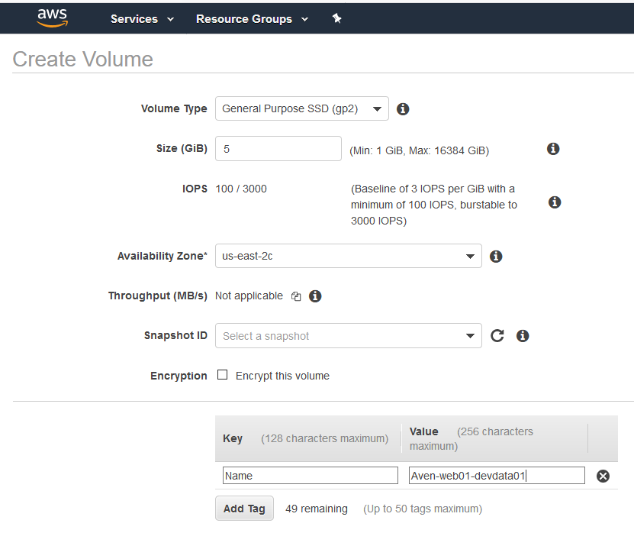

Its created and now it is available to attach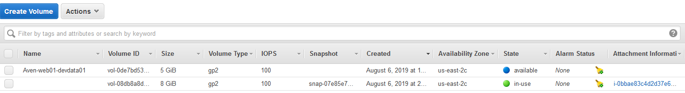

1. Attach volume

Now select your volume and click attach

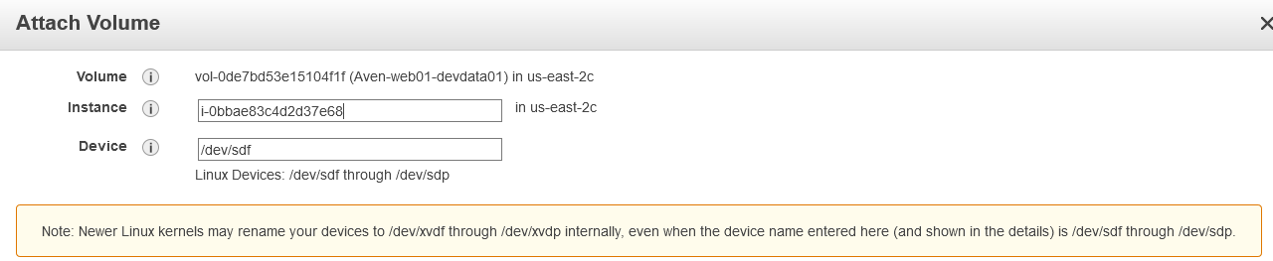

Select your Instance; Device – let it be default (this will be shown different on instance)

Now go you Instance to check if it is attached by running # fdisk -l

[root@ip-172-31-38-255 ~]# fdisk -l

Disk /dev/xvda: 8589 MB, 8589934592 bytes, 16777216 sectors

Units = sectors of 1 * 512 = 512 bytes

Sector size (logical/physical): 512 bytes / 512 bytes

I/O size (minimum/optimal): 512 bytes / 512 bytes

Disk label type: dos

Disk identifier: 0x000b956b

Device Boot Start End Blocks Id System

/dev/xvda1 * 2048 16777215 8387584 83 Linux

Disk **/dev/xvdf**: 5368 MB, 5368709120 bytes, 10485760 sectors

Units = sectors of 1 * 512 = 512 bytes

Sector size (logical/physical): 512 bytes / 512 bytes

I/O size (minimum/optimal): 512 bytes / 512 bytes

Now you see **/dev/xvdf** is the new hard disk

This disk you need to do partition

1. Partition

# fdisk **/dev/xvdf –** This opens up fdisk utility and that’s not bash shell

[root@ip-172-31-38-255 ~]# fdisk /dev/xvdf

Welcome to fdisk (util-linux 2.23.2).

Changes will remain in memory only, until you decide to write them.

Be careful before using the write command.

Device does not contain a recognized partition table

Building a new DOS disklabel with disk identifier 0x9fcb83cb.

Command (m for help):

Device does not contain a recognized partition table

Building a new DOS disklabel with disk identifier 0x9fcb83cb.

Command (m for help):m

Command action

a toggle a bootable flag

b edit bsd disklabel

c toggle the dos compatibility flag

d delete a partition

g create a new empty GPT partition table

G create an IRIX (SGI) partition table

l list known partition types

m print this menu

n add a new partition

o create a new empty DOS partition table

p print the partition table

q quit without saving changes

s create a new empty Sun disklabel

t change a partition's system id

u change display/entry units

v verify the partition table

w write table to disk and exit

x extra functionality (experts only)

Here we need to add a new partition and hence type “n”

Then it will ask you primary or extended partition (In any hard disk you have 4 primary partitions and rest are extended partitions )

Select the default

Next you can partition number or just hit enter to select the default

Next is to select the sector – In hard disk you have sectors.

First sector – default

Last sector – here, you can select the last sector or the size – better you select the size

IF you enter default it will select the last sector and the entire hard disk will be partitioned ; if you don’t want entire then you may mention the size – Let me mention 3G instead of entire

Command (m for help): n

Partition type:

p primary (0 primary, 0 extended, 4 free)

e extended

Select (default p):

Using default response p

Partition number (1-4, default 1):

First sector (2048-10485759, default 2048):

Using default value 2048

Last sector, +sectors or +size{K,M,G} (2048-10485759, default 10485759): +3G

Partition 1 of type Linux and of size 3 GiB is set

Now you can type P to show the partition

Command (m for help): **p**

Disk /dev/xvdf: 5368 MB, 5368709120 bytes, 10485760 sectors

Units = sectors of 1 * 512 = 512 bytes

Sector size (logical/physical): 512 bytes / 512 bytes

I/O size (minimum/optimal): 512 bytes / 512 bytes

Disk label type: dos

Disk identifier: 0x9fcb83cb

Device Boot Start End Blocks Id System

**/dev/xvdf1 2048 6293503 3145728 83 Linux**

The bold highlighted is the partition it got created

Now you have to hit **“w”** to write the partition

Command (m for help): w

The partition table has been altered!

Calling ioctl() to re-read partition table.

Syncing disks.

[root@ip-172-31-38-255 ~]#

Our Partition got created.

[root@ip-172-31-38-255 ~]# fdisk -l

Disk /dev/xvda: 8589 MB, 8589934592 bytes, 16777216 sectors

Units = sectors of 1 * 512 = 512 bytes

Sector size (logical/physical): 512 bytes / 512 bytes

I/O size (minimum/optimal): 512 bytes / 512 bytes

Disk label type: dos

Disk identifier: 0x000b956b

Device Boot Start End Blocks Id System

/dev/xvda1 * 2048 16777215 8387584 83 Linux

**Disk /dev/xvdf**: 5368 MB, 5368709120 bytes, 10485760 sectors

Units = sectors of 1 * 512 = 512 bytes

Sector size (logical/physical): 512 bytes / 512 bytes

I/O size (minimum/optimal): 512 bytes / 512 bytes

Disk label type: dos

Disk identifier: 0x9fcb83cb

Device Boot Start End Blocks Id System

**/dev/xvdf1** 2048 6293503 3145728 83 Linux

[root@ip-172-31-38-255 ~]#

**Disk /dev/xvdf – Is the volume we attached**

**/dev/xvdf1** – **Is the partition we created**

1. Format the partition (Types – ext2, ext3, **ext4-latest one**, xfs, FAT..)

# mkfs and hit tab twice it will show rest of the commands

[root@ip-172-31-38-255 ~]# mkfs

mkfs mkfs.btrfs mkfs.cramfs mkfs.ext2 mkfs.ext3 mkfs.ext4 mkfs.minix mkfs.xfs

[root@ip-172-31-38-255 ~]# mkfs

I will go ahead with ext4 format following the path of the partition

[root@ip-172-31-38-255 ~]# mkfs.ext4 /dev/xvdf1

mke2fs 1.42.9 (28-Dec-2013)

Filesystem label=

OS type: Linux

Block size=4096 (log=2)

Fragment size=4096 (log=2)

Stride=0 blocks, Stripe width=0 blocks

196608 inodes, 786432 blocks

39321 blocks (5.00%) reserved for the super user

First data block=0

Maximum filesystem blocks=805306368

24 block groups

32768 blocks per group, 32768 fragments per group

8192 inodes per group

Superblock backups stored on blocks:

32768, 98304, 163840, 229376, 294912

Allocating group tables: done

Writing inode tables: done

Creating journal (16384 blocks): done

Writing superblocks and filesystem accounting information: done

1. Mount it permanently

Mount the partition on to the directory you created – Below is temporary mount

[root@ip-172-31-38-255 ~]# mount /dev/xvdf1 /dev/devdata/

[root@ip-172-31-38-255 ~]# df -h

Filesystem Size Used Avail Use% Mounted on

/dev/xvda1 8.0G 1019M 7.0G 13% /

devtmpfs 473M 0 473M 0% /dev

tmpfs 495M 0 495M 0% /dev/shm

tmpfs 495M 13M 482M 3% /run

tmpfs 495M 0 495M 0% /sys/fs/cgroup

tmpfs 99M 0 99M 0% /run/user/1000

**/dev/xvdf1 2.9G 9.0M 2.8G 1% /dev/devdata**

**Lets do some exercise here**

To unmount - umount  **/dev/devdata**

To mount - mount **/dev/xvdf1 /dev/devdata**

Now I am creating some data under the directory

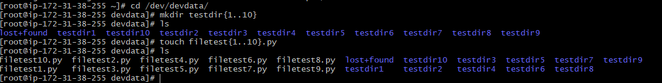

Now Let me unmount the directory

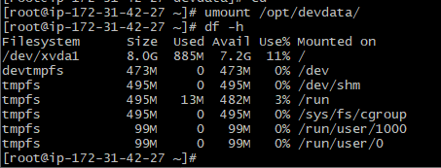

Now the directory is empty

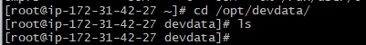

Do you think we lost the data? Actually, it is not - we just lost the door way to the place. you mount it back and see the data again.

How to make the mount point a permanent one:

For that you need to add the entry in /etc/fstab . When you reboot the instance, it will read information from this file and mount all your volumes

Format to add (press tab after each parameter): <partition path> <where did you mount it> <type of format> <defaults> 0 0

0 space 0 – dump code and fsck code [(if you want to take the dump if something goes wrong then make the value to 1) (file system check – if the system boots and if you want to run a file system check – you can make it 1)]

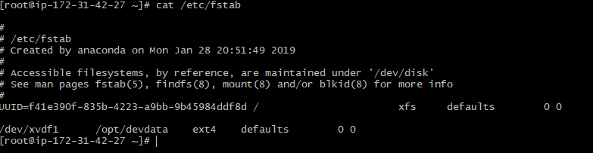

Let me unmount our data

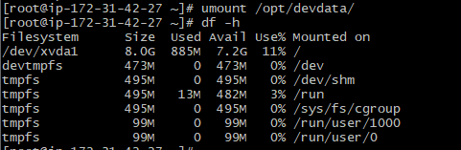

Now if you run the command mount -a – it will read the fstab file and mount it

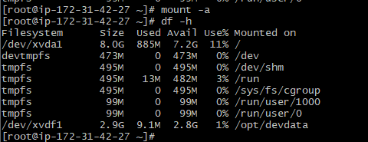

How to take a backup of a EBS volume (snapshot)

This will take backup of full volume and not specific data. The first its gonna be full back up

* Select your volume and select create snapshot
* Now go to snapshot section and you will see the snapshot which was taken



Now we have our snapshot – Lets assume now while doing the deployment in the directory /opt/devdata I removed all the directories under this which resulted in corrupted volume.

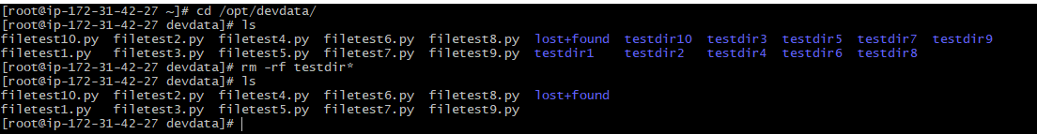

Now lets see how to recover the data with the snapshot

**Steps to recover data from snapshot**

Note: You cannot copy/move existing EBS volumes.

You can create a snapshot of EBS volume and copy from one region to other by using copy option – (it will take long time)

You can make your snapshot public by using the option “permission”

You can share the snapshot across world

1. Create new volume from snapshot

When you create a new volume, you can change the volume type; You can increase the size if you want

Also, you can move the volume to any zone

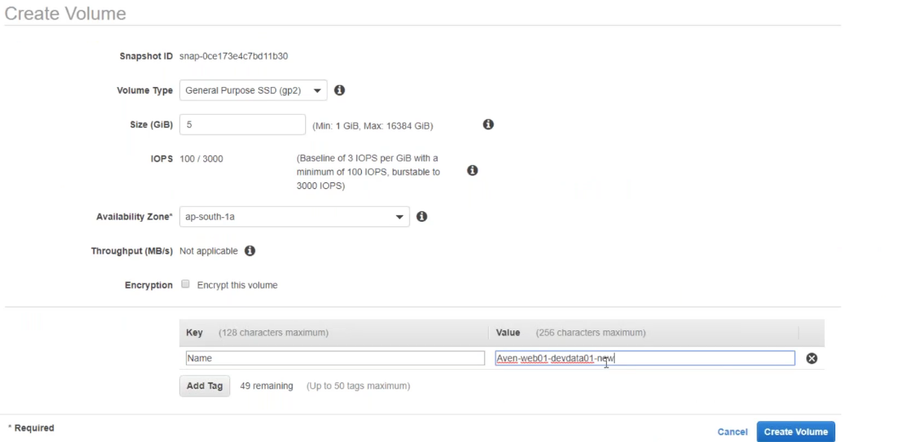

Now you can the created volume from snapshot under volume section

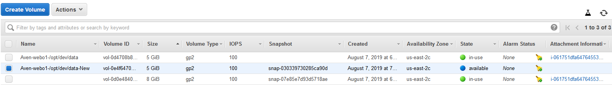

1. Unmount partition

Note: you cannot unmount if you are in the same directory

All the process should be shut down in the directory

There are some tools which can tell you what are the process that are accessing the particular directory – lsof or fuser

Lsof <path of the directory> and you can kill the processes.

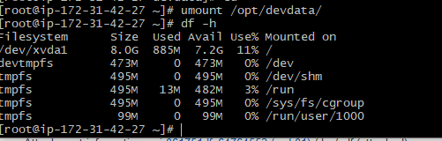

1. Detach the old volume

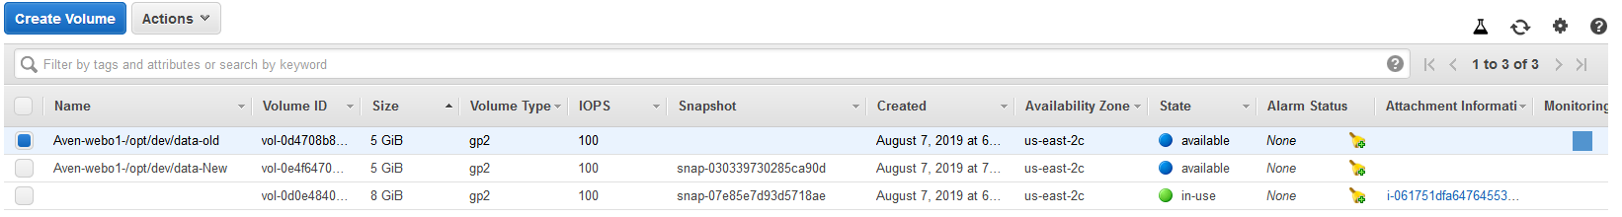

Verify in instance by running fdisk -l

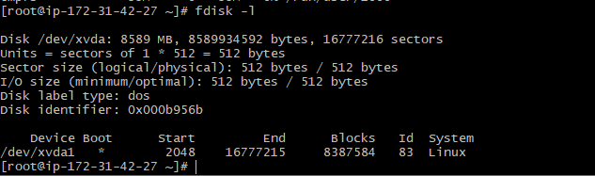

1. Attach the New volume created from snapshot

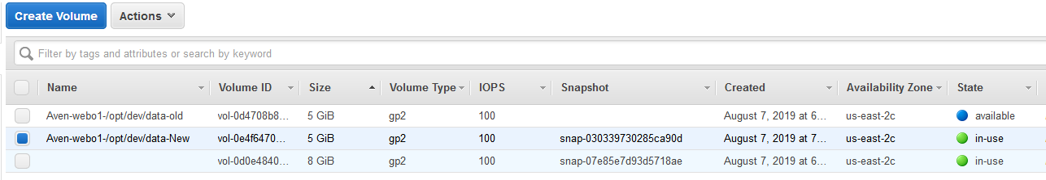

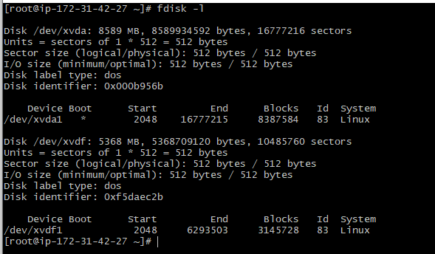

1. Mount it back

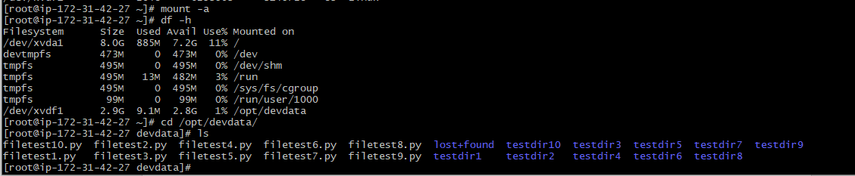

Now we have restored the data from snapshot of EBS volume.

**Elastic Load Balancer – To provide a single end point, we use Load balancer**

Ec2 services gives us load balancer as we have Ec2 instances

Singe instances won’t be enough. So, we will be clustering instances for webservices/backend services

When we cluster them together, then we need a **single end point** and that we can provide it through **ELB**

**ELB** can route the requests to multiple zones and not regions. Different instances on different zones

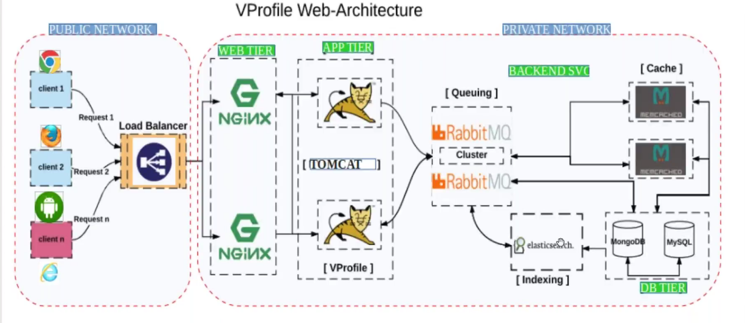

* NGINX – serves web request
* Tomcat – serves dynamic application
* M cache – caching service for database – Tomcat is going to fetch information from database and to make the process fast we using this M cache.
* Rabbit MQ -queueing service that queues the request between 2 application
* Elastic search – is used for indexing to make the search faster (amazon search, Facebook search, Google search. Any search on their website...)
* Here we have 2 NGInx, 2 Tomcat, 2 Rabbit MQ, 2 M cache – all in cluster for high availability (redundancy), Load balancing and very important one is **scalability**

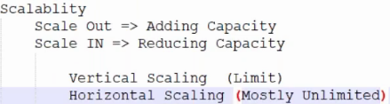

* At least we need 2 instances for load balancing.
* If you are hosting any website, your load balancer will be in public network
* In clustering, we also have concept called Network clustering with port numbers – that means I will have to just tell the load balancer that these are my Nginz instances send them request on port number 80
* We have Hardware Load balancer – that is like just like a compute

Software LB – Take any OS and install LB software

Network LB – ELB

* In LB it is very important to understand the Listener port/Front End port and other one is Backend port/instance port/service port

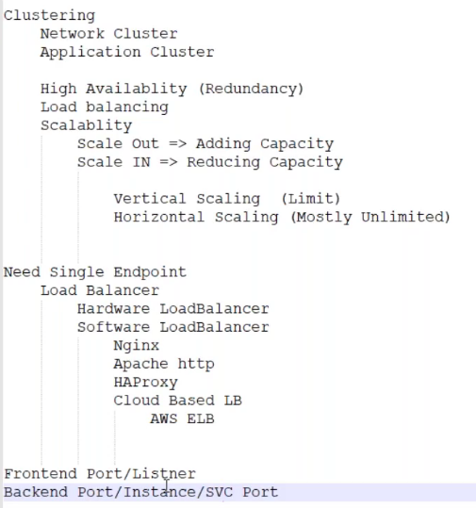

* AWS ELB uses Round-Robin Algorithm by default and there is no option to change it.

**Types of ELB:**

1. **Classic Load Balancer** – old generation, very simple – Front end port, add the instance and give backend port – Usage is just take the request from user and route it to backend you just need an endpoint (For this requirement go for classic)
2. **Application LB** – useful in micro service architecture

In the below Fig we have 2 EC2 instance that is serving website visualpath.in/devops. Now If the user makes this request, the LB will forward the request to /devops target group. If user hits /frontend, the LB will forward the request to /frontend target group

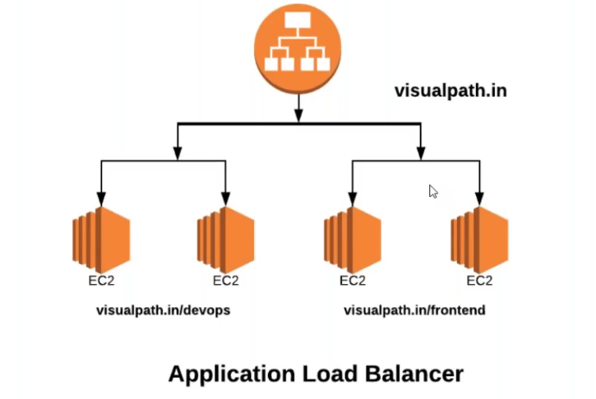

1. **Network LB** – For any protocol http, https, SMTP, POP3 you can use this LB….

**Let’s see how to setup ELB and host a webservice and access it with different ports using Application Load Balancer:**

1. Launch your instance and login (taking ubuntu here)
2. Sudo apt install wget apache2 unzip
3. Download any html website from tooplate and unzip and copy all the files and keep in /var/www/html directory
4. Start your apache service

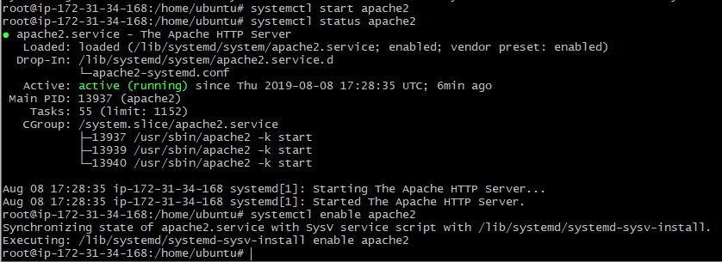

1. Now copy your instance IP and hit in browser you see your html page – it should work
2. Now here I have only one instance. To use LB we need to create more instances
3. Before that itself, I will arrange the LB
4. Under Load Balancing -> click on target groups (group of instances)-> create target group

Target group has come with Application LB

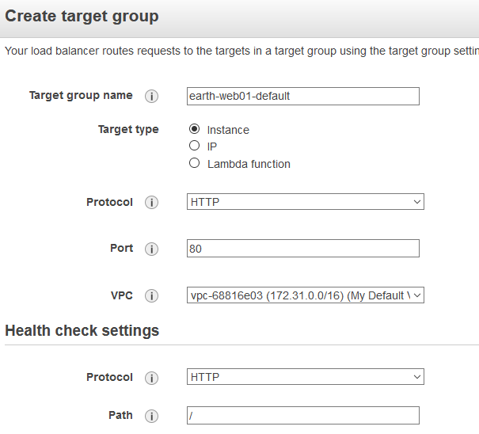

Protocol – select http or if it is https (in our case its http)

Port – port number of the service (in our case apache2 and its port 80)

Click on create



1. Now you need to add the instances in the target group
2. Go to targets under target group of one which you created and click on edit

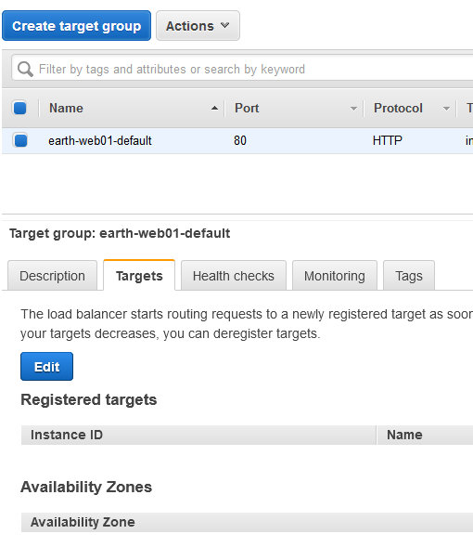

1. Select **your instance** and click on **add to register** this instance on port 80. On this instance I have apache service and it is using port 80 and hence I selected the pot 80. Click on **save**.

**This is our backend port**

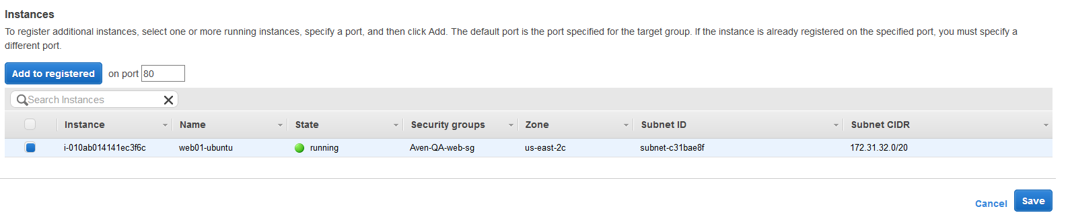

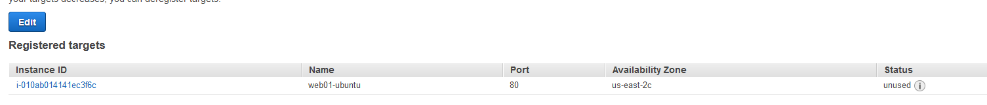

Now you see the instance is registered in **target groups**  and the status is showing unused as it is not yet used. We will use it through Load Balancer

1. Go to Load Balancer -> create Load Balancer > Select Application LB (today we will use this)

* Give a name for the Load balancer – This Name will come in the URL endpoint
* Scheme – Internet facing that means Public LB
* **Load Balancer Protocol – HTTP and port is 80 – The Load balancer URL now will listen on port 80 (Front end Port)**

You can add Multiple listeners and multiple protocols (http and https)

* Let me add one more https listener here listening to port 8090

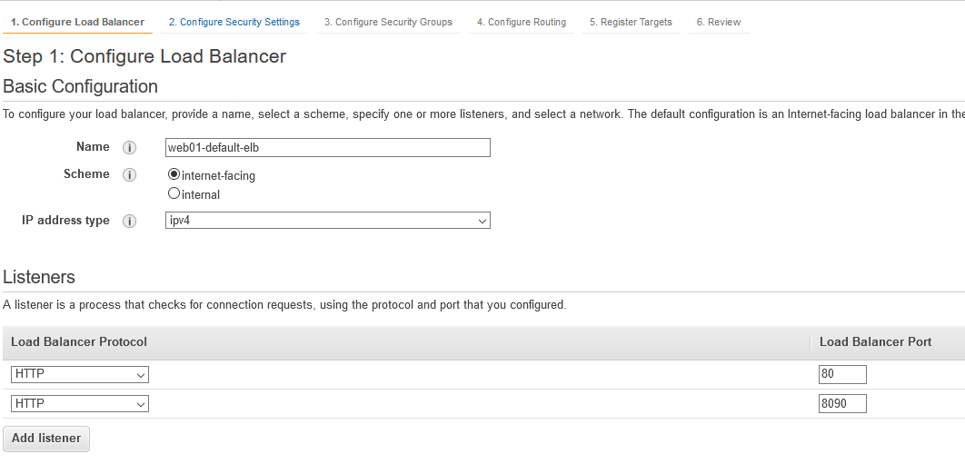

* Click on next and you get a error – You need to select the availability zone

**Question: What if the Load balancer goes down**

AWS ELB is a highly available Load Balancer because it gets created on multiple zones. You need to select minimum 2 zones

If one Zone goes down, the purpose can be served from other zones.

* Select the zones and click next

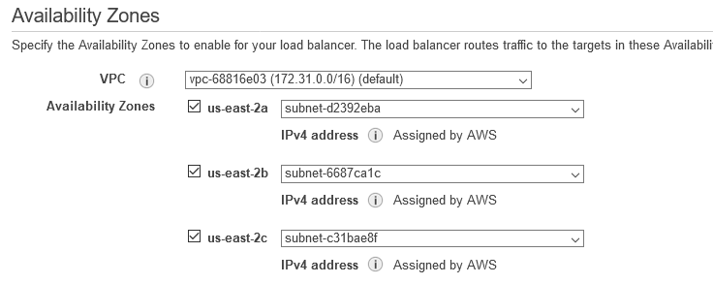

* Next step is to create a security group – give a name and port numbers and click next

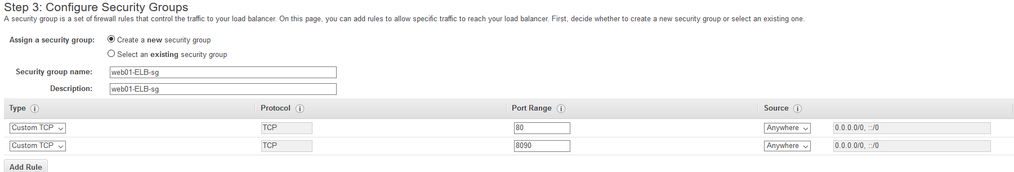fgit

* Next step is to configure routing

Where should we route the request to

I already have target group – so select the existing group and click on next, review and create



1. So Far, I have only one instance. I need multiple instances for LB

**AMI (Amazon Machine Image):**

I can launch the instance from the scratch like the way we use to do from the beginning, then install services, host webservice and every setup you did for first instance you need to do it on the new one. Since it is already done on the existing instance, you can clone the instance and that is called as **AMI.**

**Steps:**

* Select your instance -> Actions -> Image -> create image and give a name

Once you have the AMI image, you can launch the second instance from the AMI or 3rd or 4th .. or 10. You don’t have to do the things again.

While creating image you see an option to check **Reboot →** If you don’t want your instance to be rebooted like if its serving a live traffic then check in option **No reboot.** But this will take longer time for creating AMI. We are now not selecting this option.

So now you create AMI, your instance will get rebooted.

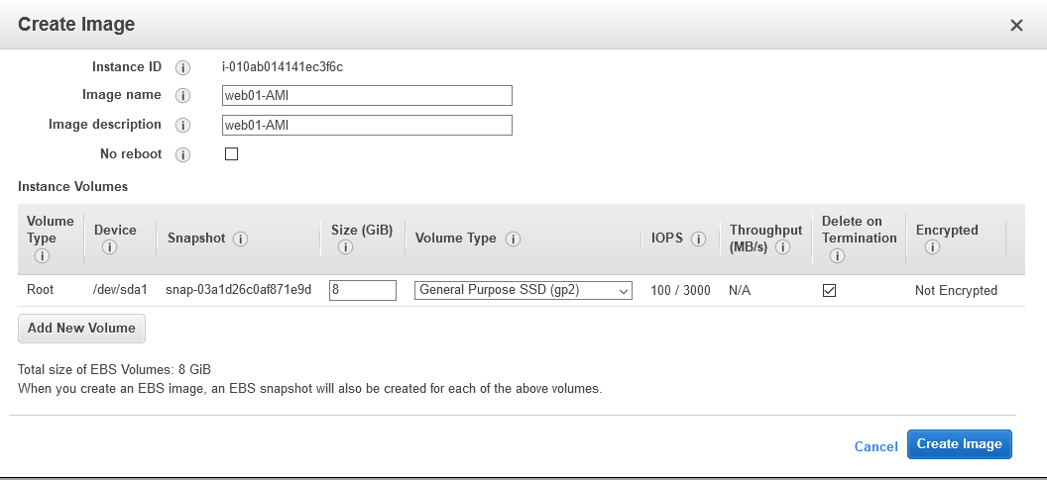

* Once you create AMI -> Go to AMI section and you see there

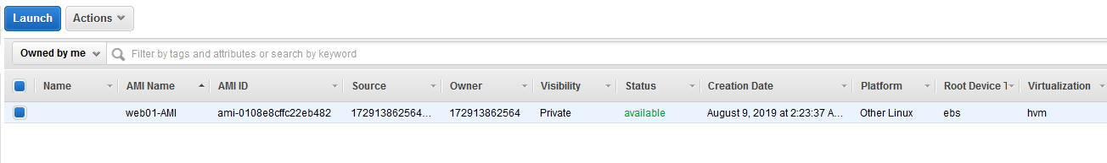

**How to launch an Instance from existing AMI:**

**Steps:**

* Either go to AMI section -> select your AMI and click on launch or you can go to EC2 Instances section and click on launch instance.
* Now in “My AMI” section and select the AMI you created and click on launch and also select the same Instance security group (not ELB security group)

Select the existing Key pair and launch the instance.

**Note:**

Now I have launched an instance from AMI and I have all the setup what was there on the existing instance. The time has changed that in this current world we don’t install an OS from the beginning. Its all we create is images.

1. Since I have created an instance, I need to add it to the target group.

Go to target group -> select your target group-> target->edit-> select the newly created instance->Add to registered and save it

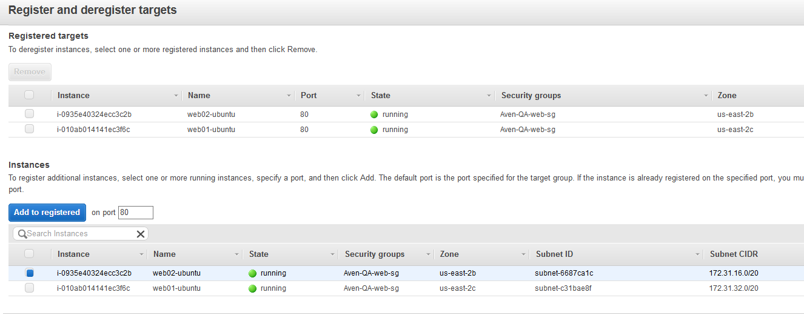

Check the status of the target group instances – Here its showing unhealthy (we will discuss this later)

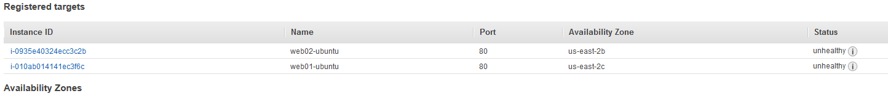

1. We have added our instance to the target group. Now lets run a test to access the website

Copy the new instance Ip and hit in browser - > you will see the website and it’s a success

1. I can now access the website directly from each instance
2. Now Let’s check the Load balancer URL –> Go to Load Balancer-> Copy the URL (DNS name) and hit in browser.

**URL :** web01-default-ELB-1863640385.us-east-2.elb.amazonaws.com

**I did try but it failed.**

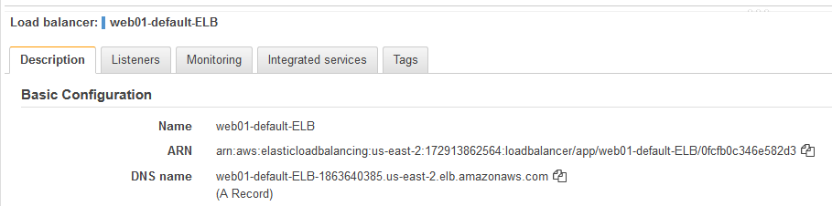

**Note:** If you are not able to hit the website from load balancer URL, the First thing you do is to go to target group and check what is the health of the instances in target group. Now I see its unhealthy. That means LB is not able to route the request to its Instances for some reason.

**Troubleshooting:**

Now Let’s check the firewall rules at Load balancer side and at Instance side as well.

**Load Balancer SG:** Inbound -> http 80, 8090 -All are allowed from any source and it looks good.

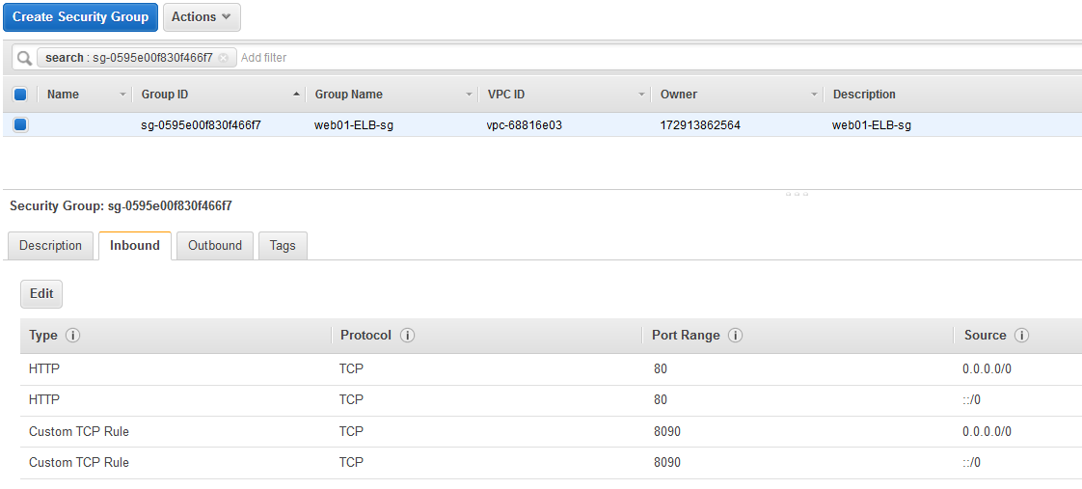

I can conclude that by LB can send the request to Instance but Lets see if my Instance allow traffic on port 80 and 8090.

**Instance SG:**

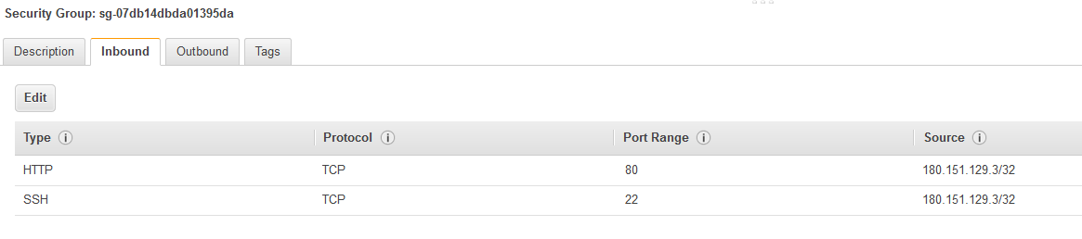

Looking at this Instance SG – I see it allows port 80 but it allows from my IP and not from the Load balancer.

In this case we need to add one more rule with port 80 and source either IP or the security group of Load Balancer (always give security group as the LB internal IP keeps changing)

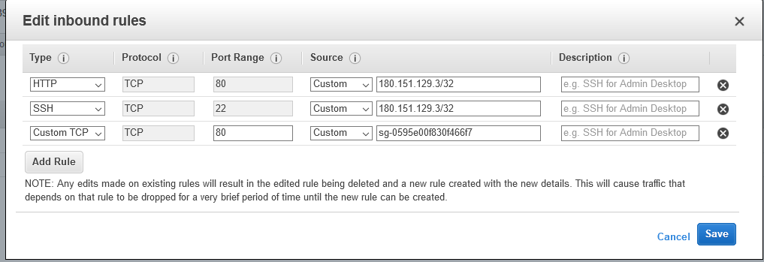

Now I have added a rule which says – allow traffic on port 80 from any instance in this mentioned security group

So, any thing that is placed in this SG can access this security group on port 80

1. Now go back to your target group instances and check the health status – It shows healthy now

**How does a Load Balancer know an instance is healthy or unhealthy?** It knows it through the health check.

Go to target group -> select your target -> Health Checks

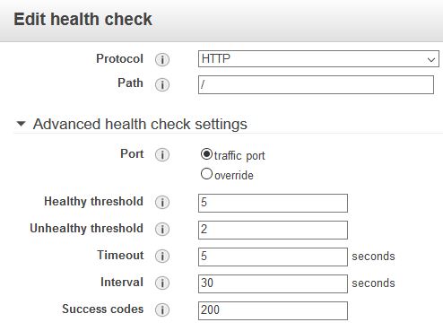

When you open a browser and enter the URL and we see instance is accessible (in our case website is accessible from instance IP)

LB also uses the same protocol and the **path** parameter under health check is ‘/’ directory means just giving the IP or the hostname you can access the website

Eg; URL: <IP>:80

Let’s say you have a website accessible in URL/devops

<IP>/devops:80 then the path would be **/devops**

**Traffic Port:** HTTP traffic port is 80 – **This is instance port**

**Override:** If you are using a different port – then you can use here – **This is instance port**

If you are using a tomcat and if it is running on port 8080 then use override and mention it there

**Healthy threshold -** This value is 5, that means LB checks 5 times – All 5 times if its healthy then only it will declare the instance as healthy

**Unhealthy threshold:** If 2 times out of 5 times it does not respond – It will declare it as unhealthy

**Time out:** LB sends the request and if the instance doesn’t respond in 5 sec then it will be marked as unhealthy

**Interval:** It will send all the requests in an interval of 30 sec

**Let’s see how to setup ELB and host a webservice and access it with different ports using Classic Load Balancer:**

I will here shorten the steps and we did the same using Application Load Balancer above

1. Launch an instance
2. Host a website and test whether you can access it from Instance IP
3. Now I need another instance which we created using AMI earlier and now will do using Launch **Template.**

**Launch Template:**

AMI is also automation – where I can launch an instance from it but still while launching, I need to provide the information like Instance type, configure instance, storage, security group, key pair and all of that. To avoid this and to launch an instance in just a single click this launch template is useful.

To create a launch template, we need an AMI

Template is new style of Automation. Its easier. Most of the automation is based on templates.

* Click on Launch Template and select create new and give all options here like we use to give while launching instance.

Give a name

Select your AMI, Instance type, Key pair, Security Group

You may add a extra interface to add an IP

Give a tag name

In advance section you have **User Data field** - and if you want you can put your script or any commands to execute when VM comes up –

* Now launch your instance using launch template.

**In case now if I want to launch some 4 instances, I can just do it with a single click from launch template.**

* Go to launch template
* Select your template and launch an instance with template option
* Select the template version and change the tag name if you want
* Select the number of instances you want to launch
* Click launch

Since you created all these from the instance which was already setup – In our case we are having http service hosting a website. Since you created the AMI and launch template from that instance, now you don’t have to do anything, and you can directly access your website. Verify and it should work.

1. Now we have 2 instances – Now let’s place it under load Balancer using **Classic Load balancer**
2. Here we don’t have any target group like in application Load Balancer
3. Go to load balancer → create → Classic load balancer →and select the frontend and backend port

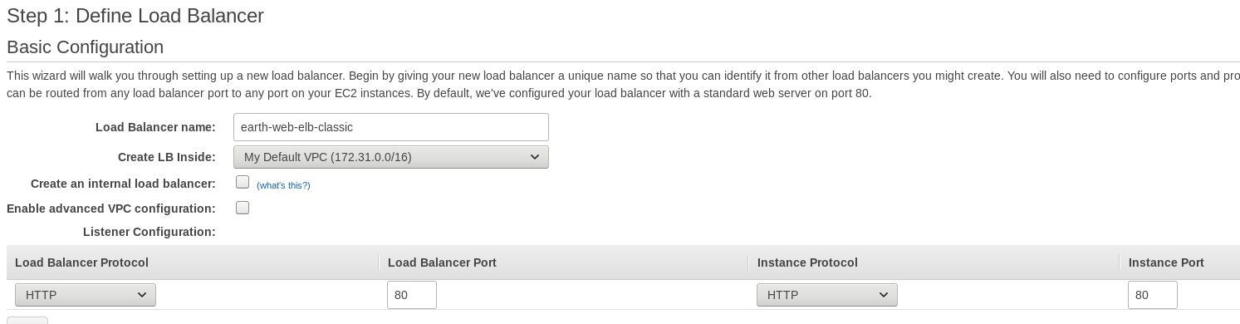

1. Next is to select your LB security group –
2. Next and next and then select your instances to add to this LB – LB created
3. Once the Instances are healthy, access the website from LB URL and it should work.

Clustering concept has scale in and scale out. How do we know when to scale out and when to scale in – We need to monitor

In every organization who is running PROD support they will have a monitoring team who monitors 24/7.

**Cloud Watch service: This will help you monitor your AWS resources.**

Monitoring is by default setup. We don’t have to setup any monitoring solutions here. The only thing we do is you setup your metric and set up alarms for it.

For ex - If you go to your instances under monitoring tab you can see what all are getting monitored for your instances. Like wise we have monitoring for the services in AWS.

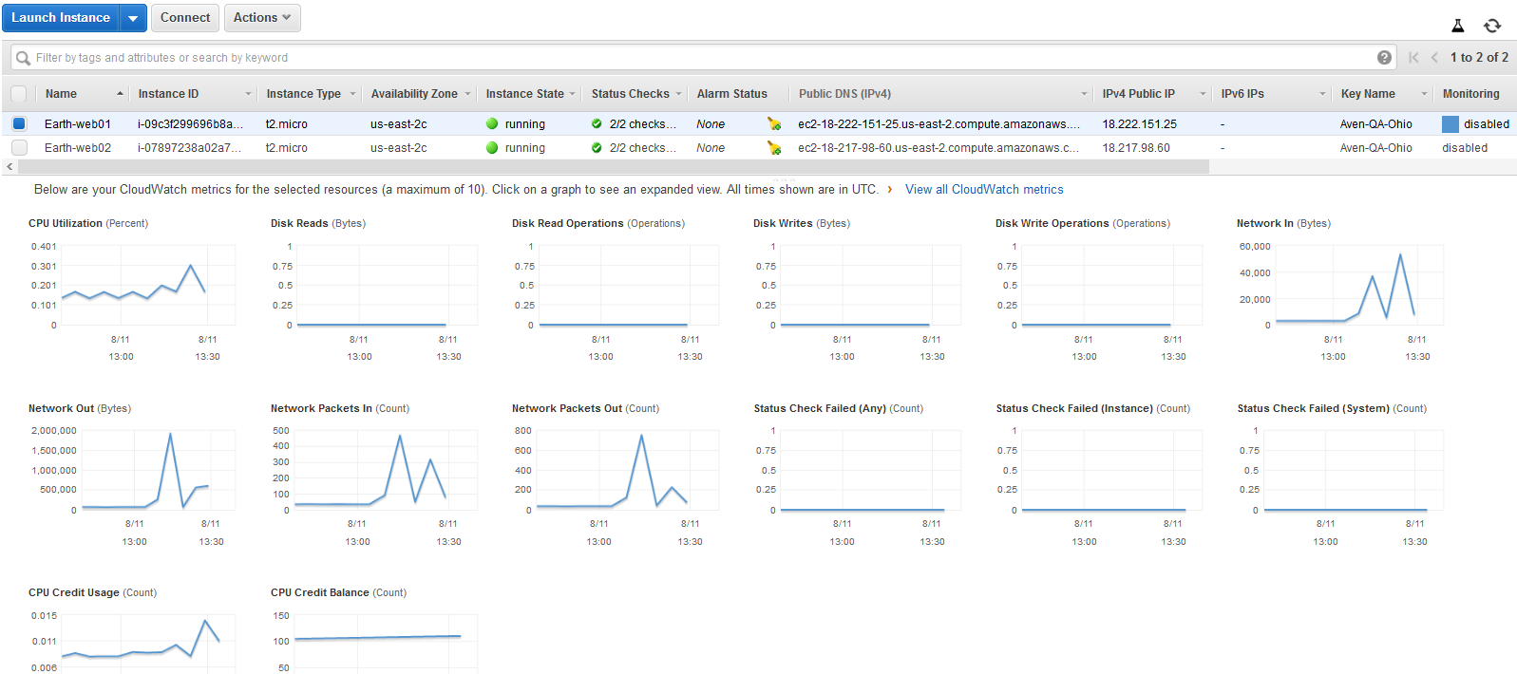

Any service you use in AWS, Cloud watch will create metric for it(Only if you use that service).

Under CW if you go to metrix you can see that here.

See below – In Ohio region I have used below services and it has setup metrix for it.

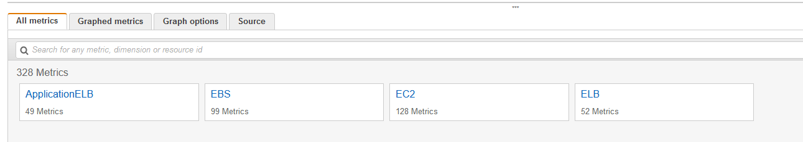

You can visit here particular service and check the particular instance or anything and it will show you live graph of the load.

Here you can choose to select if you want to see for last one hour, last 3 min last 1day, 2day,3day or you can customize your filter as per your choice and see what the spike is for particular time.

So, Cloud watch is already monitoring your service, but it is not telling me when it is spiking high.

**For that you need to set up an Alarm:**

Here I will set up the Alarm for below 3 thresholds.

**For Warning Threshold** – when CPU goes greater than 50

**For Critical Threshold** – When CPU goes greater than 70

**For OK threshold** – When CPU is less than 30

I will take an example of setting up Alarn for **CPU** metrix.

* Go to cloud watch and select Alarm

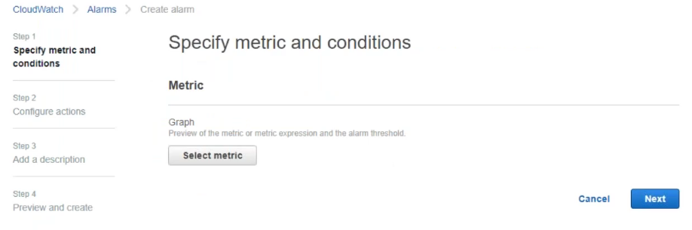

* Select your metric → Ec2 →Per instance metric → Select the CPU utilization metrix for your instance

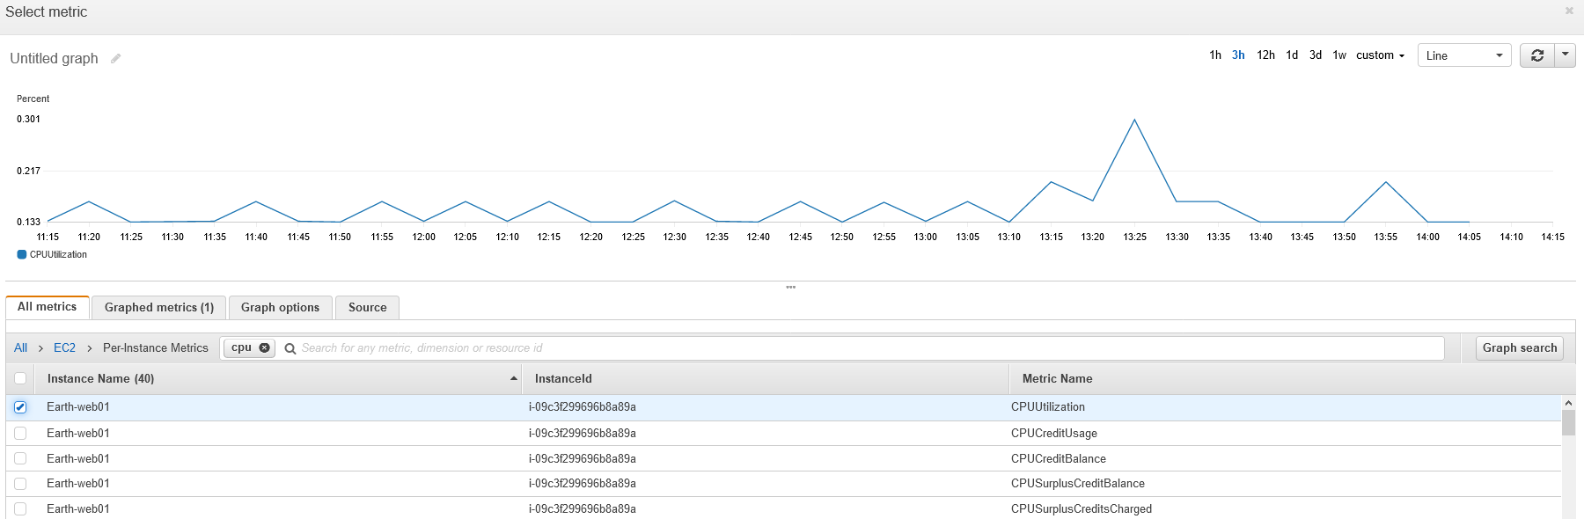

* Under Conditions – **Whenever CPU utilization is** parameter and give the value you want.

I am giving here – Whenever the CPU is greater than or equal to 50 % that means As soon as the CPU utilization spikes it will not send me the alert. I will wait for a period of 5 min (that’s what I mentioned in **PERIOD parameter**) you can edit this value per your choice.

In real time you set as per the requirement. Because CPU spike is normal. It goes up and comes down. But if it’s going to stay up for a long time then it’s a problem.

Under **Additional configuration (1st snippet below)**

Define your data points - 1 out of 1 (this is linking to the period you set)

If I define 1 out of 2 → that means it will wait for 10 min.

**In the next step** you need to select Alarm and define what it need to do when it cross the threshold that we set as 50 for CPU

For this you need to create a **NEW TOPIC – This will use SNS** service here.

Cloud watch uses **SNS** service to send notifications

Give a topic **Name –** Monitoring_Team_Prod

Give the email address of monitoring DL or where you want to send it – here for now am giving my email ID – [overseas.well@gmail.com](mailto:overseas.well@gmail.com)

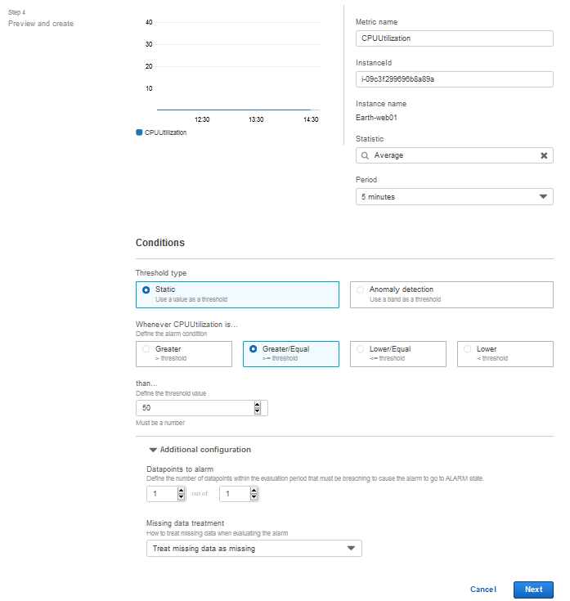

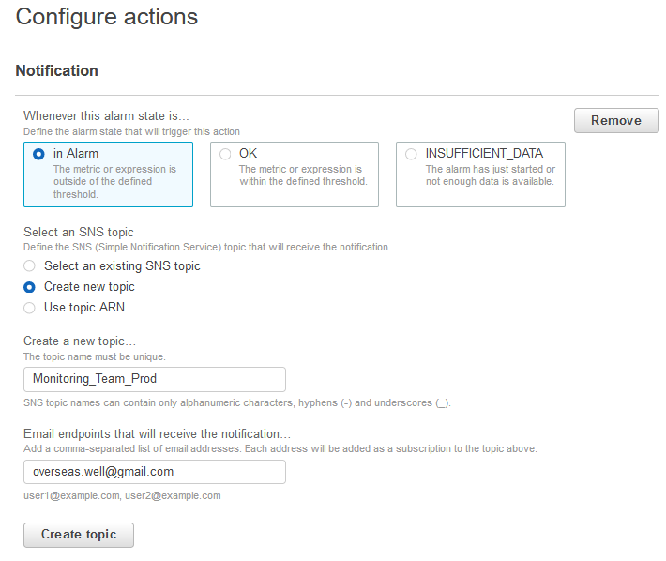

* There are like few other actions here

**Auto scaling action:**

**Ec2 action** – When the CPU reaches its threshold, you can define here what action needs to be taken like reboot the instance, terminate the instance or stop that instance

**(We will see this option later)**

* Click next
* **Alarm name –** this name has to be unique – **this will be the subject Line of your email**

Warning | Earth-web01 | CPU HIGH

For me if the CPU goes beyond 50 – its just a warning and that’s one threshold, I will also have another threshold for alerts

* Click next and create Alarm



So Far, I have set up an alarm for metric CPU when threshold value of CPU goes more than 50 – an email will be sent as warning Alarm

***Home work - In the way you set threshold for Critical and OK as I mentioned in the beginning.***

Now I have setup a threshold warning if CPU goes more than 50

Soon you register an email ID for notification – you will get an email to confirm the same

**Summary:**

I have created a warning threshold

5 min is the data point - If the load stays more than 50 for 5 min then it will trigger Alarm.

After the Alarm trigger, we have actions of sending email notifications

Let’s Test this warning scenario:

For this I need CPU utilization to go beyond 50 and I set this for warning

To do that we need a tool called Stress (this will stress your system)

Install epel-release repo and install stress

yum install yum install epel-release -y

yum install stress -y

**#stress -c 10 -t 500 -v** run this command and check your CPU utilization in duplicate session

Now Let’s test it as the CPU load is now 100%. Clould watch will monitor my Ec2 instance every min as I enabled detailed monitoring. Our data point is set to 5 min. if the 5th time when CW checks the instance and its CPU still 100 percent, an alarm will be triggered, and email notification is sent.

**Auto Scaling**

Monitoring gives alert →Monitoring team receives it →Monitoring team will escalate to your team →Then we will see ok load is going high →we login to the system and verify and see yeah its high so many users connected → so what we will decide to do is **scale out →** We have launch template and we will quickly launch an instance.

But then this whole process takes lot of time and the entire process is manual.

**Now how about thinking to automate this whole process:**

When it crosses the threshold → Instead of sending an email and human takes an action,

How about a tool automatically takes an action → Load goes high, It will launch an instance (Scale out 2 instances 0r 4 ..10..20 insatnces) and when load is coming down it starts deleting.

This process itself is called as auto scaling.

* Auto scaling service automatically monitors and adjust the computer resources based on the alarm
* It needs an alarm and we will set any alarm in AWS using cloud watch
* We need to decide our metric and set alarm
* CPU utilization and network out are the 2 popular metric in auto scaling
* In auto scaling, we have auto scaling groups that works based on scaling policies
* We have to define the scaling policies (Ex: if CPU >30, then launch 2 instances for me; If cpu is >60 then launch 4 instances for me and so on)
* In the same way revere scaling policy that when it comes down delete instances
* Load balancer is not an requirement in autoscaling group. It doesn’t matter whether you have a load balancer or not. Autoscaling group works on instances and not on LB
* Auto scaling group means it’s a group of instances and if you say I want 4 instances in the group, It will make sure you always have 4 instances in the group. If you delete any instances, it will re-launch the instances.

**Below is the metric in autoscaling group;**

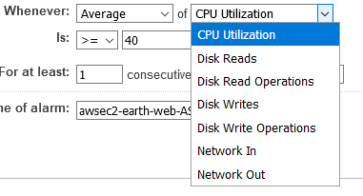

Disk reads and other disk related are new feature added

**STEPS to implement Auto Scaling:**

Let’s create a new ELB classic and test it if its working

**For this setup you minimum need an AMI that’s it.** (If no instances not a problem)

1. Go to auto scaling group
2. Create a autoscaling group – but before you create it will ask you to create **launch configuration.**

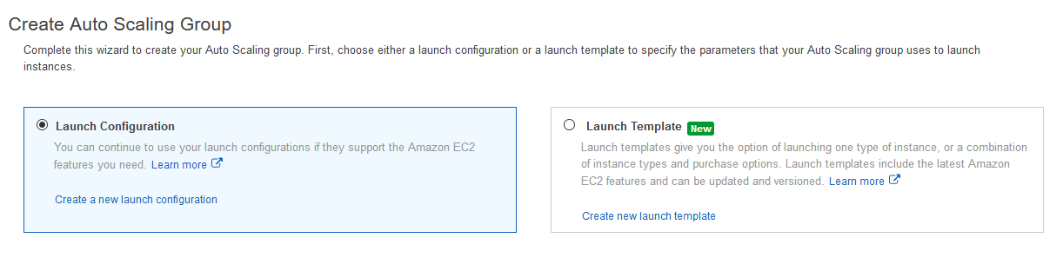

Launch Configuration is for auto scaling group but now auto scaling group also supports launch templates. You can create you launch template and use them or use the default launch configuration for auto scaling. Anyways we have seen launch templates so now we will use launch configuration

Auto scaling group should know what kind of instance, SG, Keys and so on it requires , so we use launch configuration

1. Create a new launch configuration and select your AMI→ select the instance type→ and give launch configuration details with enable cloud watch detailed monitoring (this will poll every minute and launching will be faster)

In advance options you can give your commands or script to execute those automatically after launching

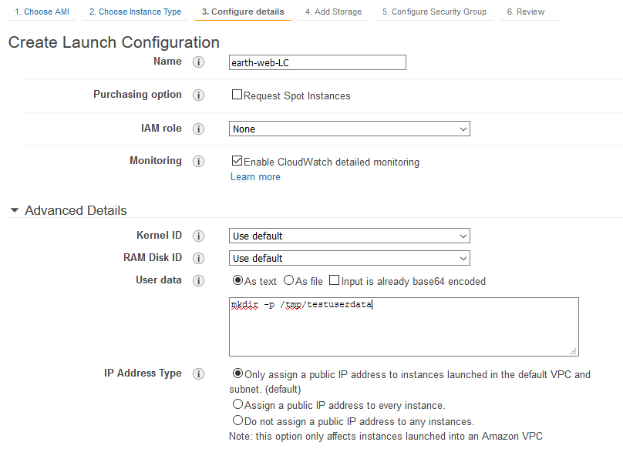

1. Next select your SG, Key pair and finally create launch configuration
2. Now comes the auto scaling group

Give a name ; Group size – 1 how many instances you want to get started with

You may give 2,3 4.. per your requirement

VPC- take default for now and later we will learn this

Subnet – it is asking to select your subnet/zones – Select all that is there under your region

**In Advanced details** - If you want your instance to be added to any LB then you can do it here.

**Health check** – you can select ELB

Load balancer will anyways do health check that it will forward request to those instances which are healthy. Now here for autoscaling, health check we have selected ELB, now any of the instance in LB is not healthy →Autoscaling group will launch a replacement.

So, selecting ELB for health check → HC is done for ELB and EC2 also

**Enable CW detailed monitoring** also so that it will check your LB every min

**Instance Protection →** when ACG see any instance if unhealthy, it will delete the instance and then launch an instance. Just say you don’t want that unhealthy instance to be deleted as you want to check want wrong then you add your instance under instance protection. ASG will take this instance out of ASG but it will not delete this instance. For now we will skip this

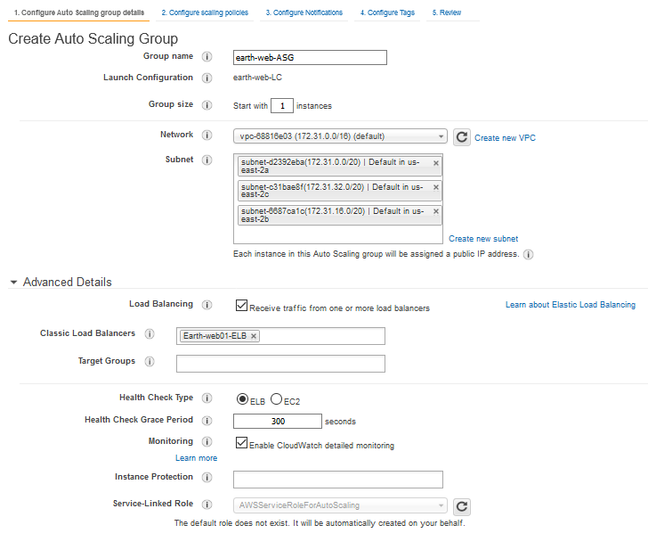

1. Click on next – create scaling policies
2. You got two options in scaling policies

**Keep this group at its initial size:**

If you don’t want to scale out or scale in automatically based on an alarm. That is in your previous step you selected 1 instance as initial setup. This will make sure at any given point of time I have one instance always up and running.

Let’s say you have a requirement where they say we don’t need automatically scale out and scale in. We want always 4 instance and if something goes wrong monitoring team will take care and if required, they will increase the size or change the number of instances. If that is your requirement then you can select this option changing the initial group size to 4 in your previous step.

**Use scaling policies to adjust the capacity of this group:**

Now Let’s say you have a fluctuating load. Based on the load you launch the instances. Then only you select scaling policies. Don’t just select since we have options.

If your requirement is based on the load, you add instances and delete instances. Then select the scaling policies and you say scale between 2 and 10 instances (min size and max size).

Now select **Scale the Auto Scaling group using step or simple scaling policies** and here you need to setup alarm for Increasing the group size and decreasing the group size.

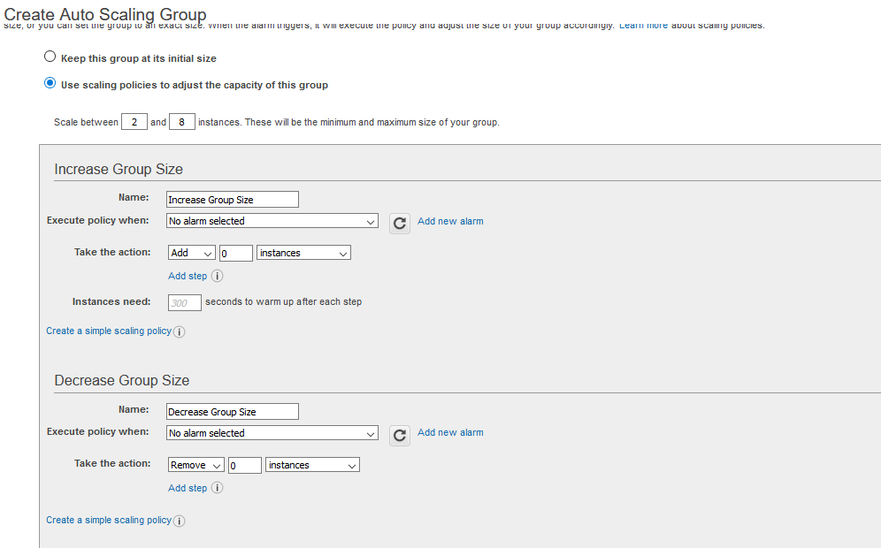

**Now first create alarm for Increase group size**→ click on add alarm

Select your **SNS topic** or create new – I already have it so select it

My metric is CPU utilization – give the value when ever CPU utilization is >=40 for at least 1 consecutive period of 5 min. then click on create alarm.

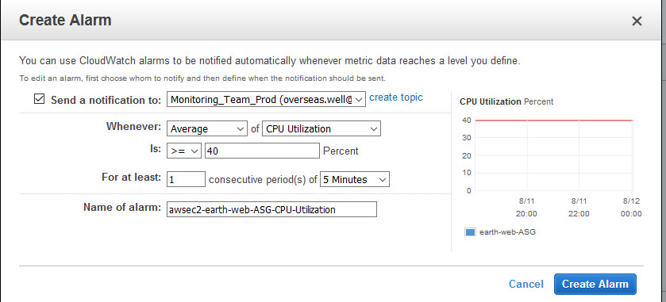

**Take the action:**

Here you can define add 1 instance if CPU is 40 to 49

add 2 instances if the CPU is 50 to 59

add 3 instances if the CPU is 60

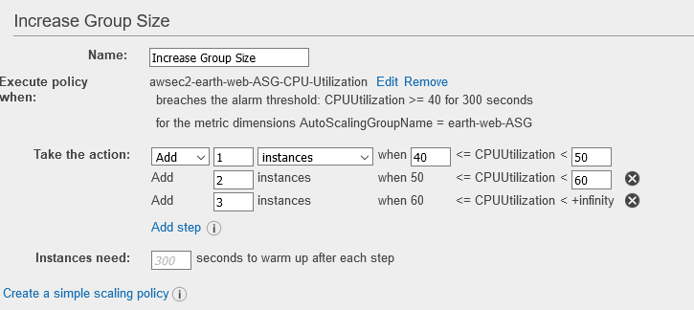

**Instances Need:** default value is 300

Let’s say I have set this to 100 sec→ Let’s say now your CPU usage spiked above 40, stayed there for 5 min so, its an alarm. So, based on your policy it will launch one instance. When it is launching the instance suddenly the load spiked 50 60 70. That time it not going to take any action. It will wait for 100 sec to trigger the next action and that’s the warm up period

**Now create alarm for decrease group size:**

This is scaling in. You would need to delete the instances if the load comes down

In the above scale out that is increase group size we defined 3 alarms and if all the alarms gets triggered then in total we have 7 instances got created (Initial 1; at 40 it will create 1 ; at 50 we got **2** and at 60 we got **3).** Now the load is coming down and we have very less users so you should be also scaling in deleting instances.

Similar way decrease size but in reverse **order**

Add new alarm

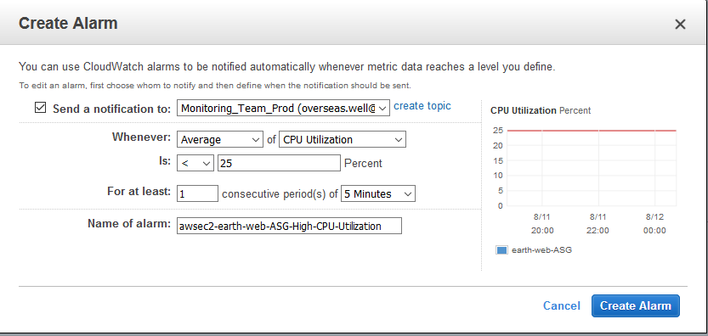

If the CPU utilization is below 25 then remove one instance ; less than 15 then remove 2 ; if it comes to 10 then remove 3 instances.

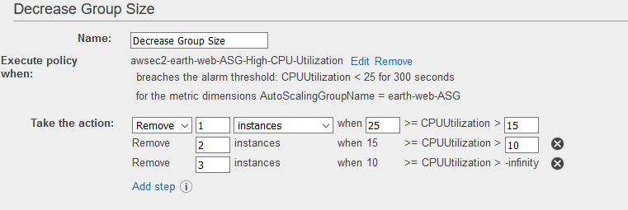

1. Click next and next and add tags

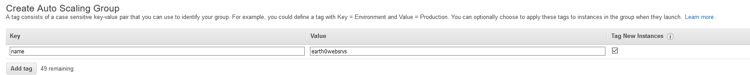

1. Review and create auto scaling group

Now we have created our Auto scaling group

Now go to your EC2 instance →and you will be seeing an instance got created from autoscaling – since we have given instance size as 2- always 2 instance will be running

Also see under LB → you should be able to see the instance as you have selected that

Hit the LB URL and check if you can access it – Yes I can

Now go to Autoscaling groups

**Under** **notifications** →create notification and select your SNS topic and it will send notification if any new launch, when you terminate, failed to launch and failed to terminate. This is nice feature.

**Under Scheduling →**

We have configured CPU utilization metric and ASG will scale based on CPU utilization (scale out and scale in).

sometimes there are business requirement that at particular point of time the load will be going high/low, then you can schedule the action here for scale out and scale in.

You can give the min and max instances and mention the time when you need to add instances.

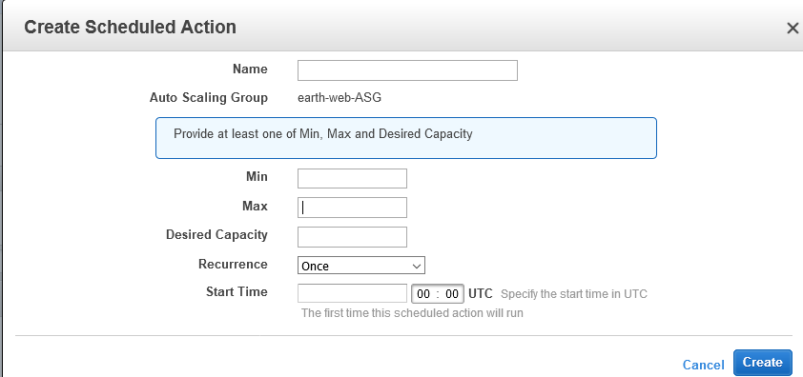

Any time you can **edit** and do changes like launch configuration, desired number of insatnce,

**Now an Important interview question:**

We have our website earth and it is accessible. Now let’s say the developers are going to make some changes to the website some code changes adding some new features and stuff. There is a build process after that, and we get a new software to be deployed on the machine. Now our instances are part of **autoscaling group**. How do we deploy?

**How do you make any changes/edit/updates/deploy on instances in Autoscaling?**

* We launch a new instance from AMI
* Make changes to newly launched instance
* We create new AMI from new instance that we launched and changed.
* Create a New launch configuration and we update the launch configuration(you cannot edit the exixting) name in autoscaling group
* Update the LC name in AS group
* Delete old instances based on your downtime.

**Let do this Exercise:**

1. Login to one of the instances which are part of ASG – **Here I am not launching a new instance from AMI**
2. Stop the httpd service
3. Remove everything the old website (earth) and deploy a new website from tooplate (infinite-loop)

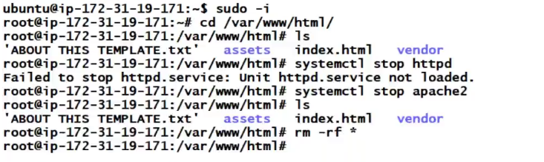

1. I have copied by new websire under /var/html/www – infinite loop

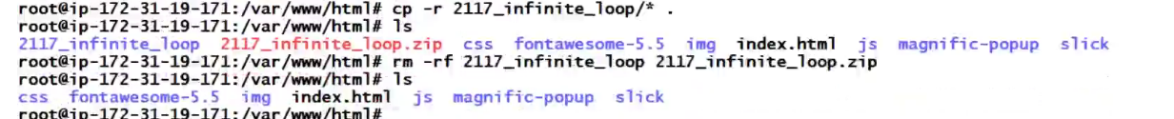

1. Restart your httpd service
2. Now Test whether you able to access your new website from that instance. It is success
3. Now lets create an image from that instance
4. Soon you create Image (Assume you have checked the option NO REBOOT)

**What happens now ? AMI will get created – Instance will get rebooted – This instance is part of ASG – AGW will mark this instance as down and delete this instance and then launch a new instance.**

**Now our existing instance is gone**

**That is the reason – never make any changes to a live instance**

Hence Follow below steps

1. Now our new AMI is ready and I will upgrade this, but before create a launch configuration as we cannot edit the existing LC in ASG
2. Create a new launch configuration → you can also create a new one by copying the existing LC and click on edit AMI and then select your new AMI to create a new LC

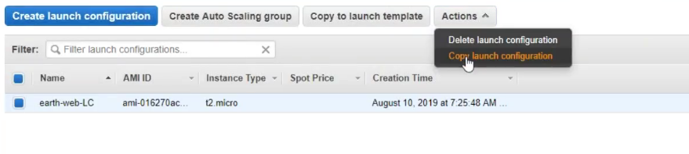

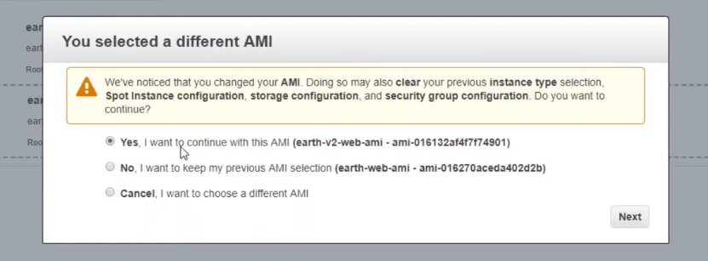

Rest of the details after this section you may keep same

Now I have created a new launch configuration. What difference it makes from other LC is this new LC has New AMI

1. Now go to your ASG and edit your ASG and change the launch configuration to the new one and save it.

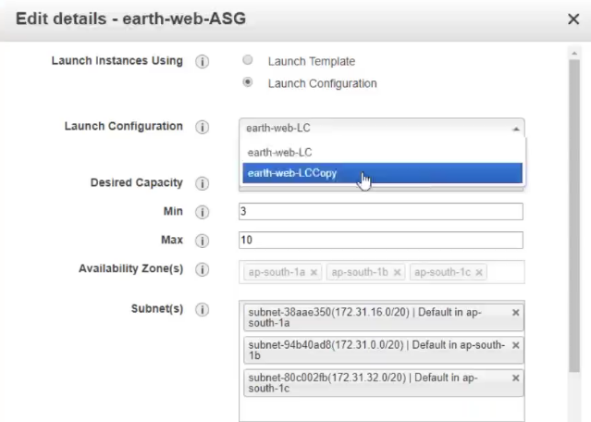

1. After saving it may take an action later, as we have desired size of instance is 3. For us to test now immediately you can reduce the size to zero which will delete all the instances at once.

If you don’t require any down time, then you can do one by one.

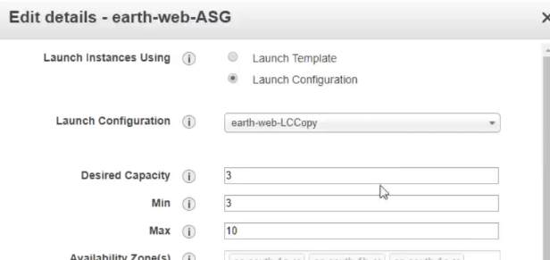

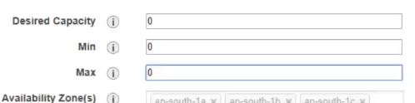

Here I am deleting all the instances with downtime. Deleting instances status, you can check in activity history tab. Some time you see here connection draining and that means some user is try to connect and this wait for a while and if still connections are not getting closed, it will terminate the connections

1. Now all instances are deleted and now again am gonna change the capacity to 3, 2 and 10 .

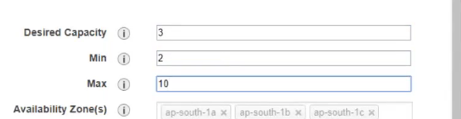

1. Now in a while ASG will launch the instances but this time it will launch with the new LC that we created, and you can now run a test hitting the browser with any instance IP and you should be able to see infinite -loop website

**Amazon S3**

* Software as a service (SAS)
* It’s a very popular service and everyone uses S3 some or the other purpose
* To easily understand its like your google drive but much much better than that.
* This can be accessed from anywhere in the world and you will get an endpoint to store your data.
* This is a file storage and not a block storage like EBS
* To use EBS, we need to create volume, attach volume, partition, format, mount and then use.
* In S3 you create a bucket and map it and then start using it
* Mapping is directly through http and https service
* One of the best File storages out there in market
* AWS claims 99.99% availability for S3
* You can store and retrieve data anytime from anywhere on the web
* You get unlimited storage
* We can do cost controlling of S3
* Any file here in S3 is called as an object. We can create our directories and manage our storage
* Its not an Ip based. You get an endpoint and directly use it to access data
* We use Ec2 instances to run our applications and our applications needs to store data regularly. We have web data, APS server data, logs and so many other things that gets generated running on Ec2 instances. We can connect our bucket to the Ec2 instance and you can use one singlr bucket to map with the multiple instances

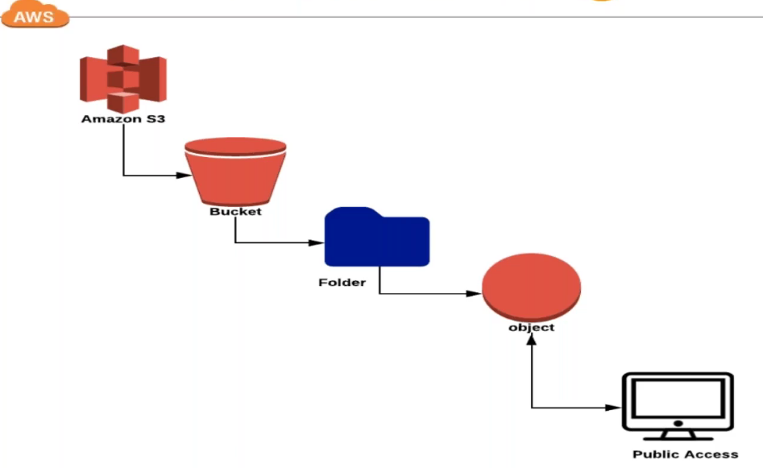

* Let’s say, we have these 4 instances under our load balancer. When uses access it will be routed to one of the instances. If the EC2 instance is storing data in the EBS volume (local storage) and if the user access another instance through LB and that data wont be available in the other instance. But if you have a shared storage like S3 bucket, you can retrieve data from any instance
* EFS is another shared storage which is based on NFS (this will see later)
* In S3 we have different storage types and we can do cost controlling using these
* **S3 Standard –** Here data will get replicated into multiple **zones.** We won’t see the replicated file. You will see one single file but behind the scene it will replicate your data into available multiple zones.It might be having more zones also, but we don’t see what the scene in the background is. If your data is lost in one zone, still it can be recovered from another zone and this will be done automatically, and we need not worry about it. Here access will be **fast**
* **S3 standard Infrequent access –** The data which you not going to use regularly. Like old log files which you don’t use it regularly, but you want it to replicate into multiple zones, but not fast access and you can save some money using this storage.
* **S3 One Zone-IA –** This is like above IA storage, access will be slow and it wont be replicated in other zones. This will be stored in one zone. The data which you don’t care about too much or even it is lost its fine like very old logs. You can save more money here
* **Amazon Glacier –** Much slower, long time storage, If you want your data to store for a year , 5 years , 10 yrs.. like compliance, SLA ..Here I dont want to access the data regularly and its accessed very rare but I need the data for a long period of time. You can move your data from other storage to Glacier anytime you want

**Intelligent tiering a new data type – Which will automatically move your data based on your use case to different storage.**

**If you want to automatically move your data from one storage to the other, you can setup Life cycle Policies**

**Let’s do the Practical session on S3:**

1. Click on create bucket – Bucket names are unique
2. Select a region – Buckets are not region specific and you can create it any where, but which region is select is based on the user proximity again
3. Click on next and you see here different options

**Versioning –** When you do any changes to your object, its gonna take backup with timestamp and you can recover your data with the help of versioning but the cost is gonna increase – In case required you can set (For now am not selecting)

**Server Access Logging-** Let’s say am using this bucket for hosting a static website which we can do using S3 and in case if you want to store the logs, then you need to select your target bucket (If you don’t have other bucket then it will take the same available bucket) but it is recommended to use a different bucket

**Target prefix –** Here you mention your file/log extension like .log (we will use this later)

**Tag –** You can create a tag and here the tags are more useful in cost calculation. This will appear in your billing and you can see which object is used more and understand where you are getting more bill

**Object Level Logging –** This is for developers

**Default Encryption –** the data travelling using https will be encrypted but the data at S3 we call it data at rest will not be encrypted but if you want to encrypt it you can do that. When you enable this option speed will be little lower. If you really need to encrypt data at rest then you select this option.

**Object Lock –** This is generally used in case if you don’t want your data to be moved or deleted

**Cloud watch request metric:** There are metric for S3 bucket also, but this will be an extra charge here. We will use this later.

1. Click on next

Here in this option you can make S3 bucket public if you want but still this option is not like earlier. We have many options here even to make it public which will see later(As of now block public access )

1. Once you create your bucket then under properties section you may change the settings for below

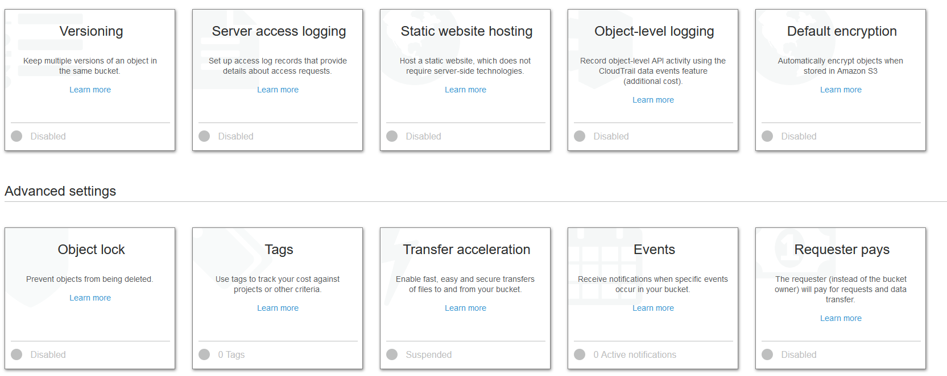

1. **Permissions Tab**

You can choose Public if you want to share your data to public

If you want to store your data through EC2 instance, then you have option of IAM user.

When you create IAM user you have 2 options **– console access and programmatic access**

Then we have IAM roles similar to access keys, but it will not give you keys directly, Queues manages keys by itself.

**Bucket policies**

With Bucket policies you can restrict access.

For example: We have load balancer and in case if you want to store the log files to bucket then you can’t use their access keys because there is no EC2 instance to provide access keys, there is no OS in the ELB. You can’t even use roles, you can’t make it public. So, the next way is creating bucket policies. Policies are Json based. This will learn later once scripting class is completed.

**For now, we use public based access and IAM user access**

**Access Control List (ACL)**

You can give access to other account user also. I can add you account and give permission to you.

1. **Management tab**

Here we will later how to set up some life cycle policy, replication and few other things

1. Now let’s upload some file here

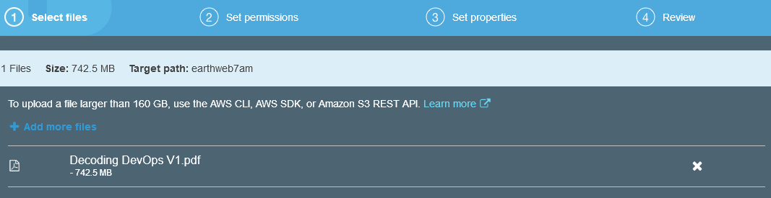

**Storing data through console not we do, we use CLI which is much more convenient to store data.**

Once upload is completed click on it and you click on the object URL to download it- Now I cannot download it as I we don’t have permission to access it publicly.

You have properties on the object class also and change the storage class

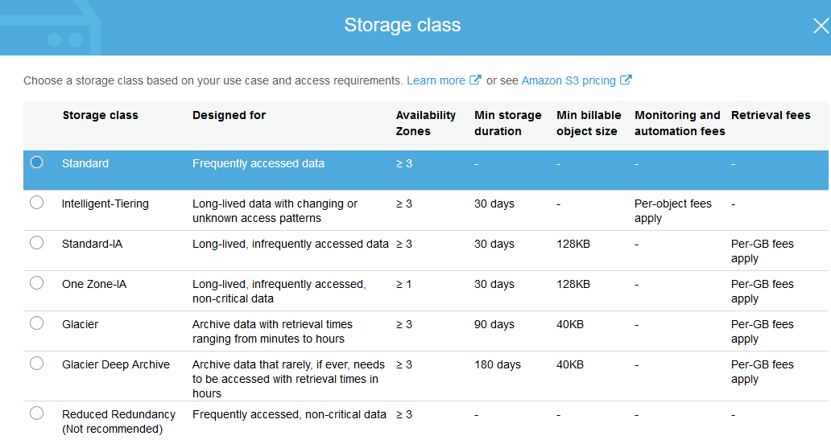

1. Under object Permission select **Public access**
2. On the bucket permission tb, All the public access will be blocked. Click on edit and uncheck Block all public access

Under this we have more options to tune control your public access

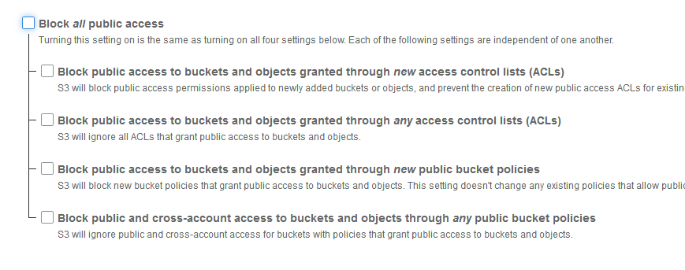

1. Now go to object permission and check on Read object – Now you can access the pdf

**How to host a static website on S3 using CLI**

**AWS CLI concepts:**

We need to upload multiple data and CLI is convenient to use in that case.

Any service in AWS you can access or implement using CLI commands

You don’t have to byheart these commands. You can use help and check for options

**When should I use CLI and when should I use console:**

When people ask you to use CLi, then that has to be for a specific reason

Mostly CLI are gonna be very long commands. Using this for everyday purpose is not really desirable and can slow you down. Sometime UI are better and some time CLi are better (below case -hosting static website using S3)

For automation you can use AWS CLI but you need to write a script that uses AWS CLI

And here if you use bash script or batch script the you are living in a very old generation because. In this fast running world we use Ansible and Terraform to do these things much more better, easy and faster way.

In any operating system you can use AWS CLI

1. Let’s launch an EC2 instance – (used ubuntu)
2. Login and run sudo apt update to update the repos
3. **#Sudo apt install awscli** → to install AWS CLI

**#aws help** →to check for options to run commands (You can also open AWS CLI documentation from web)

#aws s3 help → will list the commands for s3

#aws s3 ls → will list

1. **AWS CLI needs authentication to connect to your AWS account and authentication is not through user name and password but It’s through Access KEYS**



1. Create an IAM user with programmatic access and store the keys in the instance

Add user – s3admin and select programmatic access

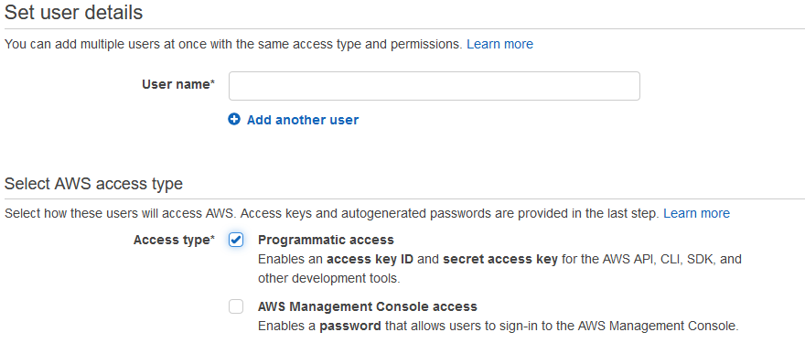

Click next and give permission to S3 under attach existing policy.

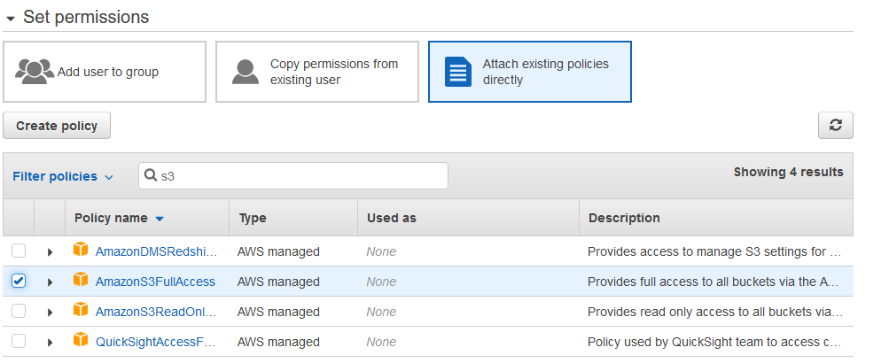

Click next and add a tag name s3 admin and click on create user→ Now you will get an option to download a credentials file in csv format and save the file with any name s3_admin_creds. You can click on show to see your access key from console

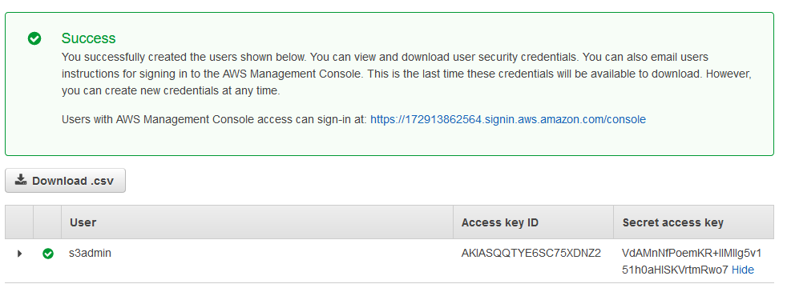

This Key is for individual access and never share this key.

You can delete the key and generate a new Key also.

1. Now to use this key from CLI type below command

**#aws configure** → when you say configure its gonna ask you access key, secret key and the region(copy from console URL). Once you provide info then its gonna store the info into this users (ubuntu) home directory. Then this becomes user specific.

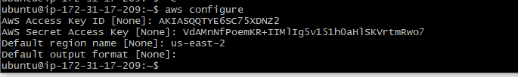



1. Now run # aws s3 ls → to list the buckets available



We have many commands here. Cp command is to copy the data, but it will be better to use sync instead of copy as cp command will copy and next time you run the same it will copy again but sync is smart that if there is any difference then only it will copy. Below is one example

* Create a folder inside your bucket → give a name and save
* This am gonna use as a destination to store the log
* Now you run the below command to store your logs

# aws s3 sync /var/log s3://earthweb7am sys-logs

* Now go check in your bucket and you will see your data

This command is used mostly to push the data to your bucket.

* Same you can retrieve the data – reverse the source and destination in the command

For ex: aws s3 sync s3://earthweb7am/sys-logs /tmp/log-sys

1. Now lets setup a website on S3 – make sure you use this case to setup only a simple website not too much complicated website – we don’t have to use an EC2 instance in that case.

Let’s download an infinite-loop website from tooplate and download it on our ubuntu under /tmp

* Let’s create a bucket with name [infinite770](https://s3.console.aws.amazon.com/s3/)
* In the next step I would like to store the log to the target bucket- any bucket you may select

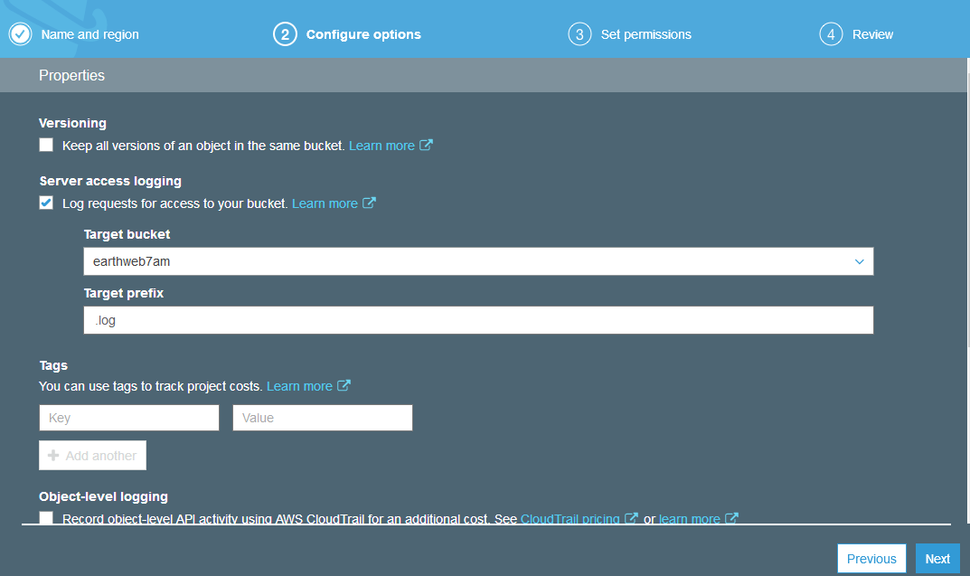

* Make this bucket as public by removing the check box – This a website now so, make it public
* Now push your website to your bucket
* Once you push data make those data public – select all and choose public

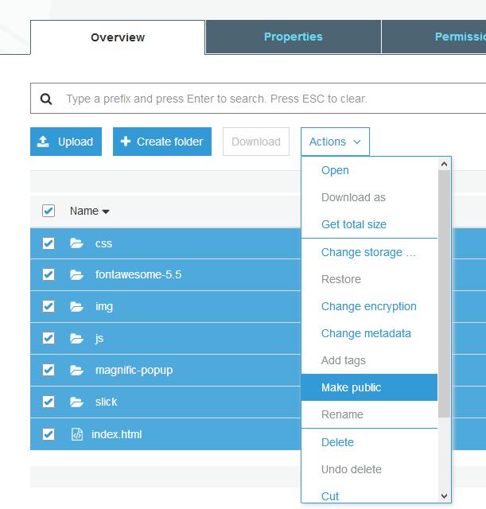

* Check for any errors while you make it public
* Next step is to enable static website hosting under properties →use this website for hosting website → give the index.html file name and that’s what we have in the downloaded website → save

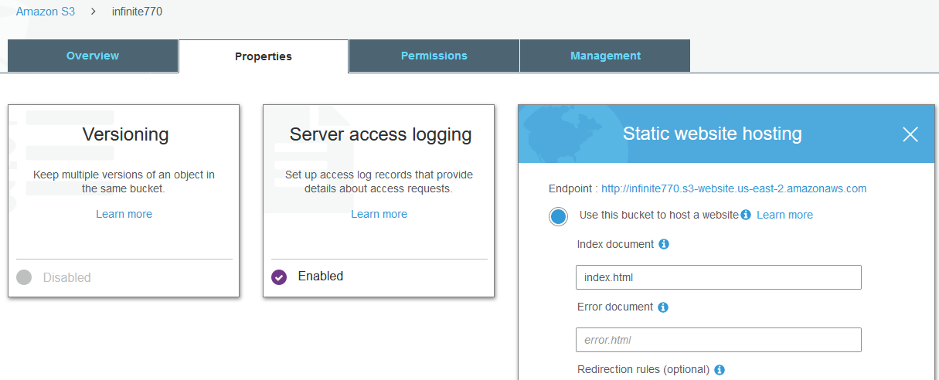

* When you enable this → you will get an endpoint to access that (above fig) - [http://infinite770.s3-website.us-east-2.amazonaws.com](http://infinite770.s3-website.us-east-2.amazonaws.com/)
* Now you can access your website from the above link and that is coming from your s3 bucket
* Also you can check the logs under the configured bucket

So, these are the use cases store your files and also you can host website.

Being developer use cases might be little different. They gonna use CLI and SDK, mostly they use SDK so programmatically, automatically their programmed will be designed to store data on s3 bucket. In that case your help may be required to give permission for the user.

1. Now we have logs created in a different bucket and using this let’s see the use case of **Life cycle management**

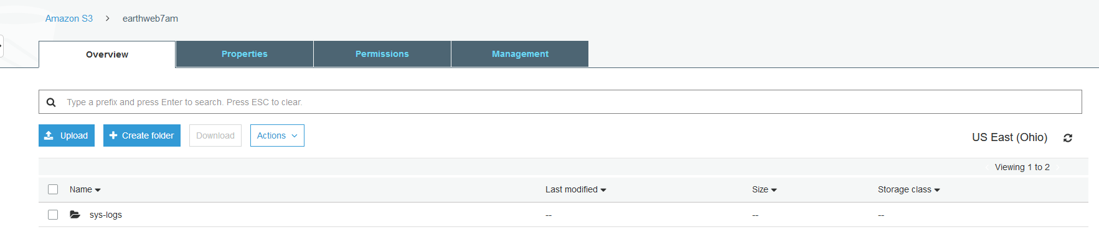

1. I am going to use this log for a sometime and later I don’t need super-fast access

Got to Management → Life cycle →Add new life cycle rule→Give a name→select current or previous version→ click on add transition and under object creation select your life cycle rule (by default it is s3 standard. I will choose standard-IA and 30 days as I don’t need fast access after 30 days)→After that I want to change into one zone IA (After 60 days let’s say I don’t care even if I lose the data)→ and after 3 months lets say I want it to move it to Glacier as I don’t want to use this data unless someone ask or there is a need but don’t care if it’s very slow access→After 180 days I will move to deep Glacier which is very slow access and if I want to store the data for long period of time.

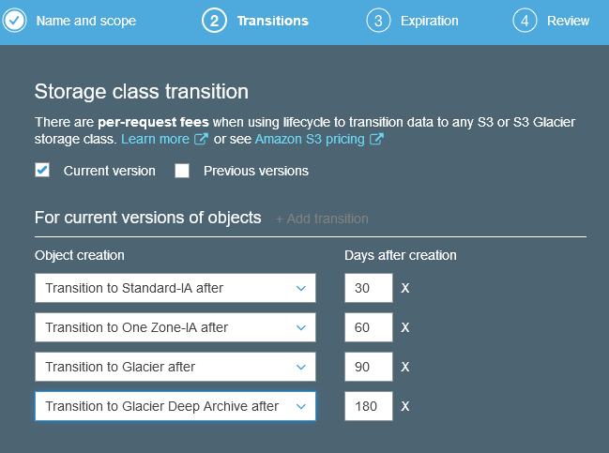

1. In next step you can set the expiration→ If you don’t want these logs after a period of time then mention here
2. Save

**Now one important question – I have used S3 standard to store data and this will be replicated on multiple zones behind the scene and there is no way to lose the data but how are you going to convince the client about this that they don’t lose data?**

All they know is in AWS there is replication service which will replicates the data. Again they will say that they are in same region. What will happen if region goes down. This will be difficult to convince them.

So in this situation, you can go for replication – Meaning replicating your data into different region which we are going to setup

Under management tab of your bucket, we can set up replication and replicate your data.

→Add rule→You need to enable versioning when you gonna do replication →entire bucket→select your target bucket name which will from your different zone→in the next step you can even choose your storage class→ Then you have roles. There is no authentication for one bucket to access other bucket but in case you need to give you can use roles here and give a name to your rule and then create.

In S3 we have few other options like **Analytics** – where you don’t know what storage class to be used the you can use this to Analyze it

**Metric: Enable CW metric on bucket and you can see the different metric here and you can set your alarm based on metric.**

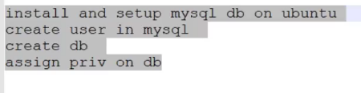

**RDS – Relational database service – Platform as a service**

This is a service which solves database admin’s administration overhead.

When we are dealing with databases there are lot many things to do. We setup the database, cluster, scaling – which are complicated, it has to be very fast, more users more I/O on the databases, taking backups, should be highly available → We need DBA admins to administer DB’s

RDS is one of the successful services. Its easy to use, scale it easily, when ever you want to can switch to super speed or reduce for cost cutting. You can scale it when ever you want. You can create replication and it gives you read replica.

Data base will store the data on the disk and the disk must be fast hence mostly we have Provisioned IOPS EBS volume/storage.

**Below is mostly used architecture:**

Your EC2 instance will be running applications which needs databases. You can create your RDS also in the same network which we call it as **VPC.** Both are having diff security group and you can connect them. You can give db information in the instance and your instance can be accessed publicly over the internet and the instance will access the db privately created into same private network.

Your db will be in private network. Your instances may or may not be in private network, **but they will access the db privately.**

**Who can use RDS:** If you have small database then you can go with RDS and if you have huge database then still you can go with RDS because anytime you can scale in. You can go from dev project directly to PROD as it is highly scalable and more over its very simple.

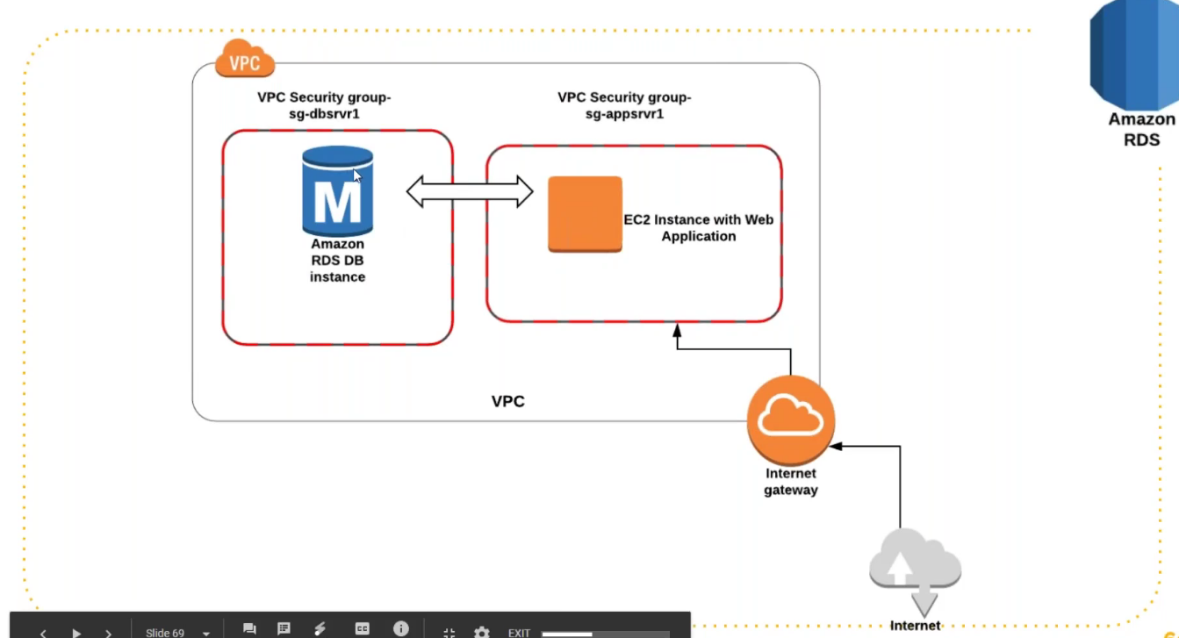

**Practical: Let’s create RDS:**

1. Go to RDS and click create database
2. Select your engine types – we have 6 types here, but we are going with MySQL database and select the version you need (I’m using 5.7.22). Amazon has its own database service Amazon Aurora and amazon claims that it is the fastest database in AWS network

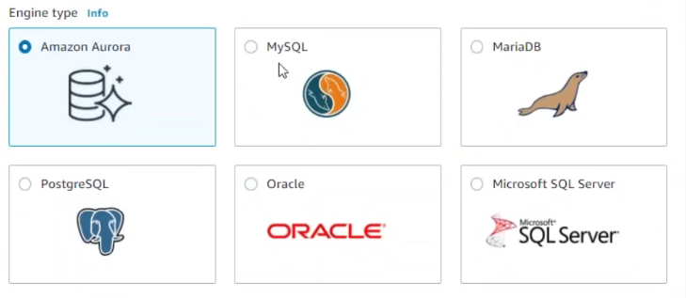

1. Here we need select a template.

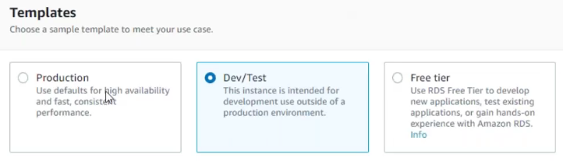

We will be using free tier but let’s see what options we have in paid tier dev/test because free tier will have less options.

Production is too expensive. In production you have multiple instances in multiple zone. If I select production, behind the scene it will create RDS in other available zones, but we don’t see it really. In production it gives provisioned IOPS disk. Any time you can switch to different storage with some downtime.

Let’s see the options in dev/test

Give a db instance name → give a password/select auto generate

Then we have db instance class. This you can select based on how may cpu’s you need and the EBS speed

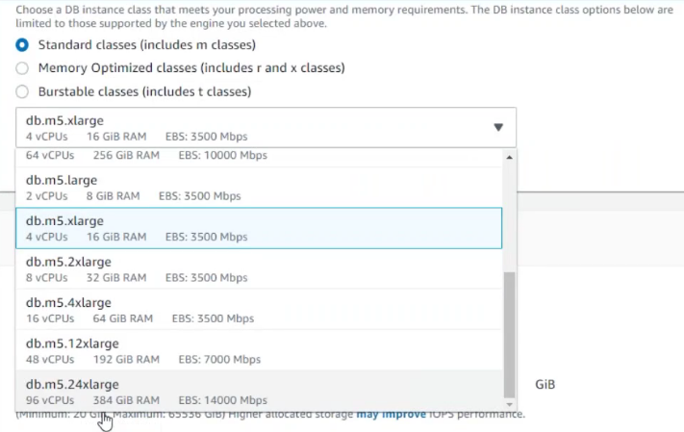

Then we have storage →General purpose or provisioned IOPS

Select your storage sixe → 20GB

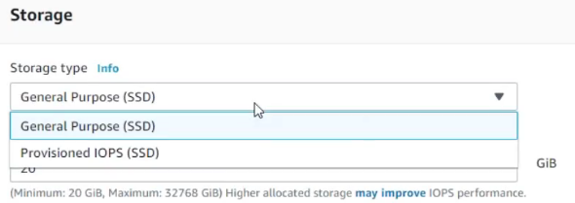

Storage Auto scaling → You can enable it for autoscaling, and it can increase the storage automatically

Availability & durability → You can select stand alone or create the instances in multiple zones.

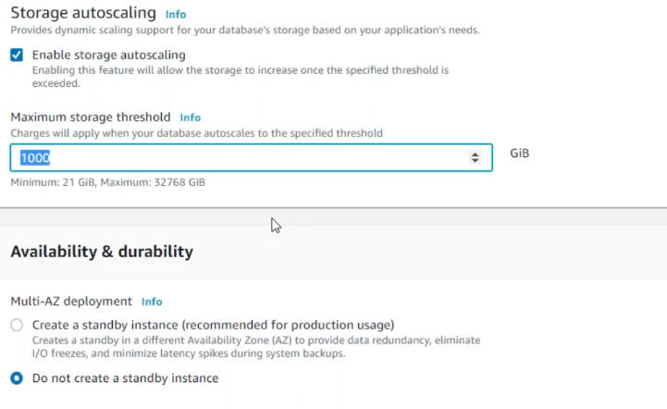

Publicly accessible → In case if you want your db to access publicly – (mostlywe will not make it public). Meaning accessing over internet

Security group→ Create new or use existing

Select port → MySQL default port is **3306**

**Under additional configuration →** You can create a database name here (accounts). Parameter group are parameters of db which sometimes we need to change per vendor request. You need an OS and go to the configuration file and change your parameter that can enhance your db performance.

**RDS will not give you any OS to login, there are no configuration files to edit. So, in case you need to change any parameter then you can do it in parameter group. You can fine tune your databases through parameter group.**

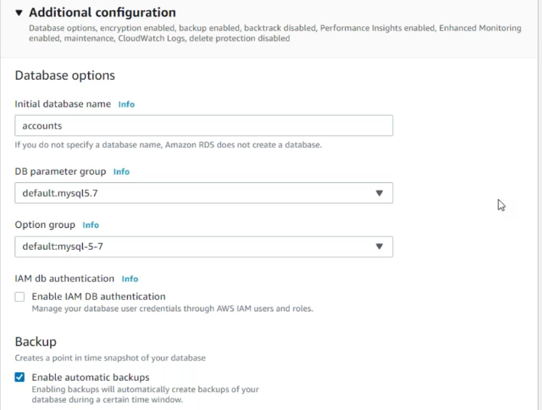

**IAM db authentication:** Now we have created a user called admin and given a password to login. Also, you can give IAM user authentication so that IAM user can also login based on the privilege.

**Automatic backups:** Automatically your database will be backed up.

**Retention period:** Let’s say if I select 7days, then any backup older than 7days will be deleted. You can also specify a backup window when do you want to take the backup (low to no business hours – depends on your project)

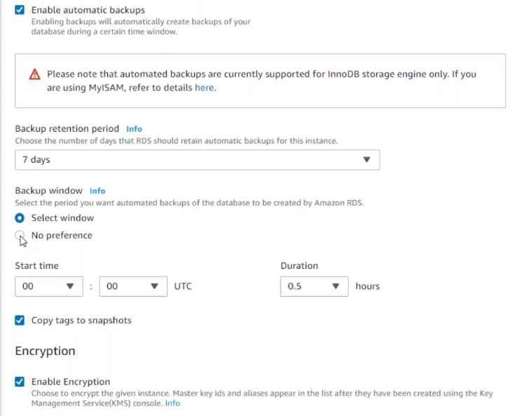

Backups are taken in the form of snapshots. These snapshots are stored on S3

You can enable enhanced monitoring, but this is not free

**Log exports: RDS** will not give any OS then how we see logs. RDS will send logs to **cloud watch.**

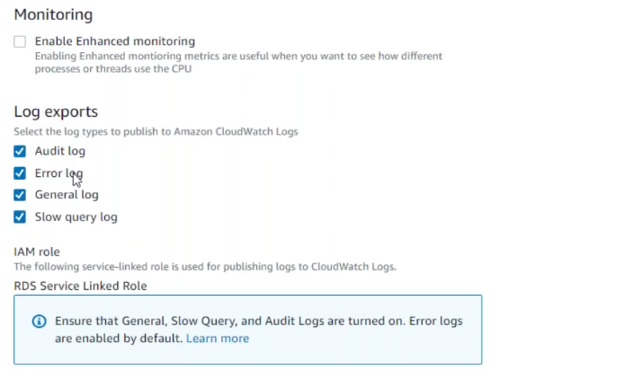

**Maintenance:** AWS gives you option to enable automatic patch upgrade. IF you want to do manually then **deselect** the option and you can also schedule the maintenance window for downtime.

**Now let’s use the free tier and do our exercise:**

1. Click on create database
2. Select MySQL and version 5.7.22
3. Free tier
4. DB instance name “vpro-prod-rds”
5. Login ID “admin”
6. Password – Riaan@143
7. DB instance size – db.t2.micro
8. Allocated storage 20GB
9. Disable auto scaling
10. Under connectivity →Additional connectivity →VPC security group → create new→ vpro-prod-rds-sg
11. Under additional configuration →database name – accounts
12. Enable automatic backups
13. Under log exports → select all
14. Create database

Now this gonna launch RDS instance. This is not like an EC2 instance. There won’t be any OS and no ssh. You get an endpoint and this you can use from your application.

1. Create an Ec2 instance in the same region and login to the instance and install MySQL client

# sudo apt install mysql-client (ubuntu)

#sudo yum install mysql (linux)

This is the client and not server. This gives us MySQl command which we use to login to our MySQL database.

I want this RDS database to access db-client instance (EC2). So, add the security group of db-client instance in RDS.

You can go to cloud watch and under log groups you can see the logs

Under monitoring tab, you have metric and you can setup alarm.

You can change the granularity to 1 sec if you are doing performance testing.

If your write IOPS or read IOPS is more, → Then you can change the storage type

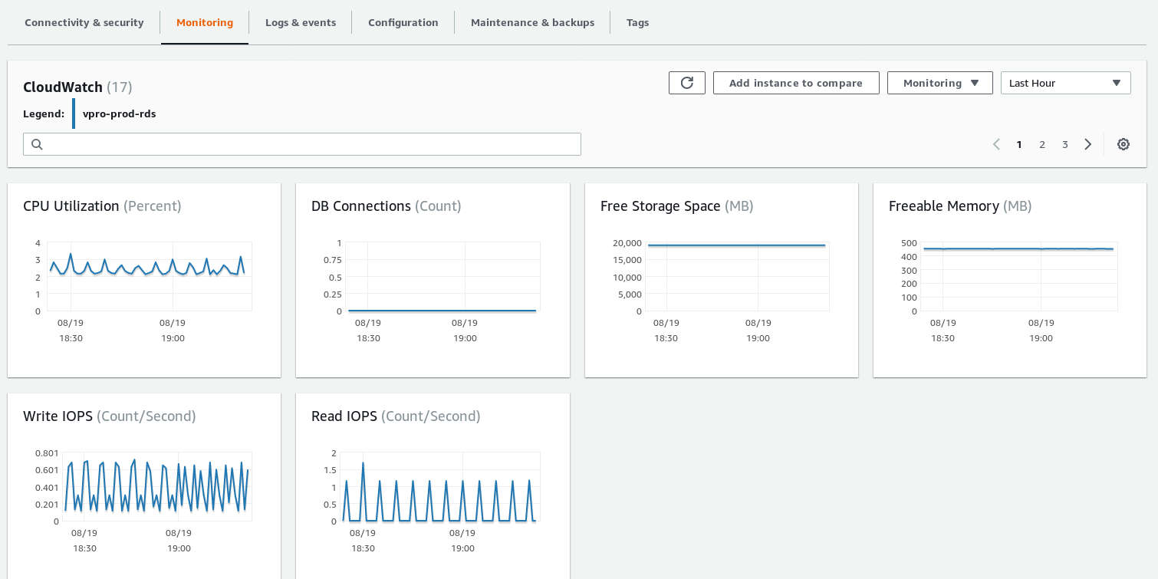

1. Now to connect your RDS below is the command.

# mysql -h “hostname” (In RDS the host name is the end point) -u “username” -p hit enter and it will ask password

**# mysql -h vpro-prod-rds.cyuh6znel2y1.us-east-2.rds.amazonaws.com -u admin -p** and then after hitting enter it will ask password

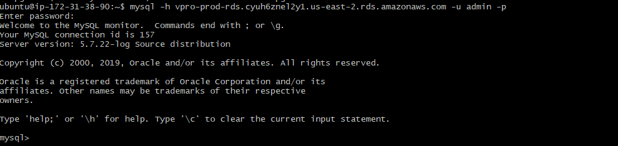

Now you are logged in

**# show databases;**

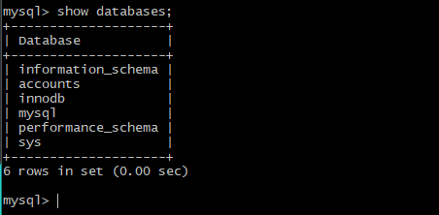

You see accounts db that we created

**In RDS under snapshots** you will have backups. We have few options here:

**Restore snapshot**→ Let’s say you have taken a snapshot before doing some change and later you want to revert the snapshot you can use this option. When you say restore snapshot it will ask you to create a db instance. You cannot recover your existing instance. You have to create another db instance

**You can anytime take snapshot by going into your RDS instance and under actions take snapshot. You can reboot your instance. You can create as many as read replica. So, all your read traffic coming to your application will be diverted to your read instance. Your read instance becomes separate and write instance becomes separate.**

**You can restore snapshot from s3 if you have created in s3.**

**Most of the things under db instance you can edit and When you do any changes it will ask you either take action immediately or in next maintenance window. And when you take your action it will tell you if there is any downtime or not.**

**V-Profile Project:**

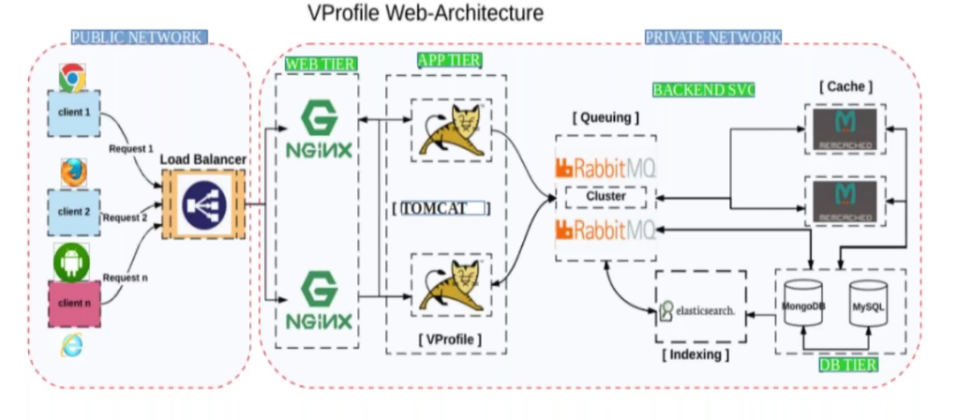

* NGINX – serves web request – takes request from LB
* Tomcat – serves dynamic application – Our application will be running on this
* M cache – caching service for database – Tomcat is going to fetch information from database and to make the process fast by using this M cache.
* Rabbit MQ -queueing service that queues the request between 2 application
* Elastic search – is used for indexing to make the search faster (amazon search, Facebook search, Google search. Any search on their website...)
* Here we have 2 NGInx, 2 Tomcat, 2 Rabbit MQ, 2 M cache – all in cluster for high availability (redundancy), Load balancing and very important one is **scalability**

**To do all docker, containerization we need a product. We have a product called V-profile written in Java**

**Steps to begin with a Project:**

1. Get the architectural document
2. Looking at the architectural diagram set up document → you will have set of doc from developers which may or may not be good. So, you need to set up everything manually first
3. The first time you have to setup manually. Once you know how to set up manually and confirmed by the developer or testers that everything is working fine then you can automate it.
4. **Whatever you are going to automate – you should know to do it manually – very imp**
5. We will follow the V-profile manual setup document here
6. We will go ahead with doing it on one single instance to reduce the cost. 1-Nginix 1-tomcat 1-sql 1-MC 1-RMQ
7. We should have different security groups for different service but to keep things simple we are using one security group
8. Follow the document while you follow this document.

**Keep the below ready:**

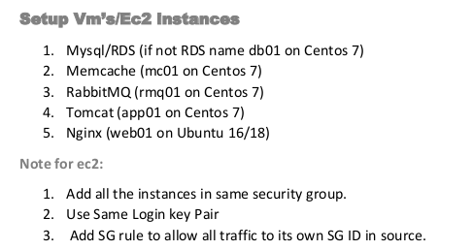

**STEP1: Create your database**

*Either you can use RDS or manually install database on EC2 instance. I am using RDS here*

Let me first setup the RDS: RDS→create database→MySQL→Free tier→db instance identifier = vprofile-prod-rds→master username =admin→password=12345678→No autoscaling→let it be default VPC→select your default subnet group→No public access (our tomcat,M cache and all in same network and hence we don’t need public access)→create a new VPC security group by name = vpro-prod-rds-sg→default port 3306→under additional configuration→db name=accounts (that’s our project requirement)→disable automatic backup for now to speed up but this is required when you do a project→disable version upgrade→create database

Here, we are keeping min setup just for project set-up

**STEP2: Create all required EC2 instances**

**First let me create our Nginx instance that will be running on ubuntu**

* Create a new SG

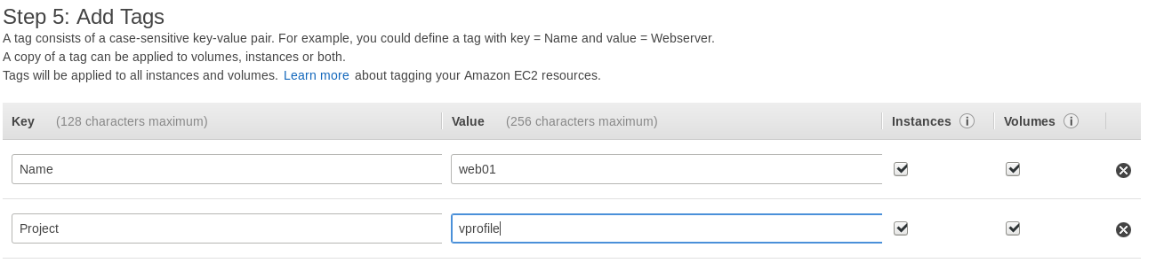

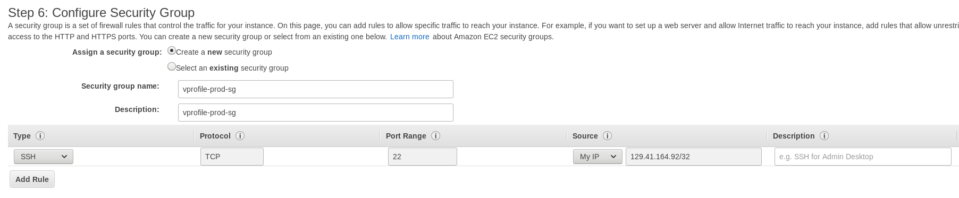

* Create a new Key pair = vpro-login-key
* Launch instance

**Now let’s launch other 3 instances which are centos (select the same SG and Keypair that we created)**

Now I have created all the instances I need and named as per my requirement

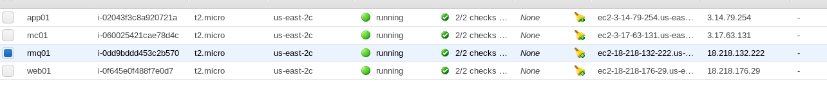

All the instances that we created are in the same security group. SG is not really a container, but they are rules which are applied on the instance per application or connectivity requirement

For example, we are using here tomcat and that’s run on port 8080 and it wants to connect Mcache runs on some port. When it making a connection there is no rule that is specified in your security group that allows the connection from tomcat.

So, if you want to make sure all the instances in the same security group should talk to each other then you can give one rule →all traffic →custom→source is its own security group ID

OR if you want you can give specific port as well- but in our case they all in one SG

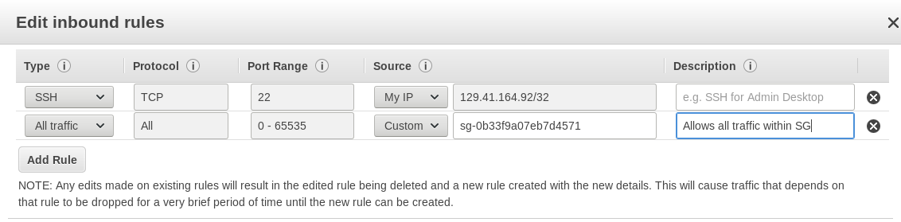

**Make a note of you RDS instance end point**

End point = vprofile-prod-rds.cyuh6znel2y1.us-east-2.rds.amazonaws.com

USER = admin

Host = db01 (This will give in hosts file)

**Now Let’s give the IP and host name of all the host for inter communication (shd use private IP here)**

**Private IP Instance Name**

172.31.42.203 app01

172.31.38.68 mc01

172.31.41.43 web01

172.31.37.212 rmq01

The above IP’s and host need to be entered in all the instances of hosts file.

Sudo vi /etc/hosts file → doing this your system should able to resolve name and IP

We use names in all configuration and hence add the entries in host file.

**Now the infra is ready and now we need to install the software’s/services/application**

First, we need to set up our MySQL database. Since we are using RDS we need to install the SQL file.

Here our SQL file is located in Git repos and we will clone it and deploy the file on Tomcat server as tomcat anyways has to connect to RDS.

**Lets login to tomcat and do this**

* Switch to root
* To make tomcat talk to MySQL→ we need to install MySQL client

# yum install mysql -y

With this client you should be able to RDS

# mysql -h vprofile-prod-rds.cyuh6znel2y1.us-east-2.rds.amazonaws.com -u admin -p

**I tried and I am unable to login**



That’s because RDS security group is not allowing any connections from tomcat

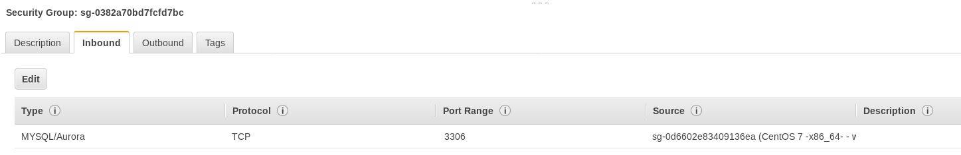

Now let’s add the rule here with security group of our instances

I have added



Now I could login and when I run show databases; it is showing our accounts database, but we don’t have anything in it. We need to deploy the SQL file

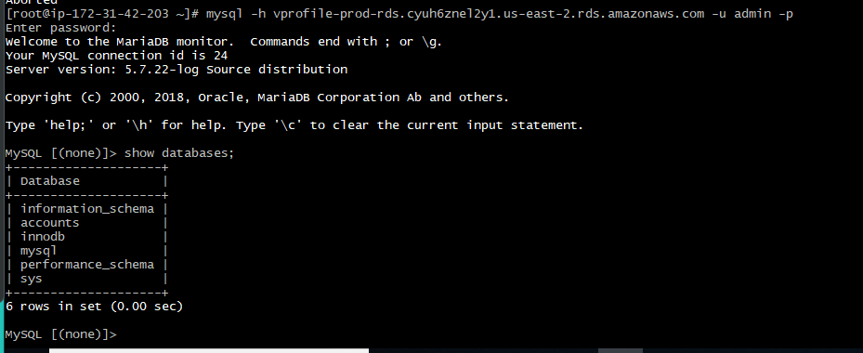

Now let’s install GIT download our sql file here

**#sudo yum install git -y**

**#git clone -b vp-rem https://github.com/wkhanvisualpathit/VProfile.git**

Once you clone under the following path we have our sql file VProfile/src/main/resources/db_backup.sql

Here, we also have application.properties file where we mention the database details later (Mcache,RMQ,Elastic search)

Now we need to initialize this sql file

**# mysql -h vprofile-prod-rds.cyuh6znel2y1.us-east-2.rds.amazonaws.com -u admin -p accounts < db_backup.sql**

Running the above command along with database name and input redirection to our sql file will initialize the database

Now we have our sql file deployed and now if you run the command show databases; →it will show you the contents in it

**Now Let’s setup Mcache on Mcache instance:**

* Let’s login t Mcache instance as root
* Install the service
* Start the service
* Now you can see Mcache is running on port **11211**

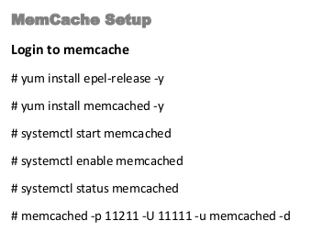

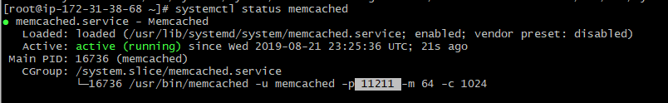

Later we gonna tell this is our Mcache and we can see also how it cache it.

**Lets Setup Rabbit MQ:**

* Rabbit MW setup is little longer.
* First you setup erlang →That’s the dependency
* Socat also dependancy
* Next you download the rpm package for RMQ
* Import its KEY
* Then install RMQ server from the RPM
* Start Rabbit MQ
* You also have to put the configuration "[{rabbit, [{loopback_users, []}]}]." Into the RMQ config file and that’s the developer requirement
* We have add user in RMQ
* Give a tag which will make the user administrator
* Restart RMQ service
* Run all the steps as below snippet

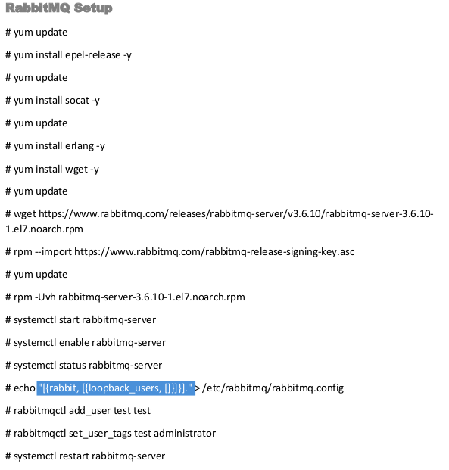

**Now Let’s setup our Tomcat:**

* This is our main application server
* Setup epel repos
* Install java
* Download the tomcat tar file, extract it and then start the tomcat service
* Move your application to tomcat
* Install GIT, Maven
* mvn install command will generate artifact (application)
* Remove the default application of Tomcat which is in /webapps/root directory of tomcat
* Copy our artifact to the that directory and rename as ROOT.war a
* Start tomcat service→when you start, its gonna extract ROOT.war to a directory called ROOT

There is no systemctl command to start tomcat but you can create one also. Tomcat runs on port 8080

* Make changes in application.properties file under our extracted war ROOT directory

Instead of local host we mention RDS endpoint

User name and password for RDS

Mcache name, RMQ name and user for RMQ

* Restart tomcat

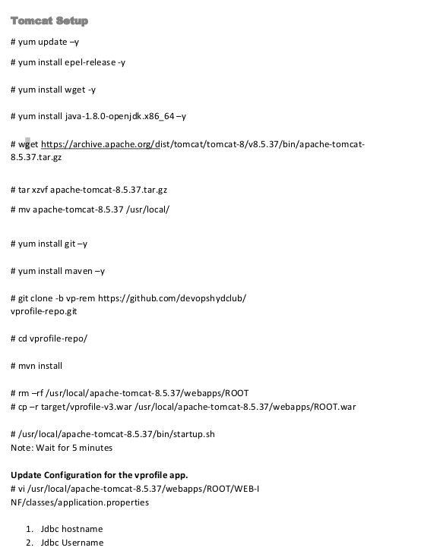

* Let’s test if tomcat is accessible→Enable port 8080 of tomcat instance
* Now hit the tomcat IP with port 8080 and you will see the login page of our Vprofile application
* We won’t be able to login to this application because the login details is stored in the database and it needs to connect the database and to connect you need to update application.properties value

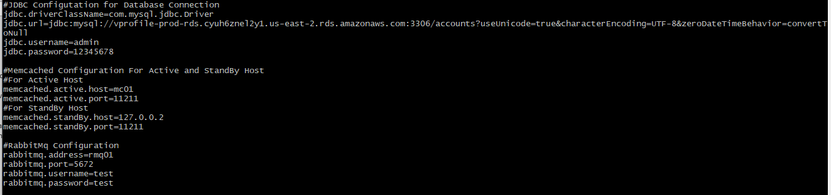

* Restart tomcat

**Now Let’s setup our Tomcat:**

We are not going to hit the tomcat server directly. We going to hit Nginx and Nginx will route the request to tomcat

* Login to Nginx instance
* Remove default Nginx web page
* We create our own file where Nginx acts like a load balancer giving the details of the backend server app01 on port 8080
* We will have Nginx listen on port 80

**Lets Setup Nginx**

* # apt update

# apt install nginx -y

# rm -rf /etc/nginx/sites-enabled/default

# vi /etc/nginx/sites-available/vproapp

upstream vproapp {

server app01:8080;

}

server {

listen 80;

location / {

proxy_pass http://vproapp;

}

}

* Create a soft link and this will be explained in Ansible class

# ln -s /etc/nginx/sites-available/vproapp /etc/nginx/sites-enabled/vproapp

Sites-available is a directory in Nginx where we give the configuration and we create a link in site-enabled, your application will be live

* Restart Nginx # systemctl restart Nginx

**Validations:**

Security group of nginx instance should allow port 80

Hit the Nginx Ip in browser and you should get our Vprofile application login page (Nginx routed request to tomcat)

Now lets login to our application with username and password which is stored in our database

User ID admin_vp password admin_vp

If you are not able to login then there is problem with tomcat and database connectivity

**GIT**

* Source code manager
* A version control tool
* Invented by Linus Torvald
* Good speed
* Fully Distributed

This is what we do, or the developer do daily many times. Many developers will contribute to a project doing their code changes daily and they need a version control system to have a track of what changes made.

Even for us Devops also need version control – we also write scripts

We should know about the version control to understand developer query. When he talks about commit merge and any other, we should know what it and its behavior is.

Our devops life cycle starts soon the developer commit their change.

**Centralized version control system –** Best example is **SVN**, where you will have a centralized server, and this has to always up and running then only different person from the team can check out and check in or push the source code.

**Distributed version control system – GIT,** Server will have a repository and also all the developers will have the replica of the server repository in their local machine.

They commit the changes locally. So, versioning doesn’t stop even if the server is down. Once they want to host the code to the centralized repository, they can push their code. You push the code to the server only if you want to collaborate. When you don’t want then you keep versioning locally.



**Git commands:**

# git clone “link of repository” →to download the repository

#git config --global user.name [“username”](mailto:overseas.well@gmail.com) →to register a user

#git config --global user.email [overseas.well@gmail.com](mailto:overseas.well@gmail.com) →to register email

# git add . → Any files/dir in the current working directory will be added to the index

#git commit -m “message for your commit”

#git push origin master → to push the commit/code to GitHub remote repository master branch

#git push origin sprint →to push the changes to remote sprint branch

On local system If you on sprint branch you can just say git push but for best practice you always issue this command with branch name” git push origin sprint”

#git pull →to pull the latest changes

#git checkout ‘branch name“ →to switch to the branch

#git rm “filename“ →to remove a file in git

#git log --oneline →so show smaller commit ID

#git diff commitID1 commitID2 →To see the difference of the files

#git config global → to do any configuration changes

#git config –list → show you all global configuration

#git branch -a →to see the available brances

#git branch -d “branch name” → to delet a branch

**GitHub:**

* GitHub repository we have private and public
* Public anybody can see but only authorized people can do changes.
* Private nobody can see. Only authenticated people can see
* GitHub gives you one free private repository and unlimited public repository
* Once you create a repository in GitHub you will get 2 links to your repository
* One is http and the other is ssh (Lets see http now). https://github.com/accountname/repositoryname.git

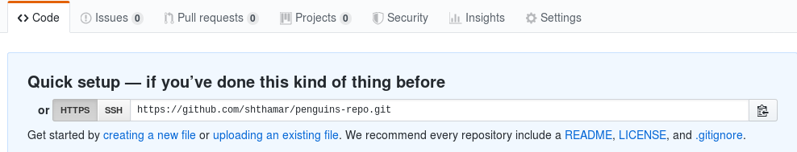

* You can also create a repository using command line and push it to GitHub

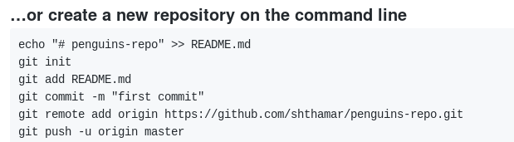

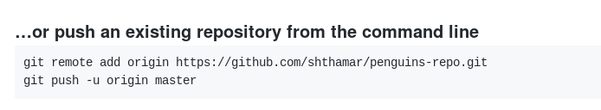

* I have created a repository in Github and now lets download the remote repository to local repository using **clone command**
* Create a directory and cd to directory and run clone command along with the URl of the remote repository
* It will ask for credentials as our repos is a private one

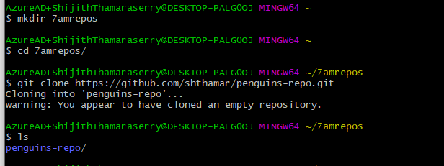

* Goto the repository and do ls -a to see the “.git” directory and under this dir you have config file which will have the information of your remote repository like the URL link and so many other options
* There are 2 types of config files. Remote repos config file and the other one is global config file
* Global config file will not be created unless you run the below command. Unless you have the global config file with user name and email, you cannot do any commit

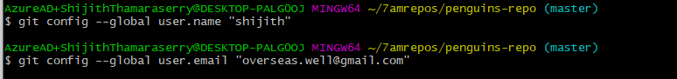

* Let’s see how to push files/dir to remote repository
* Create some files/dir. git add command is gonna do indexing. git commit will read the files from indexing to do any commit to local repository.
* Once you commit check log #git log and you will a commit ID for this with time stamp, author name who made changes and what time and what message for that commit

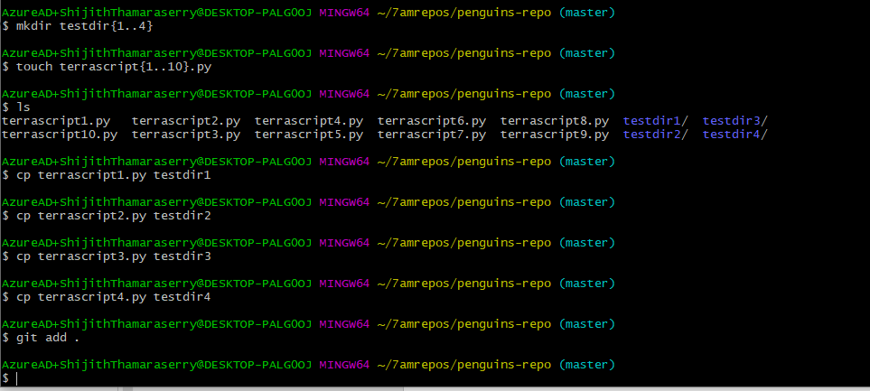

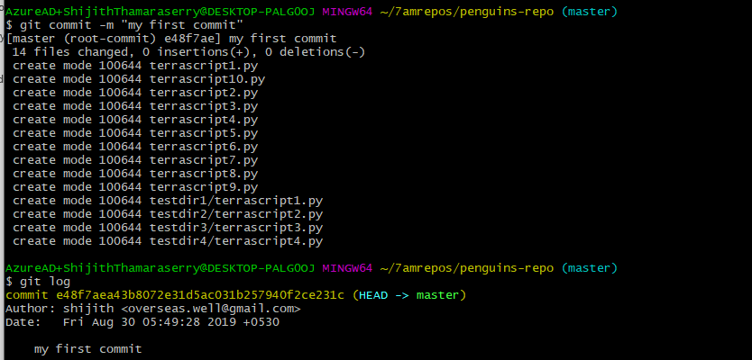

* Now let me push the commit to master repository that is GitHub repository

git push origin master

**Git Branching:**

* I have created a branch on my repository
* When you create you will have the same data what you have in master branch.

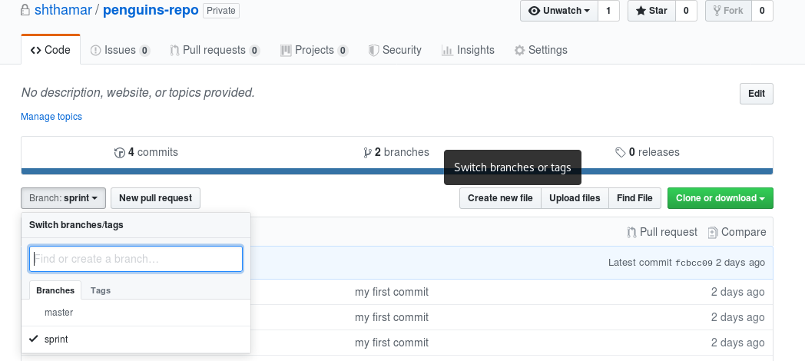

* Now go the local repository and clone the remote repository if not yet done
* Git pull command to get the remote new branch on local
* git checkout sprint to switch to the branch
* Now let me delete some files here

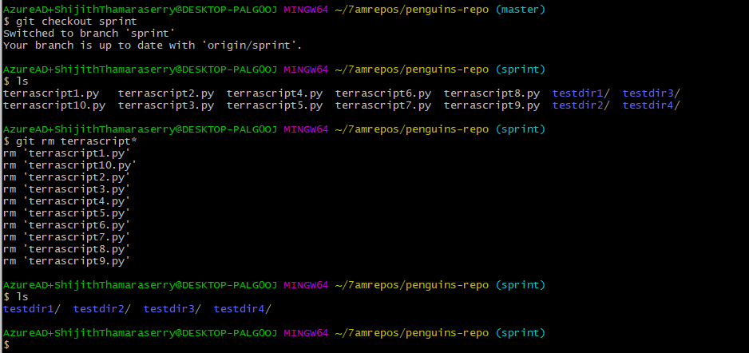

* Let me add some files here

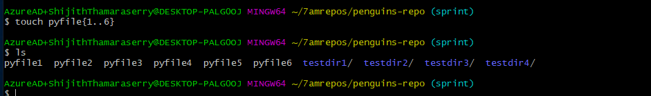

* git add and commit the changes
* Now to make sure on which branch you made changes/commit just run git status and also check in log

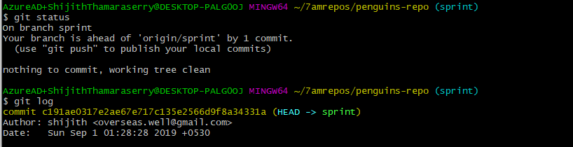

In the log Head is pointing to sprint (HEAD -> sprint)

Head means current data of the file is pointing to sprint branch and there is commit ID for that

* Now let’s push the changes to remote on sprint branch
* Check your remote repository for those updated files under sprint branch
* Now create a branch sprint2 from sprint branch from github
* On local now if run git checkout to branch sprint2 – this will not happen because you need to run first git pull to pull the changes and then try git checkout to new branch
* Create some 5 files on this branch locally



* Now commit your changes and push the change
* Now we have our master branch where our stable code is there. Lets say now our all work on sprint and sprint2 branch are completed and the code here is now stable, I can send it to the master repository by **merging the branch.** Now I want to merge it with master so run **git merge** **branch name** from your master branch. And then run **git push** to see the changes in github.
* There is a concept called **lock the branch** so that nobody can commit the changes on that branch.
* Now let’s create a new branch under sprint2
* Go locally and edit a file in it and then git add, and git commit the changes
* Now again edit the same file and then git add, and git commit it

Below is current state of my file the last line is the second time edited file.

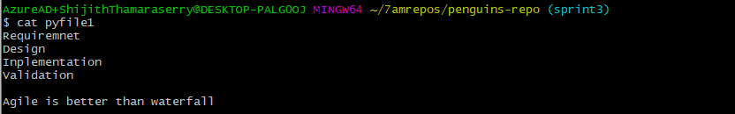

* **Git log –oneline** will show you small commit ID



* **Git diff** commitID1 and commitID2 will show the difference

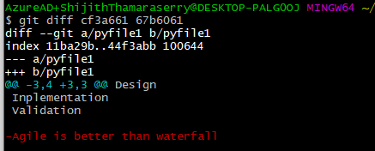

* Now I know the last line was added and after adding application not working. So I would like to revert the changes **git reset –hard “previous commit ID”** the head will now point to this commit ID
* Now go check your file and changes should be reverted

*This is one direct way of reverting the changes but developer uses more different ways to revert any changes.*

*Note: As a good practice always create as less as possible branches*

**Git conflict:**

This conflict is a fight within developers that they are trying to commit some thing and someone else is over writing the changes this is one problem and there are many other problems also.

Git conflict basically has to be resolved mutually by humans and not any tools. As a tool what we can do is before you make any changes always do git pull so that you have the updated repo and then start doing your changes.

**SSH Authentication Exercise:**

* We have key based and password-based authentication. Key based login is more secure. You can enable or disable password-based login in /etc/ssh/sshd_config file and Restart sshd service.

**Exercise1 – ssh from server1 to server2 using password authentication:**

* Create 2 EC2 instance and login to one of the instances.
* Change the password Authentication parameter to “yes” in /etc/ssh/sshd_config file
* Restart sshd service #systemctl restart sshd
* Let’s create a user #useradd devops and a password to this user #passwd username password
* Now try to login with user devops that you created

ssh [devops@3.14.88.45](mailto:devops@3.14.88.45)

ssh -v [devops@3.14.88.45](mailto:devops@3.14.88.45) →to print verbose

When you issue -v command you can see that ssh will first always will try with key based login. It will look for a key by default in users home directory /c/Users/ShijithThamaraserry/.ssh/id_rsa. If it doesn’t find the key, then it will go for password authentication.

* This is how you login with password authentication
* Now login to the other EC2 instance and make password-based authentication to yes
* Restart sshd service
* Create a user and a password for that user
* Logout and now try to login with user you created, and you can login
* Now let’s login back to our first instance and do ssh to second instance from there.
* Here you should use the private IP to do ssh because both systems are in same network (we will understand this network concept in VPC later)

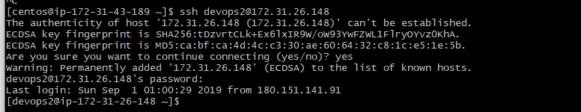

**Exercise2 – ssh from server1 to server2 using Key based authentication:**

Ssh -keygen is the command we use to generate the key pair. We call Key pair because it is generated into pair private key and the public key

* Login to server1 and generate a key pair
* Generate a key pair # ssh-keygen

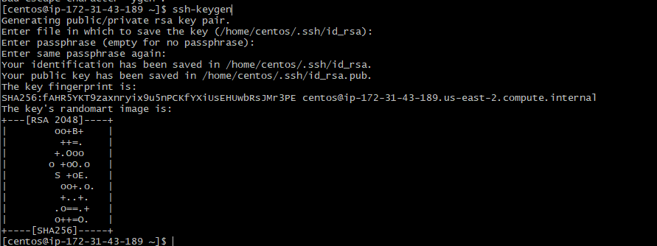

Go to the directory and you can see **id_rsa** → **Private Key** and **id_rsa.pub** →**Public Key**

Private Key is like Key and public key is like lock. Key matches with the lock the lock opens.

If you lose the private key, you cannot regenerate the key because its generated in pair.

We put the public key on servers where you want to login under **user home directory/.ssh/authorized_keys file).** We use private keysto login to these servers.

* Place the publickey of server1 to server2 under authorized keys

There is a ssh copy RSA ID command

#ssh-copy-id user@privateIP

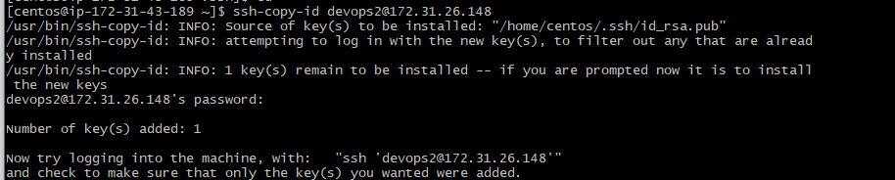

When I run this command on server1 by default it takes the public key from default directory and it will push to the server2

* Now I can do ssh from server1 to server2 #ssh devops2@server2PrivateIP

**Implementing key based login for GITHub:**

* Go to your gitbash and generate a keypair

Ssh-keygen

* Copy the public key and paste in your GitHub account under below location

Account settings→ssh and GPG keys→New key and paste the key.

* Now go to your github repository and select ssh base under clone or download tab and copy the ssh link
* Go to your system/gitbash and try to clone with ssh link and you will be able to do without and any password authentication.
* You can go to config file and verify to see the remote URL is SSH link

**Maven – (Build tool for Java) – version 3.6.0**

* Build Tool specific for java
* We don’t do much in build tool or Maven, but we need to understand what commands are used and what output does it give

CODE➔ComplieCode➔classfiles➔unit test➔Integration Test➔Archive the files➔Deploy/Store➔Test on Local Machine➔Push code to the centralized version control system

This entire phase is called as build process and If this they have to do manually it takes a lot of time.

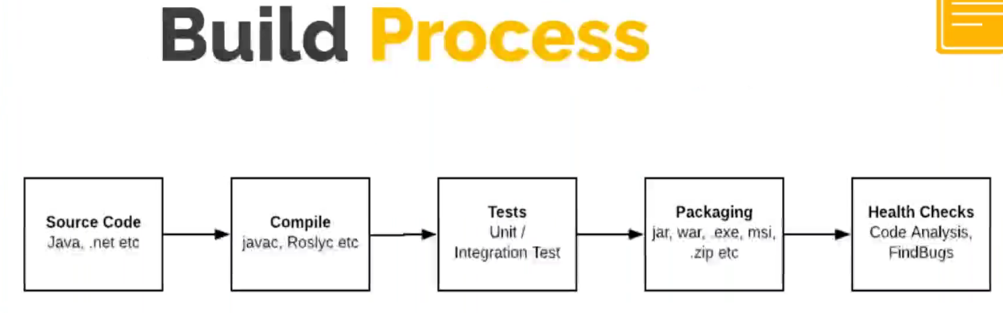

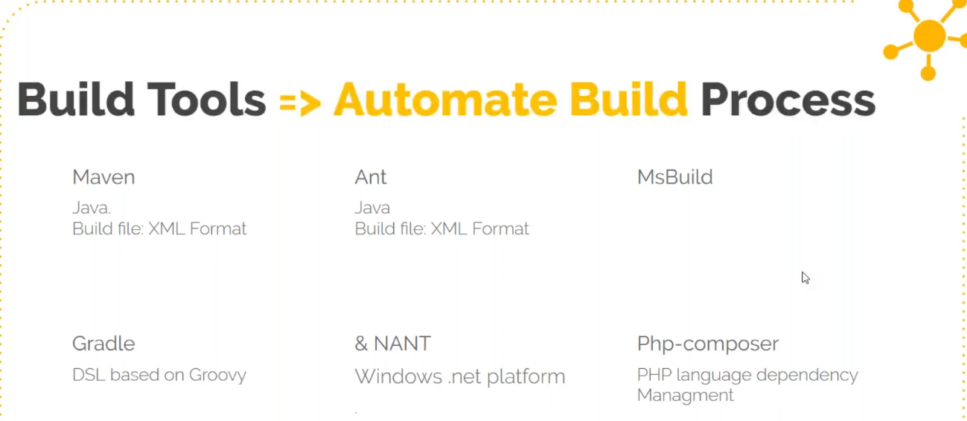

**Maven phases:**

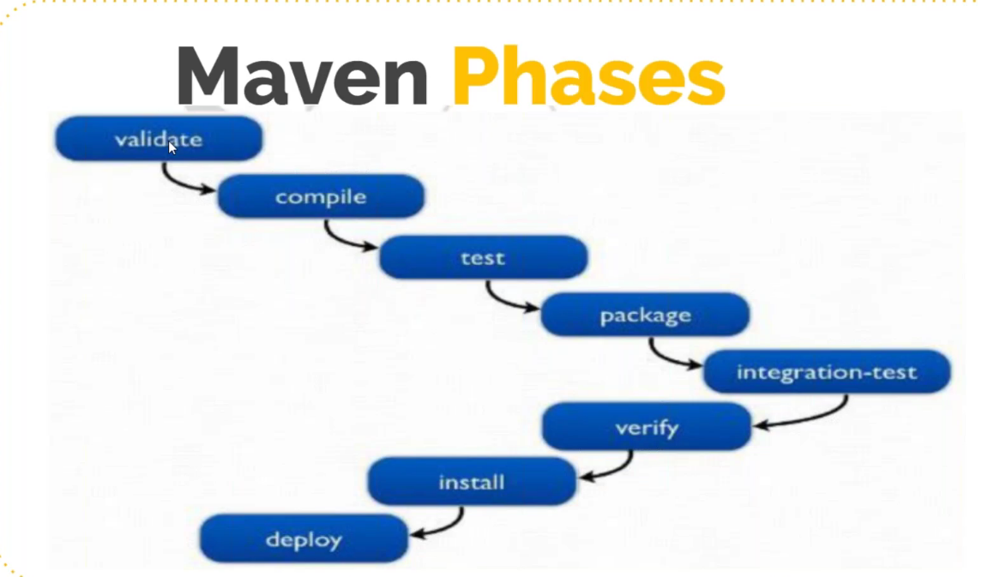

1. Validate – Validates directory structure, syntax check. It will read a file called **POM.XML**
2. Compile – you need to be in the source code directory and you run **maven compile**, it will compile using a java compiler.
3. Test – Developer will include the unit test in the source code. When you run **maven** test it will read those unit test file and execute unit test cases and return the result in xml format and stored in the same directory
4. Package – **Maven package** will take the compile file and package it together in the format mentioned in **pom.xml file** (war,ear,deb,exe…)
5. Verify
6. Install – When you say Maven Install, it will executes all the previous phases and also download the dependencies which will be mentioned in the POM.XML file
7. Deploy – This will take your artifact package and deploy it to server (but we use Jenkins for deploy)

Maven need JDK to run

JDK - java packages which contains JRE and development tools that can be used to build/develop the java code

JRE – java packages used to run any java software’s

**Maven Installation:**

1. Login to any Ec2 instance
2. Update the repository

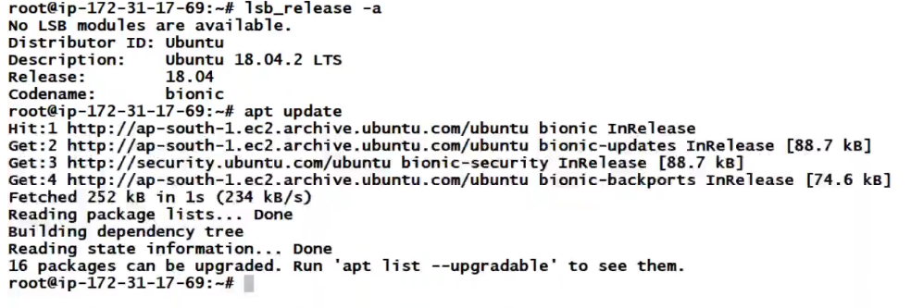

1. Install JDK

apt search jdk will list the java



Now install



Java -version will show you the java version

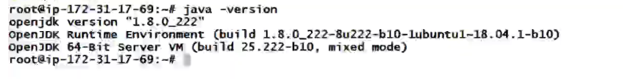

1. Install maven – we have 2 ways to install maven

Running the below command will install the latest version of maven.

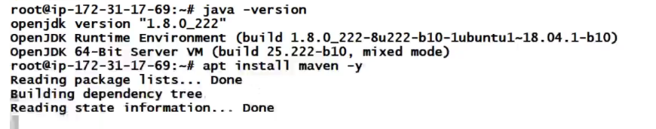

mvn -version will show you the maven installed version

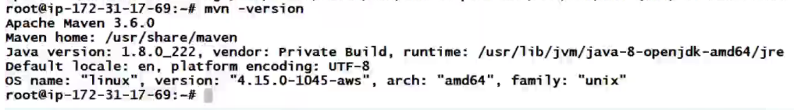

In case you need a particular version of maven to be installed then download it from the maven site

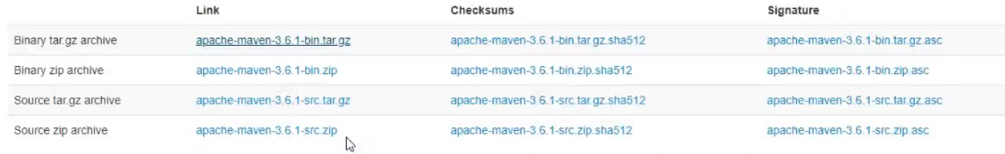

Let’s download maven 3.6.1 from the above

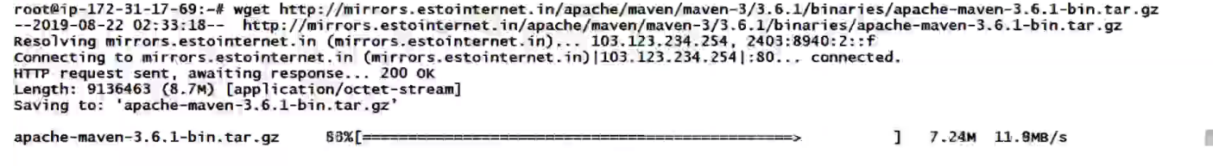

Untar the downloaded file



Now you can move the directory to the path where you want maven to be installed



Now maven is installed and to invoke maven go the bin directory

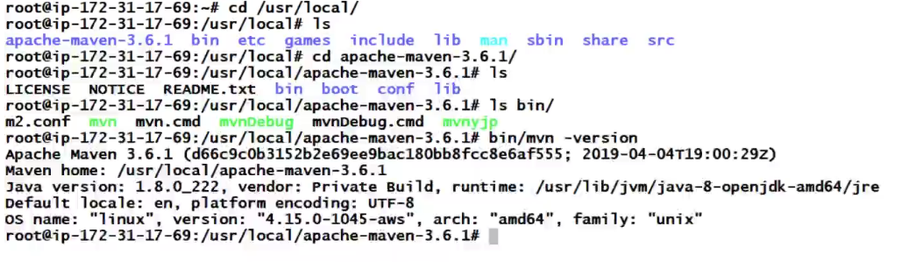

Now I have installed two maven with different version in different directory but the default maven you can check by running the command which maven



1. Since maven is installed, we will clone our source code and use maven to build our source code

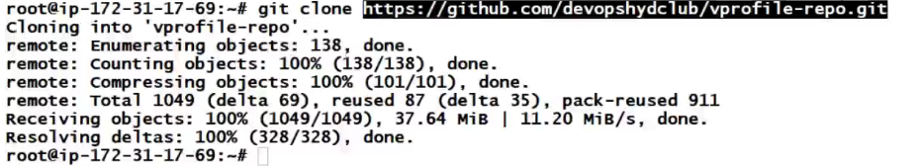

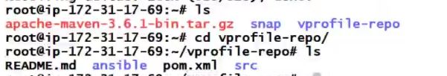

Here we have a pom.xml file which can tell you that you can install this source code using maven

This is the configuration file and if you run any maven command, it will read information from here

Developers will be making the changes to the pom.xml file and sometimes you need to make the changes probably changing the version.

1. Now we are in source code directory and let’s run maven **install** and this will execute all the previous phases, download the dependencies

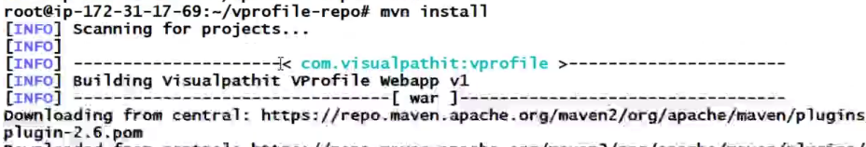

Now it says build is success – you will get message if it fails at any stage



1. Once the build phase is completed, you will see a directory called Target. In this directory you will have the output of the build that is artifact



The name of the artifact is vprofile; version is 1; and the extension is war → as per POM.XML file its created.

**Continuous Integration**

This is where the devops life cycle starts.

Developers write the code, build the code, test the application by installing on local machine and finally push the code to the centralized repository. Like wise there are multiple developers who does it multiple times in a day.

So now here we have a problem, In that centralized place the code gets merged by different developers. The code is getting tested in the local machine and they push to the centralized repository. Now let’s say there is a demo it to the customer. We don’t demo it one developer code or application to the customer. It will the merged code from all developers we take it from centralized repository. Individual developers do their code testing manually on their local machine but when it is merged by different developers to the centralized repository, that time also it need to be tested. There could be conflict in build part, there cold be conflict in dependencies, there may be so many other conflicts because of which the build process fails. It will generate other kind of error when a code is merged together and building it. Now all these errors bugs need to be fixed very quickly because we have a demo to the customer in 2-3 days. Now this is the panic time that we couldn’t fix all the bugs and the deadline is post pone and the customer is not happy. So, we are not able to deliver the product not because the developer mistake, but the process is not good over there. We are merging the code but not integrating the code. Integration is painful if you going to do at the end. But if you change the process a little bit then it is easy. The developer tests the code locally and push it to VCS, as soon as there is a commit in the VCS there should be some process to fetch the code, build it, do some more test and return the result to developer. If it’s a failure the developer gets to know, and he/she will stop doing what he is doing and fix the code and push.

Like that after every commit fetch it, build it, test it and notify to developers. This process is called as CI.

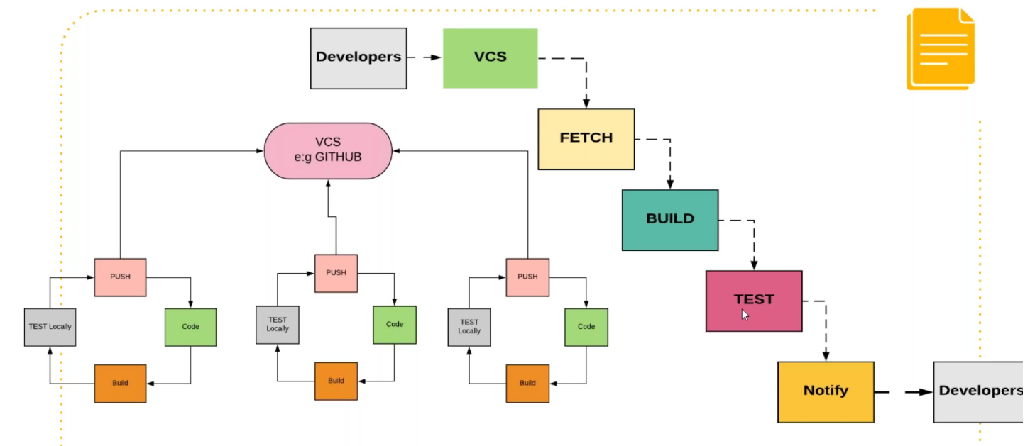

**Jenkins**

Jenkins is one of the widely used Continuous Integration tool in market. It’s an open source tool. Since it is an open source there are variety of tools gets integrated in it. The main power house of Jenkins is its plugins.

Jenkins servers the request on port 8080

***Jenkins Plugins that we are using*** – Maven, GIT, zentimestamp,

**Installation:**

Prerequisite 1. Java, JRE, JDK

2.Any OS

NOTE: Any time any installation fails, uninstall them and do the prerequisite and then install. Purge command will cleanly uninstall any failed installations - #**sudo apt purge Jenkins**

Installing by running the jar file is not a recommended method. This runs on the foreground and there is no systemctl command to manage it

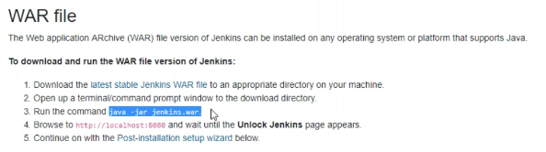

1. First install Java – sudo apt install openjdk-8-jdk -y
2. Go to official Jenkins website and see Jenkins.IO documentation for reference

<https://jenkins.io/doc/book/installing>

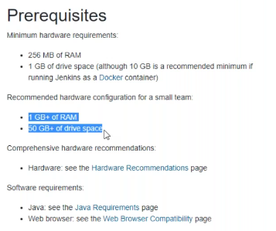

1. First you need download and add the Jenkins repository key by running the below command

wget -q -O - https://pkg.jenkins.io/debian/jenkins.io.key | sudo apt-key add –

1. Add the repository URl

sudo sh -c 'echo deb https://pkg.jenkins.io/debian-stable binary/ > /etc/apt/sources.list.d/jenkins.list'

1. Run apt update

sudo apt-get update

1. sudo apt-get install Jenkins to install Jenkins
2. Once installed you can check status

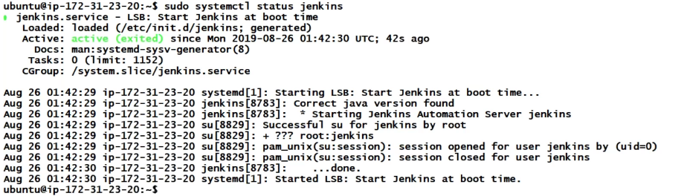

Jenkins will have a home directory - /var/lib/Jenkins – anything and everything of Jenkins will be under this directory

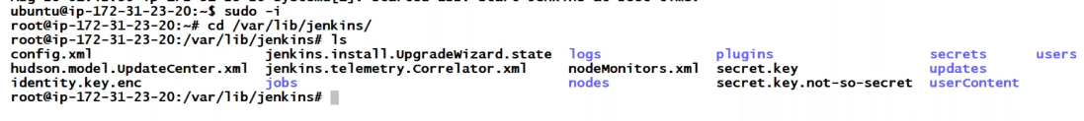

1. Check for the Jenkins port and try to access its console



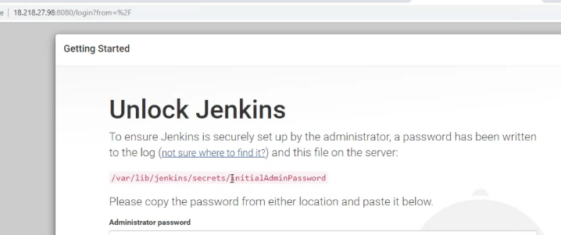

It will give you initial password to unlock Jenkins. And then install plugins and finally add a first admin user to access this Jenkins

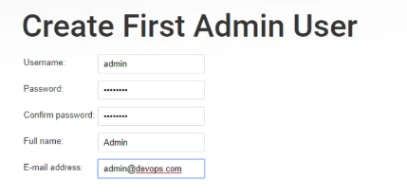

In the next step you will see the URL of the Jenkins and this will be recorded in your configuration file.

**How to take backup of Jenkins:**

Stop the service and you may run tar command to archive the Jenkins complete folder



Output



**How to move Jenkins from one server to another server:**

On the target server install Jenkins using package manager and then take this source tar ball file to target server and extract it under lib directory f Jenkins and start it and use it.

**NOTES**

Below are the sections we have inside job



Jenkins have its workspace where it stores all the source codes

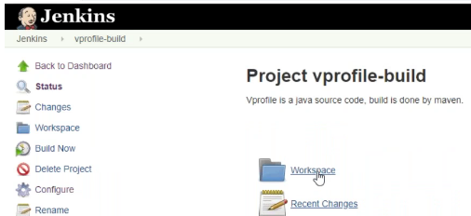

The same workspace you can see on system also

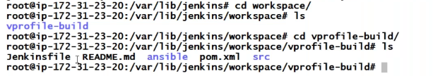

**A simple versioning method using $BUILD_ID and $BUILD_TIMESTAMP parameter:**

We can do a simple versioning using BUILD_ID and BUILD_TIMESTAMP

When ever you run mvn install to build any job – It create the artifact under Jenkins workspace/your JOB Name/target directory.

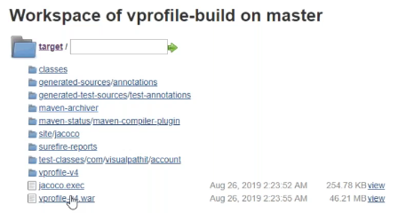

Here our artifact naming doesn’t have any build ID and time stamp. Whenever there is a change code or commit it will pull the latest code and create a new build and overwrite exiting data. Now in case if I want to roll back, I need to talk to developer to revert the commit to the previous one and then you build the job again. But this needs developer involvement and we don’t need that. Instead we can maintain a different version of artifact.

Below is the cheaper method of **Artifact** versioning and later we will see advanced versioning methods using Nexus.

* Go to your job →click on configure and then under Build section create execute shell with

cp target/vprofile-v4.war target/vprofile-v4_SBUILD_ID.war

This will copy the war file with Build ID naming convention and every time you build it will copy the artifact with build ID (Build ID will be different for every job you build)

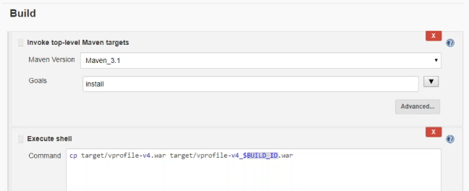

* After you update this – save and run the Job
* Now you will see artifact got generated and it copied with build ID

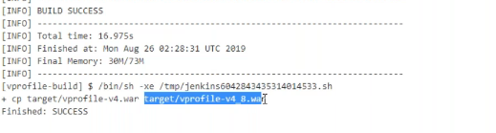

Here it has taken number 8 because that is our Build ID number

The next time you run the job it will copy with 9.war. The number is fine, it is getting incremented every time. But if I change the job and hence it is not a dependable versioning Method. So, what we can do is we can have one more variable BUILD_TIMESTAMP and this comes from a plugin. You install that plugin and you will get that timestamp variable, and this will have current timestamp.

* Go to manage Jenkins → Manage Plugins and you can see 4 tabs

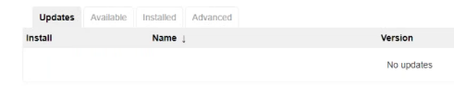

In available sections you can see all the available plugins like skype notifier, twitter, build notifier, build parameter and like that the list so long. It’s impossible to learn all the plugins. You search the plugin you want and install it. Now let me install timestamp plugin for our versioning

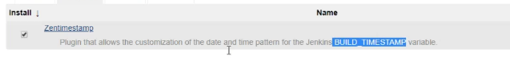

When you install this, you get the new feature of using it.

* Go to your job →configure and see a new feature is enabled. Here you can give the timestamp. For help click on question mark and it will show you the format which you can edit also to short like I did here.

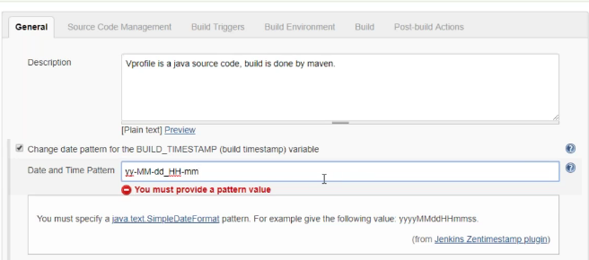

* Now under your build section give the variable

cp target/vprofile-v4.war target/vprofile-v4_SBUILD_ID_$BUILD_TIMESTAMP.war

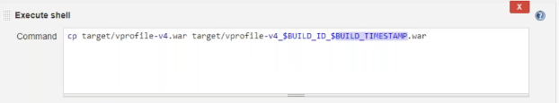

Now this will return the value in the format we mentioned under build stamp

* Save and build the job and you will see the artifact getting copied with build timestamp

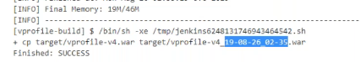

Check in your workspace also and its looks like a s/w version

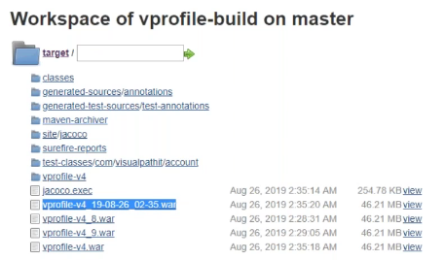

**How to notify Developer or any person about the failed build job using Jenkins:**

This is not our job to fix code errors. Our job is to notify developer through Jenkins whenever a build fails.

In the post build action, you can do that using email notification but now here we don’t have an SMPT server which can forward the email. Like Gmail we access the UI and Gmail’s smtp server will send email to other places

Every organization have their own mailing server. Here we use GMAIL but the steps would remain more or less same

* Go to manage Jenkins →configure system and this is the place you do global configuration of Jenkins

**NOTE:** *Here you can see our Jenkins URL and that is used for other tools internally and this is not the URL that we use to access Jenkins.*

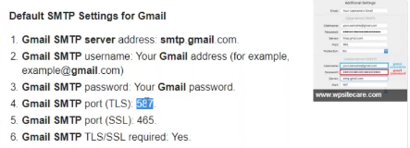

At the end you have **email notification server** section where you can give the details of your smtp or any other mailing server details. Here, I will use Gmail’s smtp server.

* Google gmail smtp server settings



So, it is smtp.gmail.com. You should be having a Gmail account and don’t use your existing gmail account as we do some changes here related to security feature.

Fill in the information in email notification server settings like gmail’s smtp server, your gmail ID, password, use TLS and the smtp port (default is 25) but here gmail smtp TLS port is 587 and then click of **Test** to test the settings by sending to an email address.

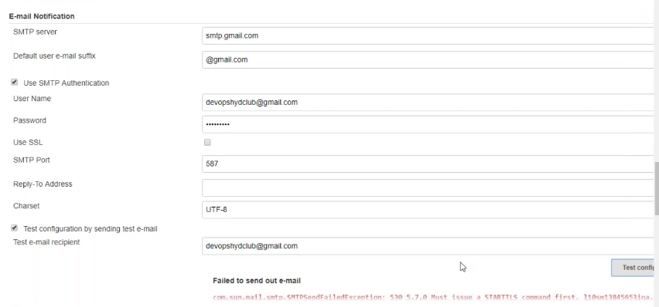

This test will fail if you don’t change some settings in Gmail because this will send email through command line and by default google will deny that. Hence do the below changes in your google settings by clicking on security→Less secure app access→Turn on access

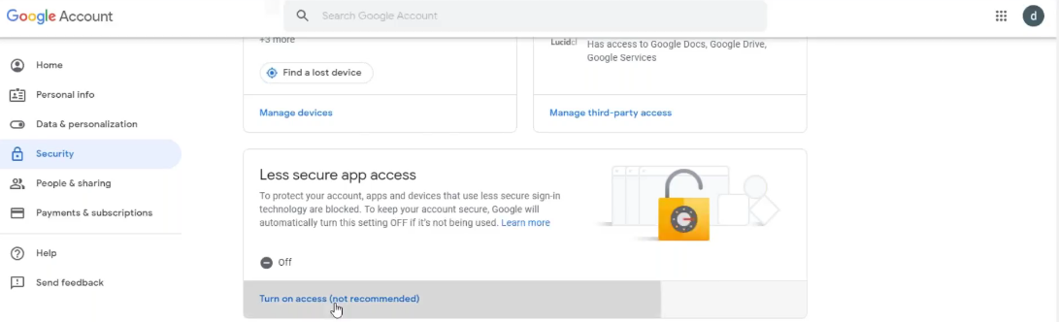

Also, you need to disable captcha (google disable capcha for gmail) and click on unlock captcha link and its done. Now test again and you be done

* Now goto your Job → configure→under post build actions select email notification and give the email address of the person/group to whom you want to send notifications. You can give multiple email address by adding a space.

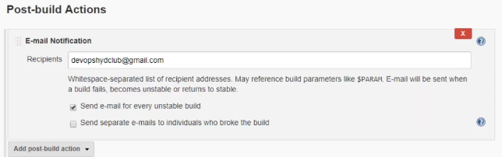

Now let me edit the command in execute shell section of our job. Some wrong command so that job can fail

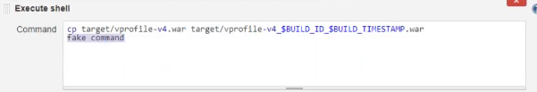

Now run the job again and you can see the output of the failed thing along with to whom it will be notified.

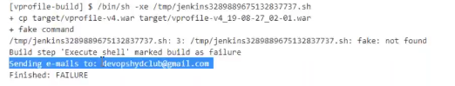

Now you would have received an email for this failure.

**Software repositories- Storage location for your software packages/artifacts – NEXUS/Jfrog..**

We are versioning the artifact. In the build phase we call it as artifact but the other way it is called software. We everyday run multiple jobs. These jobs create software’s or artifacts and we are versioning then and we get different version of the same artifact or multiple artifact. You would be having lots of artifact or software’s to manage. So, storing such huge artifacts on Jenkins is not recommended. Jenkins workspace is not reliable to store your data. We wipeout workspace sometimes. Anyways Jenkins is not a storage space. You need a place where you can version it and store it properly and that should give you links to download software’s. It could be integrated with other tools where you want to do the deployment. Probably you may create a script and use wget to download and deploy it to some servers.

We use lot of software repositories like when we use apt install, Jenkins and we have set up repository URL, yum install, google playstore on your phone and so on.

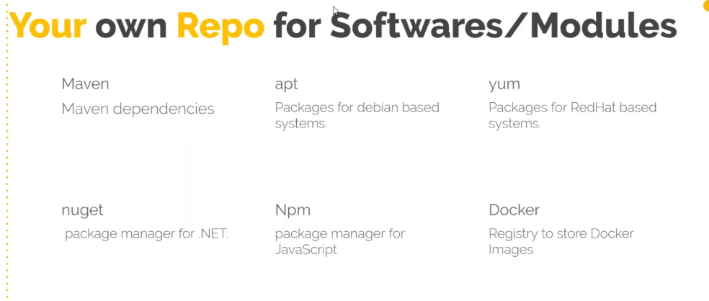

You can use your own software repository and we will use **NEXUS** software repository.

These software repositories can be used for 2 purpose

1. When you build your artifact, you want to version it and store it
2. Package manager for dependencies – but we cant achieve this here as it involves lengthy configuration

**Nexus:**

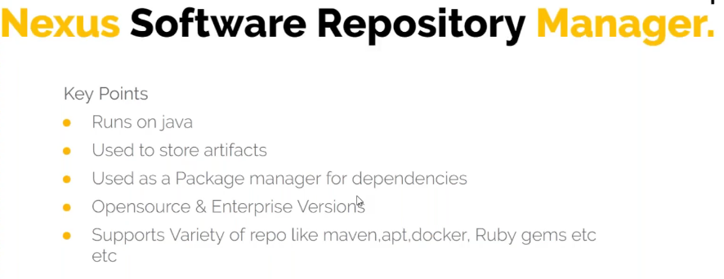

Developer push their code on github→Jenkins will fetch the code and build the artifact→pass failure notifications for developers and →push the artifact to **NEXUS repository**

**Installation:**

*T2-micro instance will not be sufficient to run Nexux*

*We need min 2GB of RAM also*

*Always run nexus with nexus user – It’s not recommended to use root or any other users*

1. Launch a separate Ec2 instance for Jenkins – I am using centos7

Nexus runs on port **8081,** so enable this port for Ec2 instance and login

1. Install JDK - do a yum search to list all JDK



1. Download Nexus from its official website

wget https://download.sonatype.com/nexus/3/latest-unix.tar.gz under /opt directory (anywhere you can do)

1. Once downloaded extract the tar file





Sonatype-work will have the actual storage

Nexus-3.18.1-01 will have configurations and binaries to run nexus

1. To start nexus – go to bin directory of nexus and run # bin/nexus run

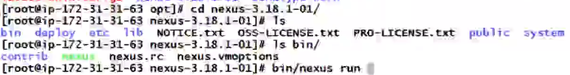

This is a manual process going into the directory and the start nexus. To avoid this we will create a system ctl file and give its configuration so that it can run the binary and start the service

# vi /etc/systemd/system/nexus.service

[Unit]

Description=nexus service

After=network.target

[Service]

Type=forking

LimitNOFILE=65536

ExecStart=/opt/nexus-3.16.1-02/bin/nexus start

ExecStop=/opt/nexus-3.16.1-02/bin/nexus stop

User=nexus

Restart=on-abort

[Install]

WantedBy=multi-user.target

1. Let’s create a user Nexus and give the ownership to nexus and sonatype directories.

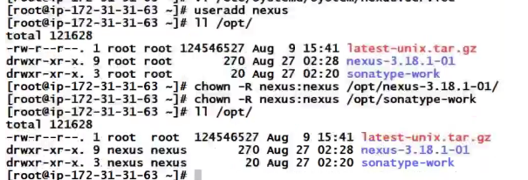

1. We have a configuration file where we mention Nexus should run with Nexus user





1. We have created a new systemctl sytemd file and hence for the changes to take effect you need to reload daemon and then start nexus using systemctl command.



Also enable the service #systemctl enable nexus

1. Now you can access nexus with port 8081



In nexus older version we have context “nexus”( https://IP:8081/nexus) in console URL but now it’s just https://IP:8081

1. Now click on sign in – previously for nexus default user ID and password was admin and admin 123 but now you have to unlock it just like we did for Jenkins and set a new password

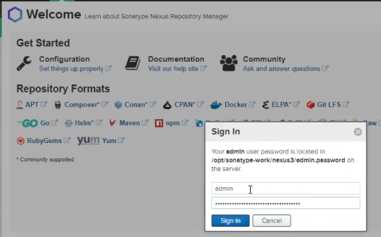

Once you will login it will show different types of repositories formats – but we will go with **maven**

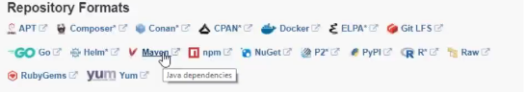

1. Create a repository

You have 2 tabs here – one is settings tab and the other is browsing tab accessing your repository

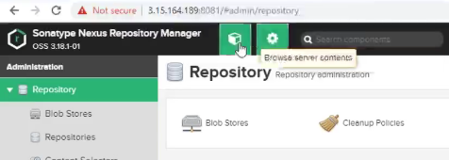

Go to settings and click on Repositories→create repositories→select maven2 hosted→give a name and rest details we will keep default and click on create

We can also set some policies if we want for different use case and also we have blob store that is storage (we use default)

1. Once repository created you can access it under browsing tab and click on browse and your repository name. Now it is empty as we have not uploaded anything there.

We will not upload anything manually, but we will use Jenkins to have upload our artifact to our Nexus repository

**Jenkins pushes the artifact to Nexus settings:**

To achieve this, we will create a **separate job** that takes the artifact and pushes to nexus repository that we created.

We need 2 things here – We have to copy the artifact from the **build job** to a **separate job** + We need to push it to nexus. So, need 2 plugins here

* Create a new job **(vprofile-nexus-versioning**)– for copying the artifact from the build job to here and then pushing the artifact to nexus and to do this let’s install plugin

Manage Jenkins→manage plugins→and install below 2 plugins





Now go to your Job →configure→Build→copy artifact from another project→Give the jobname from where you want to copy the artifact and under Artifacts to copy →give the particular artifact.war file or if you have multiple files then give the regular expression (**/*.war - ** means go into every directory recursively and look for any files that ends with .war) but for this to do you need to archive the artifact in this job

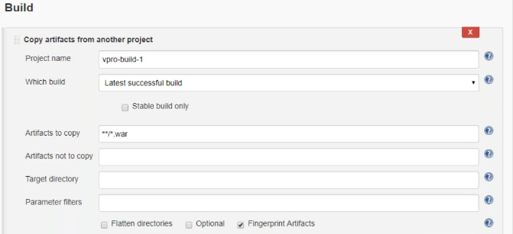

Click on save.

For the above to work you need to go to your build job from where you are copying the artifact→configure→Add post build action→archive the artifact→in files to archive parameter, mention **/*.war and save

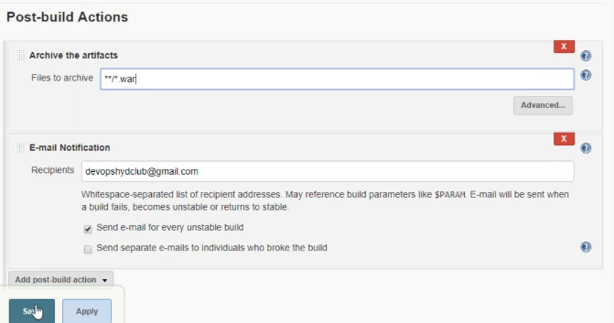

* Now run the build job and you will see the artifact created in your workspace

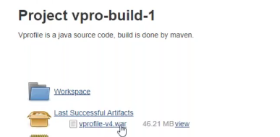

* Now go to your nexus job - **vprofile-nexus-versioning** and run the job **–** it should copy theartifact from build job to here

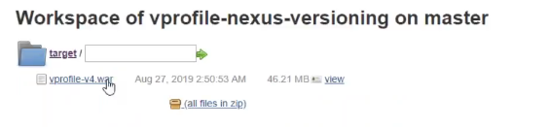

Like that not only artifact bit you can copy anything

* Now we need to push the artifact from nexus job to nexus repository

Configure →Add build step →select nexus artifact uploader→select which nexus you want to use→mention your nexus URL (URL we are accessing it from public IP but you **must** mention the private IP as they both are in same network )→you need to give the login credentials →click on add and select Jenkins and give the nexus admin credentials

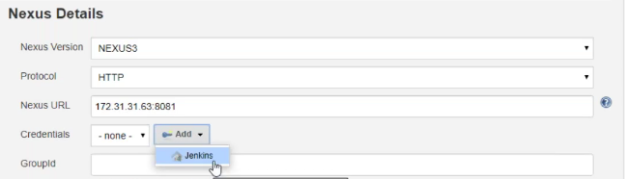

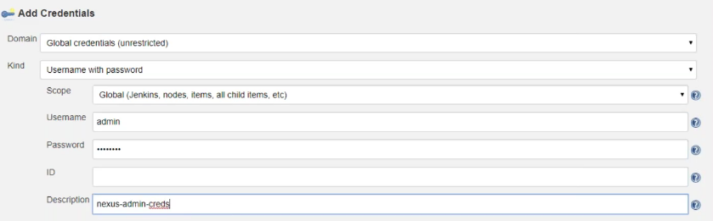

Select your credentilas→group ID give QA(this will discuss later)→version=$BUILD_ID→Repository=give the name of repository that we created on nexus→click on add artifact→artifact ID=BUILD_TIMESTAMP→Type=war→File=give the artifact file name that is there in our workspace and save

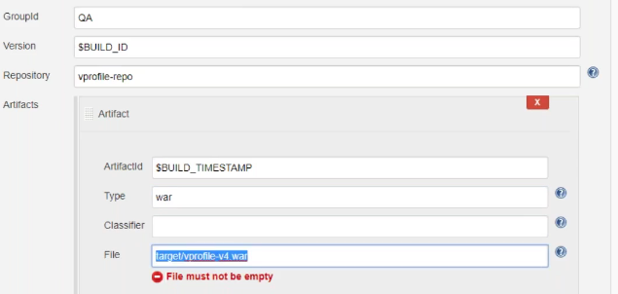

Also, setup the build time stamp

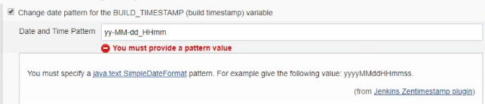

* Now click on build job of nexus

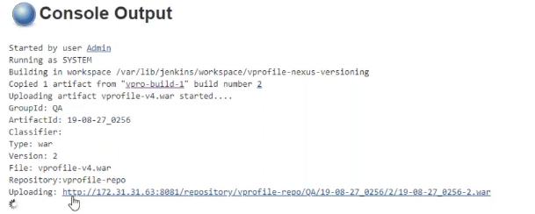

Now see its accessing this URL, and creating a directory QA under our repos with build time stamp and build ID. This is the URL where It will upload it but the problem here is Jenkins is accessing the nexus on port 8081. You should make sure does nexus allows port 8081 from Jenkins.

Check the security group of nexus instance and make the rule port 8081 is created with either Jenkins private IP or the Jenkins security group(selecting security group will allow any instance from this security group can access nexus on port 8081. This rule is only for private IP and not Public IP

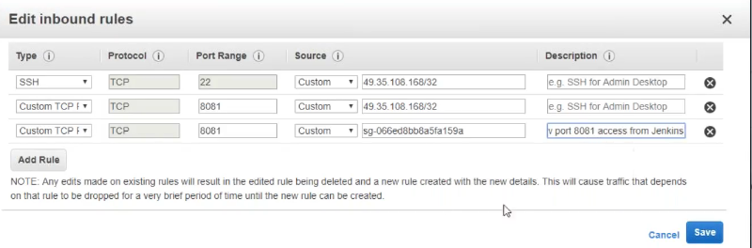

* Build the job multiple times and you should be able to see the artifact in the below structure

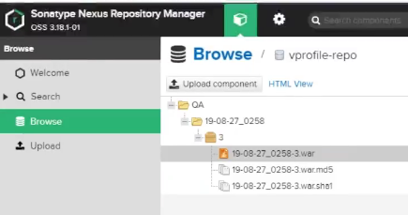

Here we were using build now option in our nexus job **vprofile-nexus-versioning** manually. I don’t want to build manually from **vprofile-nexus-versioning** job instead I want as soon our **build job** runs it creates the artifact and then it should be able to upload the artifact to nexus repository. To achieve this, you should add a **post build** step in our **build job** by selecting **build other projects** option and give the job name (**vprofile-nexus-versioning**).

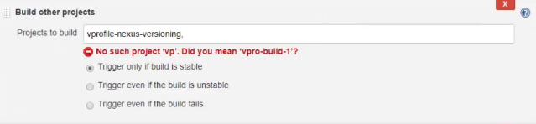

* Now run the **build job –** this you can run even from the main screen as well.

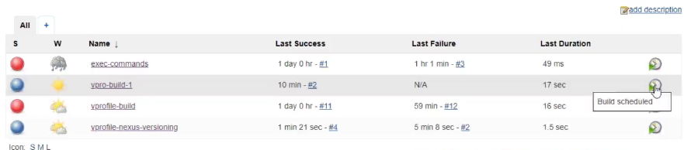

* After enabling **build other projects** option, you will see **downstream** and **upstream** in the main screen

For **build job –** Its downstream job is nexus job **vprofile-nexus-versioning** which means once build job completes it will trigger the next job that is our nexus job

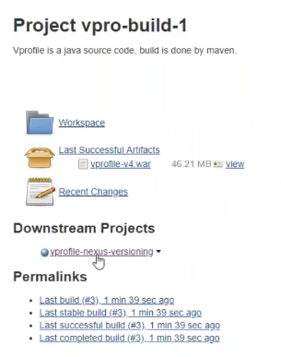

For **vprofile-nexus-versioning job –** its upstream job is **build job** which meansbuild job will trigger the current nexus job

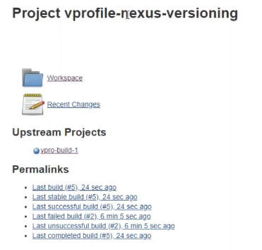

You are done with Nexus 😊

***Summanry:*** *Now you have seen using nexus with Jenkins and in the same way you can use Jfrog by using jfrog plugin and also if you want s3 by using s3 plugin to store the artifact.*

**How to deploy our artifact to Tomcat server – we will see setting up some extra features on Tomcat**

* Launch a Tomcat instance (I will take centos)



* Install JDK – which is dependency of Tomcat



* Download the Tomcat package

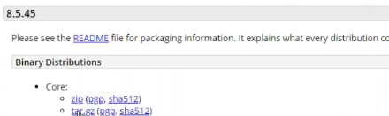



* Extract and move it to any directory of your choice /usr/local

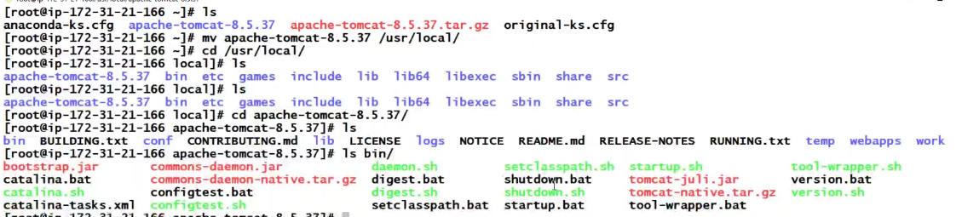

The webapps directory is where we put our websites/application. In the webapps directory you will have the main application **ROOT. You can replace your application here and access it**

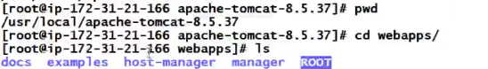

So, we deploy our application here and tomcat will extract it to a directory

* Let’s start tomcat and tail its log **Catalina.out**

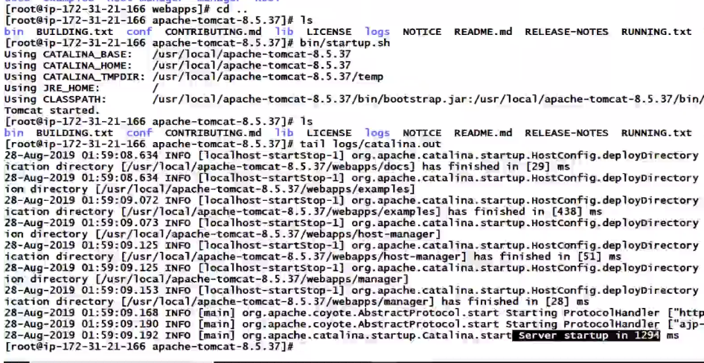

It’s started and runs on port 8080

* Let’s access tomcat now – Below is tomcat default application

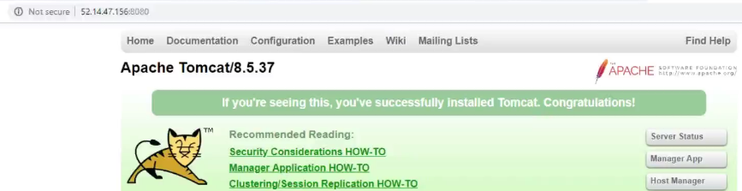

**How to deploy our artifact on Tomcat:**

* You can scp the artifact to the tomcat webapp directory
* You can also do deployment from the tomcat console using **manager Apps**

Initially for the first time you get error accessing the manager apps

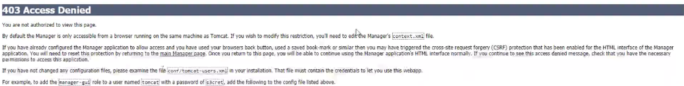

Two things we need to add here – create a user to access manager apps

Enable remote Access

* Edit the below file to give remote access



In this file it is by default set as allow connection from local IP



This is a xml file if you want to comment is “<!--" and “-->”. Lets comment the section where it allows only local IP



* Now you restart tomcat and it will listen to the remote connection also
* Lets add a user now and give a role to that user. We need 2 roles manager-gui (to access manager apps from GUI) and manager-script (gui (to access manager apps from command- this is required for Jenkins also because Jenkins will do deployment from command line)



Below I have added a user and assigned 2 roles to it. Uncomment the user section and add the below

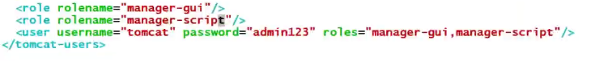

* Restart tomcat – There is no restart script →**#shutdown.sh**

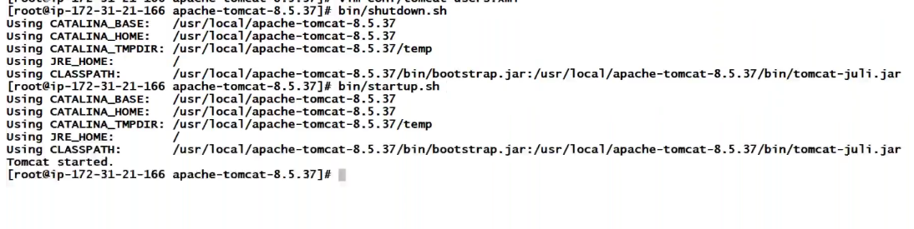

* Now try to access manager apps from console and provide the credentials and you are in.

So, from here also you can deploy your artifact→ choose file and then deploy option

This is GUI and it’s a manual process. We want the artifact to deploy from Jenkins automatically.

**Deploying the application on Tomcat from Jenkis:**

Jenkins doesn’t have any inbuilt feature to deploy the artifact to tomcat server. We do it using plugins

1. Manage Jenkins→manage plugin and do a search in available plugin→**deploy to container(**this is not the docker container, its java container for jboss,websphere,tomcat..**)→install**

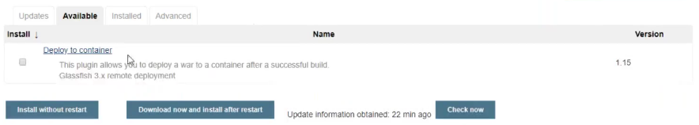

1. Now we will create a job (vprofile-QA-deploy) which takes the artifact and deploy to tomcat server. In this job either I can take the artifact from our build project or I can execute the shell command to take the artifact from nexus by using wget command. For now, I will use copy artifact from our build project

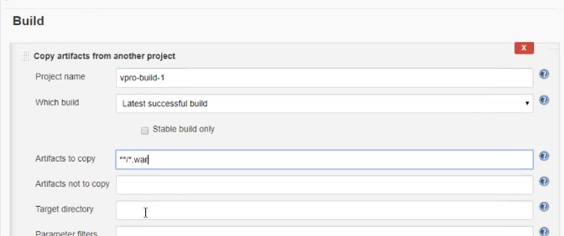

Just run a test by building the job here and you should see that artifact is copied

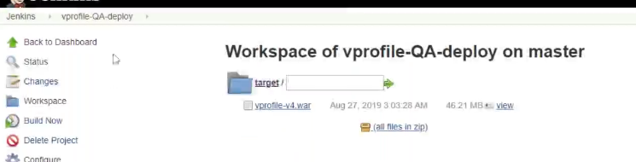

1. Now use our deploy to container plugin to deploy the artifact on tomcat

**Add post build action**→deploy war/ear to a container→select your file type→Add container→select your tomcat →give tomcat URL(private IP) and add tomcat user credentials→save and run the build

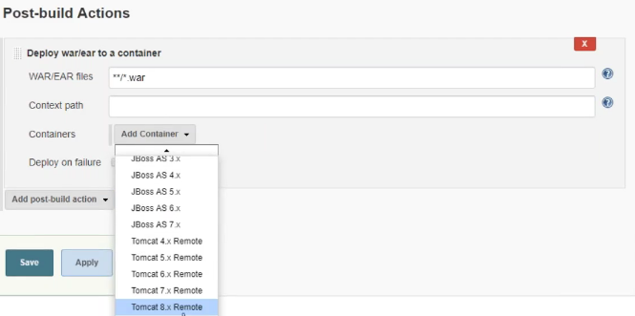

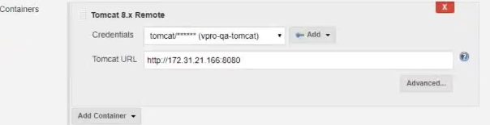

Make sure your tomcat instance security group should allow Jenkins on port 8080

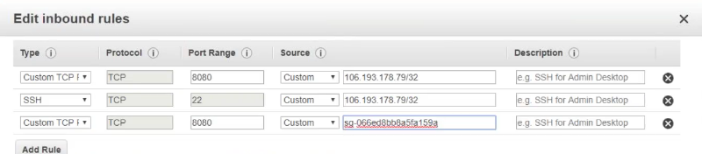

1. Now you should be able to see the artifact in tomcat webapps directory and tomcat would have extracted it

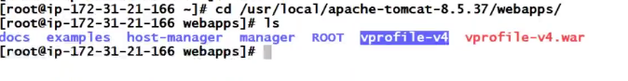

**Now let’s see how to add a post build action in our nexus job to deployment on tomcat:**

Nexus versioning you know it will do the versioning of artifact. Once it is completed, I want it to be deployed to tomcat.

Add post build action→Build other project→save

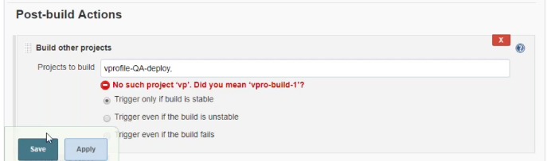

And build the job and you are done with the exercise.

**Build Pipeline view to manage jobs easily:**

We just have 3 jobs running and it already started looking complicated. It is becoming difficult to manage what jobs are getting triggered what is happening and all. Just say if you have some around 40-50 jobs and it becomes difficult to see from this below view and find out which job is triggering. For that purpose, we create a **Build Pipeline view.**

**Pipeline means multiple jobs together**

We have several plugins to create this – Now I am going to use one of them a very popular one to create a build pipeline view – **build-pipeline**

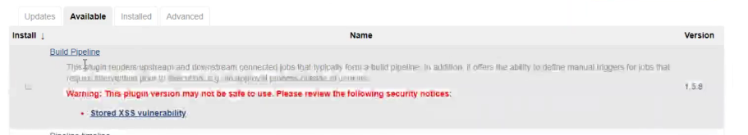

* Install the build-pipeline
* Now to create a view, click on + sign (new view)

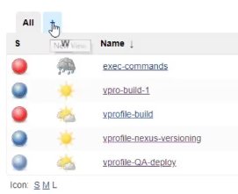

* Select build pipe line view and give a name

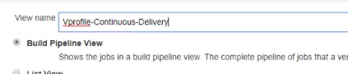

* Select your initial job →vpro-build-1
* Select the no of displayed builds →5 = this will show last 5 build
* Save

There are few other settings here but for now we will see the output.

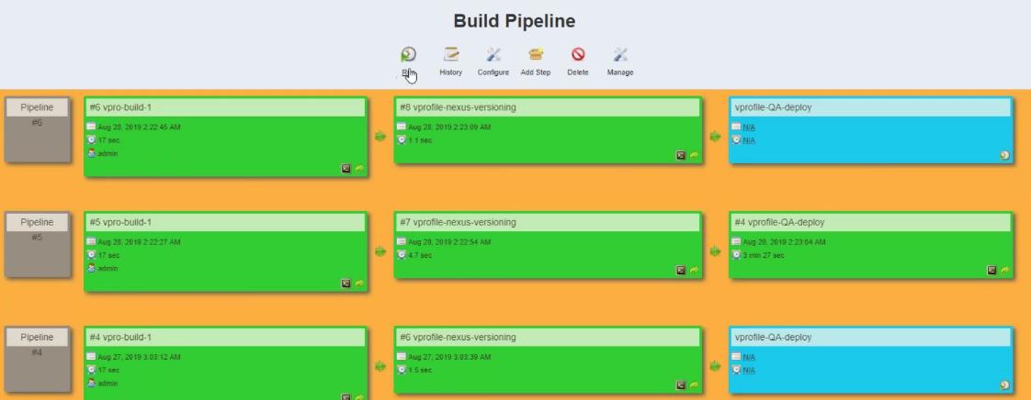

For now, we have a tomcat server – let’s say it’s for QA

We need one more tomcat server for **PROD** – so am creating one by selecting the option create image (AMI) from existing tomcat server and then launch a new tomcat instance from this image.

**Code Analysis:**

This is also one more kind of test. We know Maven executes unit and integration test. So that test is taken care and there is one more test which is on the code. Before you deploy on QA machines, you need to run few more tests on the code called as code analysis. This test detects vulnerabilities or any future upcoming problems. Now your code would be working fine. This code doesn’t detect any syntax error and some functional errors but not exactly s/w testing. Lets say if you are not following some best practices like developer sometimes, they put the password, IP address, username in the code and the code analysis will detect this. Also, some other form of vulnerabilities like SQL injection and so on. It will detect and it has its own set of data or files database with all the best practices and vulnerability check. Its gonna match it with your code and if there is any mismatch it will alert you.

There are so many tools out there which can do code analysis like check style, coverture, mstest for Microsoft, SonarQube scanner …

**Check style:**

1. Install the **checkstyle** plugin in Jenkins

Also install violations plugin

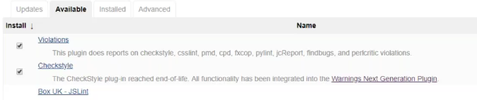

1. Lets create a new job for code analysis by selecting the option copy all settings from build-job which already have the source code integration, buid..
2. We need the source code here – Also I will build the source code, so it downloads all the dependencies. Adding one more build top level maven and goal as **checkstyle:checkstyle and this check all the vulnerabilities and best practices and gives you an xml report.**

In case if you want to see here itself then add Publish check style analysis results in post build action and this will read the xml report generated and give you the graph.

1. Save

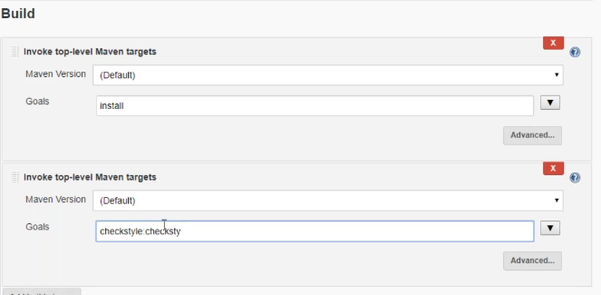

This below Publish check style analysis results is deprecated. This is older one, but we will see the latest one in later session.

1. Now build the job and once completed build the job again as we need 2 datapoints to compare. You will see a new option checkstyle-warnings as below

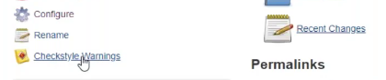

Below is the graph on right hand side with 700 warnings and doesn’t look like a graph :D

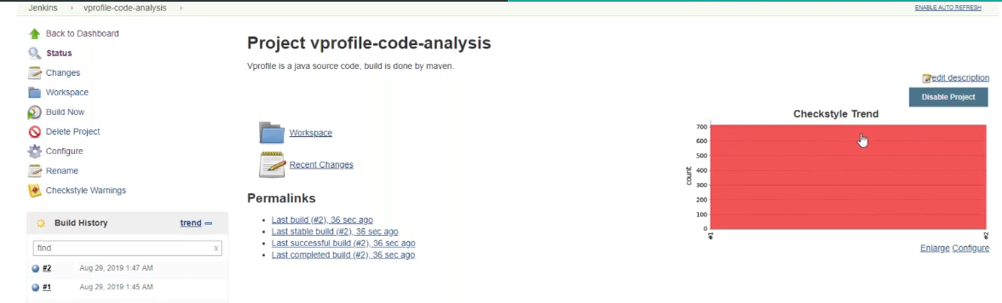

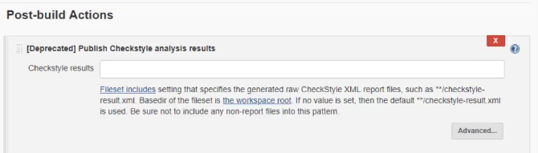

Code analysis has to be the part of build pipe line. Once our build job completes, it should trigger our code analysis

**I have the below setup now:**

**One build job** – it will create artifact

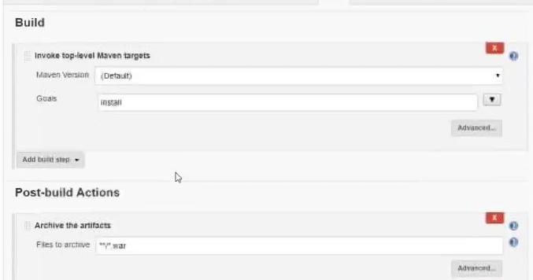

Here I will define in post build action – Once the build code completes, trigger the **code analysis job**

**Code Analysis Job –** In this job once the code analysis is completed, I want it version the artifact and store it. For that in post build action→I mention build nexus job

**Nexus Job –** I this job I have defined once the versioning is done then trigger **deploy to QA job** (tomcat server)

**QA-test job**

Once the deployment of QA is done, we would like to run software test cases (software testers will give).

S/w testers will write test cases. You need to have it in the source code. Once you deploy the code to QA machine, you execute their test cases. They will tell you how to execute it. We need to setup a job which will run s/w test cases.

For now, to imitate this process, we use a plugin called http request in our job and select the plugin in our post build action and give the URL of Jenkins and run the job. This is just a URL test but here we assume it as our s/w test case. Also I build option execute shell enable sleep time for 120 sec as it will take some time to application to come up #sleep120 (no hash)

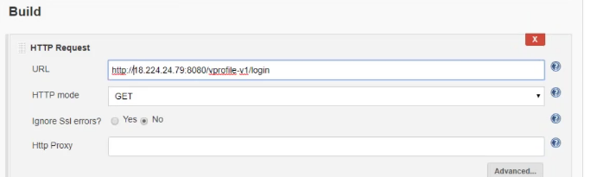

**Deploy to QA job:** add post build action build other project and select **QA-test job**

**PROD-deploy**: Now I need one more job where once the test QA job is completed and the test cases are successful – I want to trigger a job which can do deployment on production – this will be same as QA job

But change the tomcat URl to PROD

**Now run your source job – build now**

It will create artifact→code analysis→nexus versioning→deploy to QA→

Check for your **pileline job**

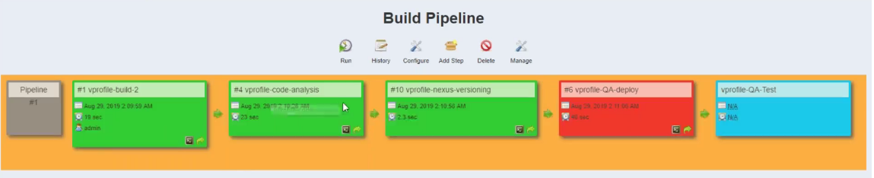

Continuous delivery – We deploy automatically till production but not on Production

Continuous deployment - We deploy automatically on production without approval

Let’s say we don’t want to do continuous deployment- but I want to put the job in to the pipeline and don’t want to trigger it automatically to deploy it on production. This build pileline plugin gives me one feature that let me integrate production job without even triggering it.

For this you can go to your **QA -test job** – configure →Add build action→build other project manual step (This option comes when you install build pipeline plugin)→in down steam project name give **your PROD deploy job name**

*This Manual step what it does is- It include it to your build pipe line but not trigger it automatically. There would be a button to manually trigger the job*

Below is number of jobs what we have in our pipeline now

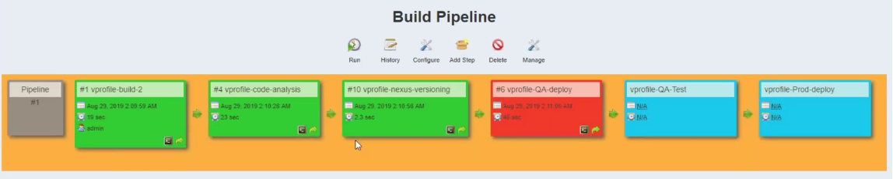

Yellow color – indicates the particular job is getting executed

Blue- the jobs are yet to be executed

Green – completed successfully

Red- failure

Now let’s trigger the pipeline and you should see all your jobs are getting successful but you rproduction job will not get triggered. But you will a button over there to trigger the job

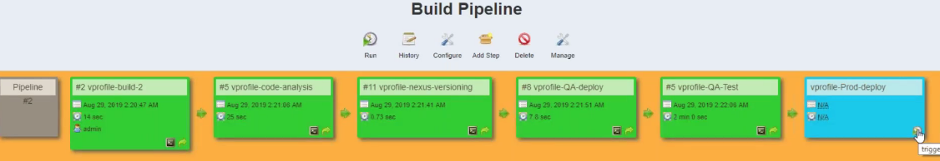

**Jenkins Master/slave:**

With master slave concepts you can have distributed builds, you can run n number of jobs, you are not restricted with the Jenkins resource, cross platform builds as in you want to build some windows-based jobs or mac OS based project and many more things you can do.

**Prerequisites for adding a node to Jenkins:**

1. We can add any node to Jenkins (windows/Linux/Mac.)
2. Make sure there are proper connectivity between master and slave
3. JRE, JDK, java based on what you need
4. We need to have a user on that machine which Jenkins will use to connect to that machine, and you should have a directory on that node with ownership of user
5. You don’t need Jenkins on slave, but you just need Java as a dependency

**Setting up node and adding to Jenins master:**

1. Launch an instance
2. Install JDK 1.8
3. Add a user #useradd devops and set up a password for this user #passwd devops
4. I will user ssh password-based login here – so make changes in /etc/ssh/sshd_config and restart sshd service #service sshd restart
5. Let’s now create a directory - /opt/jenkins-data and change the ownership to devops and give 755 permission.
6. Make changes in security group so that Jenkins can to ssh to this machine
7. Login to Jenkins→manage Jenkins→manage nodes→new node→give a name→select permanent agent→ok and mention the other settings for this node

**No of executers**- How many jobs can parallelly run over here

**Remote directory** – This is the directory we created on the node

**Label** →give a name

**Usage**→This option will decide what you going to use this node for.

**use this node as much as possible→**You are using this for load distribution. In this case Jenkins may select this node anytime. For now I will select this option

**Only build job with label expression matching the node→**If you are adding this node for a specific purpose like for running s/w test cases, windows build, IOS build then select this option. In this case the node will not be selected automatically, in the job you have to make sure that you are running that job in this particular node

**Launch Method→**launch agent via ssh

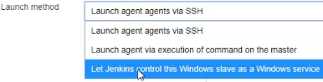

**Host→**Give the private IP as there are in same network

**Credentials→**Add jenkins and give the details of the user and how to connect to this user.

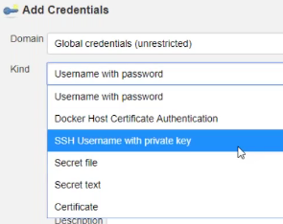

For username and password login →mention the cred**. In case if you are selecting key based login**→ For ex we have centos machine and the user is centos, you add the username and the key but the directory what we created is owned by devops. So, you add the centos user to the devops groups.

Vi /etc/group



Now centos is user is part of devops and it can do everything

**Host Key verification strategy →**non verifying verification strategy (we will see this later)

1. Save and see the logs for any errors
2. You should have git and Maven installed on node
3. Now run the job and Jenkins will use this node as we have selected to use this node as much as possible
4. Sometimes Jenkins will execute the job on its own node and if don’t want any job to be executed on Jenkins – then you can disable that option manage jenkins→configure system→an under **usage→** select only build job with label expression matching

**Seranio1 :The other case now is – I want some particular job to be executed on particular node like some windows related or some s/w test cases.**

Go to your job→put a check mark on **restrict where this job can be run** →give the node name →save

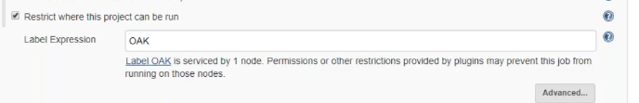

**Senario 2 :Now if I don’t want this node for any load distribution** →then go to manage Jenkins→manage nodes→select your node→configure and under usage select the option →only build this with node expression match and this option will work only if you enable the above check mark in your job for which you are using this node.

Setting the above 2 seranio – Nothing can be executed on the node directly and master cannot execute on itself directly. Now if you run the job or execute any commands it will **fail or probably waitng for the job error like below.**

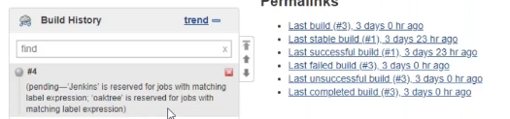

**Jenkins security authentication:**

So far, we have one user created while launching Jenkins. We can setup more users in Jenkins. Basically, you cannot setup users its just that you can integrate users from Jenkins. Users can sign up or can come from LDAP .. and you can give privilege to those users.

Lets say once you are done with all setup wrt the job and now I wanted to hand it over to the developers or for the testers. For anyone who is executing some form of jobs and they can just login and execute their job, see logs. I don’t want to give them admin access instead I want to restrict users with some permissions.

**Two things here; Adding the user and giving the permission**

**One way of adding users:**

Manage Jenkins→configure global security→check mark **allow users to signup (**users can signup from Jenkins URL and user gets added and saved into Jenkins own database**)**

**Then you have LDAP option:**

If you are using Jenkins for complete organization you can use LDAP and you can get the LDAP details from your IT team/project

*Delegate to servlet container and unix user/group data base is not recommended.*

**Now what permission to give is mentioned under Authorization section:**

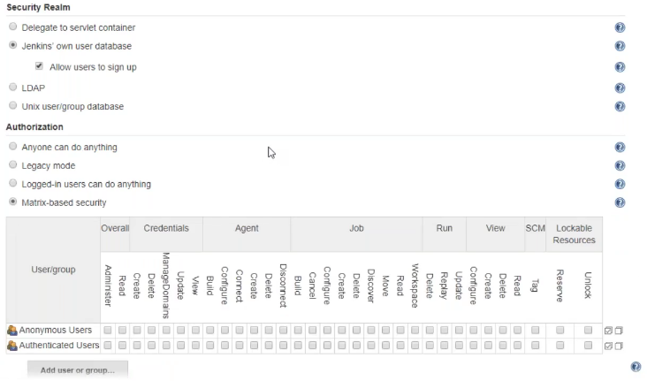

**Matrix based security –** Here you can add users and restrict what they can do

Let me add my admin user here first and then you add a user by signing up from Jenkins URL and come here click on add user and give what permission is required.

Now if you want to give access to project based like if you have one project for some users and other for some other user then, you can enable project-based authentication strategy.

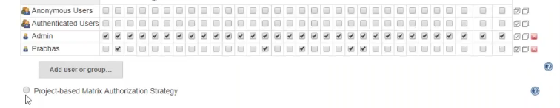

Click on the checkbox and then add the users. When you enable this option in main Jenkins settings, you will also get the same option in every job.

Now you can go to any particular job configuration and select the option and then add users so that the users will have access to that particular job

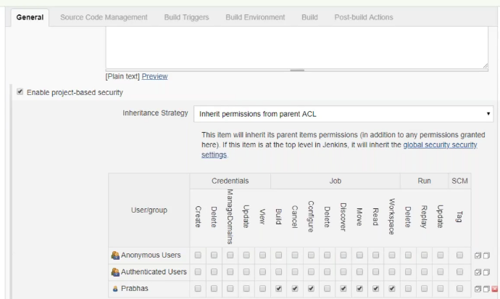

If you are using Jenkins for a single project, then use metric-based security

If you are using Jenkins for multiple project, then use project based.

There is one more plugin you can install and that’s takes the security to one step high level which will see later

**VPN – Virtual Private Cloud**

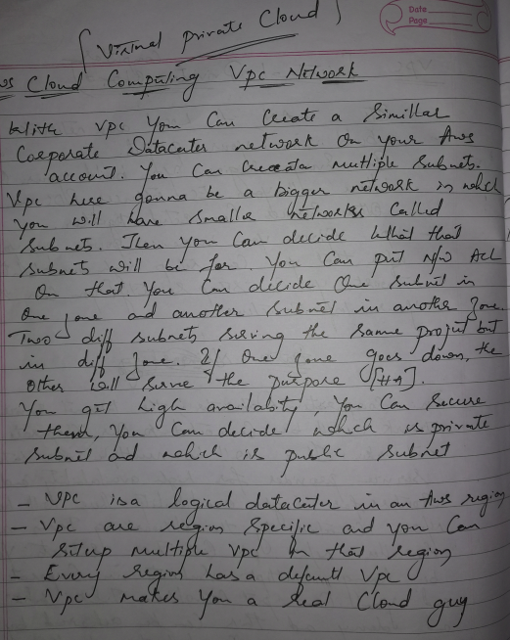





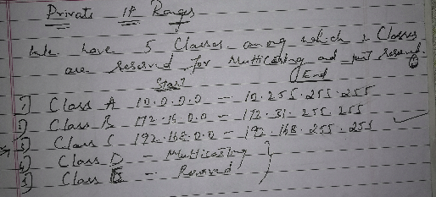

**Subnet Mask:**

Subnet mask tells more about IP address.

We have class less and class full subnet mask. We will see class full and class less can be taken at advanced level.

Below is class full subnet mask

* 255.0.0.0
* 255.255.0.0
* 255.255.255.0

When we setup the network we definitely need the above. Subnet mask is applied on your network and that tells your IP address start from which IP and ends with what IP. How many IP address you will get in your network, decides which are will be network IP, which are will be broadcast Ip , what are available IP’s. How many IP’s will be available?

**Let’s see below exercise:**

**192.168.1.10 - IP Address (class A)**

**SubnetMask -255.255.255.0**

192.168.1.0 => starting IP – Network address

192.168.1.255 => Ending IP – broadcast address

192.168.1.1 - First usable IP (Mostly the first IP will be given to the Gateway)

192.168.1.254 - Last usable IP

Total IP’s – 256 (starts at 0 and ends at 255)

Total usable IP’s – 256 -2 = 254 (2 = Broadcast + network address)

The above netmask indicates that the first 3 octet of IP address is full which is used for **network** and that cannot be changed. The last octet of netmask is zero which is used for Host and the corresponding octet of IP address (10) is free to change.

For the above netmask and IP address we can achieve the below from it:

Starting IP – 192.168.1.0 ➔The first IP is for network address

Ending IP – 192.168.1.255 ➔The last IP is reserved for broadcast address

If you want to send something to every network interface, then you can send it to the broadcast address 192.168.1.255. For ex when your computer boots and it is designed to boot with DHCP to take an IP address from DSCP server. Initially it doesn’t know what is the IP of DHCP server, so it sends a message to the broadcast address and this network traffic will be sent to every network interface in the network and DSCP server will listen to it and send the IP. Broadcast will be heard by every computer in that network.

Gateway is a routing device which sends the traffic to the other network

Mostly for netmask 255.255.255.0 → we go with class C IP but it’s not mandatory. I can even go with class B IP as well.

**172.20.10.20 – IP (Class B)**

**255.255.255.0 – Subnet Mask**

172.20.10.0 – staring IP – NW address

172.20.10.255 – Ending IP – broadcast address

172.20.10.1 – First usable IP – Gateway

172.20.10.254 - Last usable IP

**172.16.0.10 - IP (Class B)**

**255.255.0.0 – subnet Mask**

172.16.0.0 – staring IP - NW address

172.16.255.255 – Ending IP - broadcast address

172.16.0.1 – First usable IP – Gateway

Total IP addresses = 256*256

Total Usable IP = Total IP address – 2

**10.20.150.100 – IP**

**255.0.0.0 – subnet Mask**

10.0.0.0 – first IP – NW address

10.255.255.255 – last IP

10.0.0.1 – first usable IP

10.255.255.254 – Last usable IP

Total IP address = 256*256*256

Total usable IP = Total IP address – 2

Any time if you want to calculate use IP subnet calculator and it will give you the complete calculation by giving your IP and subnet mask

**CIDR notation: (/8 /16 /24)**

We really don’t use subnet mask in cloud computing, or virtualization or docker and Kubernetes. We use CIDR notation

255.0.0.0 => /8

255.255.0.0 =>/16

255.255.255.0 =>/24

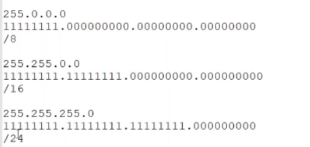

Let’s take an example of IP - 192.168.10.20/24

What class? Class C Private IP

NW address? 192.168 .10.0

BRD add? 192.168.10.255

Total IP’s – 256

Total usable IP’s -254

**Creating VPC:**

**Before you create a VPC** – you create blueprint, the architectural diagram – how you gonna set it up and proceed with it.

VPC is LAN and we have to give a NW range – let’s say our NW range is **172.20.0.0/16.**

**172.20.0.0/16 – In total we will get here 65k IP’s**

In VPC we have a big VPC range and then we going to create smaller VPC ranges called subnets

**VPC network range** **172.20.0.0/16. I will create 4 smaller subnets from it (why 4 will see in later)**

Subnet 1 →172.20.**1**.0/24 (256 IP’s)

Subnet 2 →172.20.**2**.0/24 (256 IP’s)

Subnet 3→172.20.**3**.0/24 (256 IP’s)

Subnet 4→172.20.**4**.0/24 (256 IP’s)

172.20.**5.**0……. this will go on till 172.20.**255**.0 → So in total I can create 256 smaller subnets from that NW Range.

**In VPC you have**

**public subnet** **-** In and out internet connection→like you create Ec2 instance and do ssh to them and from the instance you download some packages and all

**private subnet –** This is a secure subnet and only out internet connection will be there. You won’t be able to connect the instances from the internet. You cannot connect the instances from office or home, but the instance can connect to the internet.

**Scripting concepts:**

* **#! /bin/bash →** This tells open the shell /bin/bash and execute listed commands

The first line in bash scripting is shebang character **#! →** This tells that the script will execute on **/bin/bash** interpreter. Interpreter will read the code in the run time and execute it on the system

**Variables:**

Its a temporary storage place in the RAM.

It’s all yaml and Json world today

**How to assign a variable and access it.**

In the below example  **“=”** is an assignment operator, **planet** is the name of the **variable** and **pluto** is the **value.** That’s how you assign the value to a variable.

**#planet=”pluto”**

To access it **#echo $planet →**This command will extract the value of variable planet

**Script1:**

-o = overwrite (to avoid captive user interface). System should not ask me if it want to

I have the below script to deploy the webservice

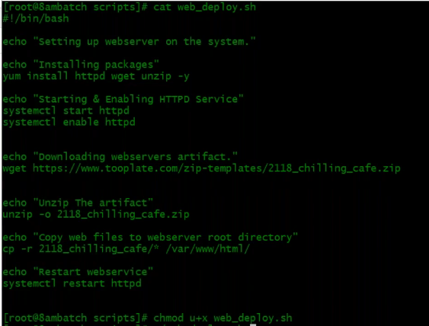

Now I can set the website very quickly using the above script. But what if I have 100’s of systems on which you want to execute series of commands like this. Then will see how remotely you can send this script to those machine and execute it.

Instead of hardcoding the inputs I will use define variables to give inputs

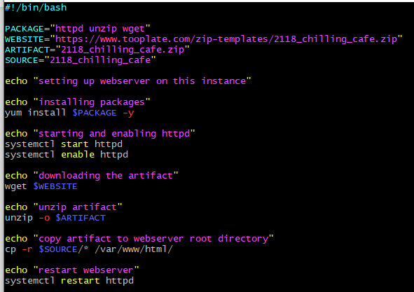

In variables you have other forms of variables. You can define variable and take it as a command line argument also. You can pass 0-9 arguments in command line.

Ex: I have the below script

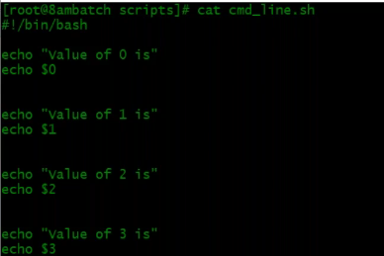

I can pass the arguments to the script. When I pass, I can use those arguments by using 1,2,3….9.It is based on the order of the argument. These are called command line arguments.

Below is the output when I run the script with some arguments

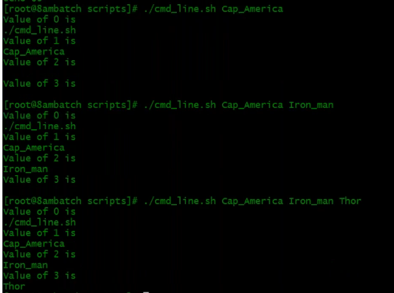

Lets use this command line arguments in our actual script. Below is my script in which I am going to pass two arguments in command line the URL and the file name. For that I have **commented** the WEB_URL and ART_NAME and in below commands I have used $1 for WEB_URL and $2 for ART_NAME

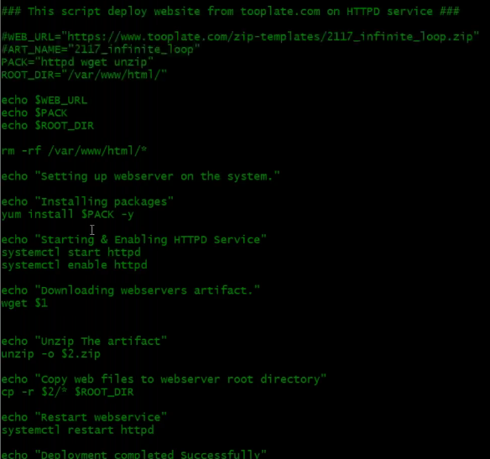

I am using two command line arguments. So now let me tell you how to run the script with 2 arguments

#./yourscript.sh “URL for downloading the artifact” “file name”



Passing these two arguments, now I can deploy.

**Some System variables usage:**

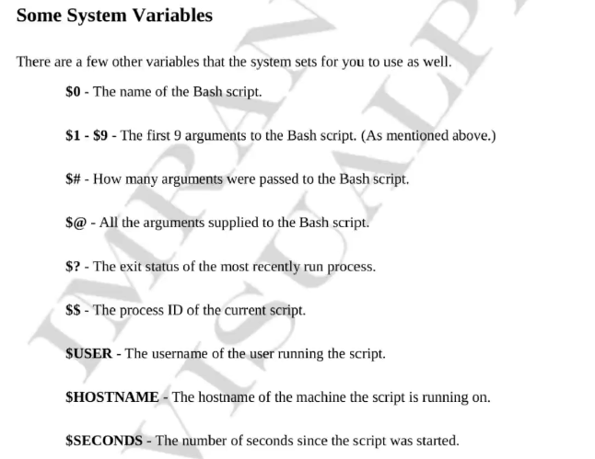

**Below is a simple script of $# and $@ usage**

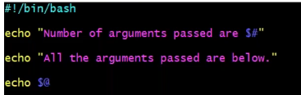

**Output is as below:**

I am passing 4 arguments to my script and it is showing howmany arguments I have passed and the name of those.

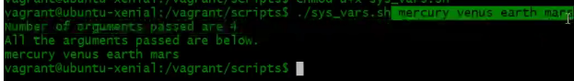

**Very interesting argument $?**

If I execute some command (ls -lrt) and then I execute $? →Its output is “0” (exit codes) which means the previously executed command was successful. If not successful, it will give you “non zero”. This is useful when condition checking a lot.

**Quotes:**

In the below example, I have used single quotes and even double quotes. I have defined a variable and then used double quotes and it extracted the variable value. But the same used in single quotes it just gave me output as it is. $ is a special charter and if you put it in single quotes then its special meaning is removed.

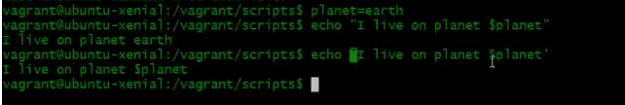

If you keep a backward slash before any special character, its special meaning of that character will be removed.

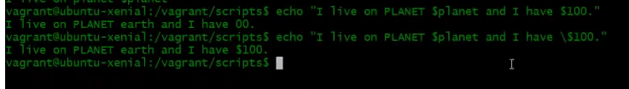

**Backtick (`)**

Let’s say I want the output of any command as a variable. Then use backtick

In below case – I have created a variable **diskspace=”df-h”**

Now If I call the variable then it just prints the same.



Now I have created a variable **diskspace=`df-h`** in double tick that means execute the command and written its output and that will be stored into the variable

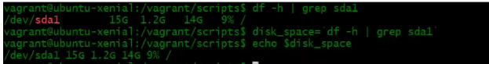

**CUT:**

In the below example I have used cut command with delimiter. In below case “:” is delimiter

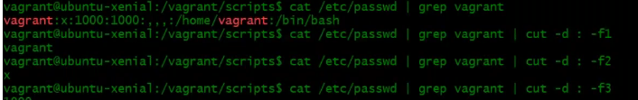

Now I can put that into command substitution and store it into a variable

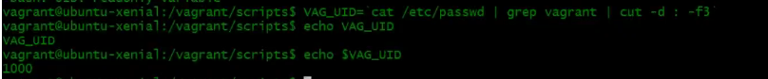

**AWK:**

In the above example the delimiters are proper but sometimes it is not proper- in the below example there are 3,2,1 space between delimiter. In this case you can use AWK. AWK is very powerful search filtering utility. In AWK you can specify delimiter but even if you don’t , it is intelligent to understand what the right delimiter is.

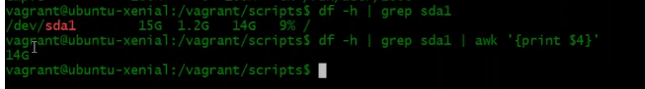

Now I can store this to a variable but this time I will not use backtick, instead I have another way to store all commands is - in $parenthesis **$()**

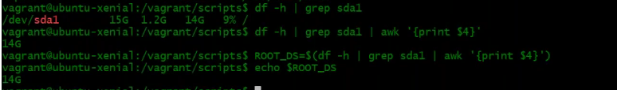

**Exporting Variables:**

Let me set some variable and when I call the variable, I get the output and the limit of this variable is only in that shell scope. Suppose now I added the variable in my script and then trying to call it doesn’t give me the output of that variable because it is calling another child shell to execute the script. Now in this case If you want to set the variable scope not only to the current shell but also to the child shell, then you need to export the variable.

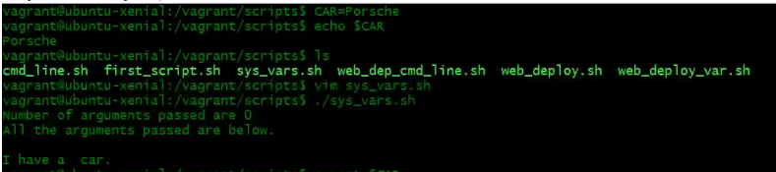

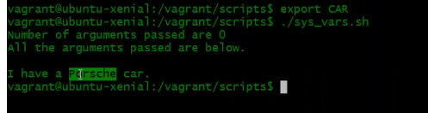

Now all these variables you set will be gone once the user logs out. To set it permanently for a user go to its home directory and you see **.bashrc** file. This file gets executed every time when the user log in. Open this file and at the end you add your variable by export command.



Now if are already logged in with the user and doing this then you have to re-login or use command #**source .bashrc**  to take effect.

This is for that particular user. IF you want this for all the users, then login as root and go to **/etc/profile**

and here you add the export variable.

You can also store all the variable in to a different file then you can source that file.

**USER INPUT variable : (**This is not recommended unless you have a requirement as some one has to be there to give the input**)**

We have seen in our script we have defined command line variable for URL of website and the artifact name and then we execute the script followed by URL and the artifact file name. Now we will see user to input these values. For which I have to use **read** command.

In the below **read** command I have a text “**Enter the URL**” →when the user enters the URL it will be saved as a value to the variable **WEB_URL** and same for **ART_NAME.**

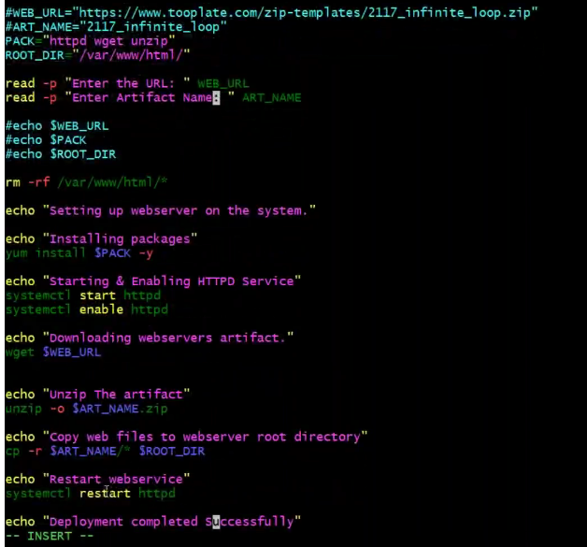

**Condition Checking IF statements:**

In the below example we have some test case inside **if statement** and it will execute only if the test case is true and if false it will not execute the statement but executes rest of the script. **IF** and in **square brackets your condition called as test case** and start your statements from **then** and ends at **fi.** Then write your rest of scripts what needs to be executed.

Test case always written bully and value I,e true or false. If the

lt means less than and gt means greater than

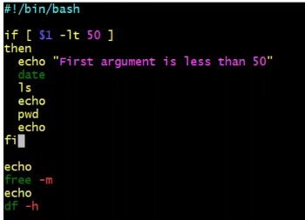

Lets execute the above script by passing an argument 30 which is true

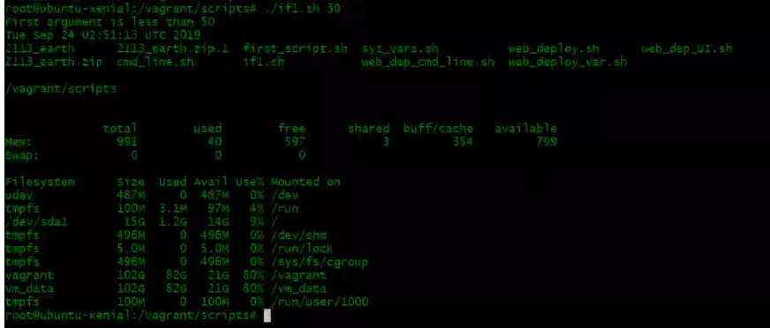

Let’s execute the same script with value 60 – which is false and it will not execute the if block but it will execute the rest

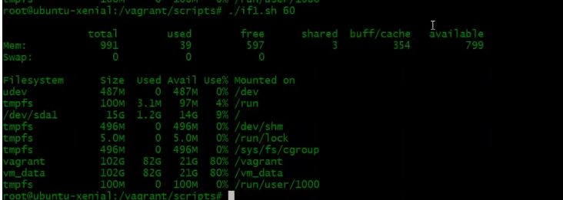

In the below example - we will see if the condition is false then execute something else

I have defined 2 variables and in “if condition” I mentioned execute something if it is true and if it false then execute something which I have mentioned. Here in end of condition I have used the terminator “**:**” .

Either you can use “==” or “-eq”

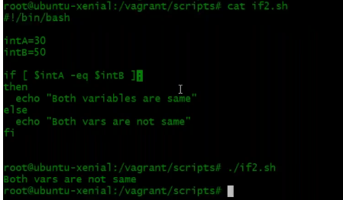

I can write the script on the shell itself by using terminator ” **:”**



I can also run two commands in one line by using terminator

**#df -h : free -m**

Also, I can use &&

#**df-h && free -m →**But in this case only if the first command is true then only it will execute the second command

So far we have seen using less than, greater than , equal to .These needs both operand left hand side and right hand side. But there are some operator where they don’t need two operand. A single operand is fine like in below example it will check if file exits or not.

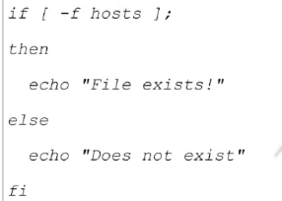

Below are some other operator

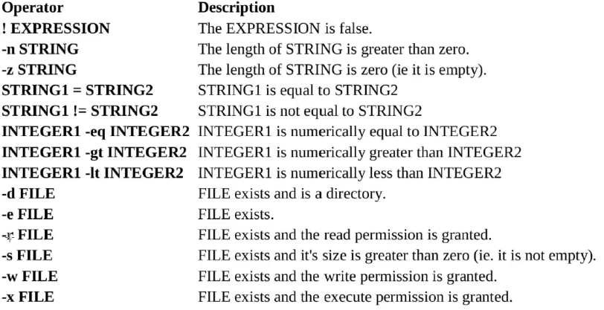

**Loops:**

This is useful if we are doing some repetitive task on 100 machines or so (just saying for an example- use case can be anything)

**Forloop** needs a list of items/range of any format

Variable= any name

Keyword = in

{1..3} = list of items

do = block (It will enter into block do)

When the loop runs, the first item(1) gets stored into the variable then it executes the command and then it comes back again and store the second item to variable (2) and runs the command and then 3rd.

We have 3 items and when it finds all items are done then it will come out of the loop and execute the rest of the things

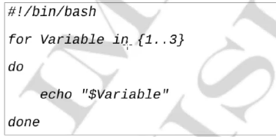

Below are some simple example using for loop

* adding users
* some list of IP’s

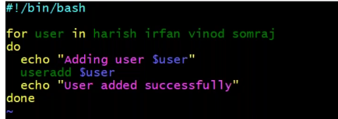

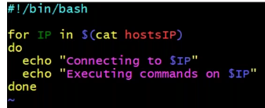

Below is the script which checks the connectivity to target machines.

On script box you create a file with all the IP’s/hostname. Before executing your main script on 100 of machines, make sure you have a common user across all the machines.

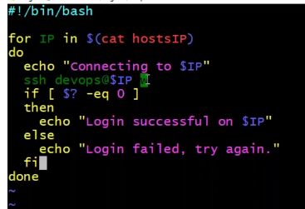

I have put 2 valid IP’s and one fake IP in the host file. You run the script and and for every machine you need to input the password and then it will give you the below output

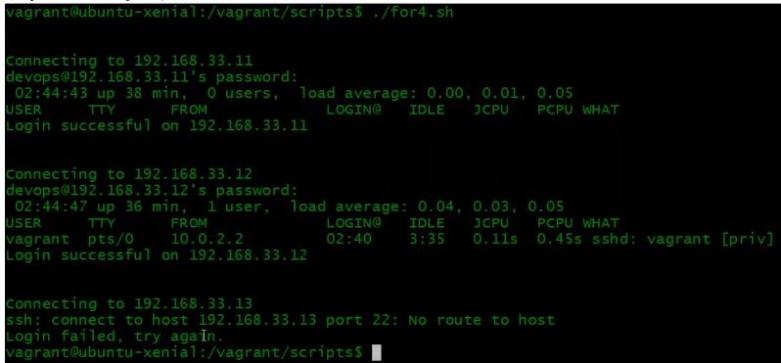

Now that works but it is asking me password while connecting to every machine and if I have 11 machines it asks me 100 times which is not relevant using this script. So, what we do is Key based login. On the script box you generate the keypair **#ssh-keygen**

Now run the command to copy to the target servers **#ssh-copy-id user@IPaddress,** here it will ask you the password for one last time and after which you can login to the target machines without password.

**How to give sudo previlage to a user:**

Login to the machine and do #visudo and search for root and you will find like below

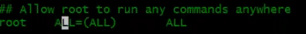

Below this add one more line for the user and add NOPASSWD.

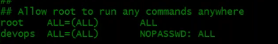

/dev/null this is called black hole of Linux. What ever you put inside this, it doesn’t come back.

/dev/null 2> /dev/null

**Let me set up a script for archiving the logs:**

Lets say we have below log exists. Let’s assume these are the log files that are growing in size.



Now lets go to our scripts directory and create a file and mention all the log file name in it. This will be the file that user will edit and put their log file name in it.

Let’s say user has given the below names

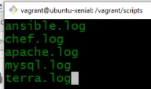

If you see – the chef.log doesn’t present and terra.log is also not present (typo error). Rest of the 3 files exists

Now the script which we gonna write should backup the files and also check if that file exists or not.

Defining 2 variable→creating a directory for backing up files→open for loop and give condition→if log file present then move the file to archive directory and if not present return error with no file exists→and finally out of if block and run the tar command to archive the files and finally remove the directory.

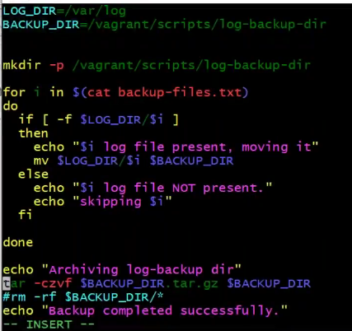

**Python scripting:**

Python is very easy to read and write. Here, Syntax is very less. Major syntax is indentation (space).

There are interpreter languages and compiled languages. Java, .net, C – these are compiled languages. You write the code and compile it before you are executing it on systems. Python is an interpreter language(puthon,ruby,bash)- you write the code and execute it. In the system you should have an interpreter. On Linux by default you have it by default but on windows you need to install it.

**Installation:**

here are 2 major versions of python (python 2 and python 3). There are many syntactically changes where you cannot execute python2 code on pythin3.

**On windows:**

1. Just download the exe file and install it. Once you install you need to setup environment variables so that you can execute it from anywhere.

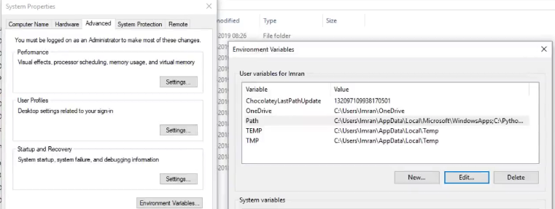

1. Edit system env variables→under environment variables→edit→click new and give the path of python

→under system variables→click edit→add new and give the path (This

is for user specific)

1. Open a command prompt and just enter python

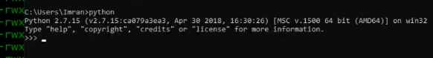

1. You can use **pycharm** editor to write python code on windows. This is one of the famous IDE for python coding. It is used by the developers. This is helpful in arrange your scripts properly. If you want to execute this on Linux then you will have to copy the script.

There are 2 versions of pycharm and you can go with community edition which is free. The professional on is a paid one.

Once you download and open it, you need to create a new project→select the location where you want to create the project→Once you create it will take some time to set up as it will create something called virtual environment which we will see in Linux system about this.

Right click on the project and create a new python file and give a name and save.

Now you can write your code in the above section and once done you can right click on the file name and click **RUN** and you can the execution of your script in the below section

**Exercises:**

In ubuntu 16+ OS you have python 3 by default and not python2. In all the redhat system you have python 2.

On ubuntu if you want to install python2 →#**sudo apt install python -y (**This will install python 2.7 **)**

Now just enter python and it will open up the interpreter.

To print any statement and to exit just press ctrl d

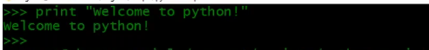

Python file we give the extension as py and again it’s not mandatory .

Before writing your script check python interpreter location by giving **#which python**

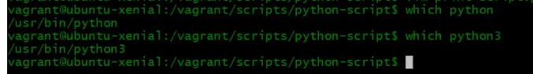

Give this desired path in your script.

**Indentation(space):**

Below script when executed works fine

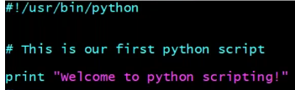

But In python space is very important. For ex if you execute the below script then you will get error

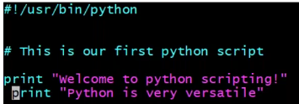



In the below statement there are 3 blocks

If block , else block and the last one is out of block

In if block →both print should have same spacing

In else block→both print should have same spacing

Out of block → this is a separate block as it starts from beginning with no space. IF this line wants to come under **if block** then it should start with same spacing where other 2 print starts under **if**.

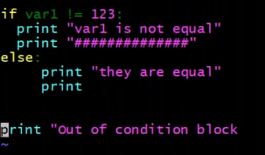

**Quotation:**

Lets open up an interpreter and define a variable. Here if you want to define a variable it should be either in single quote or double quote or triple quote . anything in single or double quotes are called string. Triple quote is called multi line string and you can open up triple quotes and keep writing enter and again keep writing and close the triple quote. you can use 3 single quote also if you want something to be stored in a paragraph. IF not defined in quote if thinks it as a variable and give error saying the variable is not defined.

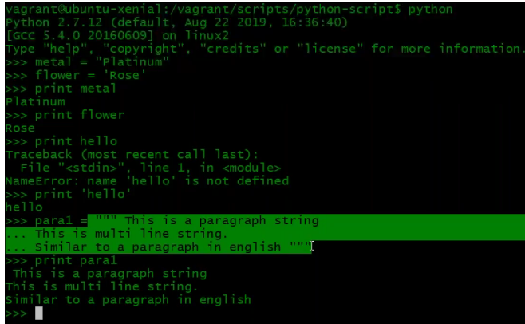

**Type of variables:**

While assigning variable you can give or no space doesn’t matter.

Functions in python are predefined codes which you can use it. There are many functions and **type** is one among them. This you call it in parenthesis and the variable name, then it will tell you what kind of variable it is.

Variables we have →**string, integer** (while defining – don’t use quotes), **float**..

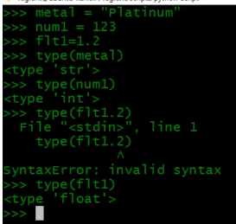

**Multiple assignment:**

In the below example **a = b = c = 123** a, b and c is not defined and at the end I have the value 123. That means 123 value will be assigned to C then to B and then to A. This is one single value in all the variables.

You can have different values for different variables. **a,b,c = 1.2,”test123”,45**

**Now I have already assigned value to a b and c in first example and later you assign value to same variable, its value is over written.**

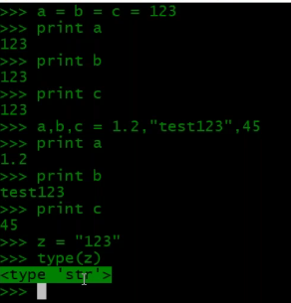

We have other variable called

**List→** Which is collection on multiple types of variables. This will always in square brackets **[]**.

List is **mutable (you can make changes).** There are functions available to edit a list

In the below example I have defined string, integer and float in **LIST**

**Tuple**→similar to list but this will be defined in parenthesis **()**. Tuple is **immutable (you cannot edit).**

There is no function available to edit a tuple

**Dictionary** →Key value pairs. Here, everything is in pair. This is defined in curly braces **{}**

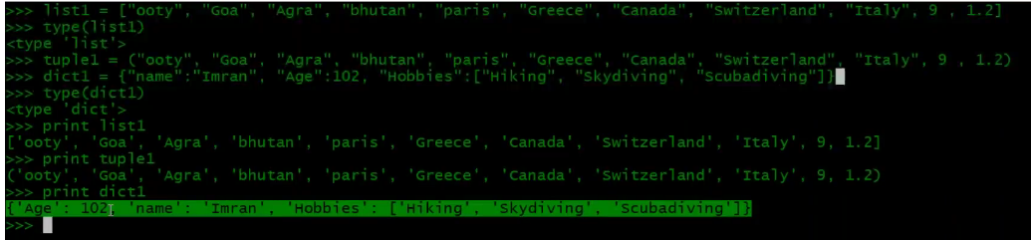

**Let’s create a new script using PyCharm and learn slicing:**

Taking a part of any data type is called slicing. This will be defined in square brackets **[].**

**Slicing for String**

Below is called Positive index:I will define a string **str1 = “This is a string.”** and now want to slice it, I use numbers which needs to be sliced in square brackets.

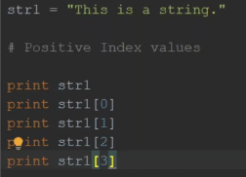

Below is the output:

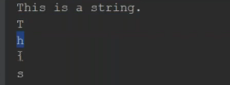

Below is called negative index**:** I use negative numbers to print slice of string - **str1 = “This is a string.”**

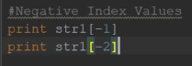

Output:

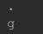

Above example are for slicing a single character. Now lets see for extracting more characters.

Extracting sub-string: **str1 = “This is a string.”**

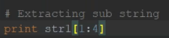

Output:



**Exercise** - **str1 = “This is a string.”**

If I want to print **ring** →print str1[12 : 16]

**print str1[:4]** →If you don’t mention the starting range then it will consider as zero (so it’s like [0:4])→This

**print str1[12:]** →if you don’t mention the ending range then it is considered as the last character ([12:16])→ring.

**Slicing for List data type:**

Let me define a string

1. **Hobbies=[“Tennis”, “swimming”, “trecking”, “Running”, “Kayaking”, “Badminton”, “Soccer”, 7]**



Let me call the string and also see some slicing

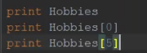

Output:



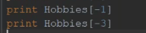

Output:



Lets see how to print a part of list:



Output:



We can use type and know the data type

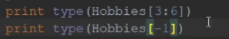

Output:

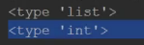

*Now the numeric 7 in the list is not in quotes and hence it is an integer. Now If I put that 7 in quotes then ,it becomes an integer*

Now Let me add one more variable

1. **Hobbies=[“Tennis”, “swimming”, “trecking”, “Running”, “Kayaking”, “Badminton”, “Soccer”, 7]**
2. **Sports=[“rugby”, “Football”, “MMA”, “baseball”, “Cricket”, Hobbies]**





Output:



(soccer and 7 is missing from tha above snippet)

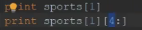

Output:

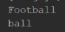

To print ket from cricket:

Print sports[4][4:] →Output is →ket

To print king from kayaking:

print sports [-1][4][4:]

**Dictionary exercise:**

Let me define a variable

**Skills = {“devops” : (“Jenkins”, “Ansible”, “Docker”, “Terraform”, “Vagrant”), “development” : [“Java”, “.net”, “nodejs”, “Angularjs”]}**

The above defined dictionary contains 2 keys devops and development and they are separated by comma. Devops has its value in tuple and development has its value in List

Let’s print some examples



**Output:**



Some snippet missing*

Here when I print I am getting development first and then devops in output because it is not indexed and that’s why its unordered and it doesn’t matter in dictionary



**Output:**





Output:



**Lets convert the below variable and value to JSON:**

**Skills = {“devops” : (“Jenkins”, “Ansible”, “Docker”, “Terraform”, “Vagrant”), “development” : [“Java”, “.net”, “nodejs”, “Angularjs”]}**

**JSON**

{“devops”:

[“jenkins”,

“Ansible”,

“Docker”,

“Terraform”,

“Vagrant”],

“development”:

[“Java”,

“.net”,

“nodejs”,

“Angularjs”]

}

**Python Operators:**

There are different operators. Comparison operator is most useful for us to validate condition

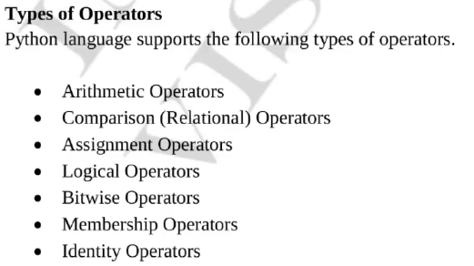

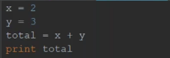

Output is 5

1. **Comparison operator:** These always return the bullion value either true or false

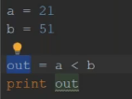

Output:



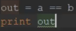

Output:

False

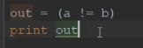

Output:

True

1. **Logical Operators:**  **OR** is the logical operator. It compares the left-hand operand and right-hand operand. Any one of the operands is true then ,the whole expression is true.

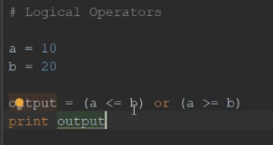

1. **Membership Operator:**  **in** and **not** in are membership operator here.

**Devops = [“Jenkins”, “Ansible”, “AWS”, “Kubernetes”, “Terraform”]**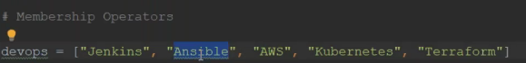

Let’s say now I want to check if Ansible exist in the list or not, I can use membership operator and it will return bullion value.

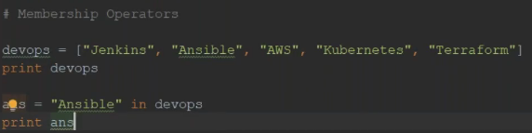

Output:

True

In the same way if you want to check Azure is not in the list

nans = “Azure” not in devops

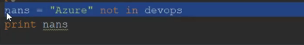

Output:

True

This will check if x exists in devops

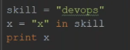

Output:

False

1. **ANDing operator:**  The difference between AND and OR is. For OR, any one operand is true the value of whole expression is true. But for AND both operands is true then only the whole expression is true

a = 10

b = 20

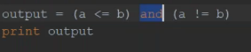

Output:

True

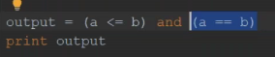

Output:

False

**Condition Checking:**

**If condition**

In bash we give in square brackets and in python we can give in parenthesis which is not mandatory also.

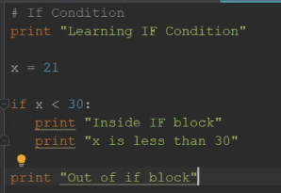

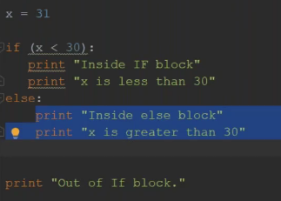

There is another condition called elseifto evaluate more condition. In python the syntax is **elif** and in bash its **elseif**

In the below example, if the first condition is false then only it will check for **elif** condition. If this is also false then it will validate **else** condition. You can give multiple elif condition.

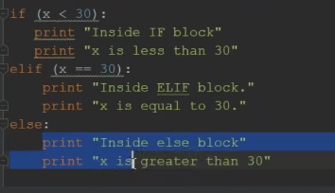

**Below is one simple programme based on what we learnt above**

In bash we have “read” to take user input and in python we have **“raw_input”.**

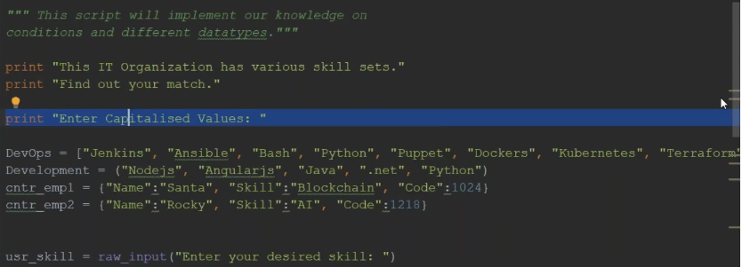

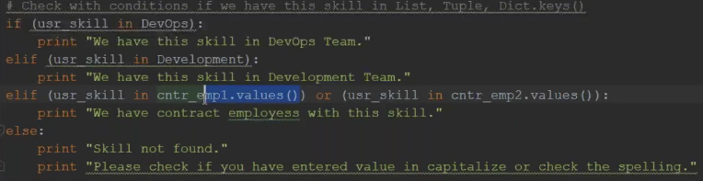

**Below some example for user inputs using raw_input:**

*Inputstr = raw_input(“enter any string: “)*

*Print type(inputstr)*

*Print inputstr*

Output for a string input:

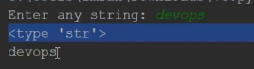

Output for a integer input:

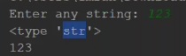

Even if you enter an integer, it considered it as a string and gave output as typr string

Raw_input will only take input as a string

Now if you want to take an integer input then, you can use another function called **input**

Using input function, you can input only integer and not string. If you input string you get error

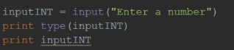

Output:

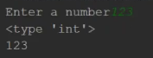

In python if you can to comment you can use 3 double quotes or 3 single quotes like below

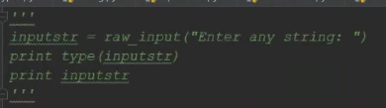

==================================================

Let’s assign some variable

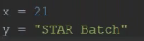

Now if you want to print a variable with sentence. Just FYI a variable cannot be put in double quotes.

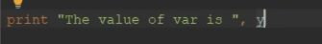

Output:



If you want to combine sentences. For combining you use + sign and that is called **concatenating.**



Output:



You cannot concatenate an integer with a string- you get below error

 here x variable is an integer

Output:



So here you can use function string **str –** this will take the integer and convert it to string



Output:



Above we have seen printing the variable at the end of sentence. Now IF you want to print in middle of sentence then you can use string specifier.

 here %s will be replaced by value of Y variable

Output:



Integer specifier



Output:



Now sometimes you have multiple variables we use tuple



Output:



**For Looping:**

If you want to do something n number of times then you can use for loop. For loop runs in sequence.

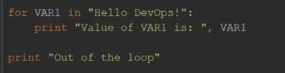

Output:

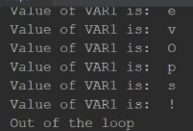

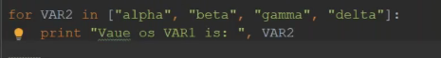

Output;

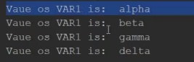 its var2 (typo error)

Nested loop using **list** function

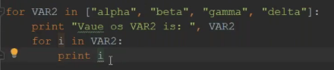

Output:

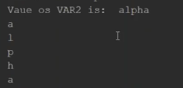

Like this it will run for all rest of the string beta gamma and delta too.

VAR2 is called iteration and here for every iteration we are iterating that iteration again.

Similarly, you can do it for **tuple** also

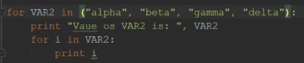

Output:

Same as above

**While looping:**

*Note: whenever you use while loop, make sure you are breaking out of the loop somewher otherwise it will have infinite loop and break your system also.*

While loop is also a loop, but it runs over a condition. If the condition is true then enter the loop and execute it and then come out.

The value of x is 0 and the condition is true, and the while loop keeps on running and crashes your CPU also until and unless you find a way to kill this loop (x = x + 1) which works like

X=0 which is less than 10 →condition is true enter the loop and execute it

Now x will get increment 0+1 →1 condition is true enter the loop and execute it

Now x will get increment 1+1→2 condition is true enter the loop and execute it

Now x will get increment 2+1→3 condition is true enter the loop and execute it

It goes on until 9 and when it comes to 10 our condition x<10 is false and it will break the loop and come out of it.

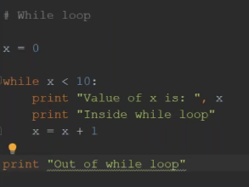

Output:

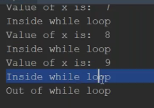

We can also use a bullion value **True** for the same example.

**x = 0**

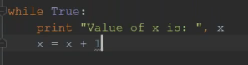

Output:

This is an infinite loop as we have not given any condition to break the loop

So always break your while loop with condition – Let’s see some examples

**Breaking loops:**

For the below example, I am putting a **if** condition if planet enclosed with **break (**if you don’t mention break then its infinite**)** – Jupiter then am done. That means the loop keeps running until it will find the planet Jupiter and this is for loop so it will do in sequence. Once it finds the planet Jupiter then it will not look for the rest of the planets as our condition is fulfilled.

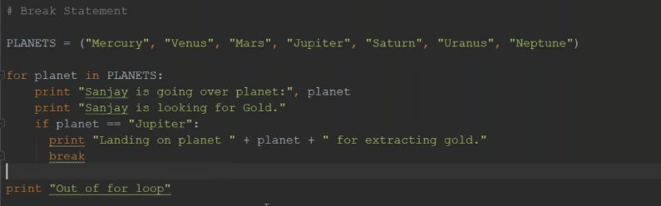

Output:

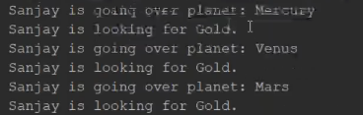

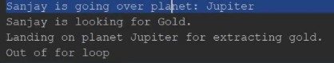

=======================================

**Let’s see using continue statement: (continue is for skipping)**

Continue can be little confusing – Let’s take same example

Let me define variable

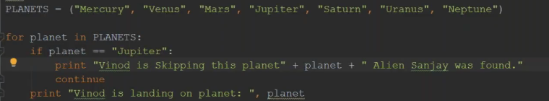

Here the first value of planet is mercury, but we have condition in our script that if the “planet is Jupiter”. So, this condition is false for mercury hence it will skip the first part and then we have a statement defined called **continue –** and it will jump in here and print the statement.

Again, it will pick up the next planet Venus and do the same this. After that same for mars and when it comes to Jupiter it will print the first part and here is the difference. **Break statement** will exit the loop if Jupiter is found but **continue** **statement** will continue to check for other iterations like Saturn, Uranus and Neptune but don’t execute the rest of the code (below)



Continue is for skipping – like you have 100’s of server and you are restarting a service. Let say for one particular or few servers you want to restart – then use the above case.

Let’s see the output:

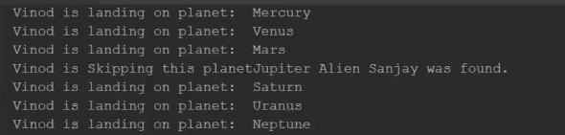

**Built in Functions In python:**

Functions are pre written code that you can call. Let’s say something you do regularly .Like you setup database server very regularly for different projects. You will write a function and you put all your steps over there that you execute to setup a database server and you declared as a function and you call it in any other script. You don’t have to write it again and again.

Python has many build in functions like you want to find a string from substring, or you want to convert sequence like **tuple** or **list** into a **string**. So, you can write your program using for loop and condition or you can use built in function.

**String name.”options” the options here is all built in finctions**.

I have defined a variable by name message and a value for it. Now I want to capitalize it which I can do using message function. message followed by a dot will show you many options and you select capitalizing.

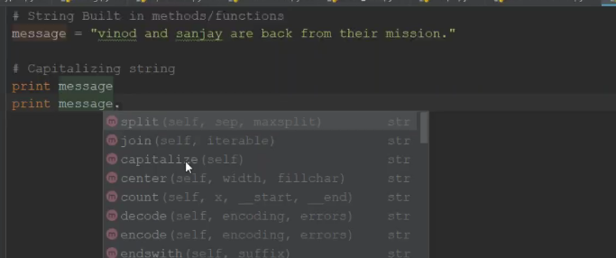

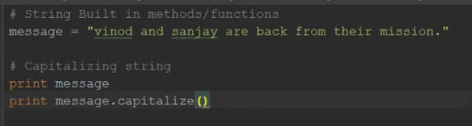

Output:

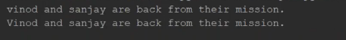

String is immutable data type, it will not edit the existing string. I will add another print and call that variable and you will see it is printing the original data.

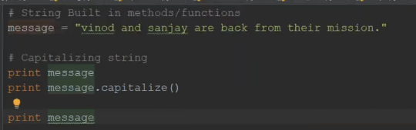

Output:

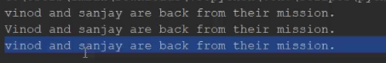

Now if you want to make this a permanent change then you should overwrite it by assigning the function to variable

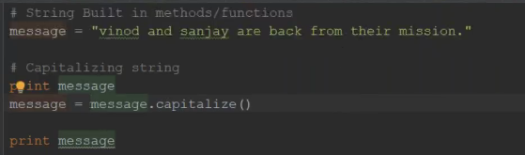

Output:

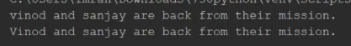

Find a sub string in a string using **find** function

I have defined a variable and I want to find sanjay in that variable and the output it gives is a index number





Output:



Now you know its 10 and you know sanjay is 6 letters so you can give another print message to extract it

print message[10 : 16]

If you want to search a string from index 21 lets say then you can give like below



Sometimes you have a sequence like tuple and you have some strings in that and you like to join it with something like a dot

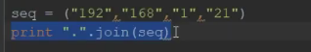

Output:



If you want to list all the string methods then you can use like below

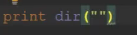

Output: (there are so many continued ..)



Like that you can do it for list, integer and so

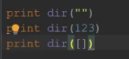

You want to see what the length of the string using len function

Range function to print the range

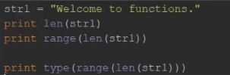

**Lets write our own function**:

The syntax will be like below and starts with def

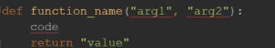

Let’s see some examples:

Let’s writes a function called add and pass 2 arguments (this is variable name which user will pass and gets stored into arguments (arg1 and arg2 – this can be any name not just arg1/2)

I am gonna do total of it and return the value

Let me define a function

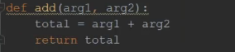

Now how do I call it – simply give its name and I need to pass 2 arguments which will gets stored in arg1 and arg2. add (2,45) or you can store this as a variable also return_total = add (2,45)

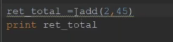

Output:

47

**Example2:**

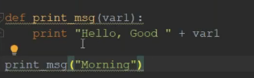

Output:



**Example3:**

Function name is print_info and it takes 2 arguments name and age. It prints the message when you call its function. Prints the age and check the condition if age is >50 and <=75 then print a message as defined.

Now while calling the function I have passed the arguments for name and age and it’s a string and integer respectively. When you pass the value and the value gets stored then the datatype is defined. When you pass a string, it becomes string and when you pass an integer, it becomes an integer.

While passing arguments you should pass in sequence I,e I have defined name and age and while calling you should pass a value respectively. OR if you don’t know the sequence then you can pass it with arguments name(last 2 lines) .

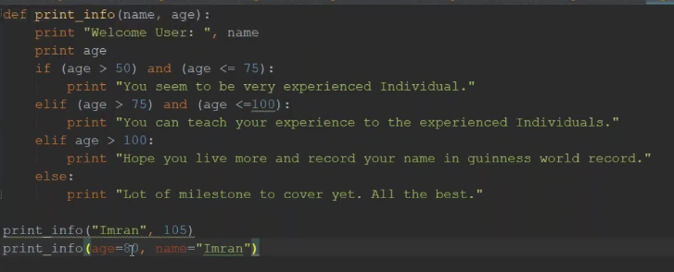

Output:

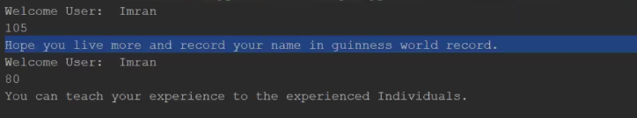

**Example4:**

Default arguments

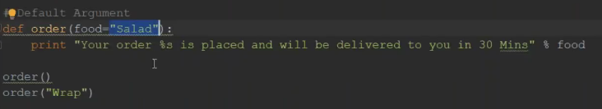

While calling firstly I dint pass any arguments and by defaults it ordered me salad

Secondly – I passed wrap and the food value will be wrap and it ordered wrap for me. This is called default arguments – if user does not pass it will use the default value



**Example 5: variable length argument (argument starting with *)**

Sometimes we don’t know how many arguments a user going to pass.

Here I have defined 2 arguments – one is normal argument and the other is variable length argument.

When I am calling the function – the first argument salad will be stored into min_order and rest of the available values will be stored in to foods. Now what is foods – it’s a type **tuple** . so what ever you pass will be stored into a tuple.

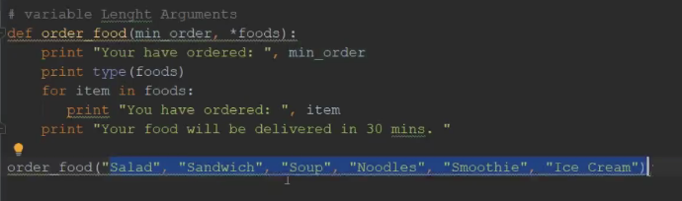

Output:

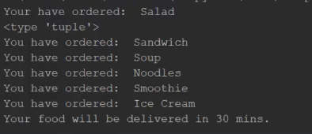

**Module –** its nothing but a script which contains list of functions

So far we have defined functions and call it from the same file. Ideally that is not the case – we define all our functions in some file and call it from some other file.

Below is one example where we have defined 2 functions (don’t have to understand the script but let’s see first how we can use it )

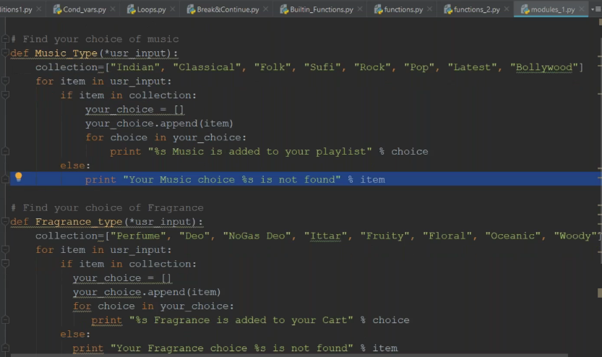

First of all, you should know the name of the script and the script name is the name of the module. Here the script name is module1.py

Let’s create another file called food2soul.py to call our functions from different file then say import “modulename/filename” which will have all the available defined values in the memory. Then “modulename”.”function name” to call it.

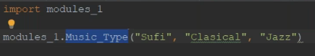

Output:

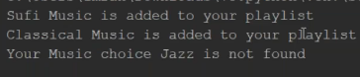

This is one way of importing module. Let’s see the other way.

You can say below to import a single function

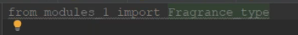

you can import all the functions using *

Importing this way, I can directly call the methods now.

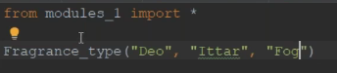

Output:

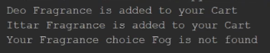

**Python usage in automating system operation tasks:**

Python interpreter doesn’t execute any windows or Linux commands. But there is a way to execute linux commands from python interpreter. For that there is an available module called OS. You say import os. OS is a module and if you want to list all the vailable methods in the module you can say dir (os)

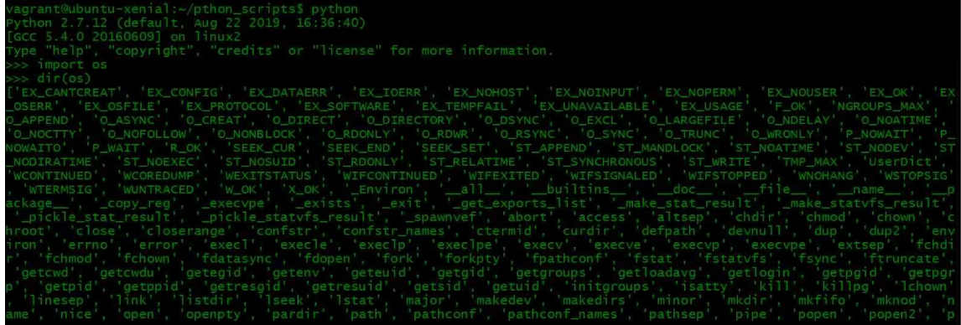

There are lot of functions available in os module and to run those you say

os.uname

os.rmdir

os.mkdir

But there is one which is used a lot which **is os.system.** This method can execute any command for you.

os.system(“here mention your command you want to execute”)

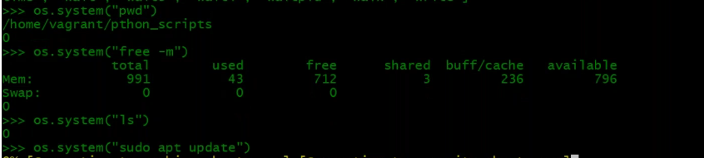

*Note: With os module command, you cannot save the output of the command. Only the exit code gets saved.*

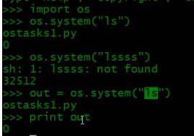

**Exercise:**

Let me write a program that will pass list of users and python script will add those users to the system and if the user already exists then it will alert you.

Let me create a directory python_scripts and create a file ostaks1.py. We are on the Linux machine so, you need to mention the interpreter path.

I am going to import os which we are going to use

Add some users in user list.

I have a for loop here which means – the user in for loop gonna hold the user name from user list.

%s – string specifier - %s will be replaced with the variable user.

Here first user variable is Md_Islam, 2nd is Irfan and 3rd is Sanjay

Its gonna run the command ID and username and if the user exists it will return 0 exit code. When you do this, you need to put all of these into parenthesis.

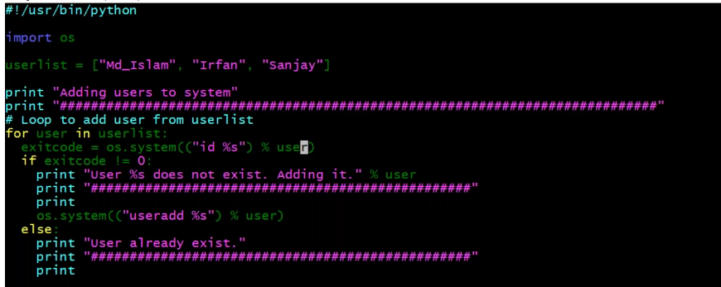

Output:

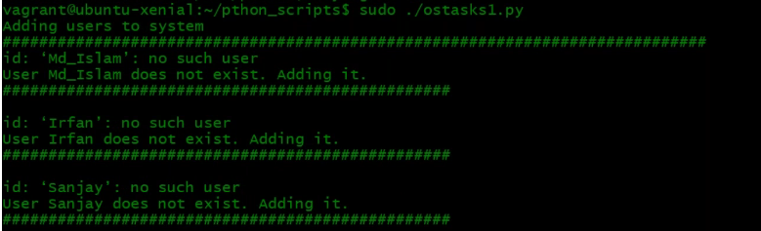

The same kind of example I will do it from python interpreter using os module

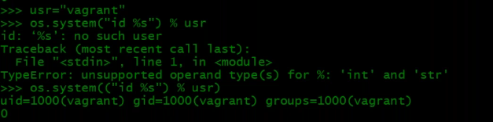

In double quotes you put anything In python, it’s a string. See the error below and then how to use it

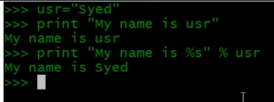

**Exercise:**

Lets see one more script.

This script is to check if group exist or not. It will add a group if doesn’t exist and then its gonna add the users that we listed into the group plus it will create a directory and give ownership on the directory to this group called as science.

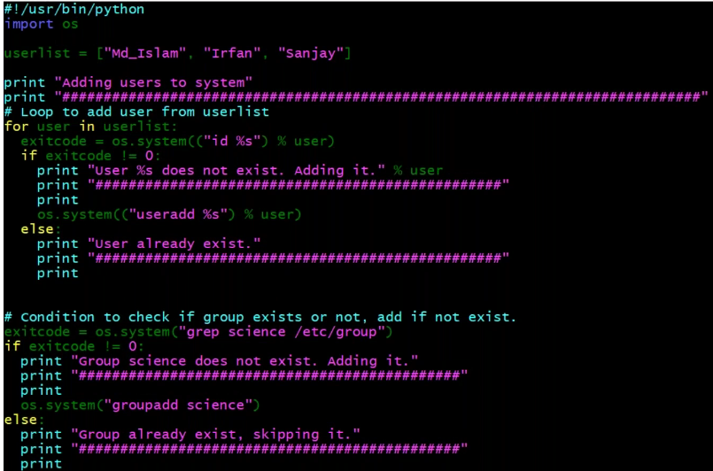

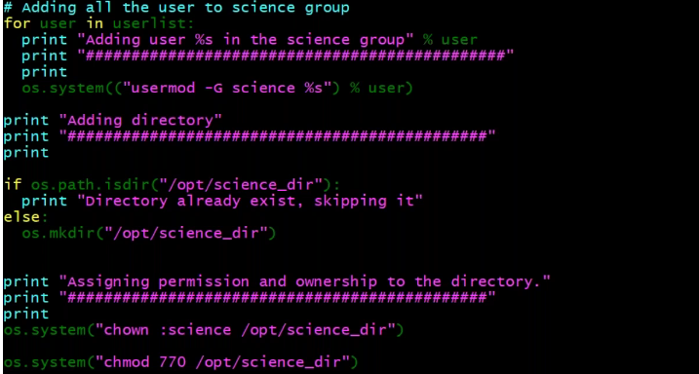

**Fabric for automation:**

These all scripts we are doing it on local machine but being devops eng we need to execute our script on 100’s of remote machines and how can we achive it. Yes, we can use os module an put ssh command but then our script become more complicated. In python we have amazing libraries that we can download, install and use them.

To install any packages in python you can use **PIP**. But you need to install it first.

Let me search PIP first. PIP is a package manager for python. Python-pip is for python2 but for python3 it is python-pip3

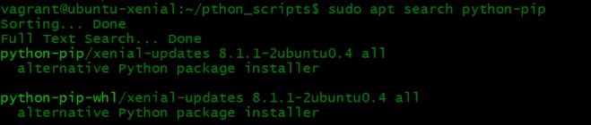

Let me now install



**Fabric** is a 3rd party library. It comes with the capability of ssh. It becomes really easy to do automation with Fabric. Onc3e Fabric is installed then I can write functions. I have to create a file called fabfile.py and in that you have to create functions. And you can call the pythons function from the shell which is very powerful thing for system admins.

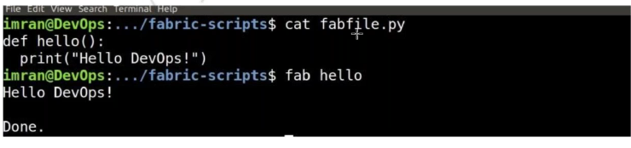

Fabric gives you lot of methods like

Local→same like os.system and execute commands locally

Run→to login to target machine and execute command and come back

Sudo→same like run but with sudo

Put→push the file

Get→download a file

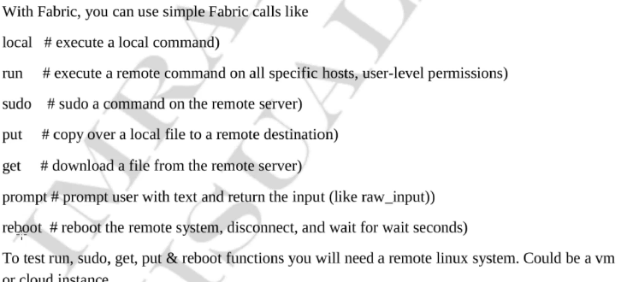

**Exercise:**

I have installed pip. Now let me install fabric and I don’t want to go with latest version which is for python3 and syntax is very different.

To install fabric which is less than 2version then do



This will install paramiko with it which is real ssh library in python.

Now Lets see how we can use fabric in doing system automation

Let’s create fabfile.py →script file should be this

What we need to import here is → import fabric.api

Let me import all fabric libraries → this is not advisable as it will get loaded into your memory and there are libraries which are very heavy, and system may crash . So, you import what you need.

In the below example I am not using any fabric method, just showing you how to execute fabric commands.

Written a function named greeting and there am gonna say msg=”morning” (default variable). I am not passing any argument then by default the value of message is morning

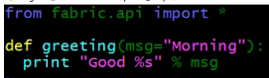

Fab is a linux command and you say fab -l to list available functions in the fab file. Greeting is the available function in our file and am using fabric method “local” to call.

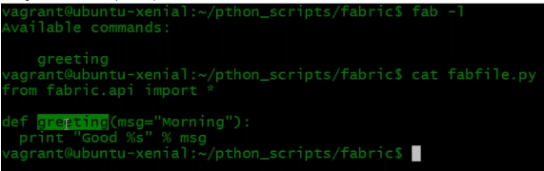

Now to call that function, I have to say

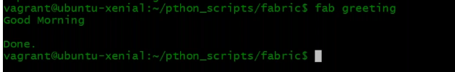

If I pass an argument to it, then message value will be overwritten

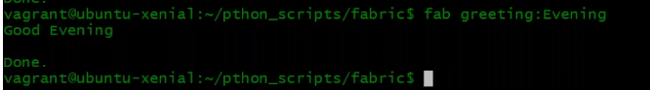

Let’s add one more function that’s gonna get system information.

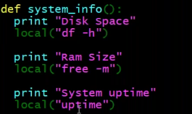

Let’s call it now and it will read the fabfile.py, it will see the function and execute it.

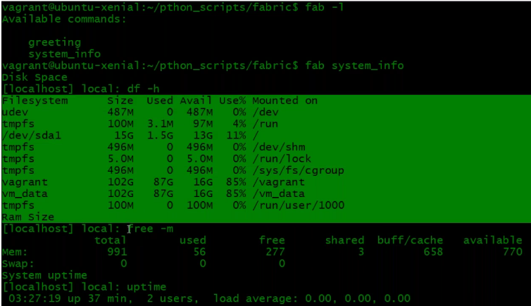

**Exercise;**

I am writing a function and am gonna install maria db(my sql server) on other VM’s

Run method is for remote execution

First let me execute the target machine info

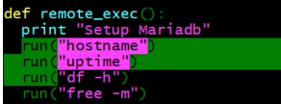

Now when I call this function from bash shell, it is going to call run method and it needs IP address, username and password. If I don’t provide while calling – it will ask me question to input hostname

But anyways now we will do it command line

Fab --help you can use to check the options

My remote machine is server1 and its Ip is  first I will execute on this

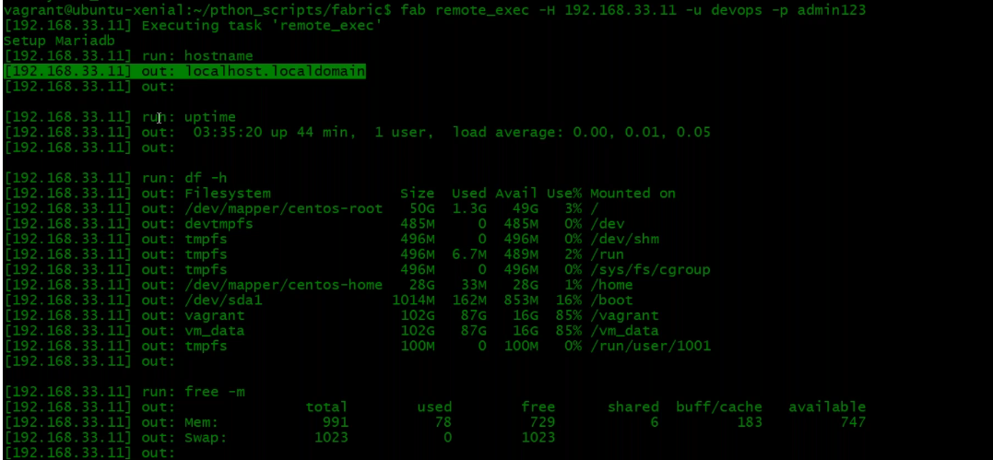

It logged into that machine, executed all the commands we defined and gives you output. This is very bad that I am giving password in command line. If you have key exchanged then you don’t need to provide password.

Now let me add one more command to install mariadb and start the service in our script file. And I want to do it for both the machines and not one.

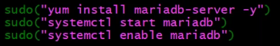

Let me call now: (I have exchanged key so not giving password)



Output:

It will install the package on both the machine one by one.

So this is one by one execution. But if you have lot of machines and your script box has good resources and you want to do parallel execution. Fabric will give you “-P” option for parallel execution



This is how you automate system task in linux with python.

**Exercise:**

Let me show you few more things in fabric. I will define another function called web_setup which takes 2 arguments. And this is to setup a website from tooplate.com and setup on centos machine. You need to give the URL and directory name(directory which is gonna be inside the zip file) -pass 2 things.

Install zip and unzip locally with local method, sudo method to install httpd and wget on the target machine, enable httpd with sudo method, locally download the zip file, unzip that,

Interesting part is fabric has some helper functions **lcd,** you can say “with lcd(local cd command)”DIRNAME – its gonna cd into that directory and execute the commands under indentation.

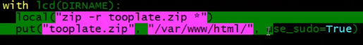

Here on local machine it will again create a zip file with local method and with put method (scp) it will push the file to remote location with sudo user previlage. /var/www/html is owned by root so you should say use_sudo=TRUE.

lcd is for local machine and cd is for target machine – cd to remote machine path and unzip the file



Then execute sudo method to start the https service on target machine



Below is the complete function for the same script file

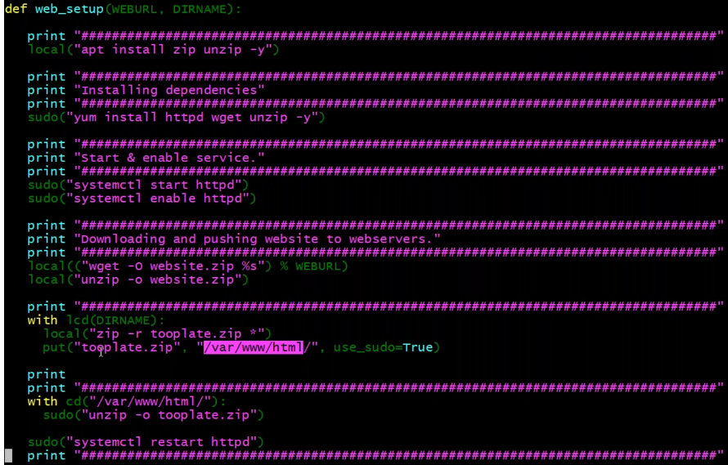

Correction in script file for this below part – it should be sudo apt



Now let’s call this function by passing 2 arguments that is URL, directory name

Fab -H <remote IP> -u <user name> web_setup:<URL>,<directory name>



You can mention the IP address, username and password in the fabric file itself. There are variables env.hosts which is defined in list. IP address is a string enclosed in list. You can give multiple IP’s separated by comma

env.user and env.password

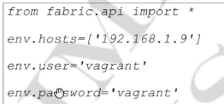

Now that we have installed fabric version less than 2



Now in case I want the fabric version 2 also on the system then it will be conflict. In this case you can create a virtual environment in python to use the both versions. You can create as many virtual env you want in a system.

We can install virtual env through PIP



I will create a directory and go inside it and say virtualenv priv_env which will create a directory called priv_env and in that it will put all the python libraries here from the system



To active it I should say the below and then if you install anything it will install in my env and not on the system



To deactivate just say deactivate

Join this below program which is good, and you also get certificate for this. This is 9-week program

Edx python mit



**Ansible**

Ansible is similar to configuration mgmt tool puppet and chef but more ease to use.

With Ansible you can do day to day automation, cloud automation, you can orchestrate lot of things from your devops lifecycle. You can do so many things and integrate them with Ansible, regular change mgmt process when you want to change anything in PROD it is much easy.

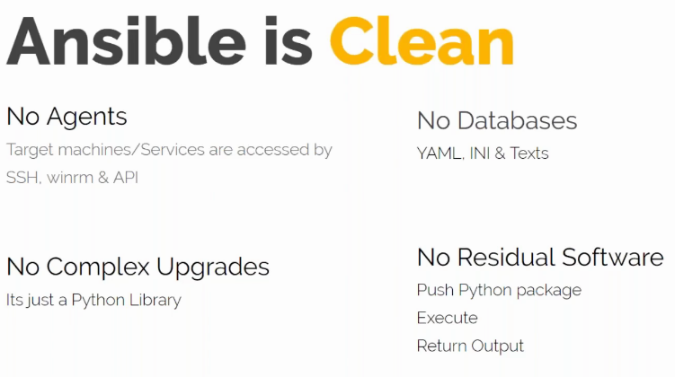

Ansible uses ssh for Linux machine and winrm for windows.

It can do API related automation also. No agents required on client machine. You can just write code and execute it. No databases required – we write code in YAML format and it is similar to JSON and its very easy. Installation and upgrades are very easy. Ansible is also a python library but we don’t interact with python script, we interact with YAML. No residual software which means it will clean automatically what is not required.

Ansible will basically create a python package which means collection of modules. A module is collection of functions.

When we execute ansible it will create python package execute it on target machine and exit.

**YAML** is a data type and not much programming

Like name : Shijith

Empno : 777

Skills :

* Websphere
* Tomcat

So, the list here we define it by using **“–“**

We never call Ansible a server, we call it a control machine. It is a python package .

It makes connection with the remote machine where you want to do automation to different technology. Like for windows it uses WINRM, Linux ssh, cloud API, it can automate network and databases also. It won’t need any agent in remote machines.

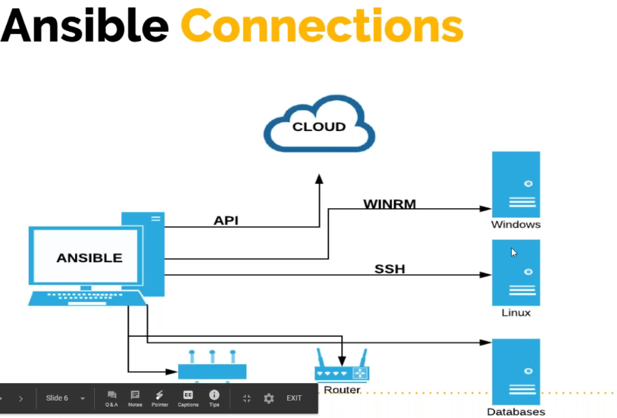

**API**

Ansible has lot of API based modules which can execute task on API servers like cloud computing. Jenkins uses API, vagrant uses API. So, you can use API with Ansible. Ansible can also execute windows commands, bash commands, shell commands on remote machine.

You can executing scripts with Ansible, but it is not recommended with shell and bash scripts and we will see this later.

Like in fabric we have seen methods like put, get and so many other, we also have in Ansible around 1000 modules like that. We call it as modules in Ansible.

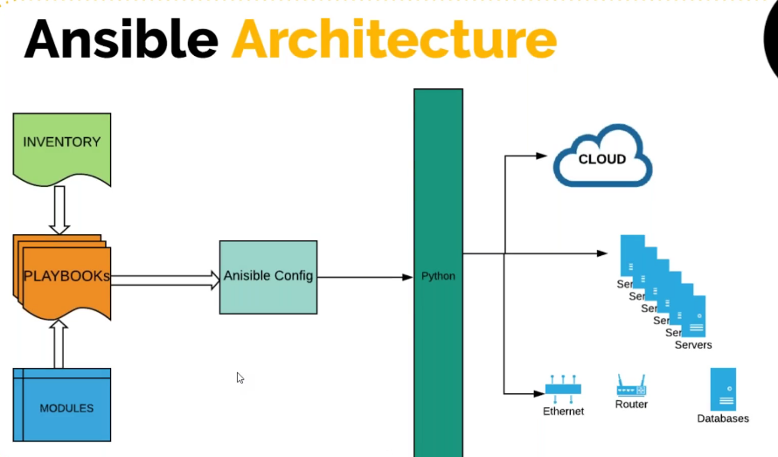

In Ansible we write playbook and we call module that needs to be executed. Ansible uses inventory file basically the host information IP address, user name , passwords.. So, when you execute – Ansible will use its ansible configuration to get right mode of communication like ssh/winrm. Ansible written in python so it develops python packages and push it to target machine, run the execution and return the output. Cloud related task it will execute locally. Network devices it will push or may execute locally. It uses python which is the base of it, you don’t write any python script. You just write it in YAML, you run the execution and it will use ansible configuration file and execute it to remote or local machine.

Author of Ansible is Michael DeHaan. He created Ansible and made it opensource. We have Ansible tower as an enterprise version where you get Graphical user interface.Then lot of contribution came in and it is acquired by RedHat – Redhat is acquired by IBM and now you can say Ansible is now a IBM tool.

Ansible is very powerful that it can replace any automation tool in market. You can use Ansible to build and release also. Terraform is better for cloud automation but you can use Ansible also.

**Ansible Installation:**

Ansible documentation you will use for anything related to Ansible going forward →docs.ansible.com

Always keep this document open for any kind of task related to Ansible.

Ansible can be installed only on Linux machine or any Unix flavor. We will now install on ubuntu machine.

We will have below setup (5VM’s)

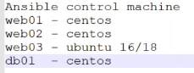

Ansible is heavily dependent on python2 (2.7). So when we install ansible, it will install python 2.7 as a dependancy

Installation:

Run all the below

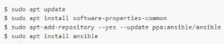

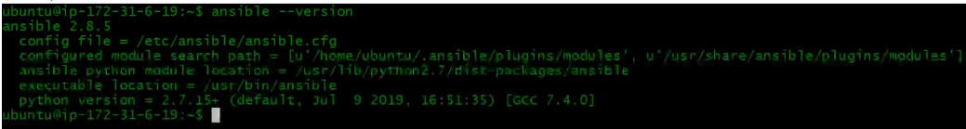

So, we are now using Ansible 2.8.5. and it is using python 2.7

Ansible has default configuration file under /etc/ansible.ansible.cfg. We can have our own configuration file also which we will see later.

Now we have done with Ansible setup.

**Let’s now setup our target machines:**

Lets launch our webservers that is websrv01,websrv02 and db. Under security group we also need to add a rule to allow ansible security group to access this machine.



Now My instance is ready

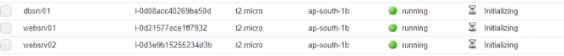

We need to add the host information of our webserver and db server in ansible machine through inventory file.

**Let’s learn inventory file**

Lets say we have a project called white-tiger which is an organization in conserving white tigers and they are developing a website for its promotion and we are in charge for operations. Setting up webserv and database server for them where they can host their websites.

I have created a directory called white-tiger and creating an inventory file called int-qa. In the inventory file I give the hostname websrv01 but that’s not enough as it is not added in our DNS/hostfile. so we need to give its IP address and that you can give it by giving a variable called **ansible_host**=<IP address of target machine> (since they are in same VPC we gonna use the private IP’s) and you have **ansible_user** variable to mention the user and **ansible_ssh_pass** to mention the password. We have not setup this user on target machine but we wil do it. Same for websrv2 and db server.

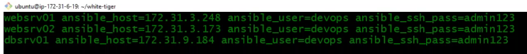

These users needs sudo previlage to install any packages. So what we will do is – we login to all 3 machines, setup users and give sudo previlage and we will enable password login.



Now add the users to sudoers file

#visudo

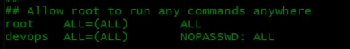

Enable password login

#vi /etc/ssh/sshd_config

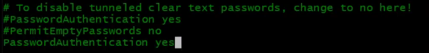

Restart sshd service

#service sshd restart

This I have done on all 3 machines now.

Now let’s test the login from control machine. Before doing this test it normally doing ssh from control machine as Ansible also do the same. This is just to cross check if you can login and do sudo and yes I can do.

Now lets use Ansible to test the login.

We already have our inventory file with our target host information.

Now lets see how to call the predefined modules

I want to do a ping test to my target machine anf for that I will say

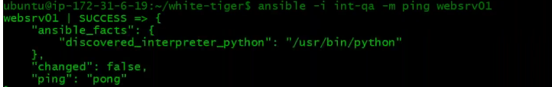

It will return its output in JSON format and it is a success message.

-i →inventory file

-m →module

Ping →is one of the predefined module

Normally when we do ssh to target machines, the very first time it will ask us the below question and we say yes and the information will gets added to the known_hosts file. But Ansible will not be answer this question and it will throw you an error.



Now how to rectify this problem, we will edit ansible global configuration file



And here we have a setting called host_key_checking which is basically enabled and you disable it by uncommenting the line



**Inventory file:**

So far we have given IPaddress, hostname , user info in the inventory file but it can do more than that. We can even create group of hosts like group of webservers to say. You can even create group of groups. You can combine multiple groups together and create a parent group and if you want to execute something on multiple group then you can use this concept. We have seen few variables that we defined so far but there are many other which we will see later. We can also mention variable at group level. Inventory can be static or dynamic. So far we used is static. We can even write some python script or any other script which gets executed and gets the hostname/IP like you are provisioning ec2 instances. As you provision ec2 instances through Ansible we don’t have its IP address, not yet provisioned. In that case you can write python script that can use boto library and gets the IP address.

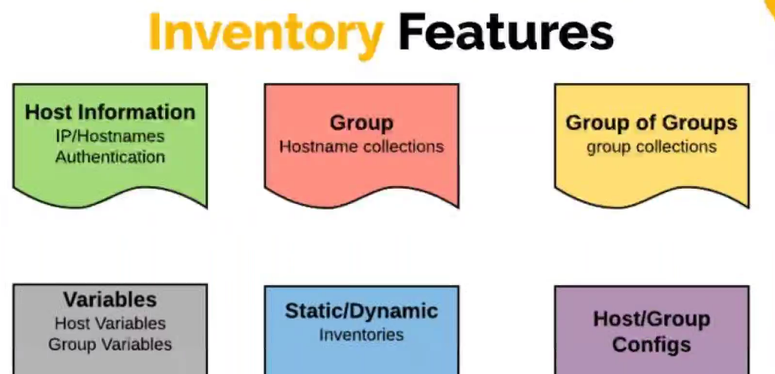

**Exercise1:**

I have moved the above same inventory file to a new directory called excercise1.

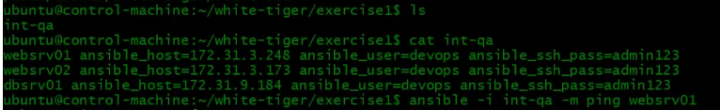

Previously we have seen how to check using the ping module.

I can even check the ping to all host at once giving all options which will do a ping test to all the host in the inventory file.



We can even use regular expression * but that has to be in **single** quote.



Lets create groups in our inventory file.

You can create groups in **square brackets** and give a group name and then add your hosts but that host needs to be declared in the inventory file. If you don’t want to declare it here, you can declare outside also which we will see later. Always prefer to create group of host even there is a single host.

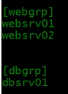

You can also create group of group – Give a group name followed by **:children** (This is the syntax to create group of groups) and then give your group names

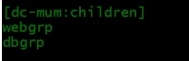

So here is our file and lets start executing

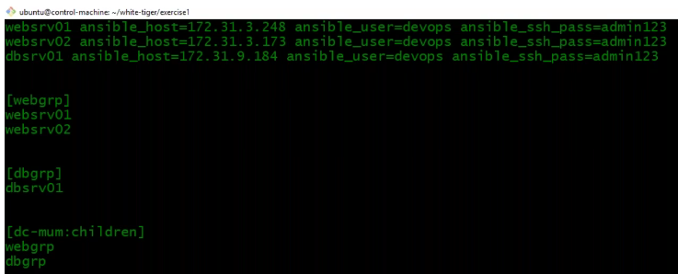

Execution:

Lets now execute the module on webgrp

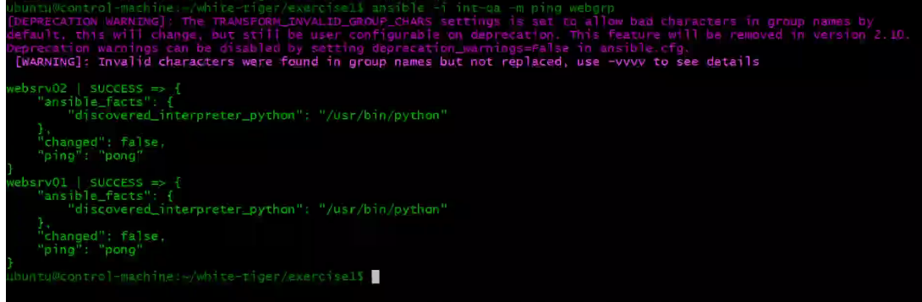

This got executed but we got deprecation warning. Which means we are using something that going to be removed in feature versions. Whenever you get this warning you need to see what you are doing and you can change that.

I have changed the group name from “–“ to “_” in group name and the warning has gone. This is not gonna create any problem but when you upgrade the Ansible package that will be removed and that becomes the syntax error and execution will not happen.

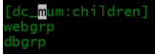

You can mention variables at group level also. To do that you have to create a separate group like below. “group name for which you want to define variables**: vars**”. You can mention this at parent group level or at the normal group level also. if the username and password is same across all hosts, then I can group it up and mention at group level instead of host level.

**Note:** Always variables defined at host level has high priority. Suppose you have same user cred across all the hosts except for few hosts, In that case you can define variables for those hosts at host level. Suppose for websrv02 we have a different user cred then you can mention that in host variables.

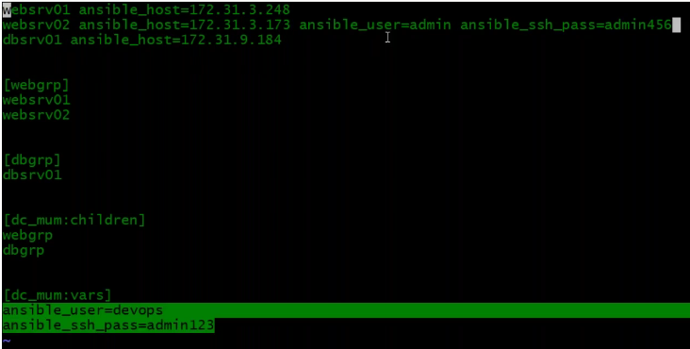

Let’s execute:

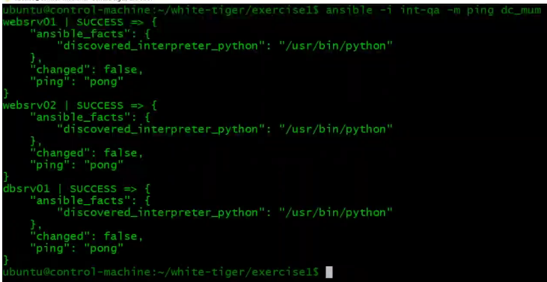

**Lets do some task here:**

Lets say if you have a single task something once or twice you want to execute for group of host or single host like installing package or restarting service, you don’t really need to write playbook for it. You can use add-hoc command and other modules to execute task on host or group of host.

Modules in Ansible are divided into many categories like below

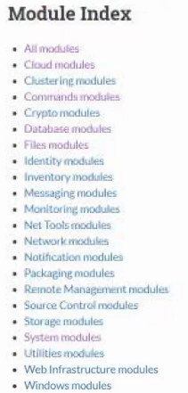

Go to all modules and you see all modules there. You really don’t have to byheart anything, but you should be able to find the information from the documentation.

For example, I want to use yum module to install/delete anything I will fo into yum package module.



And you can see the parameters listed in documentation which you can pass to yum module. For now, we are using the parameter called **name** to give the package name.

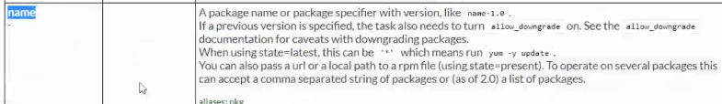

And **state** to define the state

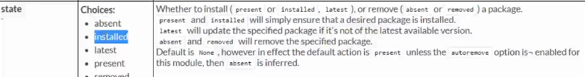

And then you can see some example here which are playbook examples. Let’s now see the add-hoc commands

Below yum= module name and with yum you really need to provide arguments what you really want to do that is -a=arguments and in double quotes you need to provide arguments like name of the package you gonna deal with, state of that package – what you want to do with that package (install/delete/update). I am here saying that package should be present but where ? in our **webgrp**

I have executed and it has failed.

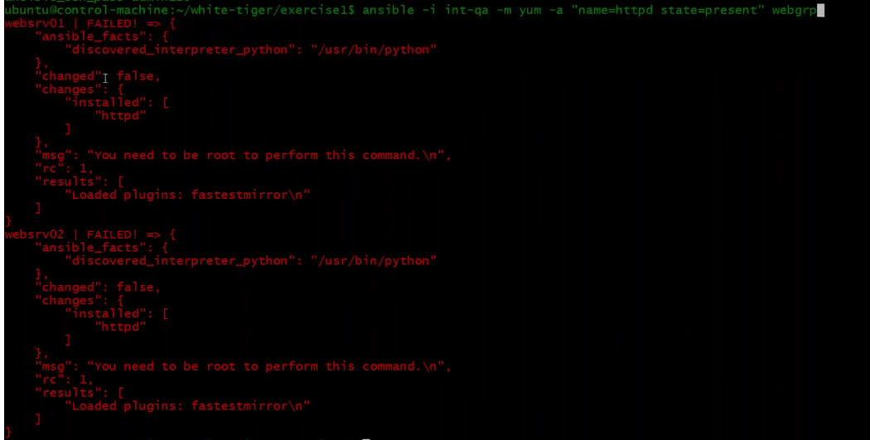

You can clearly see it is failed and the reason is to execute this command you need to have sudoers privilege and we have given it for devops user. We have our user defined in inventory and the user has sudoers privilege. So in ansible if you want to escalate the privilege you have to give --become which means give sudo in linux.



Now I don’t see any error and I can read from the output it reads changed which means changes on websrv01



Now we have installed the packages using yum module and we can also do start the httpd service with other modules called service module.



Ansible configuration is smart enough to see what is the state of the service. Suppose I say httpd

Is already running on a server and if execute again to start the service, Ansible do nothing (In below output you can see changed = nothing). This kind of behavior is called **IDEMPOTENT.** This is the default behavior of any configuration tool. This is the biggest difference between scripting and configuration tool.

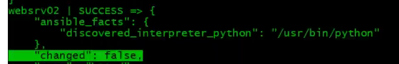

**Exercice2:**

I will now create a new directory and copy the data from exercise1 so we have the same inventory file with same data and we will add more into this same file.



Now let me create a file index.html here and put below data into this.



Let me list the files here

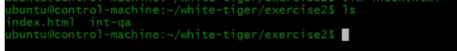

Now let me add a security group for websrv01 to allow port 80 from my IP.

Now that we already have apache installed and started on websrv01 and websrv02 and can access also the default page on port 80.

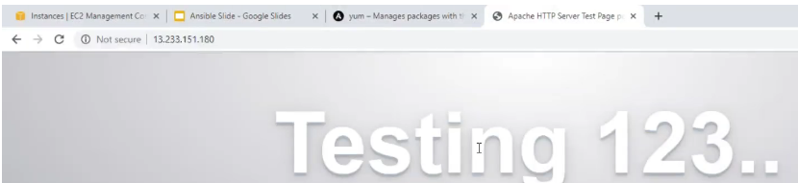

Now I am going to deploy our html file which we created instead of the default page.

And we know where to put our html file →/var/www/html

We can use ansible for that



Now I have pushed the file. Its not an html file but just to show you the concepts of pushing a file and yes I can access my website now

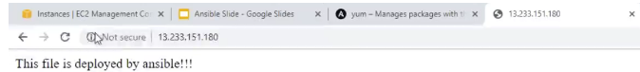

Now if you run the same command again, it won’t do any changes or overwrite the file as there is no change in the system. This is called IDEMPOTENT.

Since I have done changes in web server, I would like to restart the service. I know the state started and stopped but assume you don’t know for restarting a service then just follow documentation under services to know.



Under this service I can see now all options

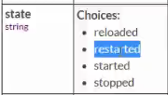

Like this you can go find everything from documentation.

Lets restart our httpd service now



Now I want to enable httpd – means httpd should come up at the time of boot. Like in Linux we say systemctl enable httpd, In ansible we have to define that with oprtion **enabled**



This all about add-hoc commands.

**Ansible Playbooks:**

Playbooks are not programming languages. Playbooks are written in YAML format. YAML is as similar to JSON and we JSON is similar to python dictionary which consist of list and string.

In YAML you have list and dictionaries. In dictionaries you may have a string as a key and value as a string or it could be list. In YAML a list is denoted with “-”. Element in the list is denoted with “-”

A Playbook is list of plays.In the below example,

The first play is **-hosts websrvgrp** and we have “-“ because its an element in the list.

Tasks is the key and its value is again a list -yum. Indentation is important in playbook. Which means yum is inside the task.

Name and state are the keys and httpd and present are the values respectively.

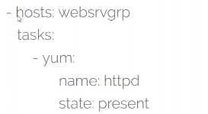

**Lets now write a playbook:**

A playbook name can be anything, but the extension should be **.yaml or .yml**

Let me create a file webdeploy.yaml

The first line in the playbook will be three“-”

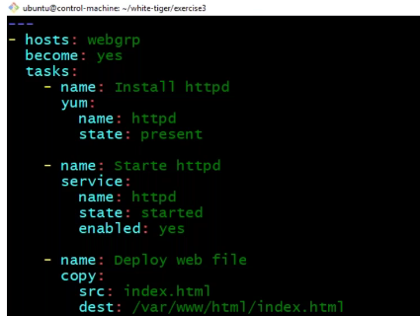

Let me explain the playbook now

Tasks is the key and its value is a list (Below highlighted)

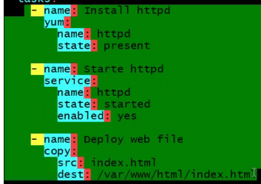

In python we separate all the elements in list by comma but in playbook we do with “-”

Now let me execute this. For execution you should say ansible-playbook

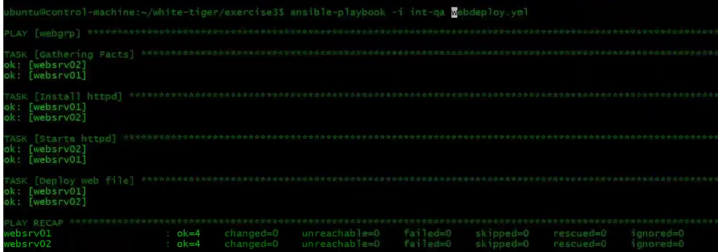

Done- no output as there is no change in system

***Troubeshooting an issue:***

**Issue:** I have my ec2 instance key saved on my laptop and the laptop got crashed

In such cases you select your instance and create an image of it. If you stop the instance then it would be fast. Once it is created, you can see the image under AMI. Now from this image you launch an instance. It is basically replacing an instance. create a new key for this instance.

**Ansible Configuration:**

We have ansible configuration file under /etc/ansible/ansible.cfg

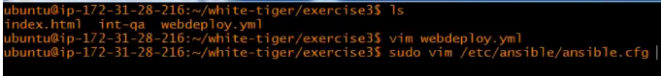

That’s the default path for the global ansible configuration file. Ansible have its default behavior and in

Case if you want to change it then you edit this file. It has lot of settings.

Since it’s a global file, what you can do is you can create your configuration file locally also where

You have your playbook and the inventory file. If you put some settings here in the local file then it will

have more priority than the global file.

Why do we create a local configuration file?

That’s because we have learnt version control system right and we gonna write a code and the code is

huge with multiple playbooks. We would like to version it. Whenever we do changes we would like to

version it so that we can roll back to previous one. So instead of creating this ecercise3 locally I can create

on github and you can keep versioning your ansible code. When you do that you would also like to give the configuration file of ansible. So having a local configuration file of ansible will always help you.

**Exercise3:**

Let me create a local configuration file ansible.cfg



The first section here is defaults whish has lot of settings. We have done one previously host_key_checking also. I will copy some of the settings from the global configuration file. One useful thing is inventory which I can define here in local file.

So far I have define the below in local file.

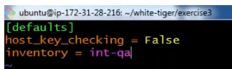

Now let’s execute ping

Since I have given my inventory path, now I don’t have to specify the inventory path while executing.

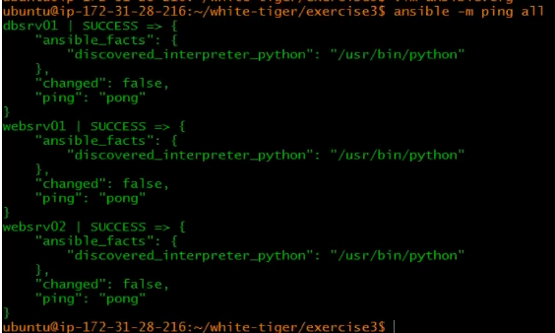

**Lets see now normally used configuration settings we use in global configuration file**

The settings start with **[defaults]** section.

**Inventory -**  we have seen already

**Library** -In case if you are building your own Ansible modules, you keep your modules in whatever location you want, and you can specify the path of it under below setting

**Forks –** This is parallel execution**.** If you have ansible to manage 100’s of machine. Let’s say you are updating a patch on 100’s of machine. We ansible is doing this one after the other machine then it takes very long time. So, I can define forks to value 5 which means execute this task for 5 machine at a time. There is no limit to define and it depends on the resources you have for VM, network..

**ask_sudo_pass** – if you have added user to sudoers but you have not given nopasswd, then it will fail.

**remote_port** – Some organization will change port of ssh from 22 to other for security reason

**timeout** – Sometimes your instances are too far away for your ansible server to do ssh like more than 10sec or 20 sec.

**remote_user** – like we specify user in inventory file, we can also specify here

**log_path** – By default Ansible will not store any logs. If you want it to store logs then enable this setting but you need to sure that this log file is owned y the user who is executing ansible command.

Like [defaults section] we have other sections like [inventory] [privilege_escalation] [paramico_connection]

**[paramico_connection]** – Ansible is built on python. In python ssh libraries is paramico.

We have plently of other settings like this.

Now I have the local configuration file with some added settings. Since I have mentioned log path, I need to create the file with owner the use who is executing the ansible commands. In our case its ubuntu user and then lets execute it.

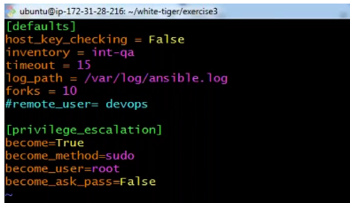

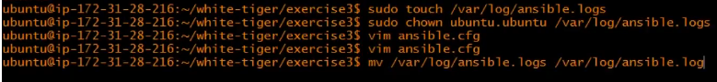

Execution: Run the ping module again and you will see the output.

**Let’s write Playbooks:**

**Exercise4:**

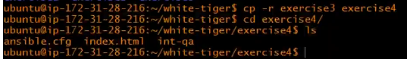

Let me now create a file here to write a playbook named web-db.yml. This is to install httpd and start the service httpd on webservers and on db server install mariadb.

We start with “---” which is not mandatory but just represents its an yaml file

Playbook is list of plays in list. In yaml we have only 3 things – List, dictionary and strings

Before I start writing let me show the difference in format between python, JSON and playbook

Below one is python format

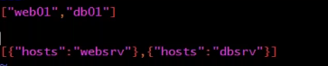

The same in JSON format is

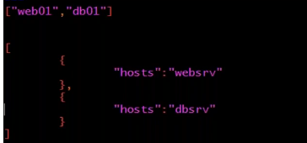

Now lets write our first playbook which has 2 plays

Like in python you separate list elements using comma, here you do it with “-” and that’s the separator

The list elements here is a dictionary and we can give more key value pair here – firstly I will say execute all with sudo privilege (become), then I can give list of tasks. Task is a key and its value is another list which has two elements -yum and -service. Yum value is a dictionary which has key and value. Service value is a dictionary which again has key and value.

You need to do indentation space – min 2 and max 3 you can use.

And for db server I will mention host and not group.

Ansible gives you an option to name your modules. I can name my tasks by using -name and it will be displayed during execution. IF you don’t give a name to the task, then you will see the name of the module while execution.

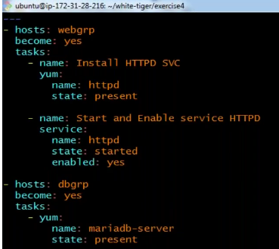

Execution:

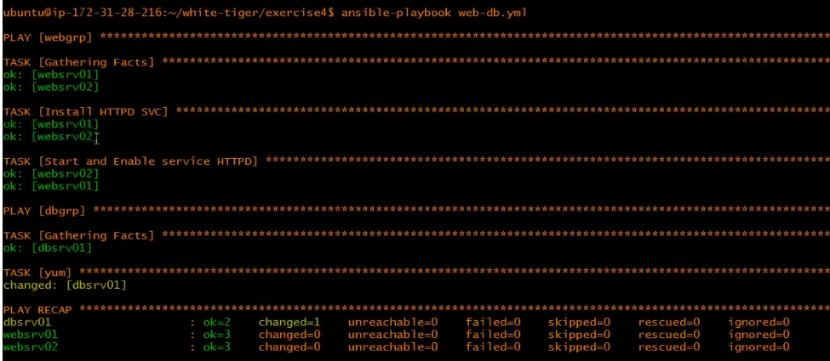

I will now remove httpd service on webservers



I will remove mariadb-server from db group



I will now make some changes in the playbook and we will go through its execution

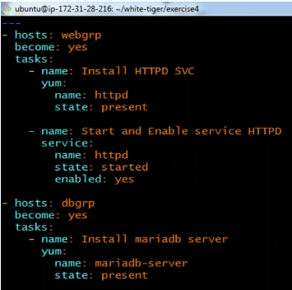

Let me execute the playbook – again it’s a fresh execution now

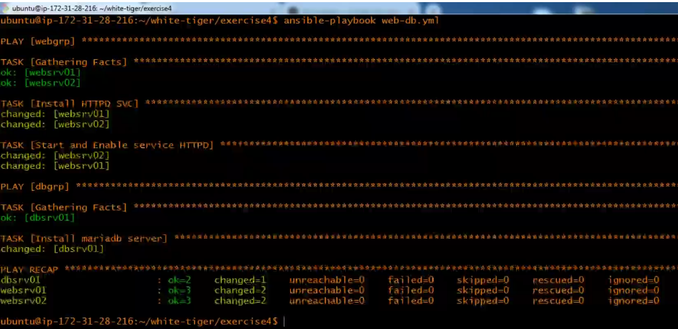

Let go through the execution now

It has 2 plays webgrp and dbgrp. On webgrp it has executed 3 tasks but we had mentioned 2 tasks in our playbook for webgrp. That’s because it will do ssh to the machine and gather all information and this is a runtime thing and its not gonna store it anywhere. It will store some info in the memory that we will see later, and it is same for the db server.

**Now lets make some mistakes in the playbook(I have made it) and now let’s go through its execution.**

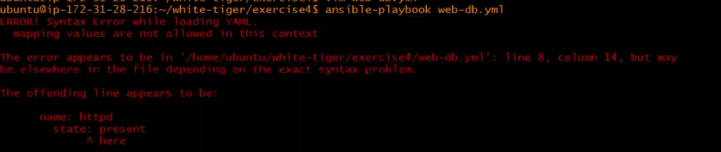

This is a indentation error. The output reads the problem is at line number so and so but it need not to be true. So don’t waste time sticking to the same line.

In playbook, the tasks are the easiest one and its all there in the module documentation.

**Ansible configuration file locations:**

So far we have seen at two places our configuration file. There are 4 places where you can keep your Ansible configuration file. Ansible will pick up the file based on its priority.

* Least priority goes to global ansible configuration file **/etc/ansible/ansible.cfg**
* If you have placed your configuration file in the home directory starting with dot **~/.ansible.cfg**. This will be a hidden ansible configuration file, Ansible will pickup the settings from this file and if it doesn’t find then it will pick up from global one
* Before that it will find the configuration file from the local which we created a directory and created a file.
* There is one more place where you can store the configuration file that would be anywhere but then you need to set the variable, you need to export its gonna be a bash variable. You need to set the variable **ANSIBLE_CONFIG** (all in caps)=”**path of the ansible configuration file**”. If this is set then this will have the highest priority.

**The best and the recommended one** would be a local one which stays in your repository, you can put it in version control system like GIT and distribute to your team members. Rest all three are system specific.

**Exercise5:**

In our exercise 4 we have our playbook, inventory file and the ansible configuration file.

Always remember the first thing you check is the connectivity using ping

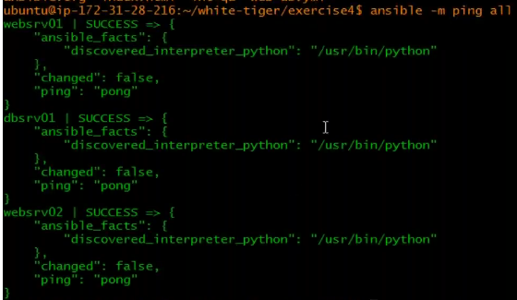

It is success and its connected.

In our inventory we have provided our password which is really bad and first thing to do is get rid of password and for that we will do key exchange.

So, we have 3 remote machines

Let me generate a key on my Ansible control machine

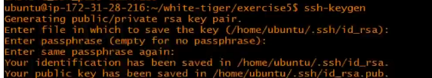



Now we will push the public key to all the 3 machines (below snippet is for one machine do it for rest do also)

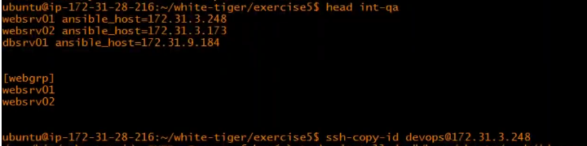

Now I have pushed the keys, so I will do a manual testing to check if its working and yes its working



Now I will remove the password from the inventory file

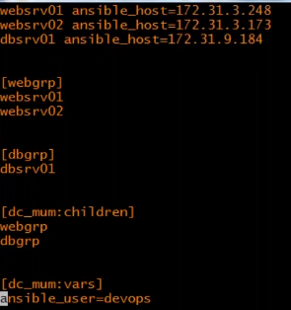

So now I have remove the password. I have the user mentioned in the inventory file and the key are at home directory which will be used by default and lets now run a ping test. Ping test means Ansible is going to do ssh to the remote machines and if it can login then we get success ping test. I did and it worked



Lets say my key is not in the home directory but at a different location. I have copied my RSA public key to /tmp location and now how dod I tell ansible my key at this location ? that you can do it again with a variable (let’s check the ansible document for this variable)



So, I can mention this in Our inventory file like below



**Exercise6:**

In our inventory file, we have given IP address of all the machines and that’s because the names for hostname websrv01/02/dbsrv01 are our own names and we want to tell this host has so and so IP address. In organization we have DNS and we can just give the hostnames of it here. We don’t have local DNS but what we can do is, we can put this information in /etc/hosts file

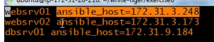

/etc/hosts file entry added

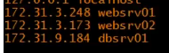

This is system specific. IP address will not be there in the inventory file. So, I am taking it out from the inventory file.

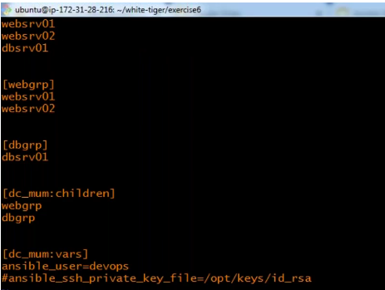

Let me test the hostnames from OS command and it has nothing to do with Ansible and it is resolving to its IP address.

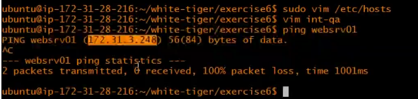

I can even do ssh with the hostname now as the IP address we have it in our /etc/hosts file and it can resolve.

We can also shift the user name from our inventory file to the ansible configuration file with variable remote_user

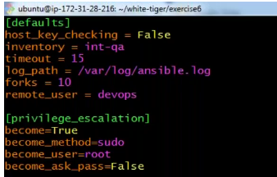

Now this is my current inventory file

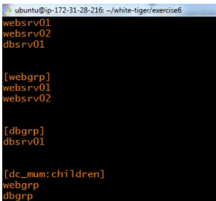

Let me install some package



And it’s working.

Now you have hostnames and group and that’s what your inventory file should contain.

**Exercise7:**

Now we have our playbook which actually installs httpd service on group webgrp and start and enable httpd. Now I want to push the index.html file to webgrp which means I need to add a task in our playbook.

Index.html



Platbook web-db.yml

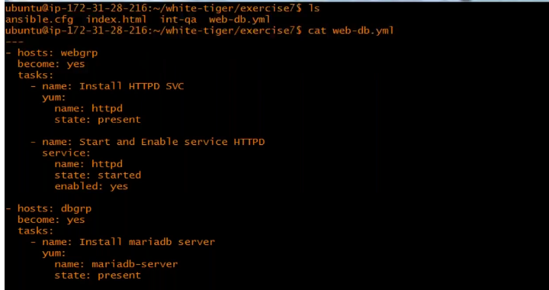

So now lets see what module we need to use to copy the file to target machine and change the permission and ownership. Lets find in documentation



Here you can go either go to all modules or you can go to system modules to search system related modules



Once you open this you can check the examples listed here

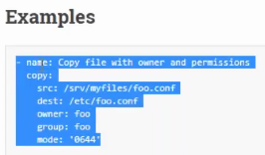

Lets add this in our playbook

When you copy make sure the indentation is correct and always mention the filename in the destination.

After adding this is my playbook look like

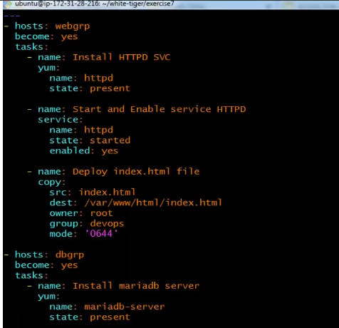

Let’s do Execution and that worked: and I can access the site



This is all about adding a task to the existing playbook.

When ever you do a new project for automating. First thing you should know to do it manually otherwise you will fail miserably. When you get into a project you will get so many services which you need to automate. You need to get the steps, perform the steps and if it is working then go ahead with automating the task.

**Let’s now see db MySQL automation:**

**Exercise8:**

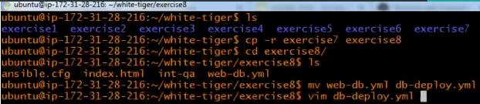

Now I need only db servers so I will edit my playbook and some more task

Let me put my new project automation steps in a notebook.

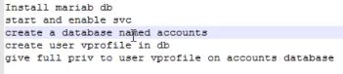

So, I now know to perform all the above steps manually, so I can automate it

1. My new task to add in my playbook is “start and enable mariadb srv”

*Note: whenever you want to add multiple task to your playbook, always add one task test it and then go to other for best practice.*

1. I need to create a database

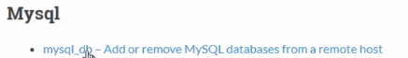

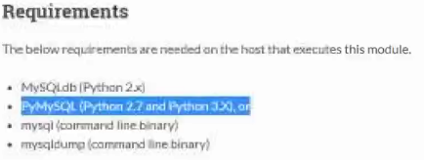

So here I use to jump to the examples to find out the variables but before you do that check for the requirements.

Below is what we want

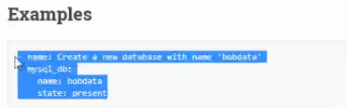

But when I paste this and after editing per my requirement and I will see running my playbook – I will get error as PYMySQL needs to be installed on target machines.



Either I can do i=this manually or I can add a task to install it but I need to know to do this manually first.

So, lets login to the target machine and do it manually first and find out the right package name

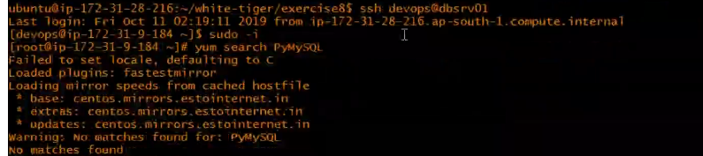

It says the package is not present. Actually, it’s with a different name we will see hoe to find that out but the other one is there in repository





Now we got the name of the package and now I can add task in my playbook for this and I added it ad executed my playbook and its working.

1. Let’s find it in ansible module documentation how to add user in db



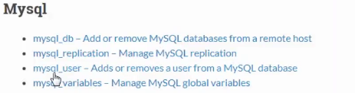

So here I use to jump to the examples to find out the variables but before you do that check for the requirements.

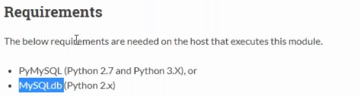

So now I know the above libraries PyMySQL and MySQLdb required on the target machines.we need to have either of those

Below is what we require to create user

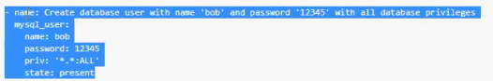

Priv is * which means for all the db’s. you want specific one do mention

Here I am giving password in clear text which is really very bad. Later we will see how to encrypt the password using ansible vaults.

Let me run the playbook and see as I have added this task – its working

Finally done with writing playbook and below is the playbook file

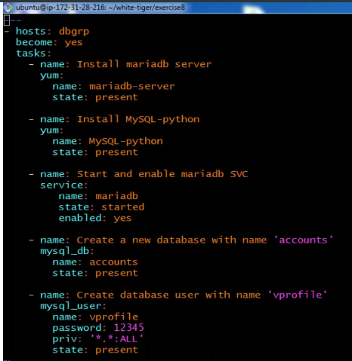

**Exercise9:**

**Ansible variables are longest and complicated topics but if you have some programming knowledge then it is easy. So far we have seen ansible variables which we have used in our inventory and configuration file. You can define your own variable’s as well.**

When ever you execute playbook, gather information is the first task gets executed. It will login and gather information and once playbook is executed it will be destroyed. All those information are variables in JSON format and if you want to see that you can run the module by yourself. When it say gathering facts, it is executing a module called as **setup. Facts** are again variables.

Suppose if you want to see the gathering facts for web01 host then you say



We will write a playbook by name print_facts.yml – from that setup module we will print some variables.

This is helpful in getting the data

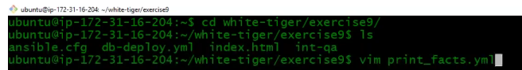

I am going to execute a module called as debug which will print. Like in python we have print, bash we have echo and here we have debug.msg is an option in this module. In double quotes you can put your message. Lets execute this one and the see the output

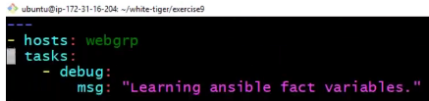

Execution;

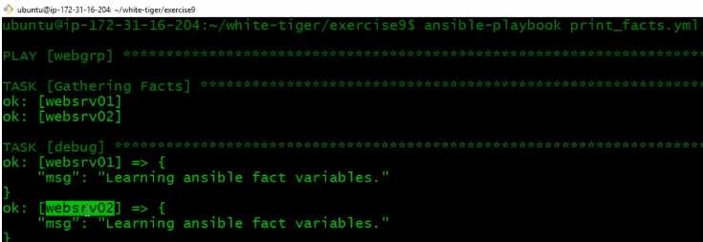

The above thing is not really required what we need is print some information from fact variables. We will see how to access variables and print it on varibales

In bash scripting if you want print variable if use **$<varibale name>** but in ansible we use two curly braces and we put variable inside that but make sure it is inside double quotes. This is called as jinja2 formatting.



Ansible_os_family variable is not defined anywhere. It comes from fact variable. When the playbook gets executed, it executes a setup module this variable gets generated and here you can see the output.

Lets execute the below playbook

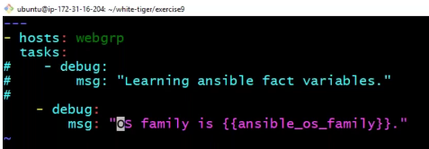

Execution:

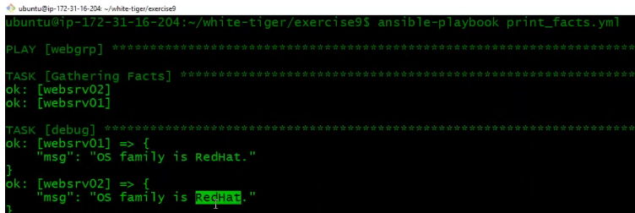

You see that OD family is Redhat but where did it come from ?

Let’s check the fact variable



This gives you lot of information, but we can grep the information



You see that

Now lets take another variable from the facts output and print the variable.



Playbook;

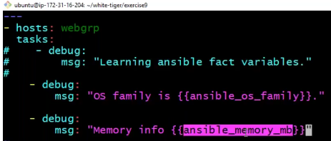

Here ansible_os_family is a variable and its value is a string but ansible_memory_mb value is a dictionary.

Execution:

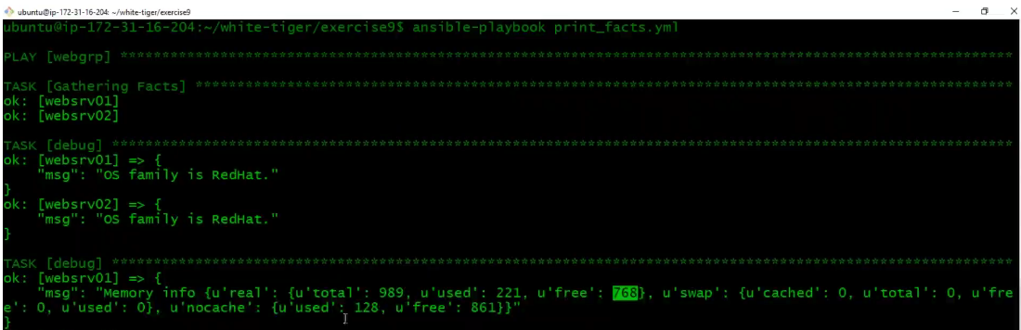

Memory info it is a dictionary where it has a key called real and its value is again a dictionary.

We access keys in the dictionary – so **real** is the key here

So, to access the key inside the dictionary you should say (below added in same playbook file) variable**.<key name>**

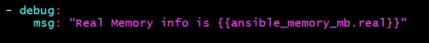

Execution:

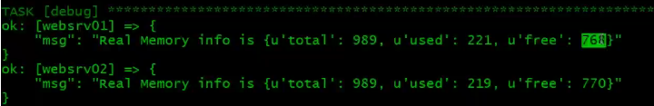

Let’s say now I want to print just free (how much free memory- 768). For this **free** is the key

(below added in same playbook file)

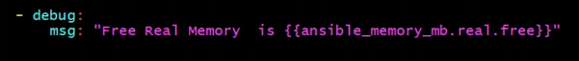

Execution:

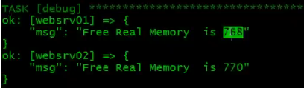

This is how we can access values from JSON datatype in ansible playbook. Such kind of task we will get a lot. Especially in cloud/API related task. When you execute API based module like EC2,EBS or Azure it will execute it locally and return the information in JSON format. From that you need to get some information and feed it somewhere else or you need to print it – This is the exercise.

Let’s do one more thing

We have seen dictionary and string. There are list also . IF you want to access list from the facts output.

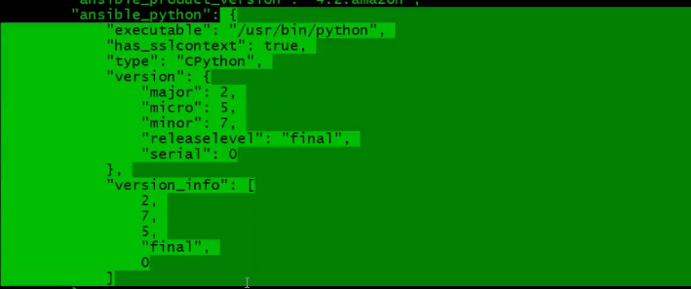

**Ansible_python** is the variable and Its value is a dictionary, it has 5 keys, the 5th key **version_info** its value is a list. From this list I want the major version of python that is **2.** Let’s see how to access this.

Here we cannot do dot because its not a dictionary, it’s a list. Here we have to give square bracket and the index number which is 0 that’s for 2 ; 1 for 7 ; 2 for 5

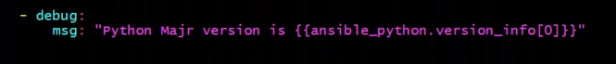

Execution:

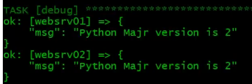

Exercise10:

Let’s see conditions.

For that I need one more Ec2 instance in websrv01 but of OS ubuntu. I will create an EC2 instance websrv03 with ubuntu OS. I need to have a devops user with sudoers privilege and push the key (this should be ready)

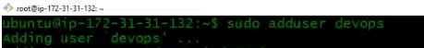

Visudo

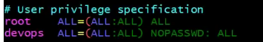

Enable password-based authentication – I will give yes now as I need to push the key and its gonna ask the password for that.



Restart sshd service

Lets now push the key



Now let’s go to our control machine and add this websrv03 host in the hosts file and in the inventory file

Hosts file – all private IP

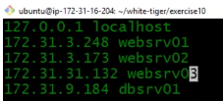

Added in Inventory file

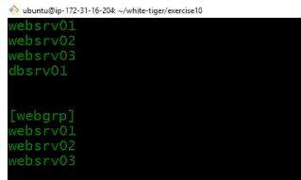

Let’s do a ping test to verify all is good and ansible can talk to websrv03



Previously we have created a playbook for our exercise which will install httpd service on centos system (below)

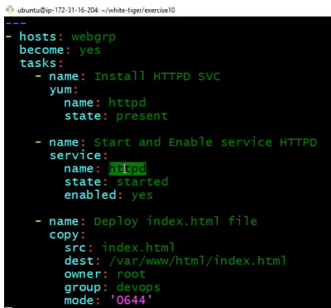

This one will not work for websrv03 as this is a ubuntu machine and the commands are different. Yum module above will execute yum commands which will not work and service commands above is httpd which also will not work here.

Let me create a playbook by name web-deploy.yml and use condition add another task for ubuntu.

In programming language, we have **IF** for condition and here in ansible we use **when**

Playbook

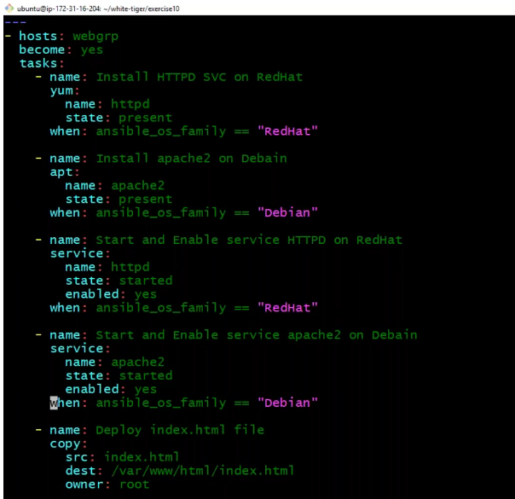

**Execution:**

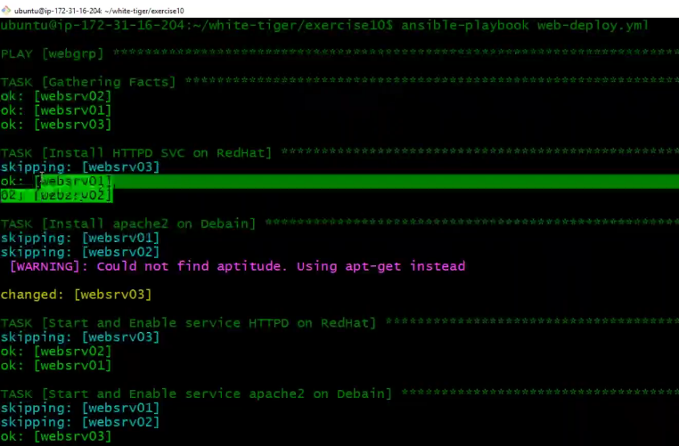

For this the first task gathering facts execution is important. IF this task doesn’t gets executed you don’t get ansible_os variable and you can’t check the condition.

We can disable the fact variables- why do we do that – sometimes for some playbook we don’t need it then you can do and it will save time.

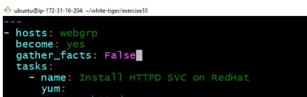

**Exercise11:**

**NTP service : NTP** service is similar to what we see in mobile phone which keeps time in sync automatically. NTP is very popular because we want our servers in our infra, in our cloud env, in our datacenter to be having the right time. If your system time is not correct it may fail for so many things like encryption, decryption, ssl communication. In logs you may have wrong time. So, we should have right time always and to make sure to do that we deploy service called as NTP on all the machines.

Let’s deploy NTp service and we see some more Ansible features;

First thing to check the connectivity

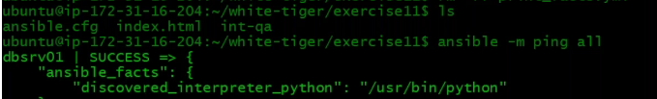

dbsrv01, websrv01, websrv02 are centos and websrv03 is ubuntu

Lets write a playbook called ntp_deploy.yml



While defining hosts you can give -hots: all or for any group you want then -hosts: [websrv,dbsrv]

We can also **name our play** – instead of starting with hosts like below

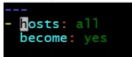

You can give

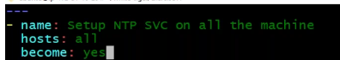

Before installing any package using apt install, its always good to run apt update.

Let’s search for the ansible apt update module documentation





Playbook:

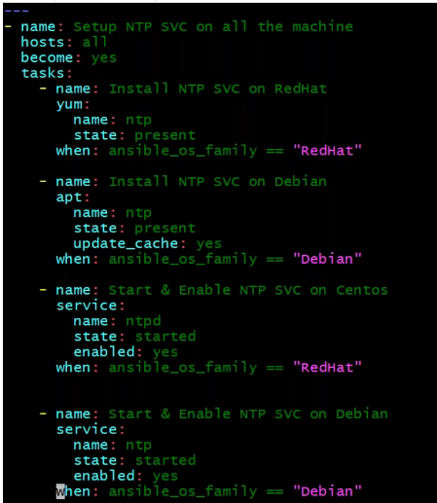

Execution:

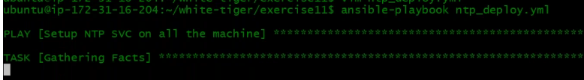

Lets now login to one of the server – websrv01

NTP has a configuration file /etc/ntp.conf

In this file you will have the below setting, the name of the server where it syncs the time

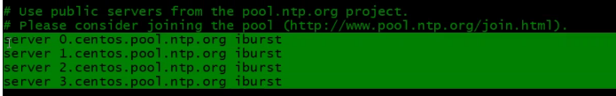

There are so many NTP servers where you can sync the time, but you should sync with the nearest NTP server.

Our EC2 servers are in Mumbai region. So, we should look for NTP servers in INDIA

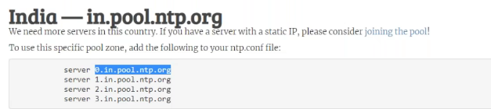

We will replace with this setting and we are going to do that through Ansible automatically

When we want to change the configuration through automation, the ideal scenario is to we create our own configuration file and replace it with the original configuration file. We push and replace it. In ansible we can do it with copy module also.

Let me go back to by control machine and create a directory and a file



I will copy the entire ntp.conf content from websrv01 and paste it in this file and do below changes and then push the file

Different OS we have diff kinds of configuration

Let’s change the below as discussed earlier

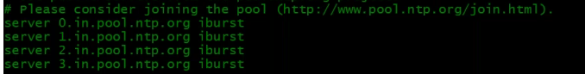

So now my configuration file is ready, Lets now edit my playbook to push this file using copy module. With **copy module** there is one more option **backup.** Enabling this option, it will take the backup of destination file before it takes the source file and overwrite the dest file.

Add the below to your playbook

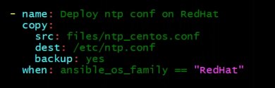

Let’s login to websrv03 server which is ubuntu and see the ntp.conf file

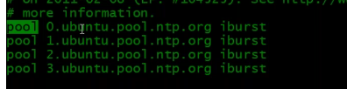

The entry here is different for centos and ubuntu. There is other difference also you see in this file. So, we should have 2 different files for different OS.

So, I will copy this file content and copy the content to a new file in control machine and then update the time for INDIA

Back to control machine



Edit the time

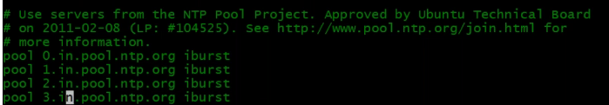

Lets add the task in our playbook for ubuntu

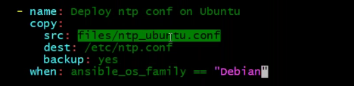

Whenever you do some configuration changes in Linux, we do restart the service. We will now add another task in our playbook to restart the service. (We will see some problem with this later)

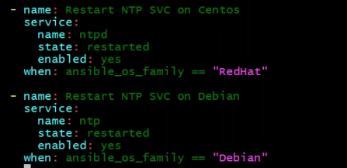

Let’s execute Playbook 

It got executed, deployed the configuration file and restarted the service also

Exercise13:

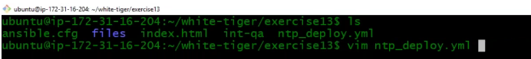

Now lets say I want to install 4 more packages on both redhat and ubuntu. So again I copy the existing task and paste 4 times and then edit the package name in the playbook. My whole playbook will be filled with package installation tasks. Lets now see what we can do overcome this using **loops**

**Loops** run things repeatedly. In loop we have number of items. It itrates over a list or a sequence. In ansible this is how we give the sequence(below snippet). In loop is going to return a variable called as **item** which we need to mention and that’s gonna be the name of it all the time. You mention varibale name in curly braces enclosed in double quotes.

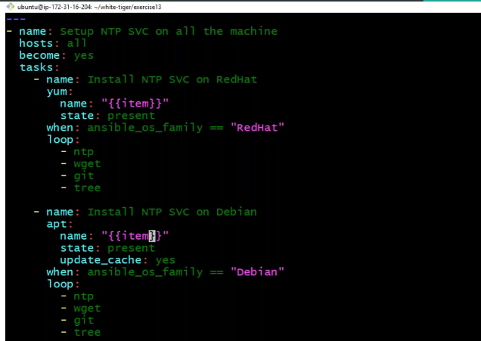

Now, this loop has specific variabel called as **item.** So this task is going to run 4 times. Forst when it runs, the value of item will be ntp ; its runs again then value will be wget and so on. Hence always use loop if you want to run some task multiple times.

Now that I have used loops and made it one step to install all my 4 tasks. Rest of the content of playbook is same like exercise 11.

Now lets run the playbook – and its success

**Let’s now learn something:**

We have already installed git using playbook and websrv03 as well.

I am goimg to remove git on websrv03

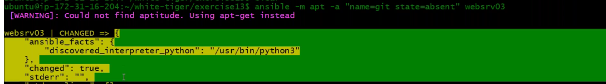

Any module that executes will return the output in JSON format.

Here in this output the key name is changed and the value is true that means actually something happened on this server. That means changes hasve been done removing the git and its true.

Now lets excute the task once again

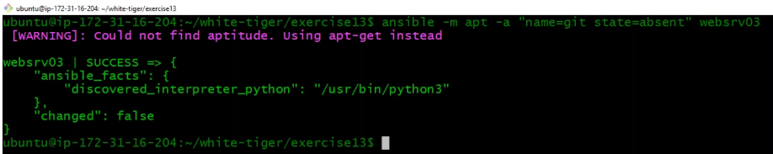

Now the key chnaged says false. Bullion value

Now let me install git again and it will return the value **true**.

Now git is installed but again I will run the module to install again and it returs the value **false**

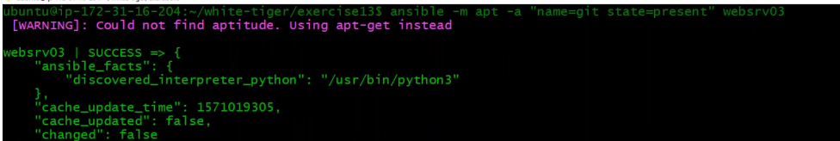

Now the false doesn’t mean the change is failure. It says success.

Now remember one thing if it is **success and changed is false,** then in playbook execution if the **changed** is true then it says **changed**, if changed is false it says **OK.**

**Exercise14:**

We run this palybook multiple times. Each time you add task again you run the playbook. The thing is we run it multiple times. This playbook can be for a production also.

Now everytime I execute this playbook the service is getting restarted unnecessarilyc which is not good.

Our NTP service already deployed and running but then I installed a new few packages and still my NTP service got restarted and its not good.

There are very specific feature in Ansible which are called as **handlers.** They should come in the same line **as tasks.** Restarting task I will put under the handler section.

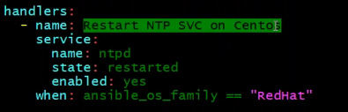

Handlers are same like tasks but they gets executed when they are notified. How do they get notified - you can mention notify in a task. You can give one or many handlers.when you notify in task make sure you give the same name.

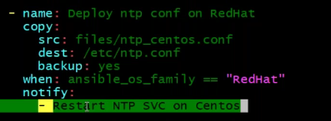

I am saying when this task gets executed and when changed is true, then notify to this handler. When notification comes to the handler – it will execute its module.

One more thing about handler. You can call handler as many times you want in the playbook. You 10 different task that are calling the handler but the handler will not executed right then and there. Even if you call the Handler 10 times, it will get executed at the end of playbook and only for once.

**Exercise15:**





We will see how to define our own variables and how many places we can define and their benefits.

We have a playbook which installs mariadb, setting up database and creating a user. We have few things in this playbook which can change based on project and environment. Suppose this playbook is for dev and for prod we have a different user and passowrd for database. This is a very small playbook. IF you have a long playbook and you have things which are repetative like databse name, passwords which is avaibale at many places in this playbook and I want to use this same playbook for a differnet project but the database name will be different. So for the new playbook we have to change this at many palces. Instead of doing those chnages at many places, we can define such thimngs which chnages per environment and project. IF you put them as variables and you change the value of the variables and it will be affected everywhere where the variable is used.

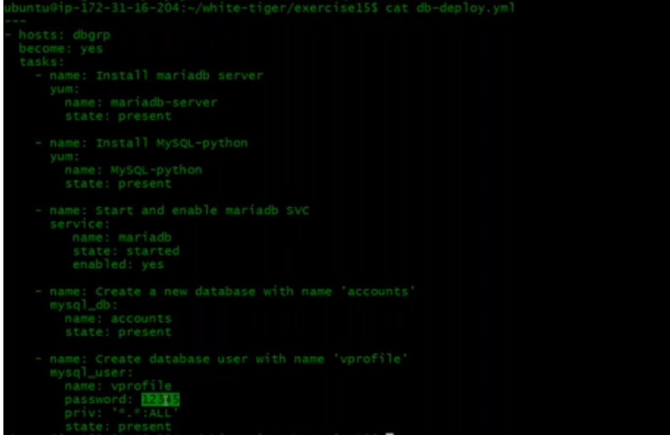

**There are multiple places where you can define the variable:**

* **You can define in your playbook. Just before the task you add the section vars(this option we will use rarely):**

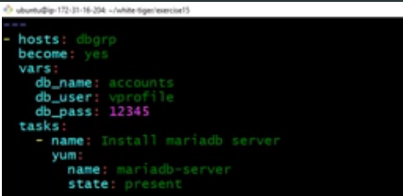

Now where ever you have this db name I can use db variable which we have defined. In bash scripting we use $ to call a avraiable but here in ansible we use Jinja2 template i,e in curly braces enclosed in double quotes.Same for user and password value

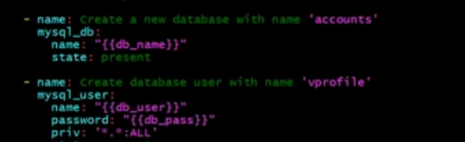

Now I can execute my playbook and it is success.

Now, How do you know the variabels values are correct ? Is it really using that value. We can use module called as **debug module.**

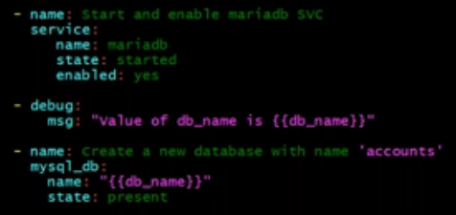

So, you can use debug to see the values of variable. Now lets execute playbook and see the output.

Execution:

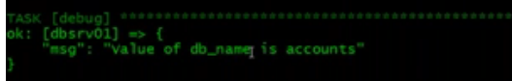

We have seen this option in fact variables but this is user defined custom variabels.

***Note:Always look for values which can change and do create a varibale for all those.***

* **Defining variables outside the playbook is always better.** Sometimes you may use the same varibales for different playbook. There is a specific directory structure for using that and you have to use a directory called as **group_vars.** In this directory you can use a file called as **all.**

In this file you will define the variable which is common for all the host in the inventory. Here all means all the host from inventory.

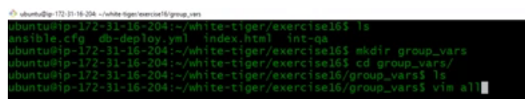

all file:



Below is our inventory and we haqve 3 hosts. For all this 3 hosts if you are writing a playbook and if you are using any of these host or all of this hosts or any of group which has this host, then those variables will be used.

Let me go back to my playbook and comment out those which we defined earlier. If you don’t remove this then playbook variable has high priority and this will be used and it will not go to group_vars all file.

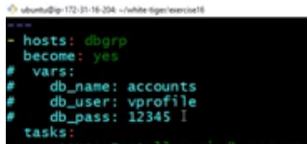

Lets execute our playbook and you can see it will pickup all the values from the all file. If I write any other playbook here, it will fetch the variables from the same all file.

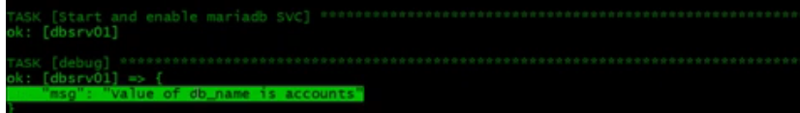

**Lets** write a different playbook to learn few things

Hosts I will give all and lets add atask with debug module. There are 2 options in debug.

msg →you have to give varibale in curly braces enclosed in double quotes

var → in this you just give the var name value and you don’t have to use jinja2 format here {{“xxxxx”}}

Playbook:

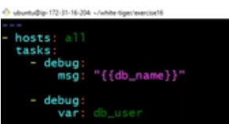

Execution:

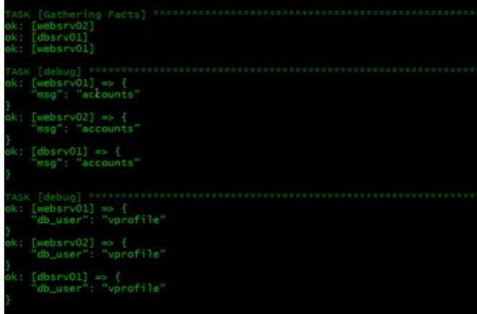

**Exercise17:**



Here, we will talk about preceedings of variables. Variables can be defined at more places.

Let me remove few files



In this exercise, we will create a user. That user name we will define as a variable first in playbook then in group_vars and few other places and see which file its gonna pickup.

Lets look at the preceedings of the variables. Ansible is designed to look at below files.

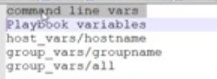

Lets prove that by writinga new playbook called user.yml

I will define 2 variables here. There is a module called as user. This is used to manage users like add, remove,set home directory and permissions. You can check the user module ansible documentation. I will give the variable name here, I will use comment also as variable.

Whenever a module is executed, system returns an output in JSON format. We can store this output using **register.** You say register and give variable name like below. I am storing it in usr_out and printing the output using debug.

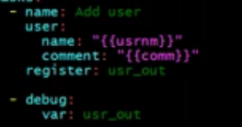

Playbook:

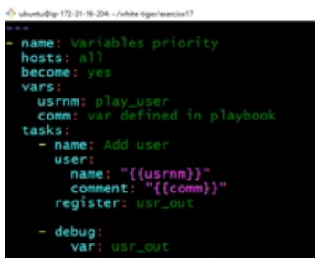

Execution:



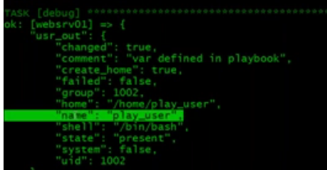

It picked up the variables defined inside our playbook. Anyways we have not defined it any where else

Lets comment out that variables

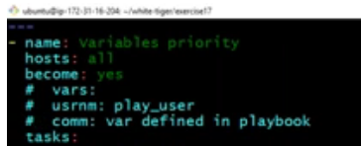

Execution again:



We see undefined error when executed.

Lets now define variable out of playbook



all file and playbook :

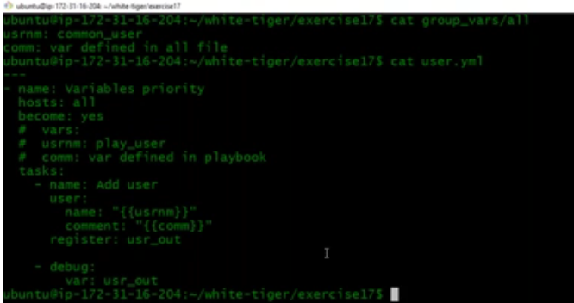

Execution:

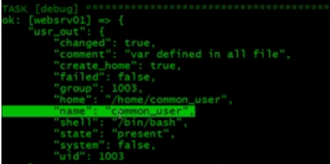

So, this is picking up the variables from all file.

----------------------------

In our inventory file we have some group also

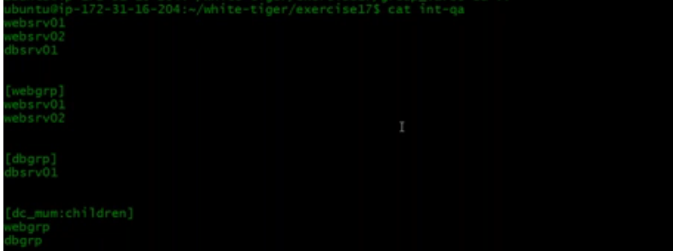

If you want to define some group specific variable, for that have to create a file under group_vars with the name of the group as in the inventory



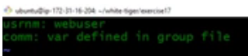

That’s for webgrp group and you can do the same for db group also





Lets review all files where we have defined our variables

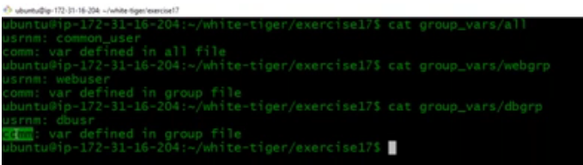

Execution:

For websrv01 and 02

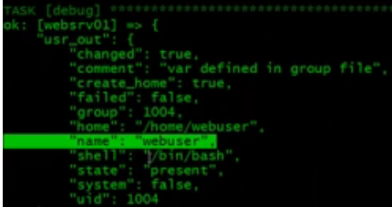

For dbgrp

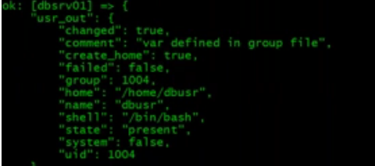

IF it is not defined in the group file. Lets say if I remove or I can move the file somewhere else



For the dbgrp, if it don’t find the dbgroup file , then its gonna pick it up from the all file.The user is already created in previous execution.

Execution:

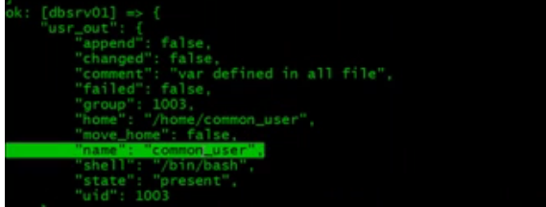

And this is coming from the all file.

Now we have one more level where we can define variables – **hostname file**

**Lets say** for websrv02 – I want a different value. So what I have to do is, I have to create a directory called **host_vars** and a file name with hostname **websrv02** as per inventory.



websrv02 file:



Execution:

After execution you can see for websrv01 it is coming from the group file ; For websrv02 var is defined in the host file and for dbsrv01 its not defined in group file, its not defined in host file So, it is taking from all file.

Now you trying uncommenting the var defined in playbook and everything it will pickup from the playbook

There is one more place you can define the variable not define but you can pass the variable name that is through command line. When you execute playbook and with -e option with variable name = value

Execution:



And you will all coming from command line defined user.

Hence command line variable variable ahs the highest priority.

**Conclusion:**

Its always better to use group_vars/all file to define your variables or you can start defining evrything in playbook the move it out and and keep it in the all file.

IF you have a senario where particular host needs a diff value then you can use hostname file

IF you have a senario where particular group needs a diff value then you can use groupname file

**Exercise18:**

**Lets** start making our ntp playbook more better and learn new things.





Here ntp_deploy.yml playbook is for installing ntp on different operating system plus some packages through loops, and then checking the condition and starting and enabling ntp service on both OS. Then we are pushing the ntp configuration file which is different fro again centos and ubuntu , Again we have condition checking whenever the configuration chnages it will call the handler and restart ntp service/

We can make it much better. You want to write a ntp playbook that’s works across organization, like ntp we have other services which are common across organization. Whenever a new system is deployed you run your playbook and the sytem is ready with all common services/softwares. So I want one playbook which will work for all across all datacentre.

Lets see our ntp configuration file

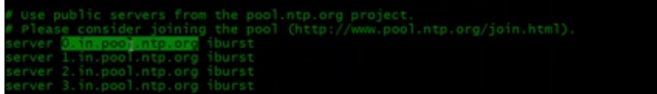

Here its syncing the time with India. Suppose you want to execute this playbook for US datacentre then the value here is different like us ntp server or if its UK then uk ntp server. The point here is this is something which will be chnaging based on the geographical location of server. You would like to have a playbook that picks up the value. The highlighted value changes that means you should be using variables over here. But can we use varibale in a file ? In playbook we can use but in file we cannot use.

We have a module called **template module** which is very popular for configuration files. When ever you want to push your configuration file, you use **template** module which is similar to copy module except it has a benefit of using variables.

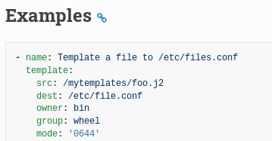

In this source, you have a template and its extension is j2. Template is as similar to your file that you are pushing except it can have jinja2 variable, it can have jinja2 loops, it can have jinja2 condition. It’s a jinja2 template. So, when you push it through template module, ansible will read this template file and see if there is any jinja2 template. IF it’s there then it’s going to interpolate that , if any variable it will change the value and push the file.

**Let’s do this exercise:**

First I am going to create a directory called template which is not mandatory . But to keep it organized.

Lets edit our configuration file

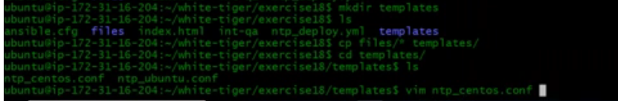

Let me name the variable in ntp configuration file ntp0srv,ntp1srv.. on both ubuntu and redhat conf file

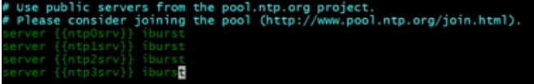

Let’s see what we have

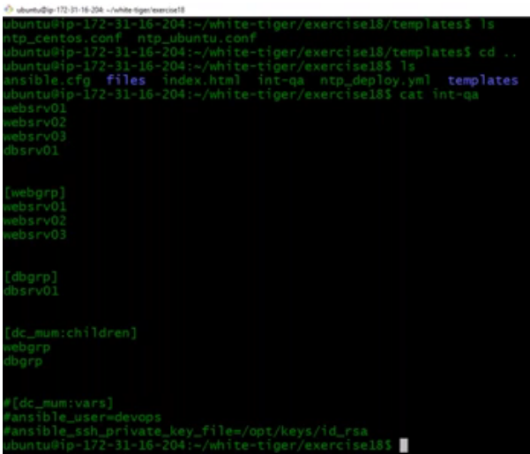

Let me search ntp servers in ASIA and we will use that



I will define the variable in group_vars/all file

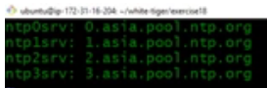

I will change the conf file names with extension j2 so we its our template file

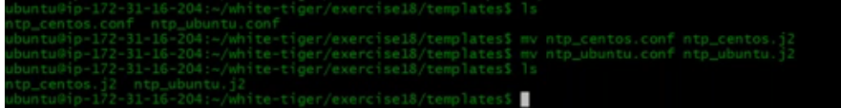

Lets now edit our playbook

Copy module will change to template ; source file will change to j2 file which we have renamed

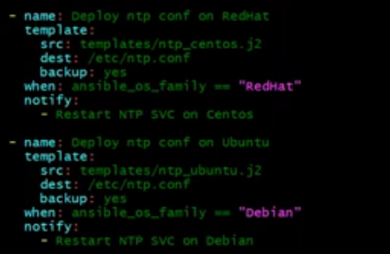

Execution:

Done and success

There are many ansible environment variables you can define. Go through documentation for better understanding.

One example is – In our paybook we give become= yes which will do sudo.

This you can set as an environment variable and use it by default.

Documentation:

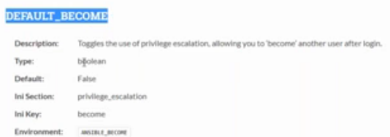

I can export the variable like below



This is temporary and if you reboot its gone, so I will set it in bashrc file

**Exercise19:**

This our ntp playbook is really a nice one and almost we have 75 lines in it. This is just a simple playbook and if we add post installation task in it, our playbook will reach around 200 line and it becomes complicated. Ansible believes in simplicity and if you want to simply it more, there is a way to do so.

And this requirement will be when you want to give your code and people from different project can use it. IF that’s your use case then you can go for **ROLES**.

Lets say you have lot of songs in one directory and it becomes really difficult to find your songs, so you create directories and put songs there. We do that because we can easily access them per my requirement. Ease of access. In a similar way we have roles in ansible that segregates things.

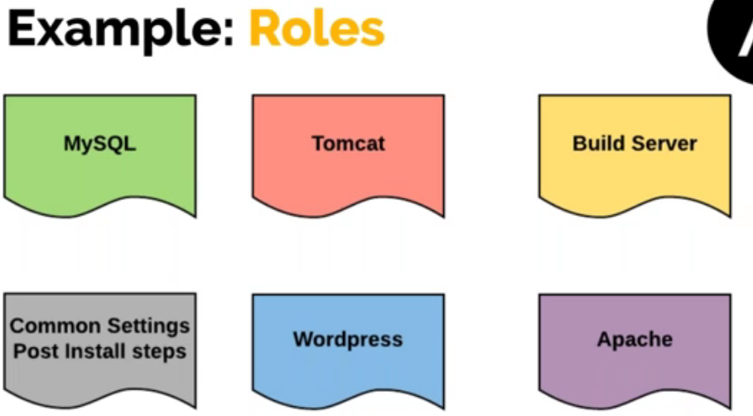

I can create different directories to handle all in ansible like handler’s different directory, tasks, templates..

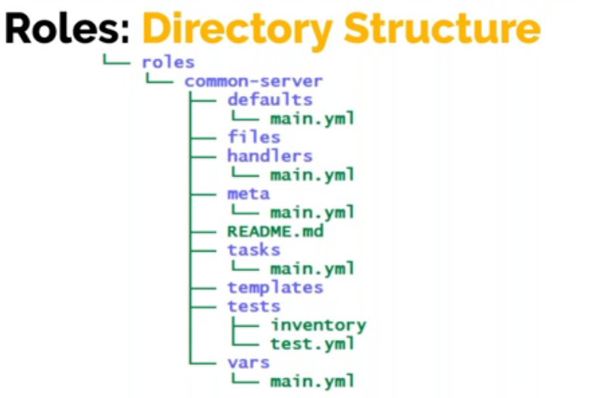

With ansible there is a simple command which creates directory structure for us. You can create manually also and then you can distribute things from our playbook.

I have copied exercise18 to 19

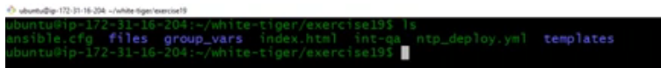

This playbook I want to distribute and when I do that segregation everything I will move out and left with only host and the role name.

In the same directory create a roles directory.



Go inside this roles directory and issue the below command along with role name

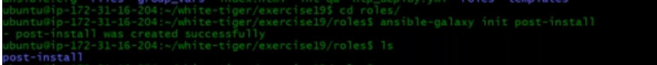

Below are the directories it will create below our roles directory

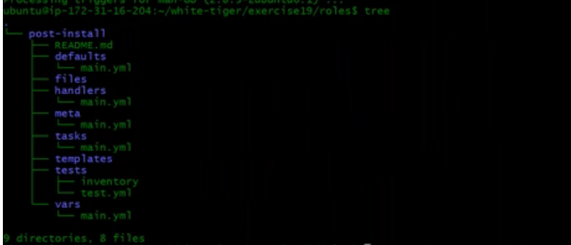

In defaults also you can put the variables, but this will have low priority than vars

Most of the time we put variables in defaults when we are using it for organization level and if someone wants to overwrite then they can put in vars or they can pass it in the playbook.

We have a directory called lint which is a code analysis tool for yaml. If organization has that standard then you can use lint and out your test cases there.

I will put some variables also in the playbook. Lets go back to our playbook and add variables for dest path of file.

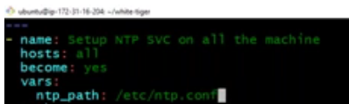



We know the directory structure and now I will copy all my tasks from the playbook and paste it to the file main.yml



When you do copy paste, you will see extra indentation. Correct those

First see how many spaces extra you got – I see 4 spaces and now in vi editor you can replace these 4 spaces to nothing - :%s/<4 spaces >//

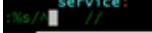

Copy the handler’s content and paste it (only the content like below)



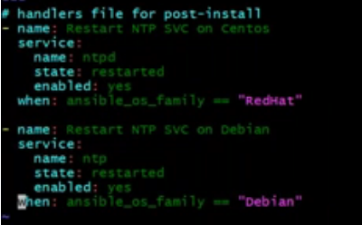

Copy the variables also and paste it in respective directory



We have variable’s defined in group_vars also – even this I will put it in main.yml

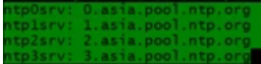

***Note:*** *Putting variable’s in defaults directory gives you this – If variables are not defined anywhere then it will pickup from default. If it is defined anywhere else then defaults variables will be overwritten.*

Let me put the templates also



Whenever you are using template module it automatically picks up the templates from the template directory and you don’t need to give the path, just give the name. When you use copy module its gonna take all the files from the files directory and push it. You don’t have to give the path, you have to give the name in the source.

Now I will remove all that I copied from the playbook and now my playbook has only below entries and then you have to give the roles and give the role name which you defined. You can give multiple roles here.

Now let’s go to our tasks file and we have do some changes there.

We have a task and it is pushing a template but this template path we have given relative path looking for template’s directory. Now this is a role – it’s going to call from the role. It will anyways when you use template it will go to the template directory and inside that again it will look for one more template directory which will not be present. So you need to remove that

Before remove:

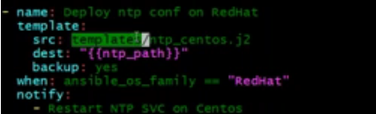

After remove;

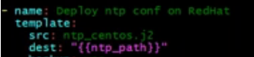

Playbook:

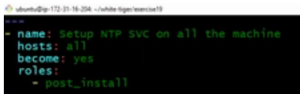

***Information:***

*My ntp playbook file was open and the session got hanged, and session got disconnected so what will happen is when I reconnect and open my playbook*

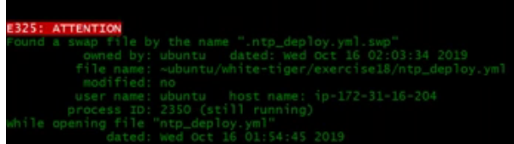

*This is because system will create a swap file for us like a backup and you remove them.*

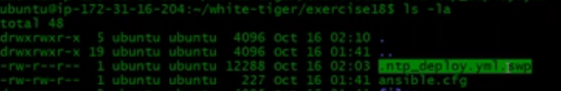

**Exercise20:**

**Encrypting variables:**

For this we will take db playbook.

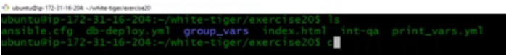

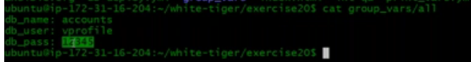

In group vars you have all file and it has variables and its value is a password. It is very dangerous. You can encrypt this password. Ansible provides us a vault Ansible vault and it gives us file level encryption. We can put file name “all” where you can all the variables. You can also create a directory named all and put several other files in that.

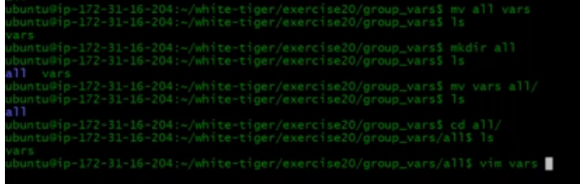

Here, instead of giving db_pass value as password, I will give another variable (any name). So the value of variable is another variable which we have not defined, we will define it into the vault.

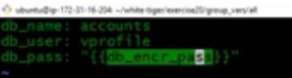

Let’s create vault now. Anisible-vault create “vault name”. It will ask for a password to create and every time when you want oto open it, it will ask for the password.

This opens up a file in vi editor and here you can give the variable and its value



When I save this and quit this file, it will create a file with the vault name and if you now cat this file – you will see its encrypted

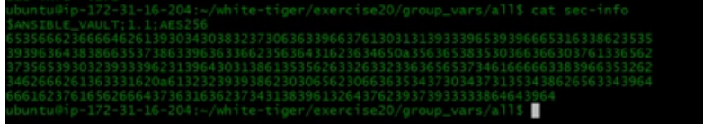

Now if you want to see the password you should say



If you want to change the value then you say



Now if I try to execute the playbook, we see an error

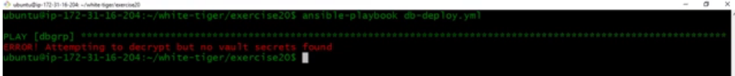

It goes to see db_pass value which is another variable which is defined into the vault. It tries to access and fails.

To get rid of this you can say



You can give this info in ansible config file also



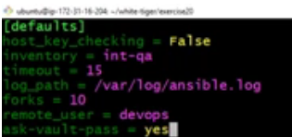

**Debugging:**

Sometimes you make syntax error in your playbook. Before executing your playbook if you want to check for syntax errors then you can say



Sometime some playfield not entire playbook. Sometimes one playfield for some xyx reasons you are not able to access the server or wrong configuration something and it displays information and that is not enough for you and if you want to see more information then you can say



If this is also not enough then you give one more v. and with 4 v’s it will actually display everything what it is doing.

In the area of debugging there is one more option with “C” . You want to execute the playbook but you are not confident, but you want to see how it’s gonna be played out. This will do dry run. It may look like actual execution but it is not.

When ever you execute playbook you always do syntax check then dry run, but then dry run will not guarantee that its gonna work as it is.

You can improve the execution time of the playbook if you are not using fact variables. In case if you are not using fact variables then make it false

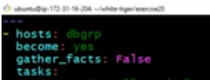

**Vprofile stack playbook:**

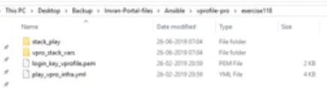

This exercise does 2 things

1. It has a playbook which will setup your Ec2 instances, key pairs , security group for stack. It will launch all your instances for nginix, tomcat and all other service
2. Execute another playbook which will setup services on those instances.

We have a directory called **vpro_stack_vars** – here we are keeping variables

So far we have seen that we are defining variables in group_vars/all file. Basically, you can create any directory of your name of your choice and then you can include the directory. Group vars or host vars are automatically imported into ansible playbook when you execute but if you want any other directory to import for variables, in your playbook you can give an option vars file and give list of files.

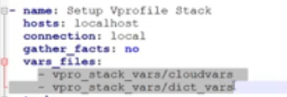

In **cloud vars** file - This file contains variable where I am specifying the region, my IP, instance type, ami – which instance to launch, subnet1, subnet2 (launching instances in multiple subnets), and security group ID (Below are fake values and we will se the actiual values when doing execution).

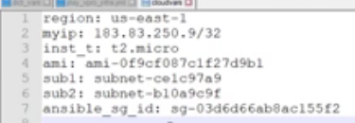

Let’s go through the **play_vpro_infra.yml to setup EC2 instance**

When you setup the EC2 instance that time you also create key pairs and security groups

First have to create key pair:

**Exercise21: To create key pair for clould EC2 instance**

I am going to write a playbook



Choose your region



**ec2_key** is the module which will create the key which uses API. There is no ssh and winrm here. It will execute the playbook on ansible machine, and it uses some python library which does API call to your AWS account. You need to install **boto** (a python library for AWS tasks – AWS SDK), **boto3** and **python 2.6 or highe**r on your ansible machine as part of requirements. You need **access key** and the **secret key** which you can put it in the playbook which is dangerous, but you can do it other way also, you can store it in bashrc file. You can check the ansible documentation examples. **ec2_keys module** will create the key pair but here you wont get the private key. It creates in the background and returns the private key but you have to store it somewhere. That means you have to register it in a variable and use that variable to store a value into some file.

First we will install boto

First update repository

If you search in repo # sudo apt search boto – you will a lot of versions of this. Its better you install all

For now, I will install the below, later we need more of it



Ansible to authenticate AWS account you need IAM user with user keys. So, we will create an IAM user in AWS.

Go to IAM→users →add user→user name **ansible-admin**→programmatic access → Attach existing policy→admin access→create user and download the user security credentials. This will be the key in csv file.

You need to setup authentication. You can refer ansible aws authentication documentation.

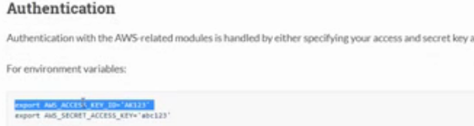

You have to export the access key ID and the secret key ID but this is gonna be only in runtime, when you logout this will be gone. So you can put then in bashrc file. You can also set this into vault file but every time you execute you need to provide the vault password.

So we prefer putting them in bashrc file (these are fake values, you put your actual value)



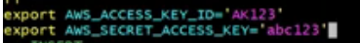

After you put do source bashrc



Now its time to test

I have a playbook that is using ec2_key module which is going to create vprokey in the region ap-south-1.

Let’s execute playbook

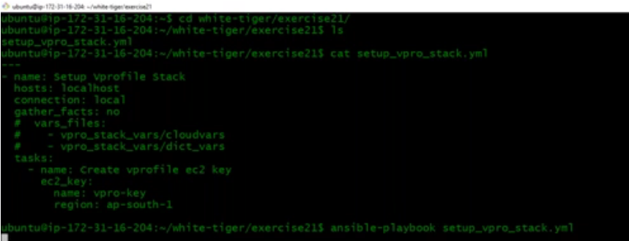

And it worked.

Let’s now go to AWS account and see – go to key pairs



Its created.

But now where is the private key for this ? IF I don’t have the private key which will be matching the public – how do I login to instance. Its waste so I will delete this key pair

So, I will go back to my playbook and register this one which is the most important thing in API tasks. Always register every task because you will need that in next step. Register will keep the output of the task in a variable and I will use msg to print that value.

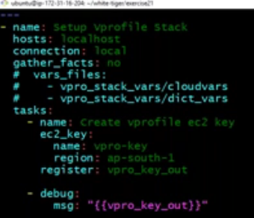

Execution:

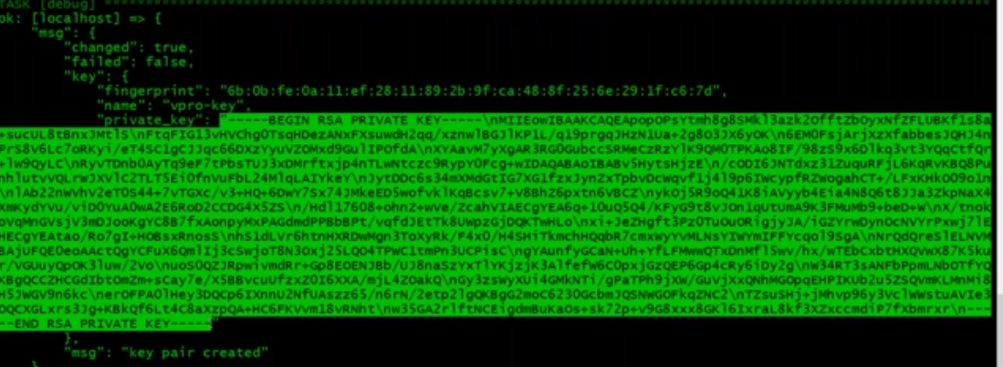

Now this is the private key which you can copy and keep it in a file and that will be your private key file. But we don’t need to do it manually, we can have ansible to do it. We can use a copy module and in the source we can specify the variable and in destination we can specify the file.

“.key.private_key will get me the highlighted value”

Let’s add this in our playbook. When using copy module we give source and destination or instead of source I can also use **content** and specify the content I,e variablename.key.private_key and that content will be written to your destination file.

Playbook:

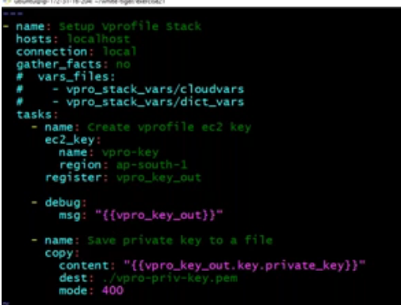

Execution:

Success and it created a file in our destination with the private key



Lets now talk about the playbook for our v-profile stack for launching ec2-instances

Play_vpro_infra.yml

**This is for launching ec2 instances**. Here we are creating keypair, security group and number of instances.

We have seen above how to create key pair and now we will see the security group.

In security group we have seen a rule adding its own security group by giving its security group ID but to have an ID you mush have a security group first then only you get ID.

So, you first need to create a security group and get the ID of this security group.

**ec2_group** is the module to create security group.

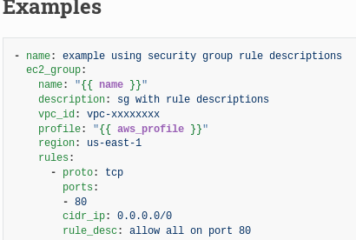

Give a name , description, region – it’s value is a variable and the variable is defined in the **cloudvars** file.

Then rules – first rule we are saying port 80 is allowed from anywhere, port 20 is allowed from myip which is again a variable defined in cloudvars file which is a fake IP – make sure you give the actual IP, then again port 80 allowed from myip for tomcat, port 80 for nginix, 3306 for mysql, and once this is done we would like to register its output into a variable vproStackSG.

***Note:For inbound rules we say rules and for outbound rules we say rules_egress***

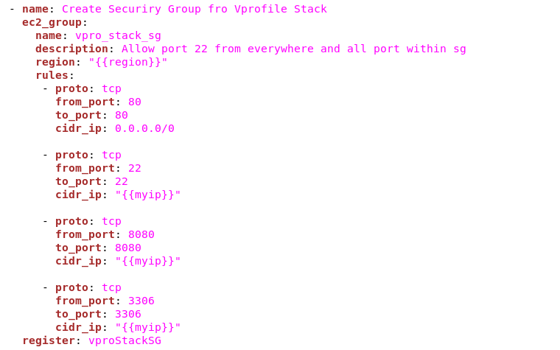

Once this is done, I am going to create the security group again and add one more extra rule which says

proto: all and group ID is its own group ID

**- proto: all**

**group_id: "{{vproStackSG.group_id}}"**

So, when we create the security group it gives output in JSON and store that into a variable (first sg one) and same security group we are writing again with an extra rule and reason why we doing it again is – if we don’t give then its overwrite the security group and we will have only one rule

**- proto: all**

**group_id: "{{vproStackSG.group_id}}"**

and we are registering hat output again. We can debug and print whats the info in that.

**The second section in this playbook is to create ec2 instance**

Module name, key name – key should already exists, instance type, image name, wait yes means it will wait till the instance is running, group, count – number of instances,

***Note: If you don’t specify VPC, it will get created into default subnet***

***One problem in this ec2 module/security group is it is not idempotent. You execute your playbook and it creates an ec2 instance, then you again execute playbook it will create again and its not gonna check if the instance exists or not. Most of the API task will be not idempotent. So you have to use some trick or technique so that it wont create again. You have to make sure whenever you execute palybook it is idempotent if the ec2 instance is already there then it should not create it again and for that purpose we have some options here we can use that as a trick.***

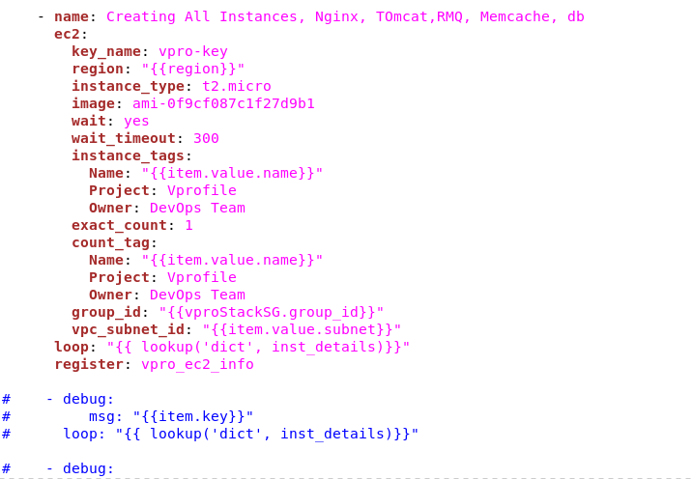

In our playbook we are creating all the instances and we are running the task in a loop and that loop runs over dictionary variable.

Dict_vars file (dictionary variables)

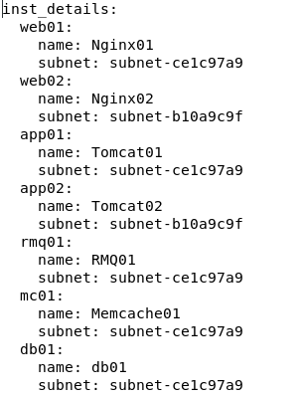

Name of the dictionary, in that we have web01 as key in that we have more dictionary name and subnet. Like when you want to group variables like web01, web02,app01… we have multiple variables and you have to group them then you can dictionary variables. These are used it in loops a lot.

If you want to use dictionary variable in the loop you need to use a method called as **lookup.** You say **lookup** and say **dict** which means I would like to load a dictionary.

Lookup is a function where you are passing 2 values one is dict (what kind of variable) and the variable name **inst_details** . In loop we are saying load the dictionary variable and this loop will have all the items defined in our dict_vars file and again those item contains more things like key value pairs.

So when you load that loop returns a variable named as item.value.name which means inst_details in our dict_vars like web01.Nginx01..

The task which we have in our playbook to create instance will make sure if you execute again, it will not recreate those instance again and that’s because we have given options:

Instance_tags. We are tagging all the instance, exact count 1, count_tag. So, when you execute this playbook its gonna count the tag, if it doesn’t exist then it will create it exact count is 1. If you already have a running instance that means you already have tag, it counts the tag - it already exists and it exist once so it will not create it again.

At the end of playbook, I have a debug module to print private IP. The debug module is running on a loop which is basically coming from variable **vproStackSG.**

**Let’s do this practically:**

Login to your control machine.

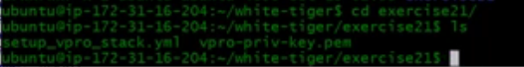

You need to set variables files first - cloudvars



myip = internet IP

AMI = we will take ubuntu OS →click on launch instance and in AMI do a search for ubuntu to get AMI ID



Subnet = AWS→VPC→you create your own VPC that would be better. I already have subnets and I will take those 2 subnets

Ansible security group ID = from ansible EC2 instance

**Cloudvars file:**

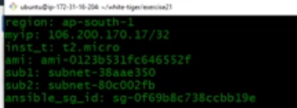

We need to create one more variable file dict_vars. here also you need to give the subnet

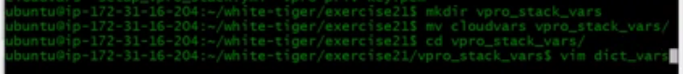

**dict_vars:**

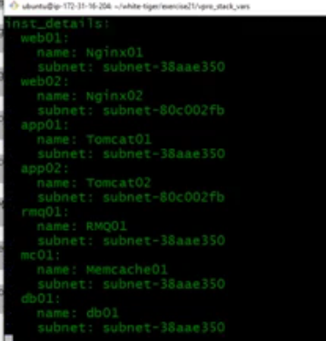

We have already generated the private key and saved into a file from playbook **setup_vpro_stack.yml**

Now, if I run this playbook **setup_vpro_stack.yml** again we see for task create ec2 key it says the key pair already exists. But we have another task to save the private key to a file for which we see error reading undefined variable.

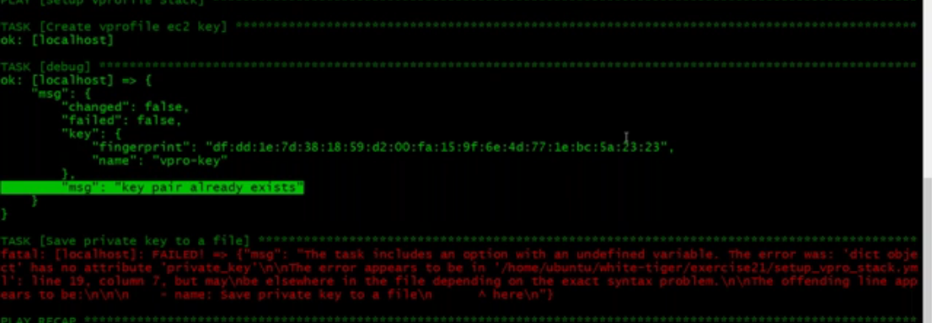

So, in the playbook saving the private key task we have a variable **vpro_key_out.key.private_key** in which **vpro_key_out** exists but in that we have **key.private_key** which we will get at the time of first time key generation. So how do we handle this situation – we can add a condition in the task

when: vpro_key_out.changed

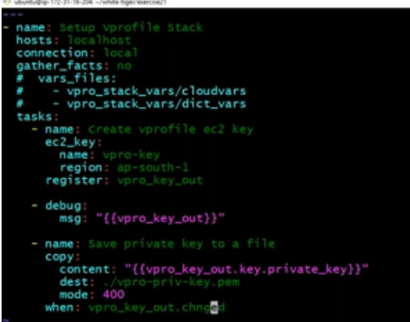

Now if I execute my playbook, it will skip the task as there is no change



You can delete the key from the AWS console and then re-run the playbook so that changed value will be true, and the task will get executed and save the private key.

Now if you execute the playbook again you don’t see that error which we have seen before.

***Question: What if a task fails in a playbook – what do you do ?***

***There could be several reasons, if its failing for connectivity you can fix the connectivity, if its failing for syntax error – I know how to check the syntax error(indentation). If its failing for variable and so on. So, ask them back if you be specific, I can tell you the answer.***

**I will remove everything from this playbook and do a fresh one:**

I am copying all the contents from the **play_vpro_infra.yml** to **setup_vpro_stack.yml .**

The better way of understanding this playbook is add task execute it. First you execute key task which we already know. Also use debug module. Create a security group – we are registering it and use debug module to print it.

Now lets run our playbook and see the execution (take the exact contents from play_vpro_infra.yml):

Execution:

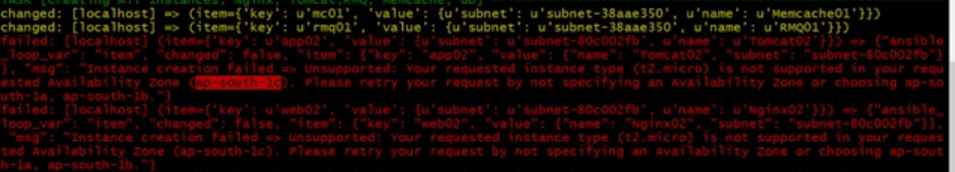

We see a error and it is not allowing t2.micro in zone ap-south-1c so I will change the subnet in dict_vars file



Lets execute our playbook again:

Its success .

Lets stop Ansible here for now.

**Docker:**

It’s very important to understand isolation so that you can understand containers.

Isolation is putting multiple services in multiple instances/VM’s. Because of isolation, we need multiple VM’s/instances/servers.

Normally we use VM’s. Every VM will have its own OS and it need some resources. It will need its own CPU RAM and storage. That is taken by OS itself and you will run your service on it. We allocate some resources and do over provisioning just in case to much of usage is happening the service should not go down. But the question is how much we really use those resources.

Isolation is expensive but we need that. We need high availability also.

This is more expensive also. All these is just because we can isolate our VM”s. Every VM has OS. More systems to manage and we need more system admins. We need licensing for OS. OS takes time to boot. We do auto scaling but it really takes much time. VM’s are also portable but they are bulky. They are huge in size. We do all this circus so that we can isolate the services. It ends up in high capital expenditure and operational expenditure.

Now what if we can achieve Isolation with in the OS or without the OS. Without having different VM’s we can isolate our services and that’s good.

I have running tomcat and mysql on same machine, but they are isolated. They will have their own IP address, their own part of network shared and resource shared. This sounds similar to VM’s but **NO.** Welcome to **containers.**

**Containers:**

Containers provides Isolation and not virtualization.

I have tomcat running along with other many services, but I don’t want tomcat to spill its problem with other services. So, what I can do is – I will have tomcat run from a directory and that directory is isolated. It will have its own IP address, network, resources. This is not gonna use the systems Java or any other libraries. What ever it is required to run tomcat, it will used from the directory itself. This directory may sound like VM but one important thing that there is no **OS** in this directory.

Its light weight, no question of over provisioning as we overprovision OS. We can run multiple containers on system, and they will not have their OS.

Container is gonna share the host machines kernel for resources.

We have nexus and it has artifacts and now let’s say I want to distribute the artifacts to developers. To run that artifact they need a system, OS on that , need dependencies and then running tomcat and then you run your artifact on that. So here we are packaging and distributing the artifacts. Imagine you are distributing the server itself/ Vprofile running on tomcat which already has all the services required and you just pull it and run it – very convenient to use this but they are very bulky as they are images of VM’s. Hence we have containers – this is just a directory, you create a container image for tomcat, create container image for your vprofile and so on. And then just distribute it. You need to pull the image and run the container. They are lightweight and they are awesome.

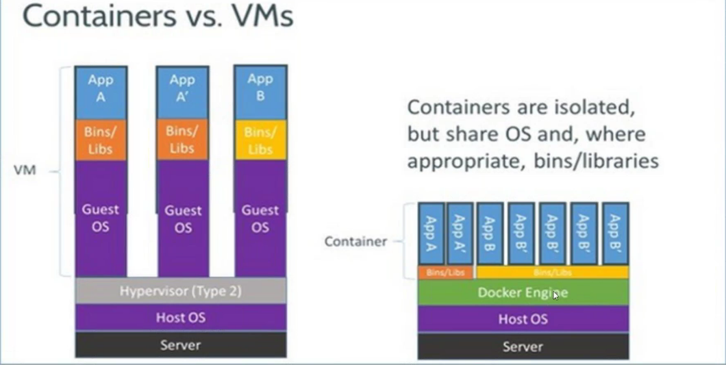

**Docker:**

Docker is a container run time environment or you can say Docker engine manages your containers.

Docker is an open source project that has many tools and docker engine is one among them.

Docker Installation:

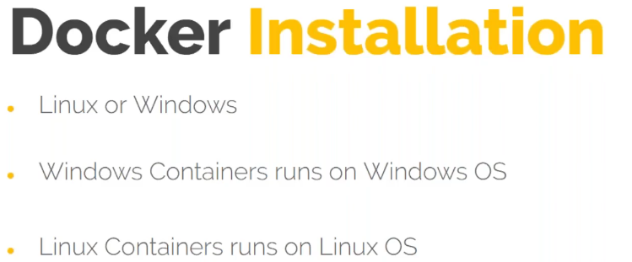

* We have docker enterprise version and community version.
* We will go with community version
* Remove if you have any previous docker installation
* Follow the official docker doc for installation
* Install dependencies
* Add the docker repository
* Install docker
* This has 3 packages docker-ce, docker-ce-cli and containerd.io

**Docker commands;**

Docker –version →shoes the version

Docker images →shows the existing or downloaded images

This command runs on root user but for normal user it throws error

If you want normal user to run these commands then do the below

Vi /etc/group

You will see a group called as docker – add the user here



To test your installation is correct – you can run a test

Docker run hello-world →it will see if image exists and if not it will pull the image and run the container from that and print the message hello world which confirms that our docker engine is properly configured.

Hello-world is an image from docker hub

**Docker HUB:**

In containers – we don’t build container from the scratch, we create container from the image. Docker hub is the most famous docker registry where docker images are stored.

Containers are running from the image. They are connected and you cannot remove the image when the container is running

Images will have multiple layers. Suppose the image had 4 layers and you run one container from it and it will add one more layer. You do some modification and create a package will add another layer.

You need to create an account in docker hub as we will use it for storing our own images.

There are huge number of images and these

Registry is a place where we store docker images and repository are the images itself.

Lets now take an image and see few commands of docker.

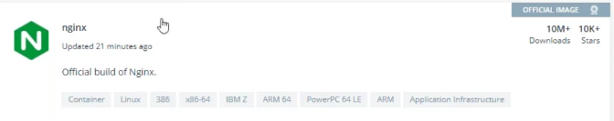

Official images are those from vendors and they have proper documentation on how to use it.

Below are the different versions of nginx

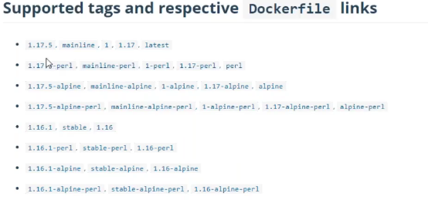

Every image will have multiple tags/version

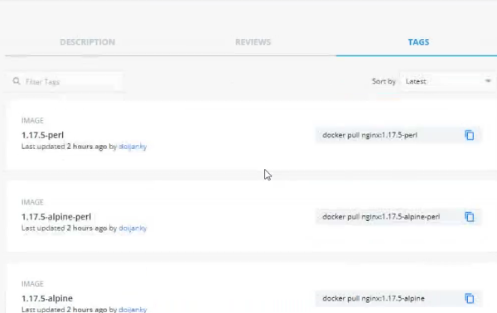

When you pull an image, you will have to specify the tag name and if you don’t then the latest version will be downloaded.

Now login to your instance where docker is installed.

Below is the one image will is already available

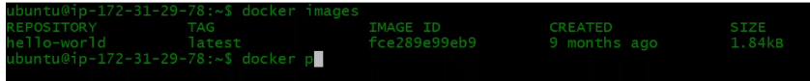

Let’s now pull nginx image from dockerhub

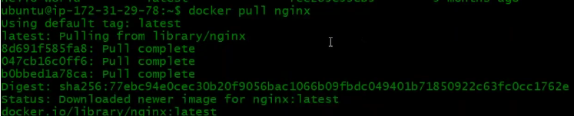

When you issue pull command it will by default will go to docker hub. Dockerhub Is not only the registry, there are other registries also like GCR, Amazon ECR..

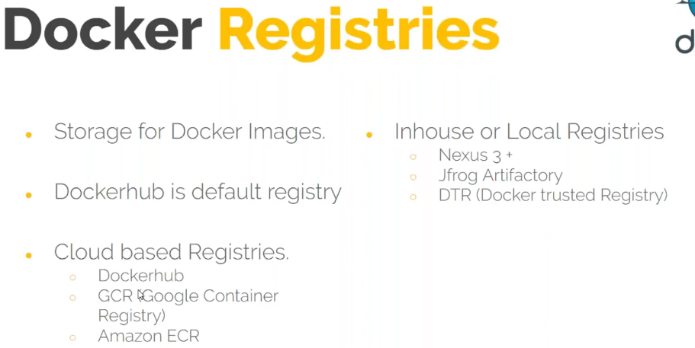

Now I have nginx pulled



Now lets run container from it – when you issue command docker run – it will create a container

Docker run –name “a name to container(not mandatory)” “image name”

If you don’t mention a name to your container – docker engine will automatically assign a name

Containers will be in inside network and if you want to access nginx from a browser outside network then you should do port forwarding which means host port is forwarded to guest port.

In our case host port is Ec2 and guest is our container

When I say HostIP:HostPort →the host will have a setting that it will route the request to containerIP:containerport

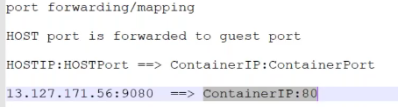

Instead of giving the hostII why cant I give directly the container IP ? →The docker engine will create an internal network

When you run ifconfig -a →you will see docker interface and all the containers will connect to this interface. This is an internal network and cannot be accessed from outside. What you can do is you can provide the private IP of the instance and that will route the request to the docker0 interface.

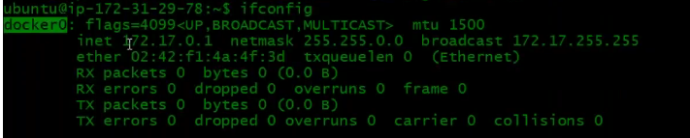

Let’s create the container

-d option is to run the container in background

-p is to specify the port

9080 is the host port – you can give any port but make sure the security group for the port is enabled

80- it is the port on which nginx is running

Once you run you will the container ID

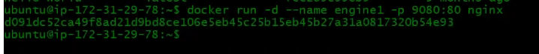

Docker ps – will show you all the running containers



Now you should be able to access the nginx from browser and that’s from the container.

instanceIP and port you mentioned.

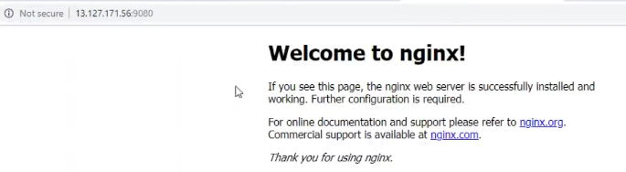

Docker stop “container name ” or “container ID” to stop a container

Docker start “container name ” or “container ID” to start a container

There is a directory structure **/var/lib/docker** → In this you will see several directories



In containers directory you will have the container directory with the respective ID

Now let me run a ps -ef command on the system level to check for the process





Here, you will see the container process 902 got created which created other process 8543 which in turn created the nginx process 8571. So that’s the proof that docker is managing the containers.

But then when you login to container and check for process it will be different and they have their own process history

**Some Important points :**

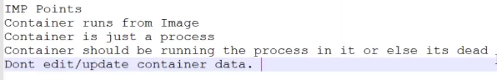

There are short lived container like hello world which you start it and still you don’t see the process running for it. You start it and the next moment it is dead. But nginx when you start it will be up and running all the time because nginx runs a command **“nginx -g ‘daemon of..”** which runs the nginx process and it wont be stopped automatically. As long as the process is running the command is running the container is running.

**Lets see another example now:**

When you do it in production style/ real time, you don’t need to manage container at so low level. You will be using some orchestration tool like Kubernetes. If you are using for some development work or testing – you will use these low-level commands to directly interact with docker otherwise if you are using some orchestration tool and this will be calling docker. But if you don’t know how this being called or something goes wrong behind the scene you will not be able to understand/troubleshoot.

Let me pull an ubuntu image – This is not an OS but kind of imitation of ubuntu OS.

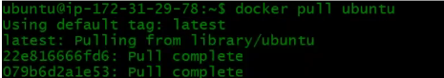

Now lets run the container for this

Check the docker ps command for running containers – I don’t see ubuntu container running

Check the dock eps-a command to check all the containers including dead docker and now I see the container is in exited state. Because it is running bin/bash and you need to attach to that shell. If not it will be dead. The process gets killed. When the shell gets killed and that’s the primary process and the container is dead. Hence we need to attach to that shell



Below is how we attach to bin/bash shell



My_linux = container name

i = interactive

t = tty session means I would like to interact with the tty session that is bash shell

/bin/bash = your system shell

Now I see the prompt that indicates I am logged (this is not the right word but rather we would say we have attached) in to container

Now I am in container and under root dir

Do ls and you see all directory structure of an ubuntu OS

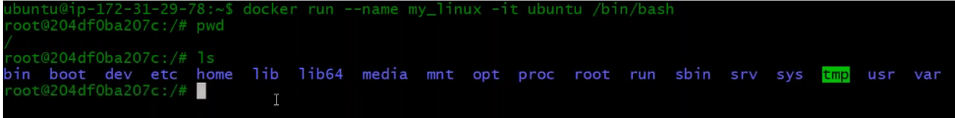

Now you can install your packages but remember this is not happening on your host OS . This is happening in the container. But we don’t edit anything when the container is running. We take container from the image. This is just to show you and get some knowledge. In case if you want to make any changes, you create a new image.

Now I am inside the container and running ps -ef to see the running process. Here bin/bash process is the first process running which is our container . If this process is killed then our container is dead.

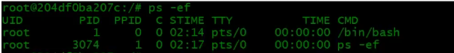

Let me exit from container and check docker ps output – The container is in exited state

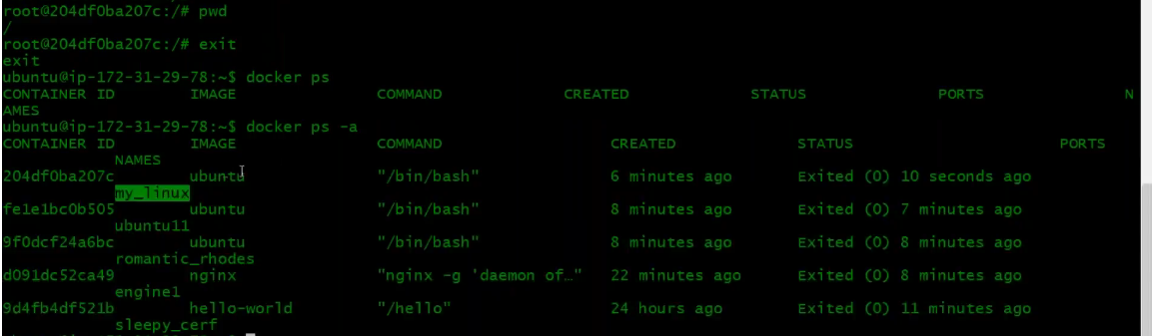

Now I can start it back but how do I login to container ? If I run docker run it will create the container

No worries there is a way to attach to a container. See the below ps output from system and I see the first process is /bin/bash which is our container.

There is a command to attach it but not at all recommended because now there is only one process here and when you run the command to attach, it will attach to the the first process of the container. Imagine if the first process is Jenkins or nexus or any other then what need to do we will see this later.

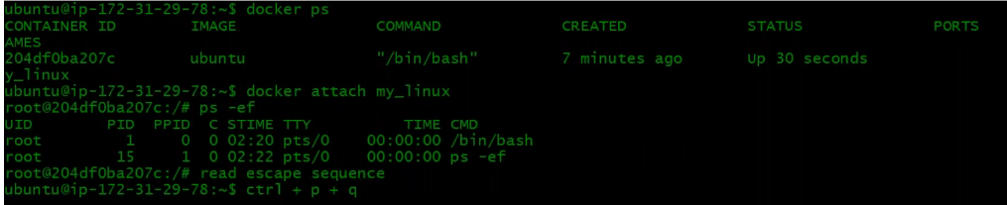

Now that I am in container connected to bin/bash

Now if I exit again it will kill the shell. I don’t want to kill it instead I will detach from the container then press **ctr + p + q**

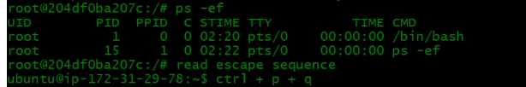

Attaching is not a good way of approach. There is another way and you can do more things with that

**Docker exec –** This is a command which will help you execute commands on the container from the host machine.

See below – currently am on host machine and if you want to execute some commands from host machine to any container (my_linux) then you can do like below



So, now you know to run any commands without logging into the container. You can do it from the host machine to any containers. But still if you want to login that is attaching you can do the below

docker exec it “container name” /bin/bash

it → this option is to attach to that shell



Now this thing you should know.

I had this container already running and then I came out of it doing ctr p q. Now that I am in the host machine and I did attach to container by running exec command. Now I run exit and come out of it and now back to host machine. So what do you think -container is now running or not ?

Yes it is running as you can see below the output. PID 1 /bin/bash was already running and now when we say docker exec -t my_linux /bin/bash it created another process in that PID 48. Now if I exit the PID 48 will be dead but still the PID 1 will be running. As long the PID 1 is running the container is running.

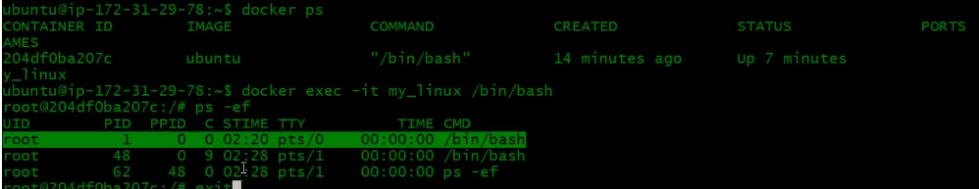

Now lets see how to attach a container to a shell

In the below output you see ubuntu is attached to /bin/bash but nginix is attached to a process. If you want nginx to be attached to /bin/bash then do the below. If nginx have the bin/bash then it will get attached



**Docker/container volumes:**

Containers are used to run stateless application which means the application which doesn’t store the data like web services, apache services, tomcat, nginx but there are stateful services also like SQL, oracle db which has data and retrieves data. From a long time, stateless applications are used in containers because the container is disposable. If the container is deleted, then all the data is gone. But if you can maintain its underline storage then you can run stateful application also.

Docker volume is a concept where you can store the data of the container to the host machine, to the docker machine. Even if the container is deleted the data is stored to the host machine.

**Lets see how to create that:**

I have pulled images listed here. Let me pull a stateful application MySQL and run it. Always refer official documentation whenever you pull any mages because you will come to know where the configuration files, environmental values, volumes and other information located in the container.

As per the official documentation I see below is the location where the container volume is located

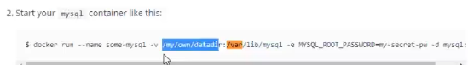

Whatever is there in the container directory will come in the host directory as highlighted.

One important thing is the host directory should be owned by the user who is running the docker container.

-e = this is to export variable

-d = detach mode

I have the latest MySQL pulled image, but I can use a different tag of image. I will go with 5.7 tag as the latest tag has some issues.

Let me pull 5.7 tag



Now I have this

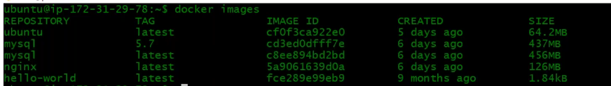

Let’s now create a host machine directory and give ubuntu user permission and then run the container.

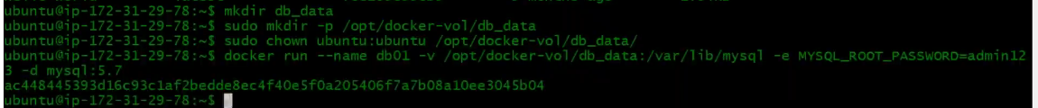

Db01 = I sthe name I am giving to the container

-v = **host machine directory which we created:container directory**

Now how do you know the container directory ? For this you can follow the official documentation or you can have a **inspect command** which you can run on the image to get the details.

-d = to run in detach mode

Mysql(image name):5.7 (tag name)

Let ‘s now run a docker ps command to check the running containers – our container is running



Since the container is running, it should have started storing data on the host machine directory -let’s check that



What ever written to the container directory is now we have it in our host machine.

To test it, we can do one more thing

docker exec -it db01 /bin/bash

Now I am inside the container and you can go to the directory to see the data

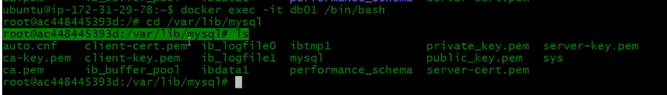

Now lets see what happens if I **delete the container**

First of all you need to stop the container and then remove.

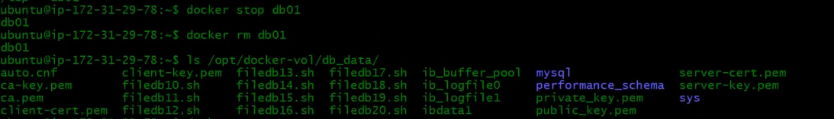

After deleting, I can still see the data under host machine directory, and you can create a new container and attach this volume to get your data back on container.

Instead of creating a directory for volume – you can use docker volume create command to create a volume and this will also create a directory under **/var/lib/docker/volumes**



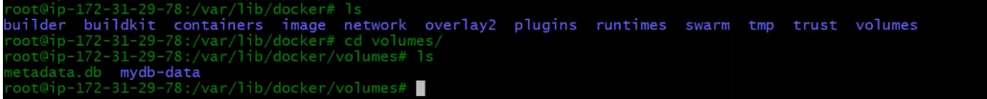

So, we can also create a volume and then use the volume to attach while creating container.



To list all volumes

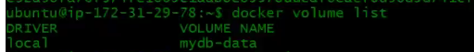

To remove images

docker rmi "image name":"tag name". If you don’t specify the tag then the latest will be removed

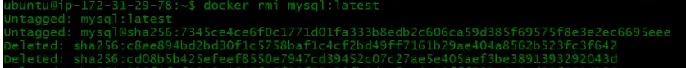

To remove an image, you need to first remove all the containers attached to it

**Building Images :**

We have seen maven build process – mvn install and it creates the artifact. Here maven looks for pom.xml file and in docker image the similar way it looks for docker file. Docker file is set of instructions that we need to write, and it will execute those instructions to create an image.

**Why do we create images ?**

I want to create a vprofile tomcat image. Where I have tomcat and vprofile artifact on it. So now if you run a container, my vprofiles comes up on tomcat. I can pull a tomcat image, run a container from that, put my artifact on it and then archive it and then create a image from that and then you can distribute it. So we definitely make changes to these images.

Docker build process will help us build our own customized images.

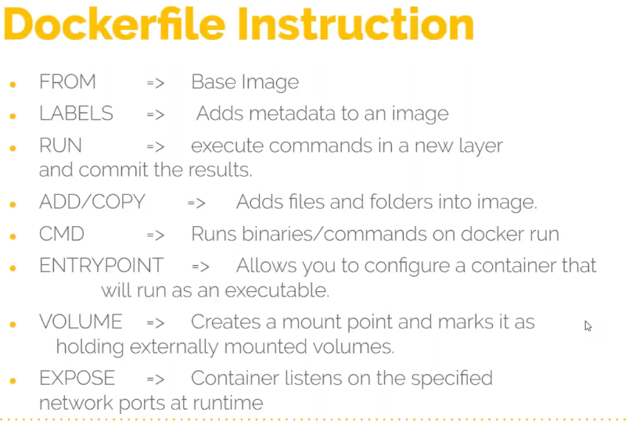

* We write a file called **“Dockerfile” (capital D).**
* Every image that we build will be based on some base image. Let’s say I have taken base image as ubuntu. So you can give the base image make from and the base image name
* Labels is just like tags
* Run instruction will tell build process that what commands needs to be executed when building the image
* Add/copy is to push a file/archive in an image like artifact. I say this is my artifact source and destination directory where you want to push the artifact. Like in tomcat directory or any configuration file also.
* CMD – is the command that gets executed when you run the container from the image.

Let me run inspect command on nginx and we will see a section like below which gets executed when you say docker run.

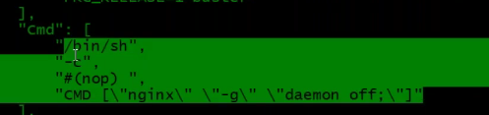

Lets me run the container



Lets see the ps output



You see it runs the command which creates the process in the container.

**So, how do you define this while building the image ?**

You define it through CMD instruction

* Like CMD there is also entry point which has high priority than CMD. In both you can give commands. IF you are giving commands in CMD then you can pass arguments in CMD
* Volumes – we have seen MySQL volume we connect – who defines the container volume.

Run inspect command on image and see

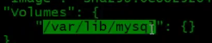

That’s why we mount this volume to the host machine because this volume are allowed to be mounted.

So, if you want to use such volumes – you can use volume instruction and give the volume path

* EXPOSE – When we run our container we map our host port with the container port. You should know whats the port that will be running when I run the container. What port number the process nginx will be running in the nginx container.



Run inspect on image and see the EXPOSE port info

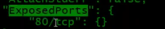

This allows the port 80. This will not open any port but it allows the port we mention here.

ENV

You can define the environment variable here

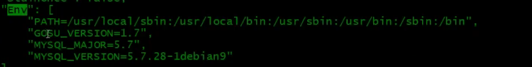

USER

By default, when you are running the container, it runs with root user ID. But if you want a different user then you can mention but make sure the user is already there in the image. You should have created with run instructions.

WORKDIR

Is a directory when ever you attach to a container you will be attached to this directory or whenever you are executing any commands on the container with docker exec – those commands will get executed in work directory.

ARG

If you want user to pass variables at the build time you can specify them

**Let’s create an image for our application from tooplate http service:**

Here I will build an image with all websites and you just say docker run and your application will be up and running. This process is called as containerizing your application.

* Let me create a directory by name docker images and a sub dir earth-web and inside this dir I will create my docker file
* You have to create a file with name **Dockerfile** (D in caps)
* Open in VI editor and start giving instructions

First you need to give the **FROM** instructions the image you want to take. Here in our case its ubuntu. Normally we don’t take OS based we rather take images like tomcat ,nginx where our service is already build and top of it we put our configurations/data.

FROM ubuntu : latest

* Give a label **LABEL** “Author”=”Imran” (You can give multiple labels)

LABEL “Project”=”Earth”

* RUN instructions to run those commands – use always -y

When we install apache, we get html /var/www/html where we put our websites. We have to get it ready first

Get the link and download under earth-web dir and extract it

Basically you need the artifact which we put in docker

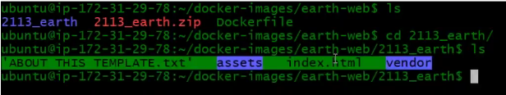

When need to archive the highlighted one which is our artifact. Always make archive in tar or gunzip format and not zip because docker build doesn’t understand the zip format



Now I have my artifact ready which I will put in my container

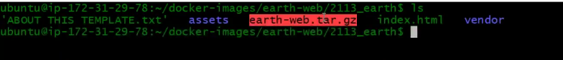

* Copy the name of the artifact and open the docker file and how to put it in the image while building the image

**ADD** “artifact name” “path to copy”

**Add** instruction can copy and even extract also the tar file

* Our service is gonna run on port 80 so we have to expose it

**EXPOSE** 80

* What command it should run when you run the container. It should bring up the apache process for this you need to use **CMD** instruction in square brackets. There is no systemctl or service command so you need to give the binary path CMD .You should know all the binaries of different service to start the process/service (you can google binary starup file for so and so service). When you say systemctl start apache2, it will basically execute the below command

**CMD** [“/usr/sbin/apache2ctl” , “-D” , “FOREGROUND”]

* **VOLUME** /var/log/apache2/
* **WORKDIR** /var/www/html/
* Save and quit the file

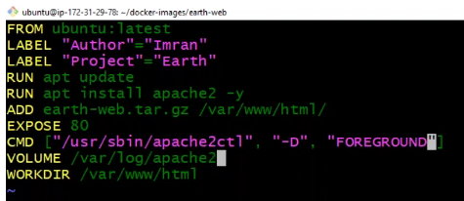

Now let’s build our image

docker build -t “give a name to the image” “path of the docker file”



When you execute this command, it will read the docker file and build an image step by step. For each step it will create a container and then delete and then create again from the previous container. Read the output of the build image which is important to understand.

Now the image is created, and you can run the container from it.



Let’s run the container now

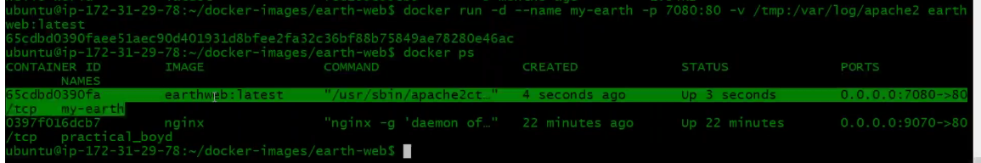

You can also run inspect on container and you see lot of information about it. IP address is one among them

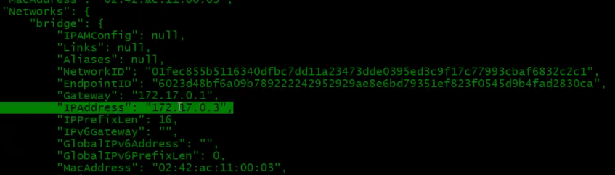

Lets access our website now

From the browser user port 7080 that’s what we defined which will route to port 80 to container and get the index.html





*In the prod env we won’t run container this way, instead we use orchestration tool Kubernetes where we create some templates to run containers*

*When ever you use ENTRYPOINT instruction – you pass arguments in CMD and that’s the meaning of using entry point. In case if they want user to pass the arguments then use both ENTRYPOINT and CMD instructions. In this case if the user passes the arguments in command line then the container CMD will be overwritten.*

**Docker distribution of Images/push to registry;**

When you build the image, then next step is to publish the image to **registry** and from the registry it will pulled by different ops team who wants to pull the image and run the container from it.

Dockerhub is a registry where you can publish n number of images publicly. In case you want to publish privately then it will be chargable. Sign up for this.

When you publish an image the below syntax to be followed.

**ACCOUNTNAME/ImageNAME:Tag**

Let me publish the existing image

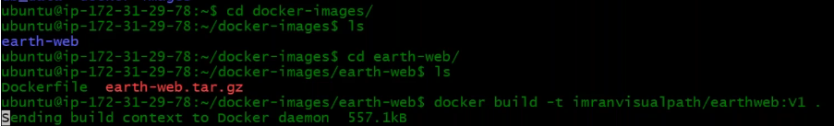

Below is the image that we build yesterday and now we build again with additional tag but the image ID remains same.



**How to push an image to registry**

First login to registry running command **docker login**

Give your cred to login

Now to push →docker push “image name”

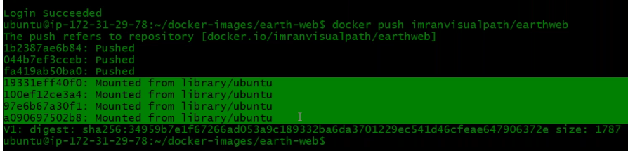

We see 3 layers got added and rest the highlighted 3 are already exists on dockerhub. So, it just creates a pointer to that. This will save the cost as data is not recreated in docker hub instead it just creates a pointer.

Now check in your dockerhub account and you should see your image.

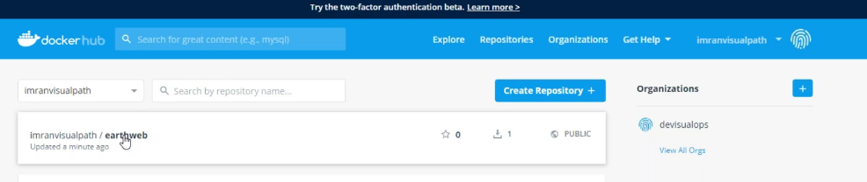

This is a public image and I can pull this image and run it.

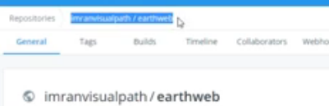

Under tab tags as you keep building your images with different versions, you give a tag and it is seen here.

You get into a project and you will be having various services in the project and if you are using docker as an infrastructure platform, then you need to build your own images for all your services.

Rabbit MQ and Mcache we don’t do any customization so you can use the image directly from dockerhub.

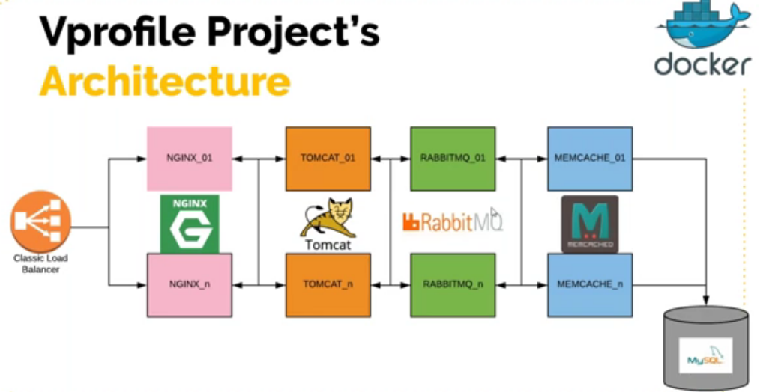

**We will now see how to build the image for application specific:**

In our docker file we are using ubuntu as a base image which is never good. If there is no requirement then you should not use OS based images. Docker hub will have service-based images and we can directly trust and use them.

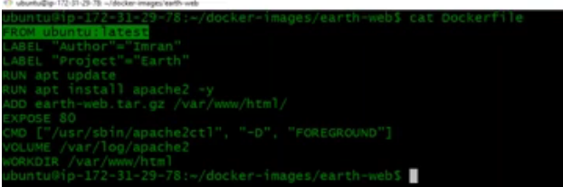

Golden RULE: Before dockerising first take your base image and understand it thoroughly. Run container from that , login to it , attach to it, see directory structure and then write a docker file.

The base image (tomcat,nginx..)whatever we are using will also have many docker files of different versions. You click and any and it will open a docker file. Which has lot of things in it which makes it very secure. The docker image what we build will not be to this level. Always use official base image.

We would be dockerising tomcat, nginx and MySQL services. We already have our docker files available in our GIThub vp-docker branch and I will clone the source code.

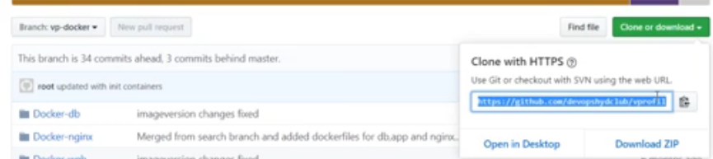

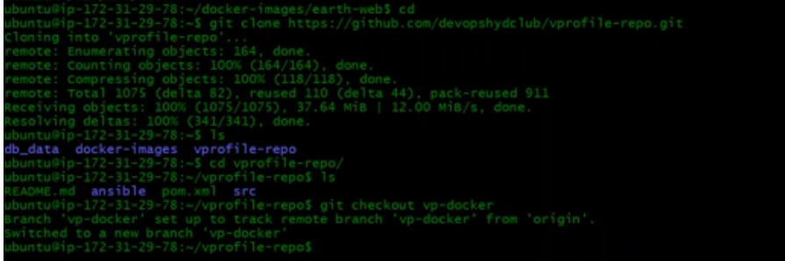

Under this we have the image docker-web. Check the docker file in it. This is a docker file to create vprofile application. You need to switch to the specific branch

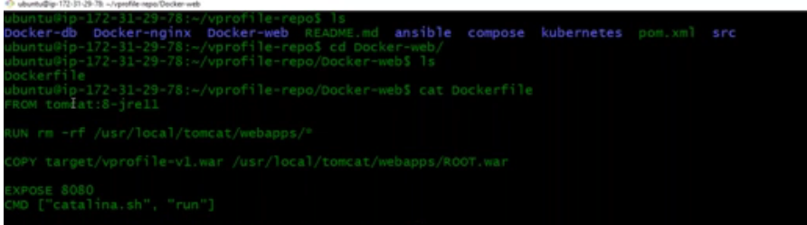

This is based on tomcat image. Tag is 8-jre11. RUN instruction is to remove the default application. Copy our artifact to the destination. Expose port 8080 and at last CMD. Even if you don’t give expose and CMD there is no issues as we already have this in the image tomcat.

We need the artifact. We need build artifact and we need maven for it.

Will do sudo apt update and then install maven and JDK. Will search and find the below JDK to install

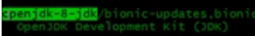

JDK install



Maven Install



We have the souce code, we have maven. Make sure you are in vp-docker branch. This branch is customized for docker related operations.

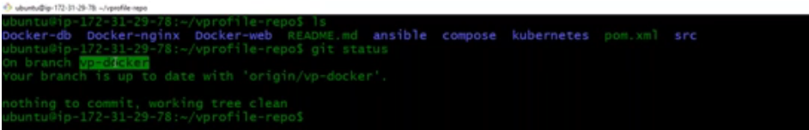

Mvn install



We got the artifact after the build process

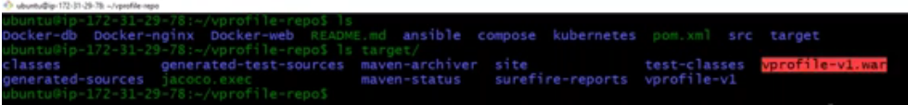

Copying the target directory

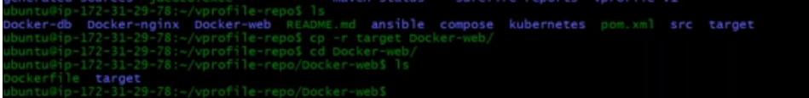

We have artifact in the target directory which will be copied to the containers /usr/local/tomcat/webapps/ROOT.war (name is important)

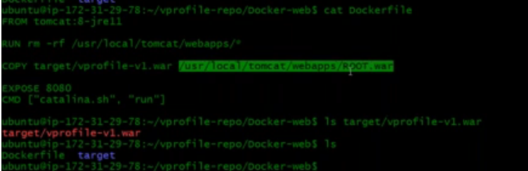

Now lets build it by giving a name and a tag



Lets see our image now

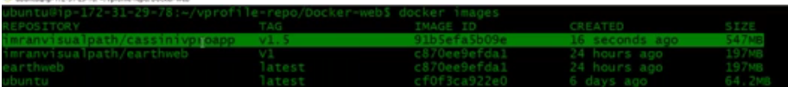

Pushing image



Lets see in dockerhub my account



**Now let’s build the db image simpler one:**

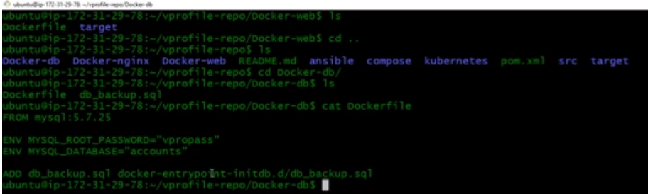

It is based on mysql 5.7 image, we have to set environment variable and then we have our sql file from our source code directory and we add it to this particular highlighted directory



For mysql if you add anything in this particular highlighted directory of the container like we are adding db_backup.sql file. While the container is coming up it will deploy the sql file in the database. Information is in the documentation of mysql in dockerhub.

Let’s build now



Let’s check the images now

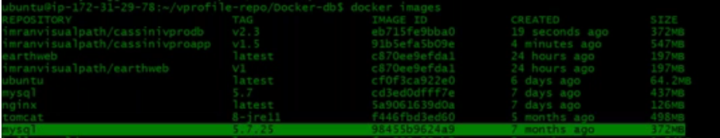

We can push this db image to docker hub

This is now our exercise to build the nginx image. So in docker-nginx there is a dicker file and you clone the source code. It has a configuration file that will be pushed. Read that configuration file.

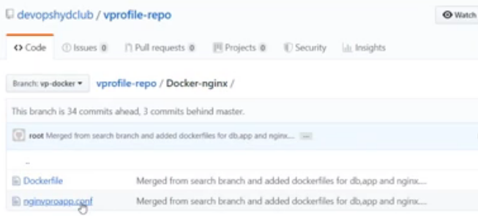

We should have all these 3 images (docker-db/nginx/web) in our dockerhub account for further activities.

**Now lets see how can we connect to containers together or link to containers;**

There is a link command (which is deprecated, and best tool is docker compose) which can link containers together. This is required here as we have tomcat and db images. When we run the containers tomcat should be able to connect to the db containers

First we run link on one container/image and then on other and then we link

**Question:** how does our tomcat application knows it has to connect to the db ? when we build the artifact there will be a file injected to the artifact which is application.properties file which has information about the database.

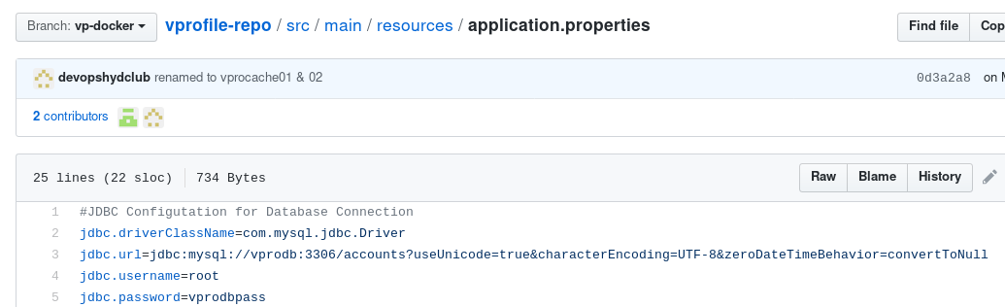

Such kind of file you read and see with what name it is referring to the database. So, when you build the db container, the container name in this case should be vprodb. Because containers talk to each other with the names and not IP. Name will be automatically resolved to the container IP.

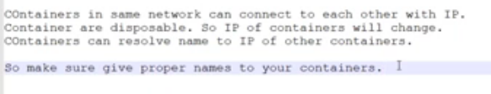

Let’s connect containers now:

I will now link db container in detach mode, Host port and container port then we need to set env variable, password we have given as vprodbpass which is defined in application.properties but in the docker file it is wrong. The point here is when building the image, you can give anything but when running the container, you should give the right value. User is anyways root so don’t have to specify that

Let’s run db container:

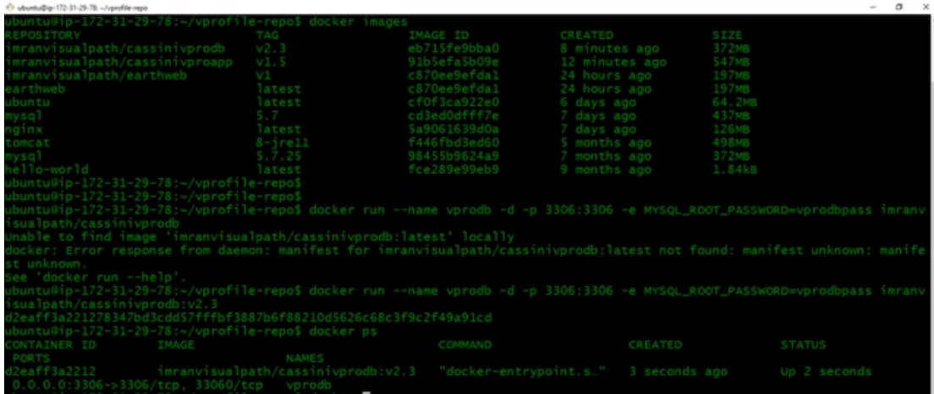

Now let’s run tomcat container and link with db container:

Here am giving name vproapp because nginx container will refer to tomcat with this name. you can check this in nginx configuration.

--link <“container name to which you want to link>:<give a link name>, port with tomcat container name:tag



Now run docker pas and you see aproapp container running which is linked to vprodb container.

Let’s test this now:

Hit in browser with dockerengine public IP and port 8080 and we have successfully dockerised tomcat.

We see the login page and now you can enter the cred username - admin_vp and password is also same and I could login.

Any time you want to see what is happening in the container, you can login to it and go to your application.properties.







So its referring to vprodb on port 3306

You can run attest from here to see if it is able to connect to db



***NOTE: IF you want to link multiple containers, link is not a good idea(anyways deprecated), you should always user docker compose which we will see in next class.***

We were told to create nginx as a homework and after doing that I have the below for nginix:

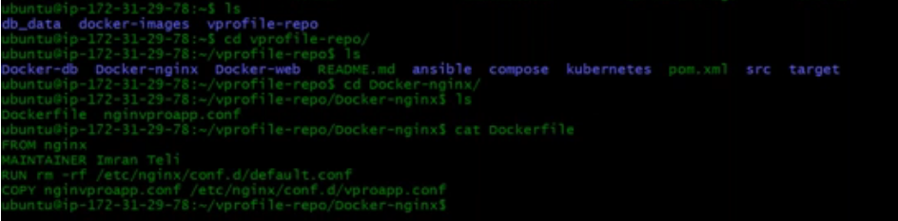

This is quite a simple docker file for nginx which takes the nginx image, MAINTAINER is the deprecated instruction in docker file which is gone, and we have to use label.

**Docker Compose:**

What is that we do working for a project and using docker and containers ? Your primary task is to dockerising or containerizing all your services.

First you should be able to do them manually then you can write a docker file for each and every service and once this is done there would be registry either you have dockerhub or any private registry. Then you have to start storing the image in registry. We can setup a continuous integration process for this like fetch the code, build the code and create a docker image and upload it to dockerhub or any other registry. This is called continuous integration of docker images. This will our first part of work.

The other part of our work is much more complicated which is to run the container and it should be highly available, error detection and automatic recovery, you should be able to scale exponentially (10 to 100 containers in a minute) and all these power you get through orchestration tool like Kubernetes.

**Let see docker compose:**

You have to first install docker-compose. Then you create a file called as **docker-compose.yml** like below. Version 3 is the latest, services means containers – web and redis are the container here, redis container is simple as we are fetching the image and running it. In web container we are saying build – docker compose can build your container from docker file, there should be a docker file in the current location, once the image is ready it will run the container and it will have ports mapped 5000:5000 (you can have n number of ports so, the below example for ports is a list), mapping volumes – it is saying dot which means current working directory with containers /code directory, and it is mapping one more volume. We can specify link – link web container link with redis container. At last we have volumes which is instruction for services and services means 2 containers here. Once you have this file ready then you say docker-compose up. We are not going to do much on this as we don’t use this much other than local setup. We don’t use this for productions. We have Kubernetes for all these.

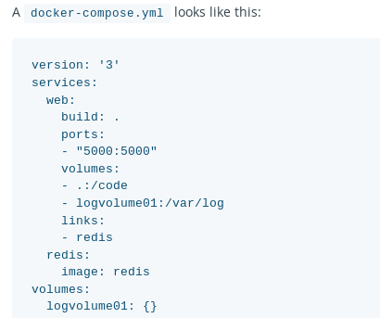

While building image you can get help by using the link - <https://docs.docker.com/engine/reference/builder/>

And one more help you can get directly from dockerhub go to the images and see the docker file there so that you will get good idea.

**Docker Network:**

When you install docker engine, Docker will create its own virtual network and whenever you launch any container, it will be attached to the network.

This is how you can see docker network

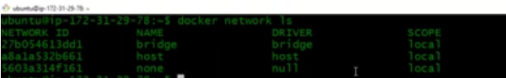

you can run ifconfig and see the docker virtual interface  
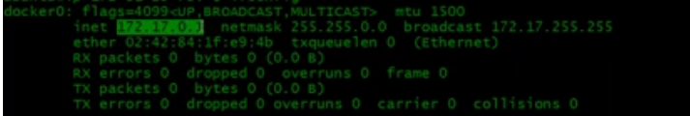

Whenever you run the container, it will be connected to the docker0 interface as shown above.

In the above ls command output you see with the name of bridge, you have the network ID, and there are different drivers but the most common you see is the bridge drivers to create virtual interfaces.

The docker0 complete line is like a switch/router.

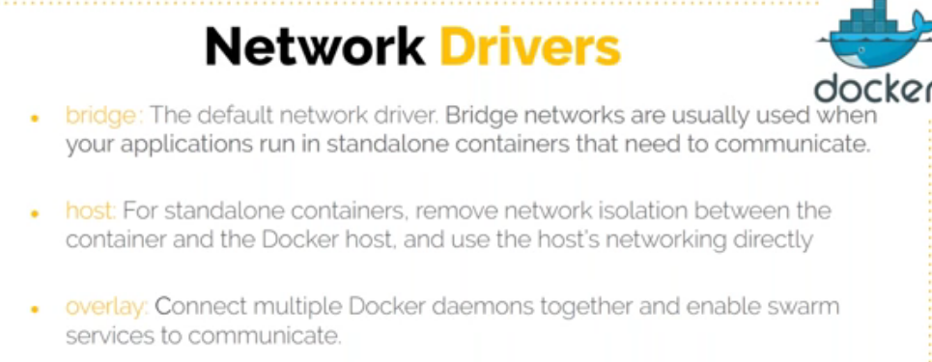

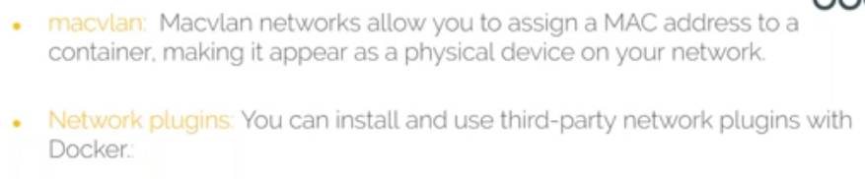

Bridge – where the container will get connected to virtual switch automatically and for standalone.

Host – If you want your containers to have an IP similar to your host IP, using host driver it will fetch the IP from your local DHCP network so it will be in the same network.

Overlay – when you want to connect multiple docker engines together. Say you have 2 docker engine in a cluster with orchestration tool. Lets say docker engineA container wants to connect to docker engine container that means you need to connect 2 computers, network together for containers. This is when we are using cluster.

Macvlan – If you want MAC addresses to your container.

Network plugins – You can use third party drivers and customize your network.

**Bridge Network:**

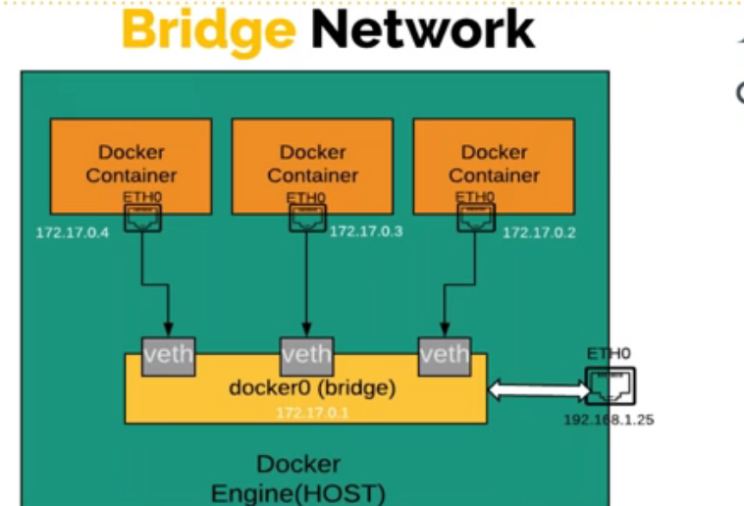

This is bridge network – you install docker engine and it will have docker0 interface and all the containers will by default connect to this interface and all will be in same network which is docker0(bridge). But of the container is in a different network, you can create your own network also and its simple

Just say docker network create <any name>

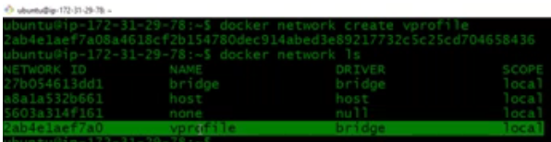

Lets run a container and then run inspect on the container ID and see the IP

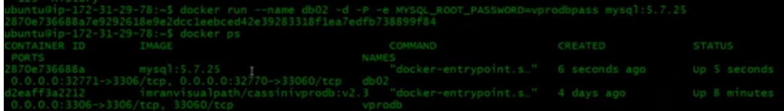



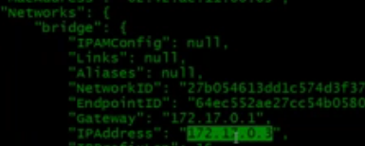

So, this is by default connected to docker0 (see below)



Above we have created our own network and Now you will see one more virtual interface got created

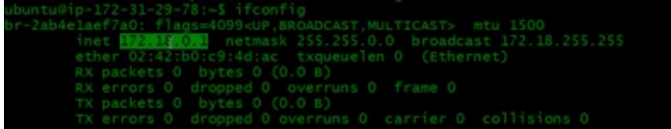

Now if I want my container to connect to this network, I should say –net and the network name



Now lets run docker ps and then inspect to see the IP

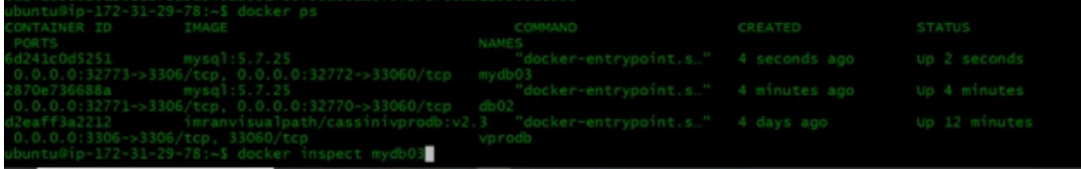

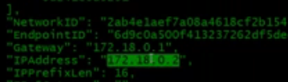

It got an IP address from the new network that we created (see below)

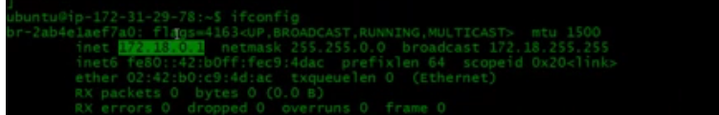

I will now create more 2 containers with name db04 and db05 in the same vprofile network. Since they are in the same network, they can connect to each other and can resolve their name to IP. But vproapp which is default network cannot connect to each other as they are in different VPC. IF you want to connect, then you have to do VPC peering.

Mostly if you are running a project to testing a project, we create network and run all the containers in that but then it is a manual process. Docker compose gives you all these process automated. Docker network will creates its own network and put all your containers in that network. When you delete all of them, it will delete all the containers and clean your network.

*Question: What is the difference between vagrant and docker*

*This question itself is wrong. Vagrant is basically a VM automation tool where docker is a container runtime platform like hypervisor which is a platform for VM. You can compare vagrant with docker compose. Docker compose is an automation tool for the container like vagrant is for VM*

**Installing Docker Compose:**

See the documentation and will get a simple command to install it with curl command



We have to make it executable



We have a docker compose file – Lets read it



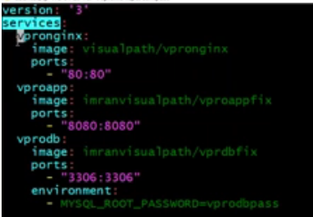

You should have your images hosted on dockerhub, so that you can specify your own image path.

Then you say services and inside that you will have all your container in same line. Here, we have 3 containers vpronginx, vproapp and vprodb. Vpronginx is simple you have to specify the image name and the port number. Same for vproapp. But sometimes you will have extra like we have it here for vprodb image – you need to specify environment variable or sometimes you need to specify volumes also.

There are many instructions available for docker compose which you can go through the documentation.

**depends_on** is a nice instruction where sometimes you want the webservers to bring it up first before bringing appserver then you can put all under depends_on instruction.

FYI.. to stop and remove containers

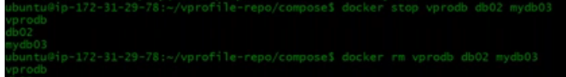

To remove image,s you say



To remove images which has tag you should mention that



Once you have you docker_compose file then you run it will create a network, pulling the image,..



This is to run the same in the background



You will see a new network also



You can check logs, but you need to be in that directory



To see all the containers running and port numbers also

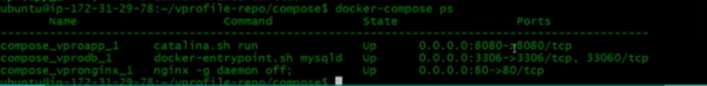

To remove containers



**Kubernetes:**

We don’t run containers directly on docker engine commands for production. Production is all together a different story. You should be having something like cluster. Clustering of docker nodes. Like docker we have Rocket. Docker engine is a container run time environment. You should have some technology which can cluster docker nodes together and if it’s getting clustered you should have some master node which can control the cluster, you can send information, signals , configuration details through the master node. If any of the docker node fails in cluster, the containers will be migrated to the other nodes and they come up very quickly. . This kind of setup is called container orchestration.

The master node or the Orchestrator will manage all your containers.

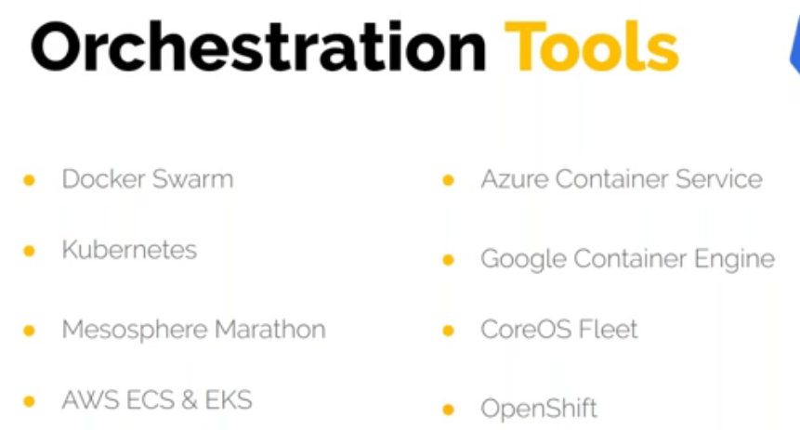

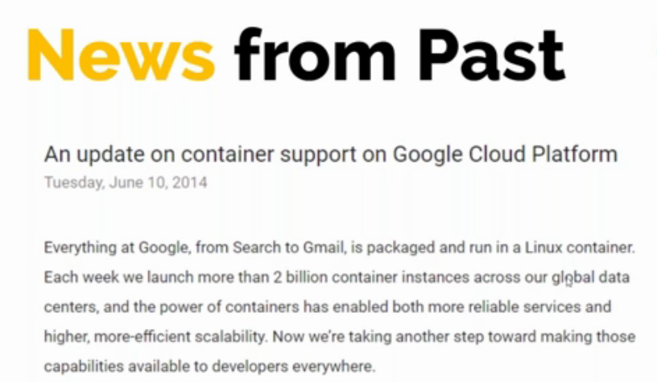

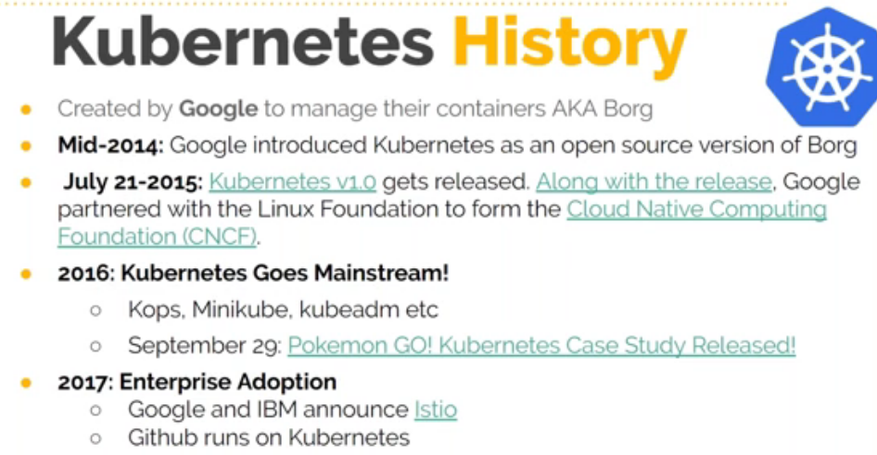

Kubernetes gives you immense benefit, not just clustering. Load balancing – like you have 100’s of tomcat containers and in front of that you can give load balancer. When you launch the container, the container will be automatically discovered by the load balancer and automatically updated in the load balancers.

Gives you storage orchestration – in normal containers you need to map a volume if you want to run stateful application and its not easy to do these things. So, Kubernetes helps you orchestrate your storage, you can map your EBS volumes, you can map NFS shares, CIFS and so many others.

Automatically rollout and rollback. One single command you can update the image of 100’s of containers and it will do rolling updates and if something happens it can roll back with one single command.

Self-healing – if something goes wrong, it can restart your containers. Delete and auto create the containers.

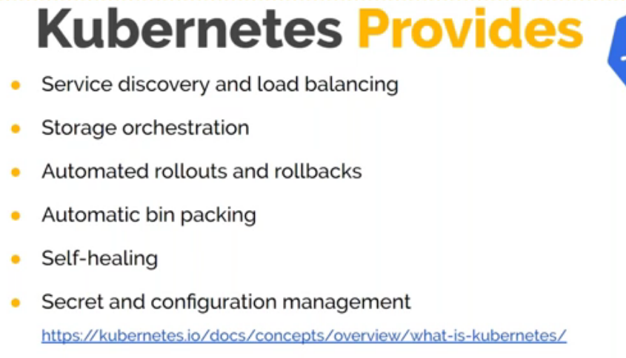

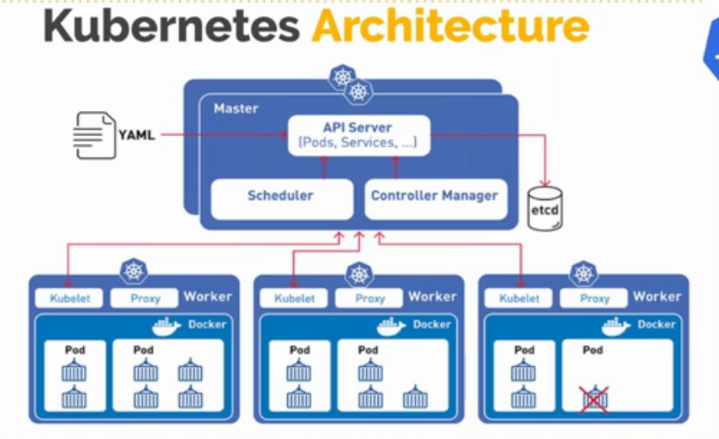

Orchestration tool for containers will have a master node or a master computer or a master server. We generally call it as a master node. The docker engines is called as worker or nodes. Here in the above diagram we have 3 worker nodes and one master node. In master node we will have services that will help you control and manage your worker nodes. Docker engine will be running on worker node and not on master node.

In master node primarily you will have API server which will take the user request. You don’t need to the master node, you will have client will execute command which will interact with the API server. API server will store the information in etcd storage. It is a key value store. You can have one or multiple nodes but failing of master node will not affect to container run time. Docker will have some agent-based services that will help manage the docker engine. Master node will not directly connect to docker engine, it will have kubelet (an agent) that will manage the docker engine on that machine. Every docker engine will run something called as POD. POD is group of multiple containers. It can have one or many containers. In master node we have API server, scheduler and controller manager. In worker node we have Kubelet, proxy and the docker engine. This is a 4 node cluster 1-master 3-worker node.

**API server:**

This is the really the main hero here. This is a service which will interact with user or any third-party tool interacts with. This is the service which gives information to other services.

You can directly use the Kubernetes API or you can use the CLI command that talk to the API. It’s the front end. You will have kubectl a command line tool a clines which connects to Kubernetes API server.

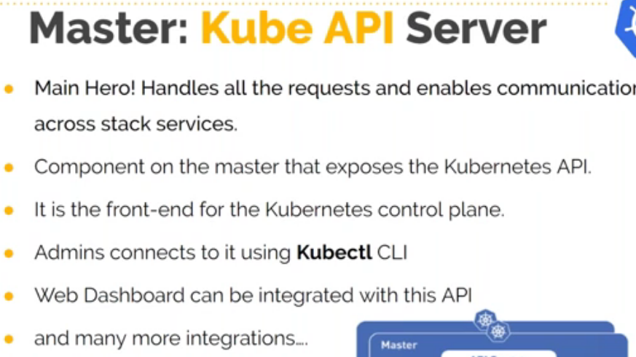

**ETCD:**

It’s a storage which stores the information like how many containers are running, whats their state, how many nodes are there and their state. API servers feed its information to this storage. This is one component you should really consider backing up because this will have your current state of your Kubernetes cluster data. There are some tools to take backup or you can use ETCD command also to take backup.

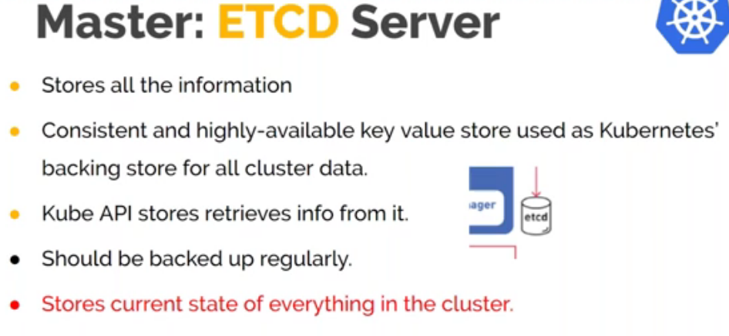

**Scheduler:**

This is also master component. Its job is to schedule containers, or we say it as POM. Scheduler is the one who defines the container runs on which node. It will match everything and if the match is successful it will distribute it to nodes. When it makes a decision there are some factors which will come into the account

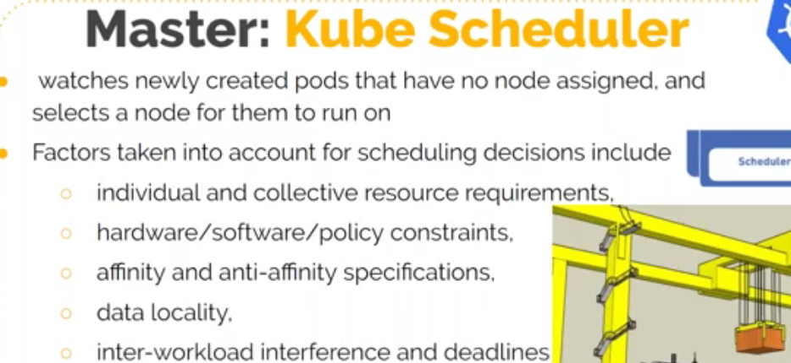

**Controller manager:**

We have discussed above that Kubernetes can do auto healing, automatically solve the container problem. Even any node fails, container manager will come to know that the node is failed, and it will start all the containers that was failed on failed node in live node. Here we have 4 components.

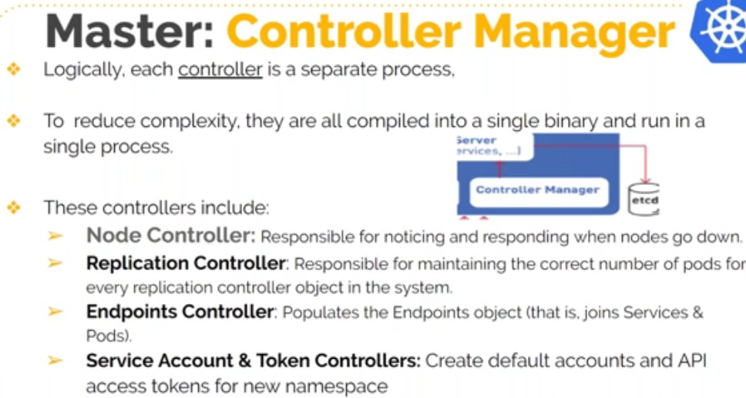

**Kubelet:**

**So,** scheduler sends the information to kubelet that you have to run the container now. It will pull the image, map the volumes, run the containers. So master node will talk to kubelet.

**Kube Proxy:** This runs on every node and we just specify network rules that this particular container is allowed to access from outside world or from this port POD.. It will have container runtime that is docker engine. This is the benefit of Kubernetes – you can have docker engine or you can have other container run time (rocket).

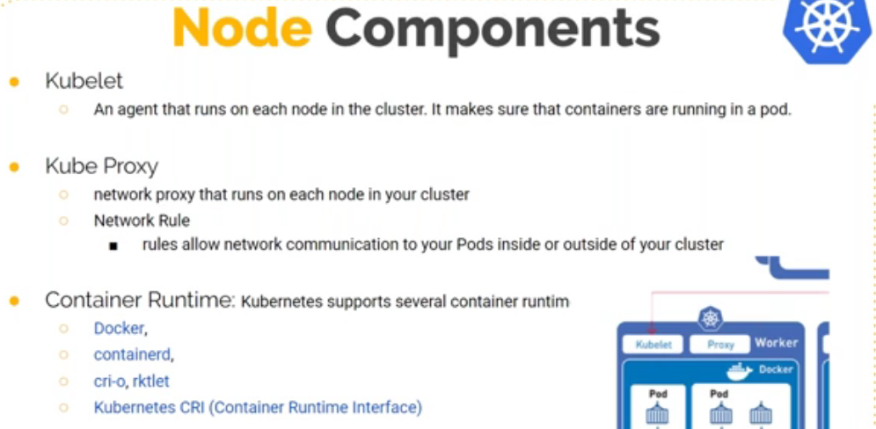

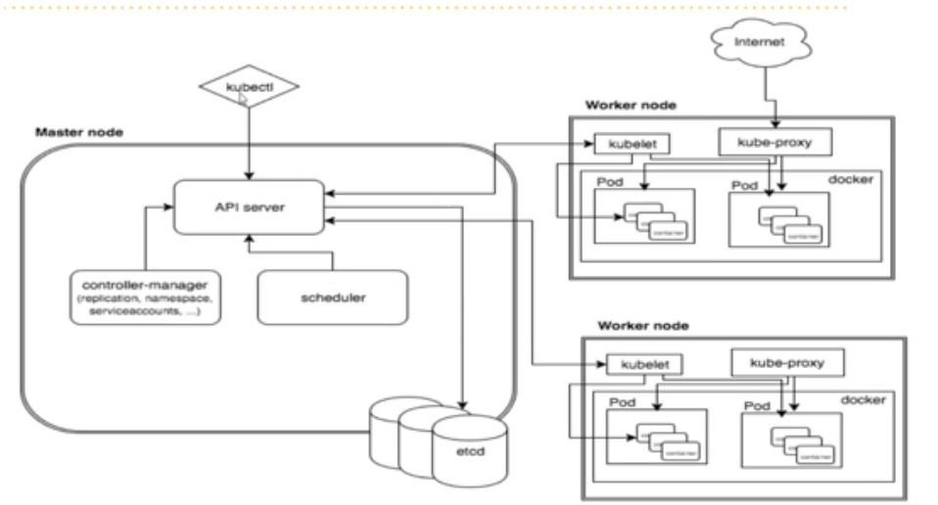

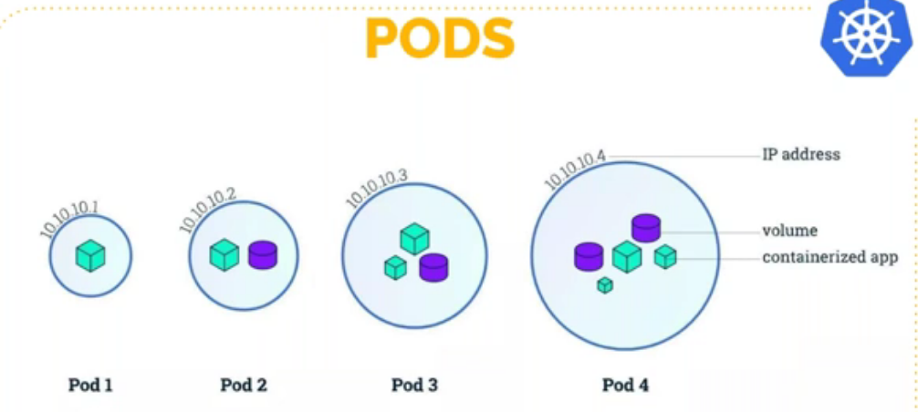

This is something different you been doing in docker. In docker we run the containers directly but in Kubernetes we don’t run containers directly. We run pods here. Pod may have one or more containers.

We have to run a pod and in that pod you specify the container that you want to run. Pods will have IP and if you are running a network service like tomcat or mysql db, which runs on a port number. So, port number will be assigned to the container and pod will have the IP.

When we say pod is group of containers that doesn’t mean that you put containers which does different work. Like you don’t put web or db container in the same pod. Multiple container that we run in a pod – make sure the other containers are just the helper container. Most of the time there will be only one container in a POD.

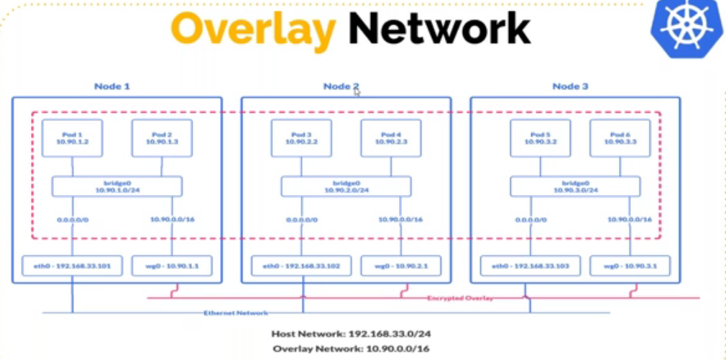

Now if you are wondering, we cluster them and till it distributes across nodes – how do they interact with each other. Let’s say you have web container on node1 and db container on node 2. How do they interact with each other ? So, when you use Kubernetes, it will create a virtual a network that connects all your nodes on the pods running in them together. Whenever you launch a pod it will connect to a virtual network and that will connect to another virtual network and both gets connection. Overlay network is to connect all pods.

Bridge0 here will act like a switch – you run a pod it will connect to switch ; wg0 acts like router which routes the request to other network.

**Kubernetes Setup:**

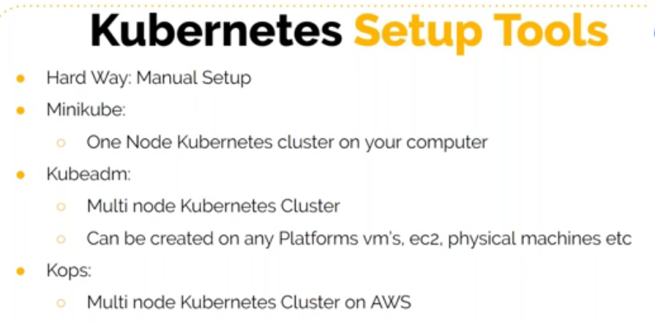

You need tools to setup Kubernetes cluster.

Minikube can setup one node cluster. Kubeadm - can setup multi node cluster for PROD and this can be created on any platform.

IF you are specific to AWS then you can use Kops.



This setup is simple – you need powershell, setup chocolaty (a package manager for windows like we have yum for linux ) This is just for learning purpose

We will go with Kops and below are the prerequisites for that

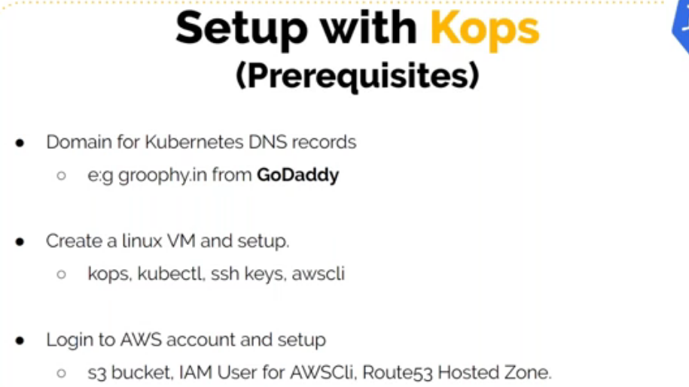

Here, the primary thing is – you have to purchase the domain from GoDaddy or from anywhere else and this is required if you want to use Kubernetes.

**Setting up Kubernetes multi node cluster using KOBS:**

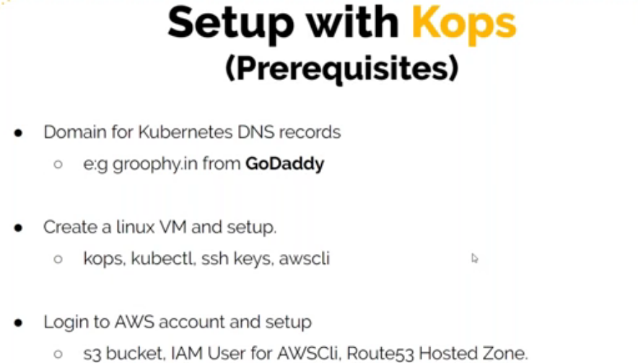

First you need to purchase a domain. We will have an EC2 instance on which we will install few tools and we will use this VM to setup Kubernetes cluster. On AWS we need S3 bucket which will store the information of bops, the current state of the Kubernetes cluster, we need an IAM user for the AWS cli for authentication and we will need route53 hosted zones.

**Different kinds of records in DNS:**

**A record – we give name maps to an IP address -** you have a domain grrophy.in. Here we say www points to an IP address of an EC2 instance, instead of giving IP address to user we give [www.groophy.in](http://www.groophy.in/) – www is the host name and grrophy.in is the domain name. When user hits this domain, the DNS server will resolve this to the particular IP address.

**CName record – we give name maps to another name** – Lets say we are using AWS ELB which already have a DNS name, so we give the endpoint of load balancer vpro.web.elb.aws.com. When user access [www.groophy.in](http://www.groophy.in/) it resolves to DNS name vpro.web.elb.aws.com and this will be resoved to some IP that is dynamic IP which is managed by AWS.

**NS record – we give a subdomain –** Lets say Kooper maps to another DNS server dns1 or you can give multiple dns2, dns3,dns4. In this case when the user says api.kooper.groophy.in →In this case what will happen is groophy.in is managed by godaddy so it will go godaddy and check what is resolution for kooper and it sees in NS record and forward to another DNS server dns1,2,3. All these DNS server will have the information lets say its goes to dns1 and this will have the information that api is mapped to some IP. So the first resolution is done on kooper which resolves to some ns record and the nsrecord will give information that api is mapped to some IP address. So for nsrecord if you give the complete URl the half part will be resolved by one DNS server (in our case kooper.groophy.in is done by godaddy) and it forwards the request to another dns server that is dns1 which will be managed by route53. In route53 you will have entry that so and so hostname is mapped to so and so IP address.

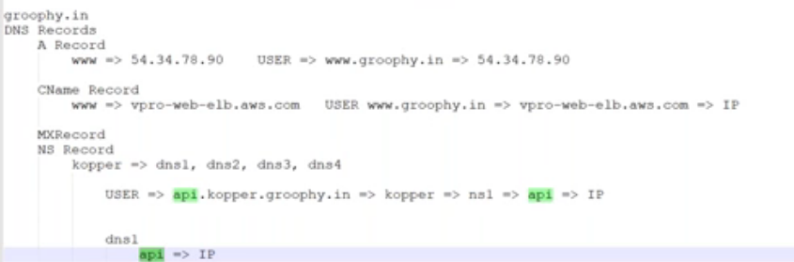

To save some cost we are doing it on NS record otherwise we can do it everything on route53.

Route53 is a DNS service where we can give all these records and we also have traffic policies where we say if you enter a URL that will be mapped to some other load balancer or it could be multiple load balancer or a multiple IP address. You can a failover policy so you give [www.something.something](http://www.something.something/) which maps to 2 load balancer and route53 will keep checking the primary site and if it is down it will route he request to secondary site.

You can also purchase domain from route53 which is expensive compared to other domain.

When you want to create any kind of records, you can use hosted zones in route53. Create→Give a name (kuberops)→create

When I create hosted zone, I get 4 DNS server. Then you create your desired record and it will be rsolved by these DNS servers. We will add records here but in godaddt we will add the NS record. So the first request go to godaddy to resolve of domain kuberops and it will say that kuberops is maintained by route53 so it will forward the request to route53 and route53 will resolve A record/ CName record or any other record that we have given here.

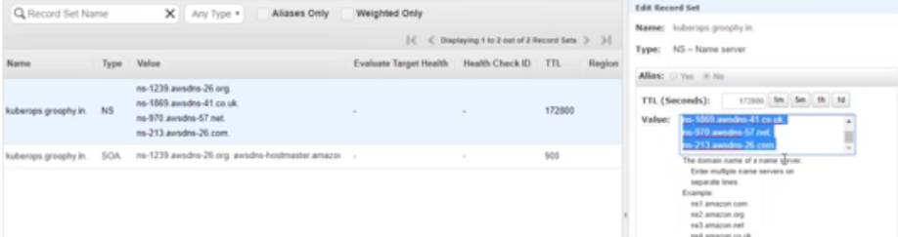

**Let’s do this exercise:**

1. First we will launch an ubuntu EC2 instance from where we are going to execute KOPS command.

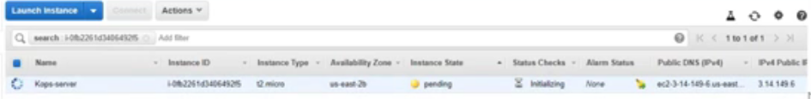

1. We need an S3 bucket to do the AWS site setup so we will create an S3 bucket with all the default settings
2. To access this we need an IAM user kuberops with programmatic access →attach existing policy and select administrator as this user need full permission →download .csv file
3. Lets now login to linux system and setup all tools on it.

**First lets install KOPS**

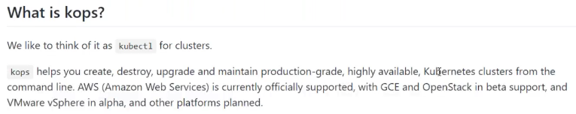

You can follow the documentation to install – a command line tool to interact with Kubernetes cluster

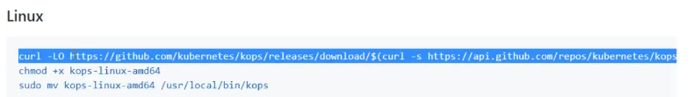

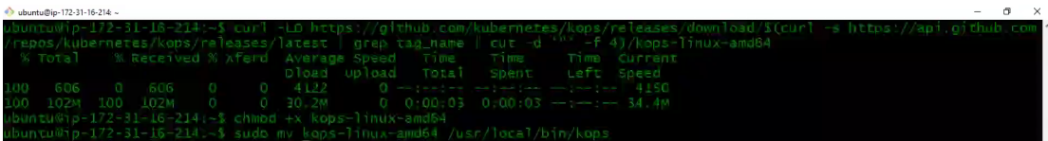

Now let’s install kubectl:

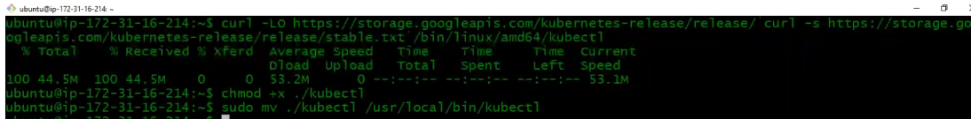

1. We need to generate ssh keys – just generate and KOPS will inject this keys on Kubernetes master and worker node.

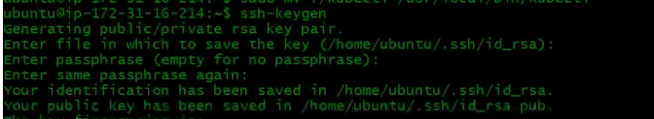

1. Sudo apt update and install AWS cli



1. Now say aws configure and it will ask for your accesskey and ID which we have created IAM user for this. It will also ask for region, select your region where you want to setup your cluster.This will be used by KOPS. Kops will internally execute aws cli command to create your master node, worker node, route53 and so many other things

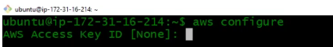

1. Login to godady account and you can see the domain you have purchased and click on manage DNS and create the NS record.

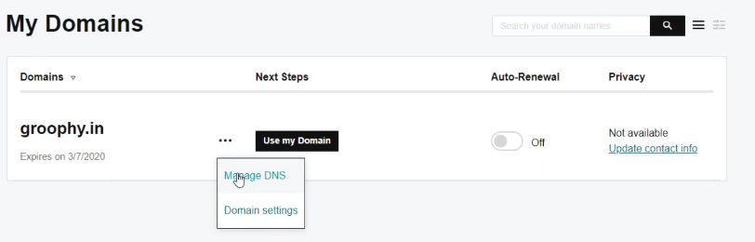

Add→select type →Name server(NS record)→give the host→a DNS server from the route53→save

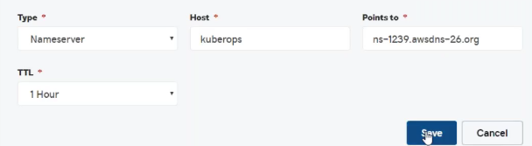

In the same way add other 3 more DNS server from route53.



DNS plays a very important role in Kubernetes cluster.

When you are setting up Kubernetes cluster with kuberian this will not be by default so you need to integrate a DNS information in kuberian

1. Let’s try to resolve our ns record and it should resolve all that 4 DNS name servers we mentioned

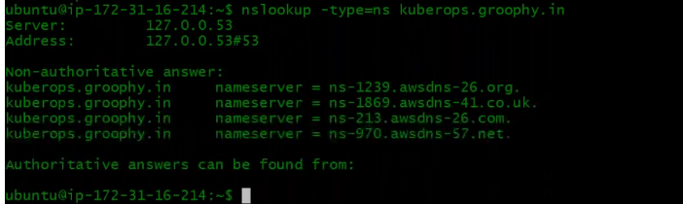

1. Let’s now execute the command which is very long

Node count = number of worker node you want

If you miss to mention the instance type then it will automatically take the m4 larger size and the cost also will be more. So make sure to mention this per requirement.



After executing this, Now you see the configuration is created in the S3 bucket and its time to apply all the changes.

It will be always 2 step process whenever you want to make any changes with Kops. First you update the configuration and you then you say the below

1. This will start creating the Kubernetes cluster



You can see your route53 record sets are started getting added which is mapped to a public IP which is a false IP for now. This IP will be your Kubernetes master node IP. Once your Kubernetes master node is up and running, it will update that IP here

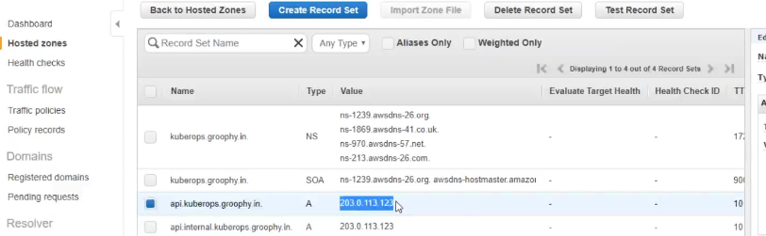

You can go to your EC2 dashboard and see your nodes getting created. You have a master node and 2 worker node.

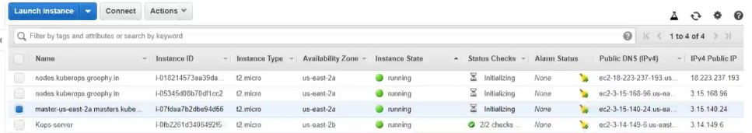

Also 2 auto scaling group will be created. One for master and one for worker.

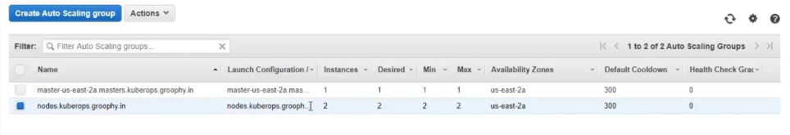

Don’t try to update things from here but do things from Kops only because if you do anything here and then you run any kops update it will overwrite everything.

Once the Instances are up and running, it will start creating all the required services in it like scheduler, controller ..

API server will run only in master.

Kubelet is installed on worker nodes

Kubectl is a command line tool to manage your Kubernetes cluster

1. Lets do a validation of cluster. You have to give cluster name but since I have only one it takes by default.

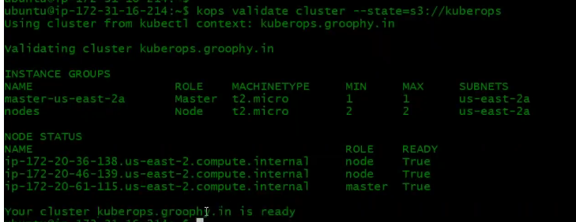

1. Lets run a test here to see everything is working in my Kubernetes cluster.

Let me clone the repository

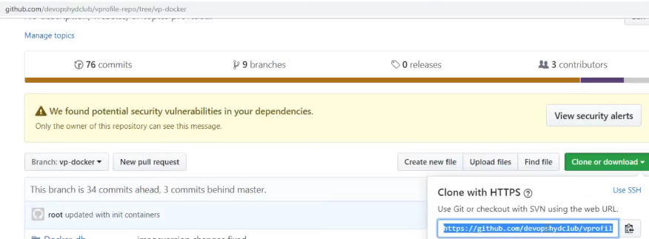



Switch to docker branch

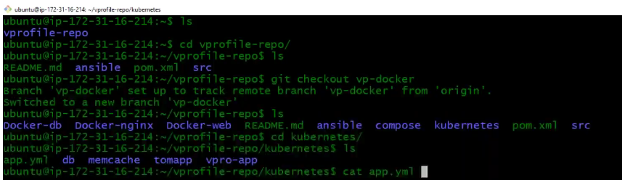

Get into the below directory and there is a file vproapp.yml

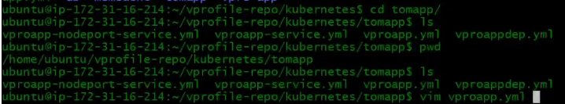

Vproapp.yml:

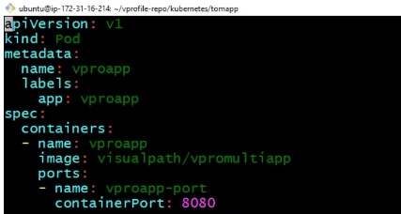

Now whatever we do on Kubernetes cluster it’s gonna be through this yaml file. These are called as definition files. So, we don’t run long commands like docker run -v -c and so. We do docker compose and in this we create yaml file and docker compose talks to docker engine. Here again we create the yaml file, give the similar information and this information will be given to the API server.

Your day to day job is like writing the definition files. Api.version, kind is pod, metadata is the information about the object which is pod – names, labels which are tags and you can give as many as label you want. Then you have spec means what you really want to do. It says containers and the list of containers. In the file we have only one container with its list – container name, image to pull, ports and you specify the the service port which is running in the container.

Now lets create this and to create it, you have to say kubectl -create. So, what kubectl will do is it takes all the information and send it to the API server.



IF you are wondering how kubectl knows where is your api server – I am running this kubectl command from Kops VM and master node is in the other machine and how does it know ?

So, when we setup kubernetes cluster through kops – what it does is it creates a file in your home directory called config under kube. It creates this file and this will have information have the information of ap URL

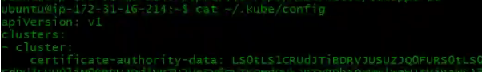



This will be automatically added to route53



And this is the public IP of your kubernetes master node. All this is done automatically through Kops.

This files also gives you information about the user which is used for authentication and for that user the certificate and key is created and already exchanged with the master node

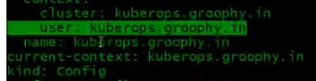

Kubectl will need this file to interact with kubernetes cluster

Getpod will fetch all the pods

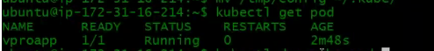

You can get more info about the pod by doing

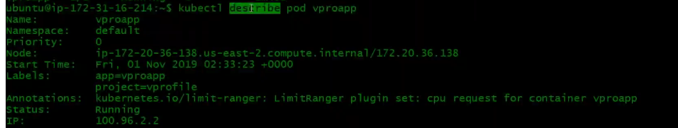

Describe command is more helpful in troubleshooting any issues. It will show you on which node it is running, the IP address of the pod, the container running inside the pod and at the end you will see the events what and all happened.

Below is how we can delete the kubernetes cluster – make sure you delete otherwise you gonna get some bill



1. We have a kubernetes definition archive file which we will take it on to your KOPS machine to learn the features of kubernetes.

Once copied then login to your Kops machine home directory and unzip that.

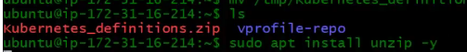

So, this directory contains some exercises



Let me check if my cluster is up and running



Its running

1. Now am going to create a Jenkins instance running on kubernetes cluster

We know how to install the Jenkins image using docker run (below)

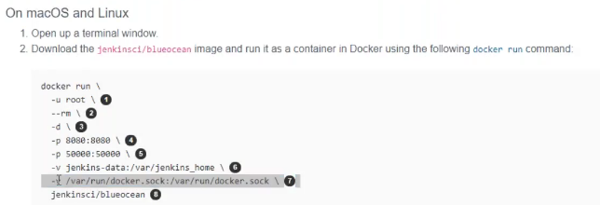

The same we will do on kubernetes cluster but we need to write a definition file. Here we don’t create containers, we create pods and with in the pod we specify the containers.

Definitions files are in yaml format, this file consists of this –

First is **apiversion** and then you specify the **kind** (object), We also specify metadata (information) sometimes which is not mandatory and finally we have specification **spec** which is real thing what is the name of the image, if you are running the pod then what is the container, what pod port it runs, what volumes it maps to – all such information’s. These 4 things you need to remember.

We need Pod in kind and its version in apiversion v1 which is stable version. In metadata specify the name of the pod (we will say jenkinsci-tool) and then label which are like tags and not mandatory. The metadata is a dictionary where we give key and value, name and labels are keys and their values you mention. We give some label like app is Jenkins and project is CI.

Under spec you say containers (you can say n number of containers in a pod). So, containers is gonna be list and in yaml list starts with “–“ , the first item in the list we give a name and we specify the image (above image from dockerhub), and then ports – here we are not doing any port mapping which we will do separately which is done through an object called as service, here we just mention the container port. When we create a pod in kubernetes, we don’t do port mapping – we just specify container port which is 8080 here.

This is the pod definition file for our Jenkins container:



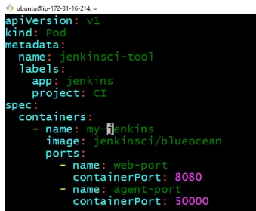

*Note: you cant use underscores*

1. Now let’s launch it



Now to see what pods are running in our kubernetes cluster we say

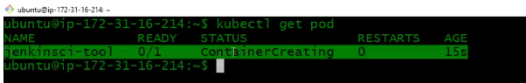

It says container creating and 0/1 ready meaning we have one container and 0 is running. See the below now

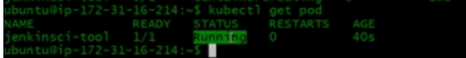

Let’s run inspect on this which is describe here



**This gives** you detail information about the pod like name of the pod, on which node it is running, what time its started, labels , IP address of the pod and at last the events.

1. Now that’s the pod running on kubernetes cluster, how do I access it ?

I want to access it from my browser on port 8080 from an external network.

To create any kind of port mapping, we create **service** object which acts as a load balancer.

So, we will write a service object on top of the pod.

Let’s create a file for this



Here the object kind is service, spec is ports and its value is a list 8080 and it should be mapped with we say node port and I will say 31001 which is like host port. You have to start port from 31000 and you cant go below than that. Specify target port and this is going to be the container port – here you can even specify the name of the port instead of 8080 which we will see later. Specify the protocol TCP. So you know in AWS we add instances under load balance same like here to add pods under the service you have to give **selector** and in selector you have to give label (**Jenkins)** which will be the label of pods (app: jenkins defined in our definition file). So, any pod with the label **Jenkins** will get automatically added in this service. And you specify the type which is nodeport (there are diff types we will see later) - this is same as port mapping, that means here it is our nodeport:31001 – on this port you can access the service and it will route the request on port 8080 on the pod **app: Jenkins** which is defined in our service file.

**File:**

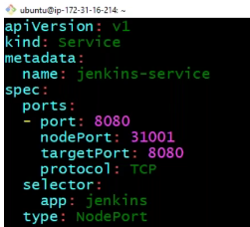

Now if I launch 100 pods and I keep same label, and the same container port -all the 100 pods will automatically added under service.

Now let’s run the service



Lets check the list of services

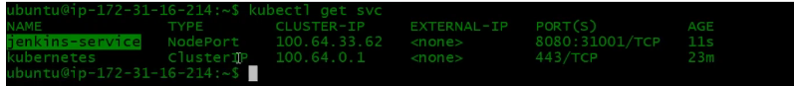

Every service will get an IP address, and this is called as static IP. You cannot depend on the pod IP because we replace pod when we upgrade them or change them. So, accessing a pod with IP is not a dependable thing and for that we create a service. Service IP will not change and when you access it, it will routes the request to the backend pods same as load balancer which does for Ec2 instances. Service is like firewall rules actually.

Lets inspect our service now:

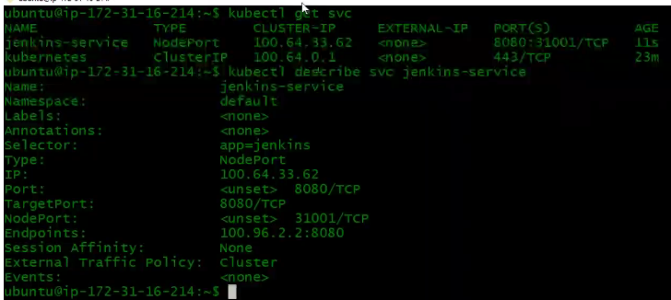

Here, 310001 port is the front-end port and 8080 is the backend port. The endpoint IP to where it is routing the request which is our Jenkins pod IP.

Let’s run inspect on our Jenkins pod

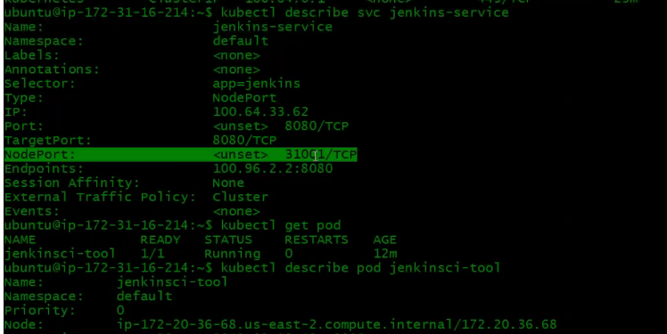

So, here nodeport 31001 is the front-end port of the node (last line) on which it is running. This node you access on 31001 and it will route the request to the endpoint IP:port.

1. Let’s access this and see:

Below are our 2-worker node (first two) and a master node (third)

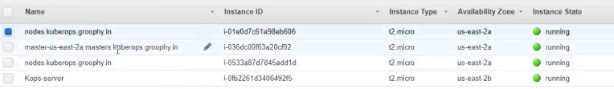

This is not the right way of accessing it, but just to show you

So, the node IP above(last line) is 172.20.36.68 which is private IP. Take the public IP of this instance

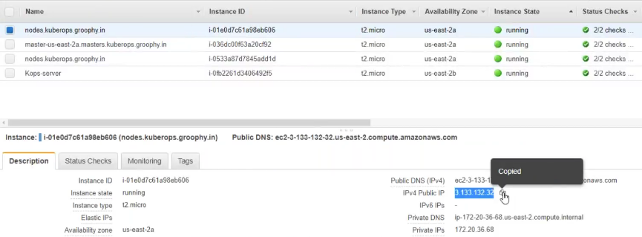

You need to allow traffic in security group of this node →allow all traffic from my IP

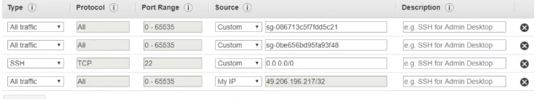

Now you access with publicIP and port 31001

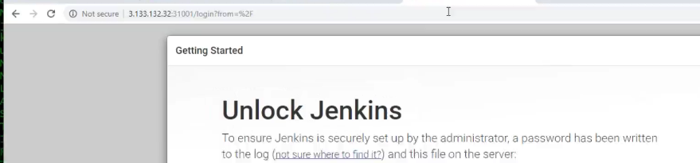

So, we now ran our Jenkins container on our kubernetes cluster, and we can access the Jenkins.

The same way try accessing from the other node and even from the master node and still you can access. We have our pod running on one node but still we can access it from the other node and even from the master node and its awesome **but how ?**

We have seen a diagram before about overlay network – all the kubernetes nodes, cluster are connected with the virtual network called overlay network and that’s the thing is doing all these.

Basically, behind the seen there is IP table rule set. So, it doesn’t matter where you access your service – it will route the request. When You say 31001 and that will be mapped to a service and a service will have an IP address and for which ever bridge IP it is , it will forward it to that particular machine on that particular port. Let’s understand service first.

**Service:**

When you want to expose any service running in the pod for the outside world or internal communication, you have to put a service and it will have a static IP address. So, behind the scene it doesn’t matter you have 10 or 100 pods and their IP address are changing, they are deleting and getting created again doesn’t matter. You have the service static IP address you access it and you can access your pods.

There are 3 types of service

* **Nodeport** – which we have in above setup which is for external communication you wanted to access based on the node IP. You want to use the node IP and access your service, then use nodeport
* **Cluster IP** – For internal communication like Jenkins wants to communicate to a database server or our vprofile app wants to connect to MySql db. That’s an internal communication – request is not gonna come from outside. Tomcat pod connecting to db pod then we use cluster IP. So we don’t need the nodeport and what we need is just the port.

We have our Jenkins-svc.yml file

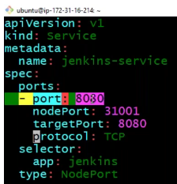

Here we have defined 2 front end port. The highlighted one you see is the **cluster IP,** this is not accessible from outside and this is for **internal communication**. Let’s say if you want to put nginx before Jenkins now, so nginx can route the request on port 8080 of the Jenkins port.

The nodeport here is the second front end port which is used for external communication.

If you don’t specify the nodeport, then that becomes your cluster IP and in the type you have to cluster IP.

* **LoadBalancer**

Now we are using nodeport to access the Jenkins and this is not the right way. You should have something like ELB. You access your ELB and that routes the request to your service and that routes the request to your pod.

In the type if you say load balancer, then in our case it will create AWS ELB and maps the service and then service maps the pods.

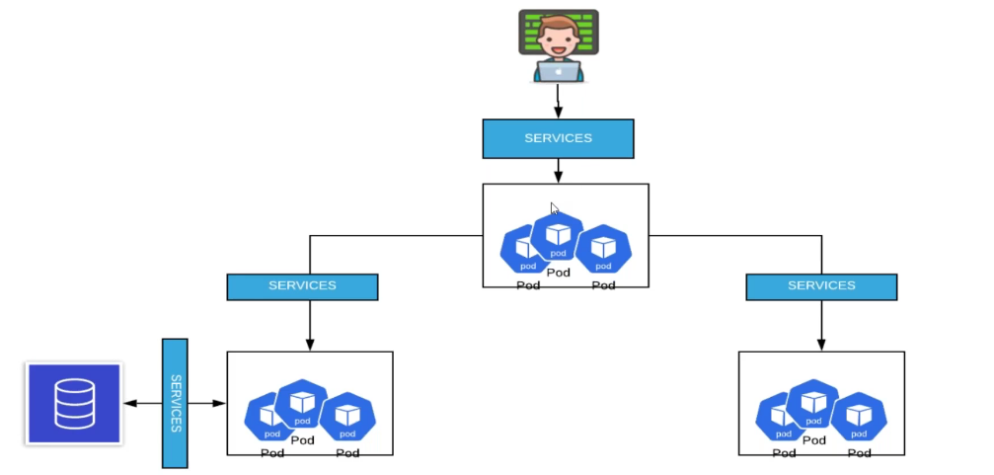

So it works like this – a user access the service and service could be either nodeport or load balancer and the service is mapped with some pod (jenkins). Now Jenkins is trying to access some other backend pod, and in that case you need to create service for the other backend pods but that will be of type cluster IP.

Below is how node port works:

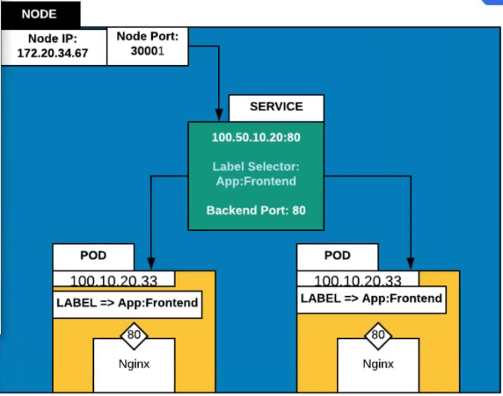

User give the IP address and the port number of the node like we did. It comes to the node IP and the port and its gonna route the request to the service. Service has the static IP and it will have the internal port. Based on the label selector and the backend port it will route the request to the pod. You can have one or many pod. The pod had IP address the container will have the port number.

Let’s say we have 3 tier app → web tier (nginx), app tier (tomcat) and db tier

Now if you want to expose your nginx to the outside world you have to give node port or the load balancer type. But nginx trying to access tomcat – here you need to give the cluster IP. Tomcat wants to communicate db then again cluster IP (internal communication)

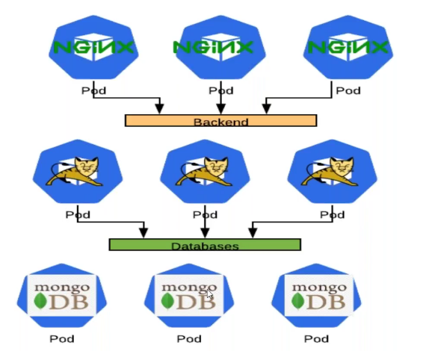

1. **Let’s create Service/Load balancer:**

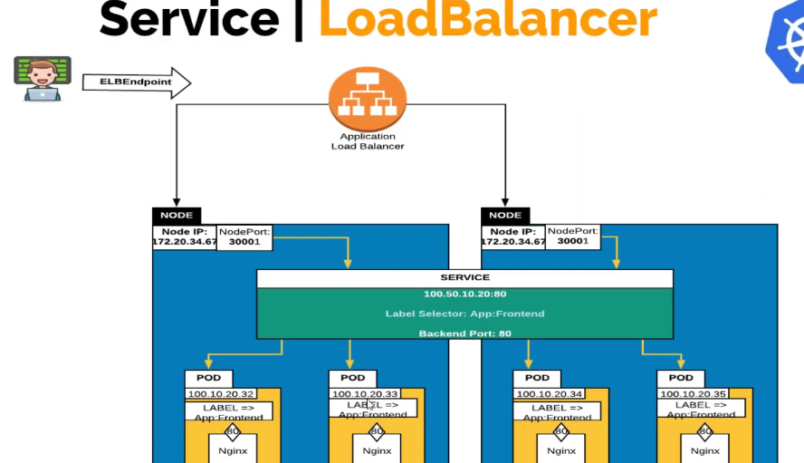

We have seen with the example – you can access any node IP but still it routes the request to the pod properly because service is not a node specific object. Service gets created across all your nodes. We have node1,node2,node3 and service will get created on all these 3 nodes. Service is not node specific, pod is node specific.

Now when you want your service to expose to the internet world, you won’t be giving them the node IP and port to access it. So, what we do is we create a service with type load balancer and what it does in turn is it will create an application load balancer or an elastic load balancer which is mapped to your node and then node will again do the same thing – forward to service – service will forward to pod.

I will delete the Jenkins service

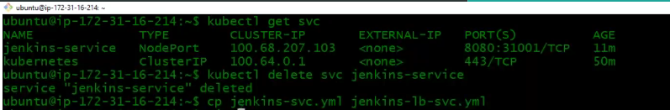



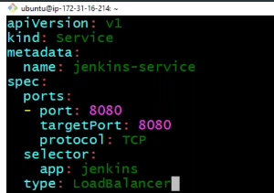

So, in service file of load balancer – you don’t have to specify the node port (if you want you can) and in type I will say loadbalancer. What it will do now is – it will recreate an elastic loadbalancer, map all your node under that. It will give node port also, but it will fetch automatically. Your loadbalancer front end port will be 8080 (-port: 8080) and it will create a service and its backend port is 8080 (targetport: 8080). So, you access your load balancer on port 8080 and then you will be routed.

Lets the run the command to create the service

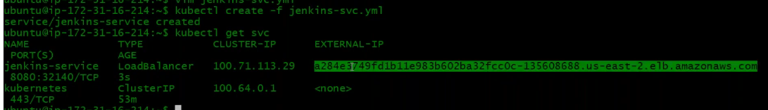

So, the highlighted one is the ELB which got created.

Let’s now run inspect on it

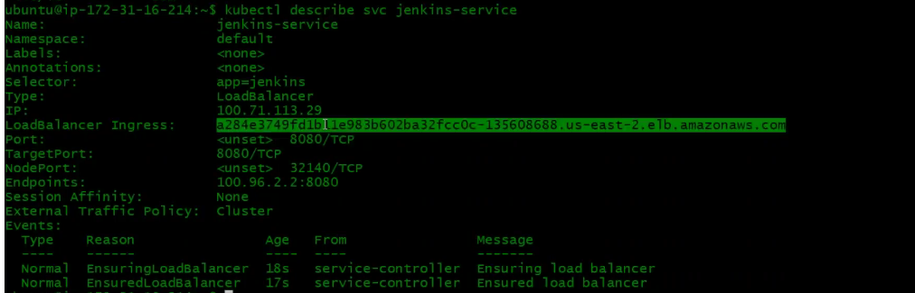

Here, the highlighted ELB is mapped to a service with IP 100.71.113.29, port for the load balancer is 8080, and the target port is 8080 which is the pod port , node port is 32140 which it has taken automatically – all the nodes will be added under ELB under port 32140, endpoint IP is the pod IP and the port number 8080 of the container.

Lets check our AWS account now-

You can see nodes are added under ELB (only worker node and not the master node)

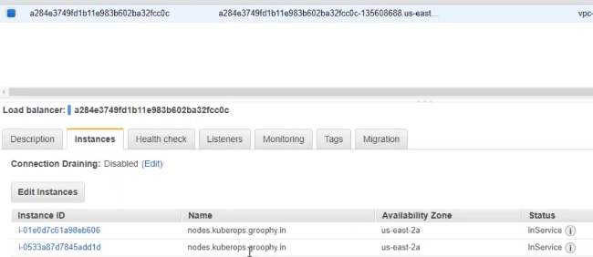

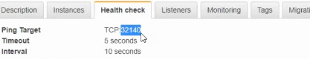

Lets now hit the browser with ELB:8080 and shouls be accessing Jenkins

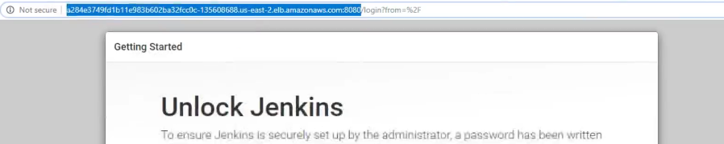

I will now delete all

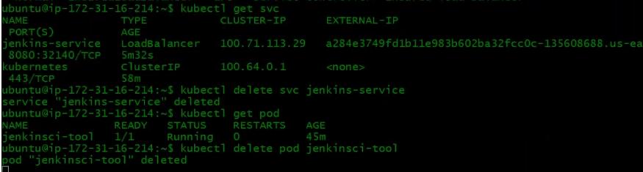

To delete the service, you say

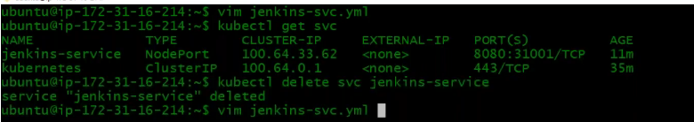

I will create it again



Target port is not mandatory that you give the port number, you can also give the port name (below highlighted), and this is really useful

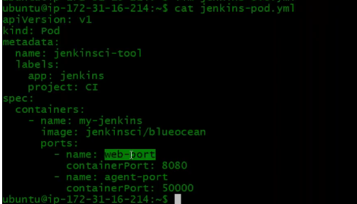

Let me give the port name instead of port number in the Jenkins-svc.yml file

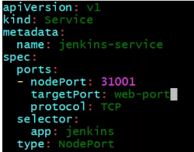

Web-port which anyways means port 8080. Now the benefit of giving port name is – Even if the target port changes, if change in your definition file and recreate your pod and if you keep the same name then you don’t need to make any changes in your service.

**Creating a single node kubernetes cluster using MiniKube on windows machine:**

You need to be having oracle VM virtual box already installed on your machine. IF you don’t have chocolaty installed, you can install by executing the below command

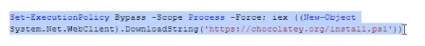

Once you install chocolaty, then you can install minikube and kunernetes-cli using the below command but make sure open powershell with admin privilege.

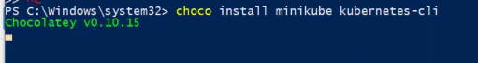

Once you install powershell, close the shell and open again and then run below command to start the minikube. When you say minikube start, it will create a virtual machine in virtual box with the name of minikube and this single VM will have all your kubernetes services like master node services and worker node services all in single node. This is just for testing purpose like if you want to test some features of kubernetes you can do it this way.

When you have minikube cluster running you also will have kube config in home directory.

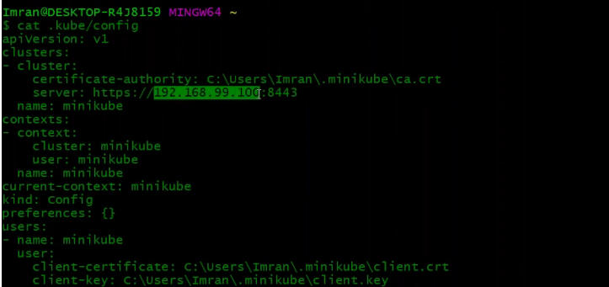

The highlighted is the IP of your VM.

Now let’s execute kubectl command

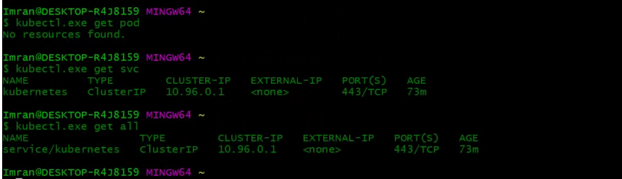

We can use the kube definition file sent to us to practice it over here

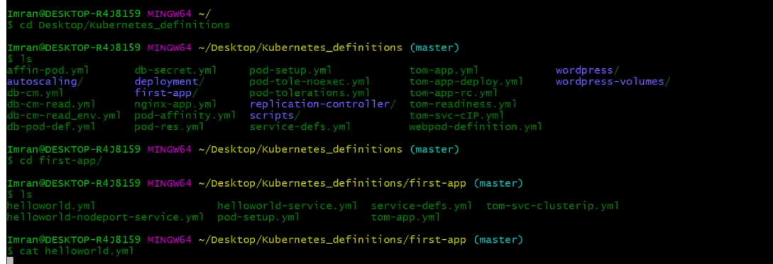

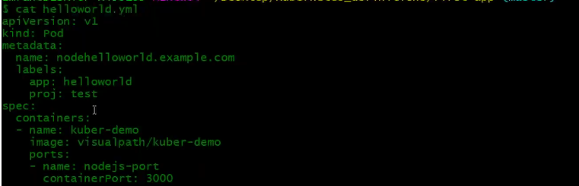

Similar definition file and the image here is in visual path account. You can pull this image or you can create an image (its in book mentioned how to create)

This is a nodejs image which says hello world that’s all.

Let’s run our definition file and this gonna take some time as its running on local machine. We have a service file.

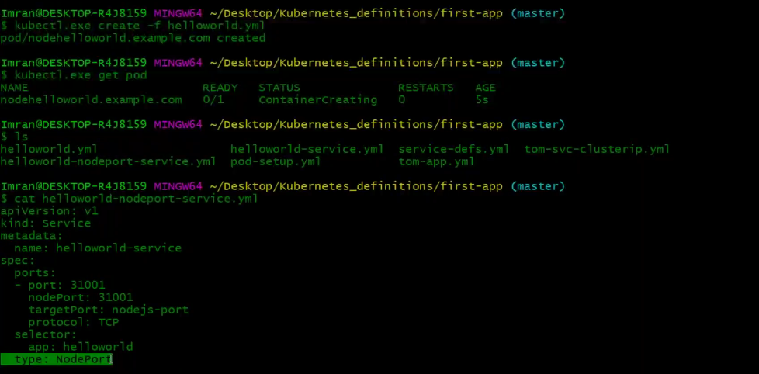

This is of type node port. This is going to map port 31001 port of the VM with nodejs-port which is 3000.

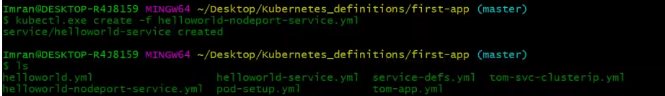

There are some other definition file also which is of type loadbalancer but this will not work here in your local machine. You can practice other things here with out loadbalancer

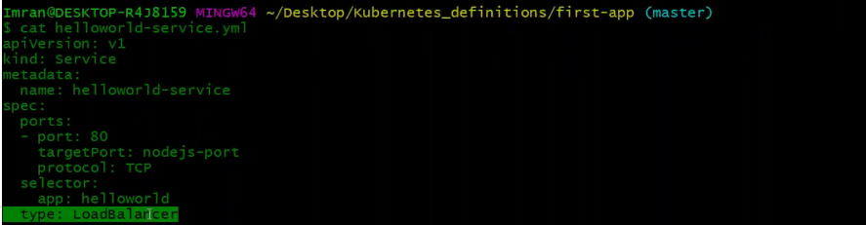

Now pod is running, and svc also created

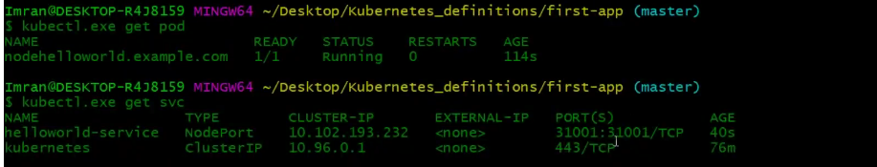

So, we have to access it on port 31001 on the VM port. We already know the VM port through kube config.



Lets hit in browser



There is one more command provided by the minikube to get you the URL of the service but make you start minikube not with admin previlage.

**Replication Controller:**

One single pod is not really a use case for prod env. IN prod we need n number of pods, high availability.

Scalability and all mapped under a service. Replication controller is more like auto scaling group. RC is an object from controller manager.

Now we were saying create the pod for me but if you are using RC then we say RC create the pod for me.

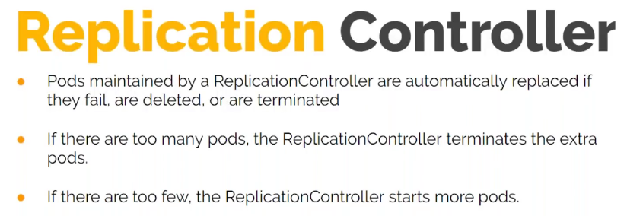

RC creates the number of replica that we specify. Here we will have group of pod or replica of pods. RC can scale your pods across the node. If you say 2 replica then RC may create 2 pods on each node and this is decided by the scheduler which pod to place where.

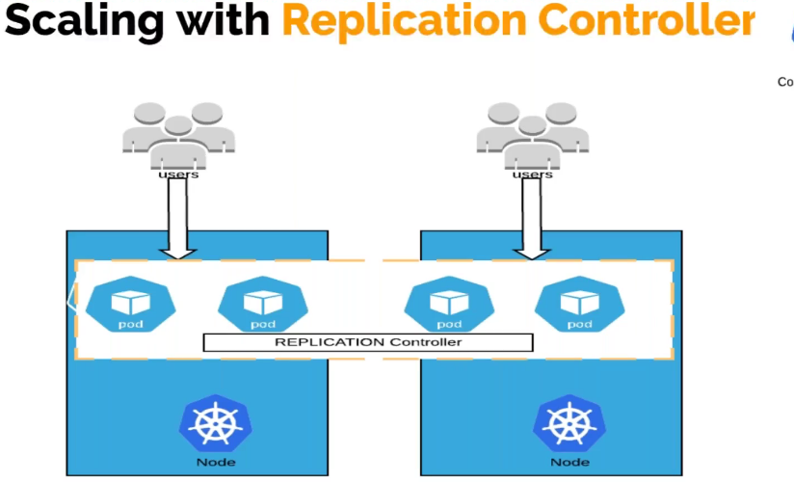

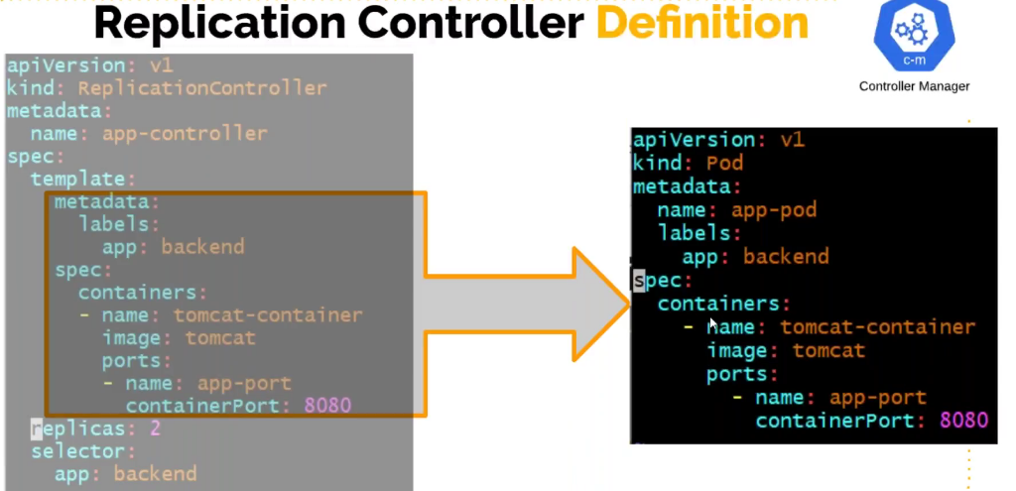

We already know specification and metadata (right side). RC you put all those things into template.

Here kind is replication controller, In specification we say template. At the end you specify how many replica you want. So this template is on the pod and that pod gets created 2 times. We have seen selector in service, selector helps us add pod under the service but here selector help us add pod under replication controller. If you already have some existing pod with the same label, those pod will be also added or considered as a part of the RC. Lets say we already have a single pod running and you wanted to create RC for it. You can create the RC , give the pod the same label as in RC definition file, and give the selector of the pod.

**Let’s do this exercise:**

1. In the replication directory, you have a file  
   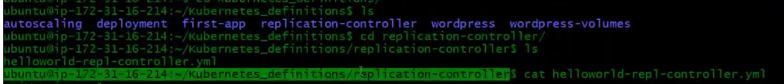

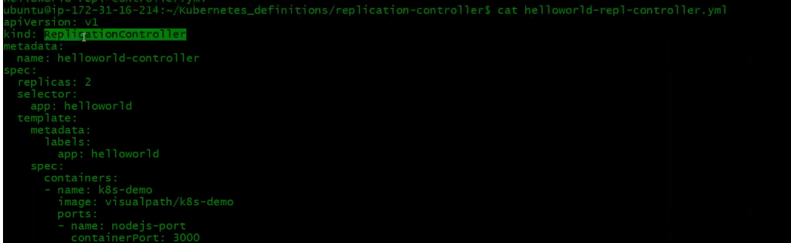

In kind you shd give ReplicationController (R&C caps). In meta data a name for the RC. In replication we have given 2 replica and selector is **app: helloworld.** So, any pod with this label will be part of the RC. In template we give information of the pod.

Let’s create



Command to see your RC



Now if should be having 2 pods which is created by the RC



There is one nice edit command where you can edit service, RC and lot many objects



This will open up the configuration of that object in vi editor . This info will be in yaml format. This is the current state of replication and you can edit it. This file may look like your definition file but its more than that.

I have changed the replica count from 2 to 4 and now let’s see our pod status and you shd see 4 replica now.

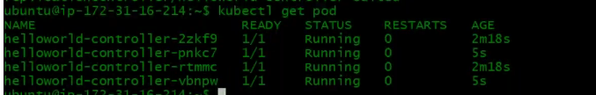

You can also scale down if you want.

There are simple commands also to scale instead of editing



We don’t spend too much time in replication controller because Kubernetes has also come up with deployment object which super seeds the RC. This deployment object is same as RC object what we have seen plus the upgrades, roll back and any kind of changes is very easy.

How about upgrading pod ? You upgrade the pod or container by changing the image or image tag. So, deployment object helps us doing that very easily.

This is the most used object in Devops. We are going to launch pod with deployment object. Here instead of RC it used replica sets the new generation controller.

It gives other benefits also – Let’s say you have a nodejs image and it has 3 versions of it .and you current nodejs pod are with version1 tag and now you want to upgrade to v2. Then you just say upgrade followed by simple command. You can edit the image name, once you edit the image name to V2 then it will do a rolling upgrade. Lets say you have 5 pods, it will automatically delete first 2 pods and upgrade them , then next two pods. Not pod will go down.

There are other strategies also – if something goes wrong while upgrading and you want to roll back, you can do very easily with simple command. You can anytime roll back to the previous version of image, you can do it very quickly and efficiently.

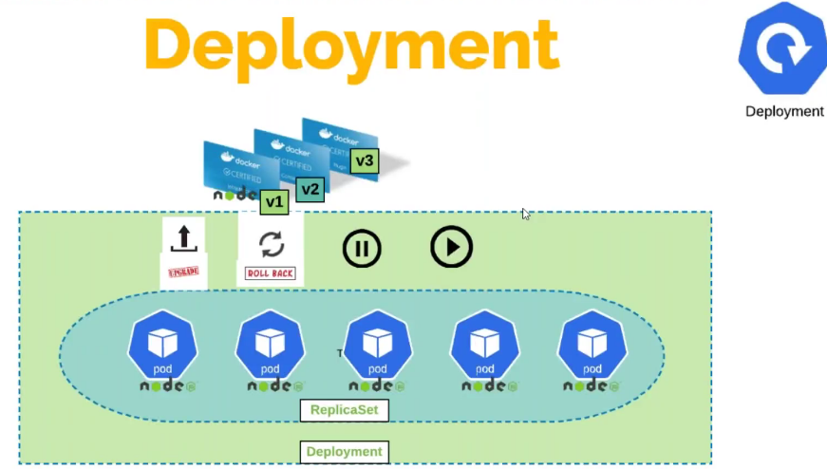

Deployment object maintains the number of replica set. Any time we can easily upgrade, rool back and even we can pause the deployment and we can resume it whenever you want.

Whatever pod we gonna use in prod it will be using deployment object only.

Let’s take an example by comparing replication controller and deployment object – It’s the same except the kind has changed

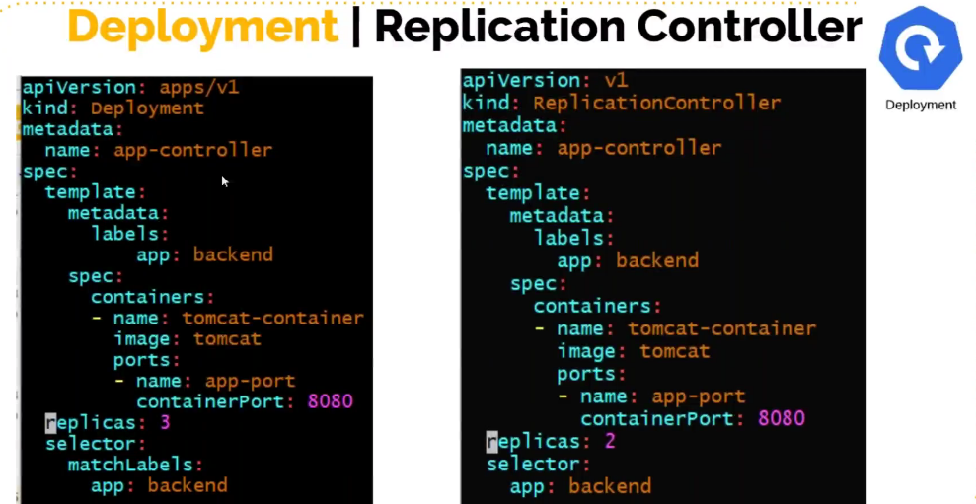

**Let’s do the exercise now:**

1. Let me first delete the replication controller

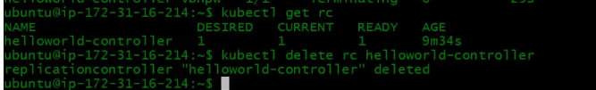



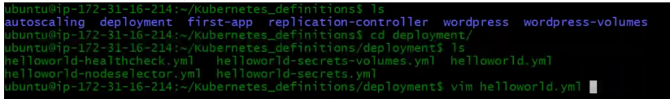

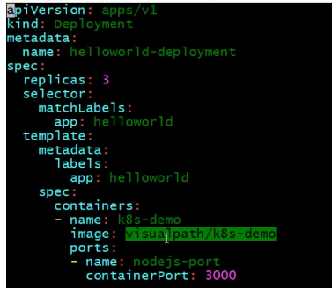

,kind is deployment, name of the deployment object, 3 replica. Previously we have seen selector and we just have the label name but now we have selector and inside that we have match label and inside we have the label of the pod (which is under templates). In the template you give the pod definition.





3 of 3 are ready now

So, deployment object will create replication set.

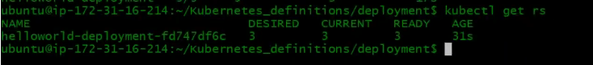

Finally, 3 pods

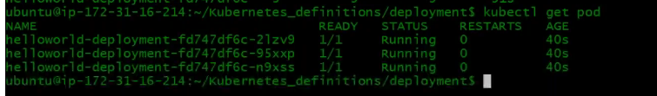

You can edit the deployment object also



Lets expose this by writing a service definition file or you can also do it in command line

Expose means create a service and type we will give nodeport. So, it will automatically get the nodeport which is the front end port, backend port it will automatically fetch from the deployment object,

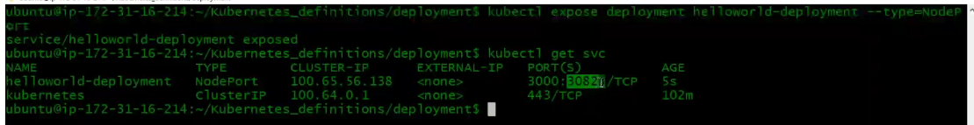

30823 – is the node port and it created internal port 3000, backend port will also be 3000

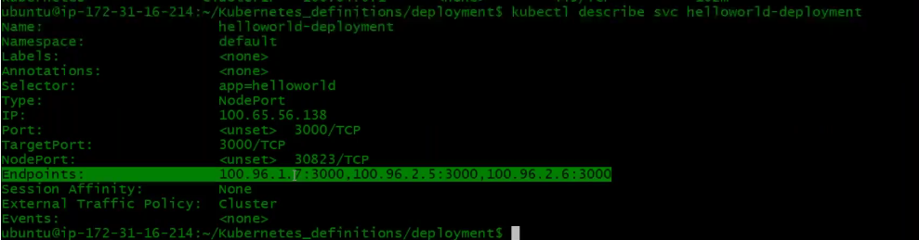

Enpoints - 3 pods automatically got added and it’s the backend port , nodeport 30823 it picked up randomly which is the front-end port, 3000 which is the internal front end port that is as similar to the container port.

Let’s access this one



Now, what ever your current state of website and you want to upgrade it, developer will create a new image with new tag or same image with the different tag and you want to upgrade it.

Basically, you need to change the image name here.

Let me get the name of the container

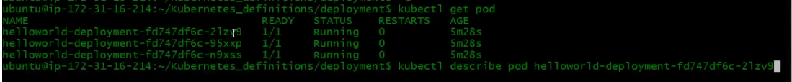

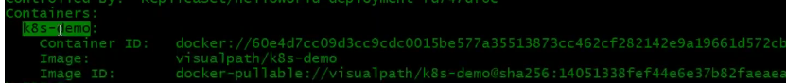

That’s the container name and you can see also the image location and no tag here that means tag is default and now I want to upgrade the tag to V2.

The command is set image deploy or deployment and the image name container name= image name:v2 (make sure this image is available with that tag in registry)

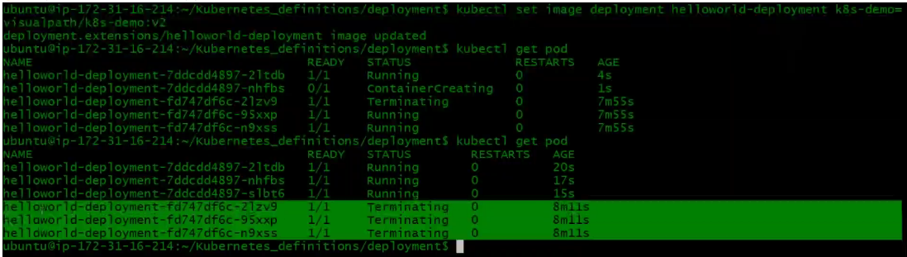

You see the new image got created, old 3 pods got terminated and new 3 pod got created with new image.

You can see the age which indicates when these pod got created.

Let’s hit browser

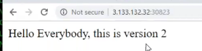

Now let’s see how to roll back



This will roll back to the previous version

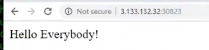



**Environment variables:**

We will see how to set Env variable and use it for pod. For our pods to run , we sometimes need env variables. Like for mysql pod we have seen, we have to export their database name , password, admin user and passwords. Sometimes developer also demand that they application need env variables. Let’s see how can we do this in the pod. Environment variable is for your container. Your container runs an application or service that will need env var. In this below diagram we have mysql container and it needs mysql database name and password. In the docker documentation also the below highlighted is given. So how do we put this in our pod.

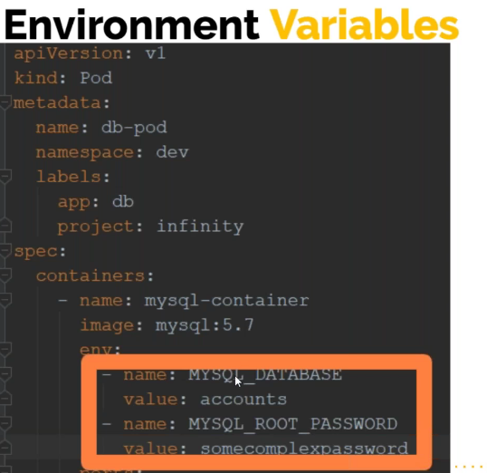

To put this to our container, in the container specification we have a key called env and its value will be list of variables that you want to export. Like above we have 2 variables and their value.

This is how you can env var for your container In your pod definition file.

If it’s a deployment definition file, it comes under the deployment definition.

There are few more ways of injecting your env var.

* Config maps

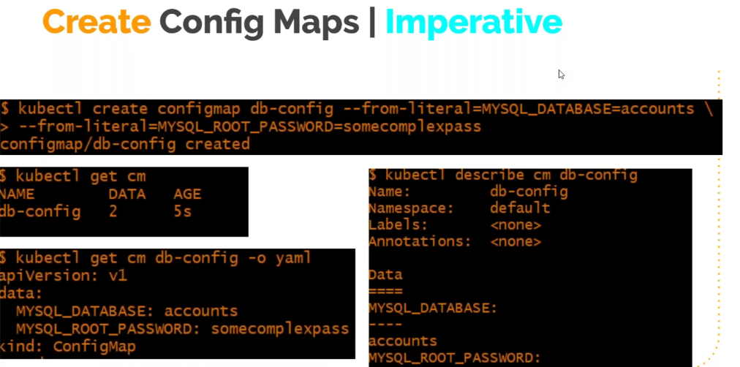

So, you can put env var directly in your pod definition file or you can set env var in config map and you can read it from the config map.

Suppose you have multiple env var across multiple pods using same nev var, you can use config map. This is simply collection of variables and to create it you give

Kubectl create configmap “name of the config map” and you have to say –from-literal=”var name”=”var value” (you can give n number of variables here). Once you do that a config map will be created and can be used by any pod.

Kubectl get cm →you can see the config map name

Kubectl get cm “cm name” -o yaml →it will show its configuration in yaml format

Kubectl describe cm “cm name” → to describe config map

So, the above is imperative way of creating the config map. You can create a definition file and create the config map declaratively.

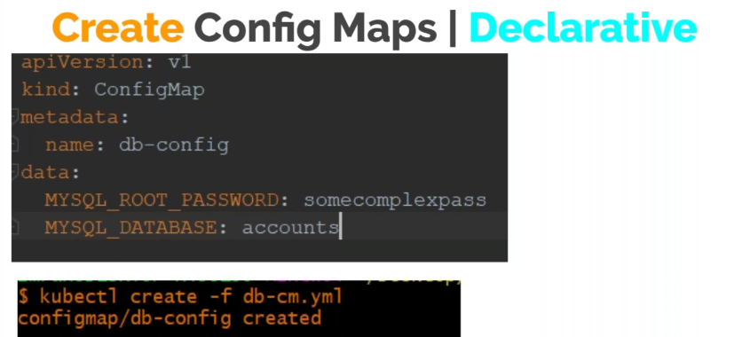

You can say in your definition file kind is configmap and then under data variable and its value.

Its recommended to go with declarative way because you have a yaml file which you can version control, which you can keep it with the source code. This is always helpful

How does pod definition read those config map ?

Instead of env and its list of variables we have to say envFrom: and then say -configmapRef and say name and give the config map name. what this will do is it will import this in the pod definition file. This is complete config map file or you can also select a variable from the configmap (right hand side)

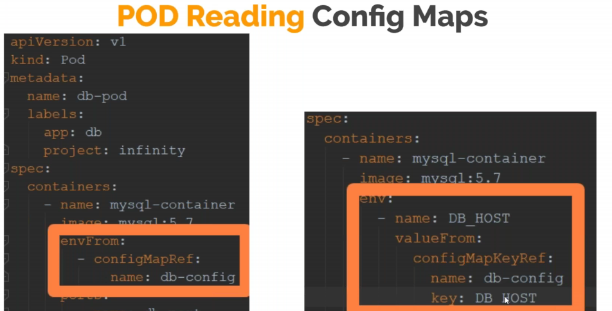

**Secrets:**

This is another object – you can encrypt the value if variable and cannot be seen directly. When You set your variable value in config map, you can print it and the value is seen. So, password value will be exposed. So what you can do is you can use a secret object and encrypt the variable value like what we did in ansible vault.

Below is imperative way of creating secrets:

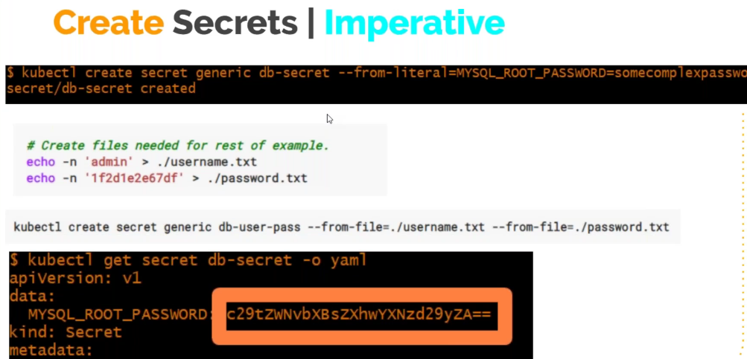

Secret is also one kind of variable but encrypted

Declarative way:

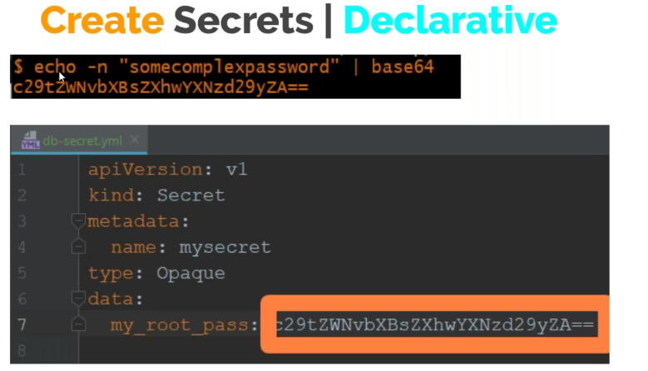

Here first you encrypt the value and then you create the secret.

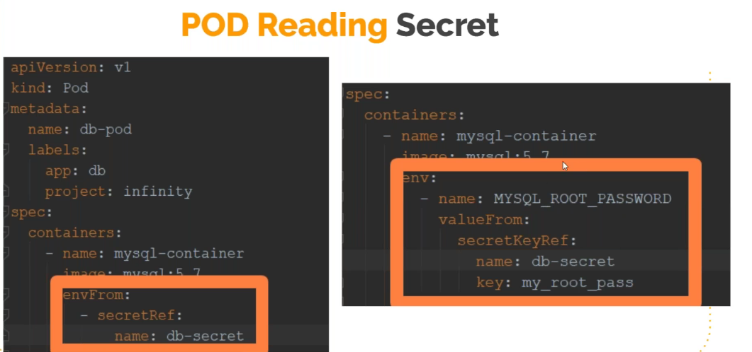

**Vprofile Project :**

In our source code vprofile repo, go to vp-docker branch ->kubernetes->vpro-app.

Before you create any pod or service, you have to create any variable that you are exposing through config map or secret if you are creating.

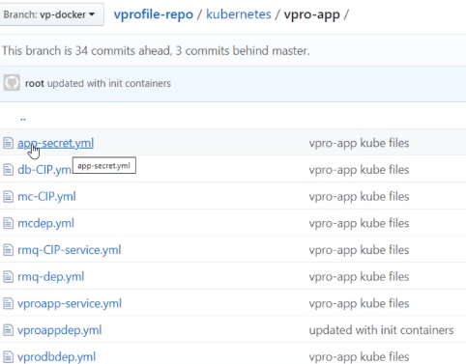

app-secret.yml is our secret definition file

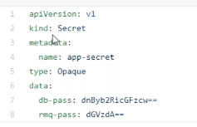

Apiversion v1, kind is secret, In metadata – name of the secret, type is opaque which is for base64 and data we have the encrypted variable db-pass and the db password, req-pass and the password for rabbit MQ.

This is kept secretly - when we create this definition file it will create the secret and can be used in the pod definition file.

**Db definition file – vprodbdep.yml file:**

In this file, we have a section under container specification called env, here we say root password value from secret key reference, name of the secret and the name of the variable that we are using. So what ever value comes form key: db-pass will assign to the MYSQL_ROOT_PASSWORD variable which will be used in the container/image that we have built.

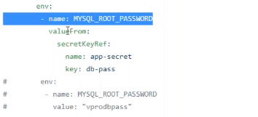

**db-CIP.yml file :**

Now we are going to create a service on top the db deployment definition on this pod.

Kind is service, name of the service, port 3306 which is internal front-end port, target port vprodb-port which is the port number for your db pod, selector is app: vprodb – any pod that has this label will be added under this service and the type is cluster IP because db is for internal usage. We don’t need to expose this for outside world. Same way we have it for Mcache also. For rabbit MQ you need to create user and env variable. A service for rabbit MQ and finally our tomcat app which is vproappdep.yml

**vproappdep.yml** - everything is same which we have done before. Go through all your files and understand it properly.

Here we have added a new thing which is **initcontainers** . So far we have seen a single container in a pod and now this is an example for running multiple container in a pod. This is not a normal container, this is called initcontainer. It’s a Key which we have specified in our definition file. This a container which will get started first than your main container. This init container will do some operations and then it will be dead.

Name of the image is busybox which is a simple image like ubuntu image, and you can specify a command to execute on a container through the key **command** and in a dictionary format you specify the command separated by comma. The command is sh -c the argument followed by **until** loop which is gonna do a nslookup on vprodb. Vprodb is our pod. So, as long as it is not up and running, its gonna wait for it. Until it returns a value it will go in loop in 2 sec interval. This will make sure your dbprod is up and running. Same we will do it for mcache also. Once it see its running then th einit container will be dead and finally it will start our main container which is vpro-app. This will be like helper container. You don’t put multiple main containers in one pod.

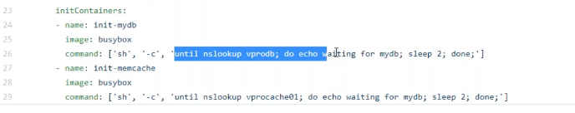

**Vproapp-service.yml:**

This is the service definition for tomcat app. This is of type loadbalancer. This is gonna create an elastic load balancer. Which is gonna forward the request to our tomcat app and then tomcat will forward through its configuration to different containers.

The primary thing is containerizing, you should already have the image and this image should be already preconfigured with the setting that refers to what container. In our dp-docker branch, we have application.properties file.



This configuration will be in our tomcat service and already we have build an image for it.

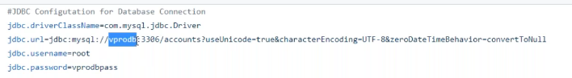This line in the file refers to db name vprodb. So, you have to create a pod with this name on port 3306 and that’s the internal front-end port, username and the password.

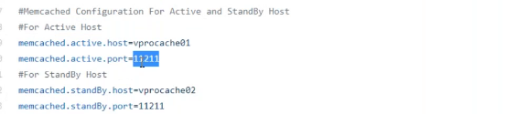

These lines are for Mcache and you ha eto run the pod with name vprocache01 on port 11211. And same for rabbit MQ

We already have our source code cloned on kops VM. We have all our definition files

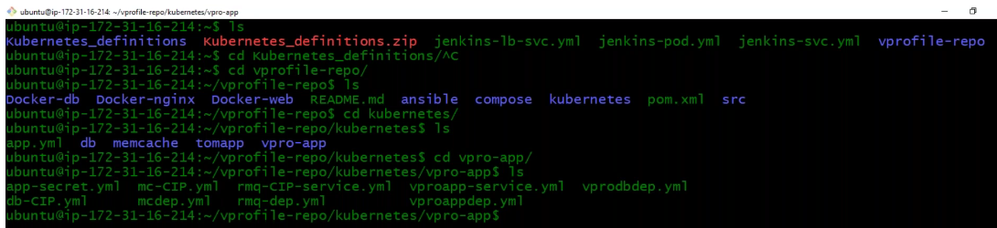

I am gonna first create secret



Lets copy the output and paste in appsecret.yml

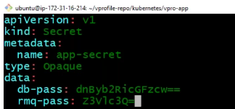

Also, in our rmq-dep.yml file we need to change the user name to guest and not test

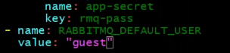

This we are doing because application.properties configuration (rabitmq section - below) is gonna be in tomcat app and we have already build up image for it and the user name is guest.

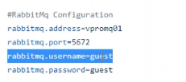

Now, when I say the below – Kubectl will read all the definition file available in the current directory and create

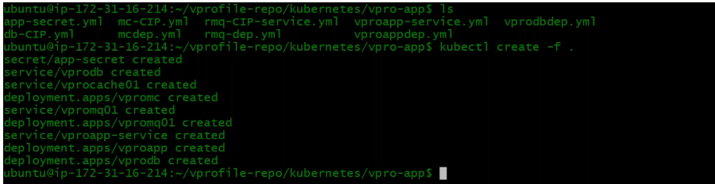

Check the status now

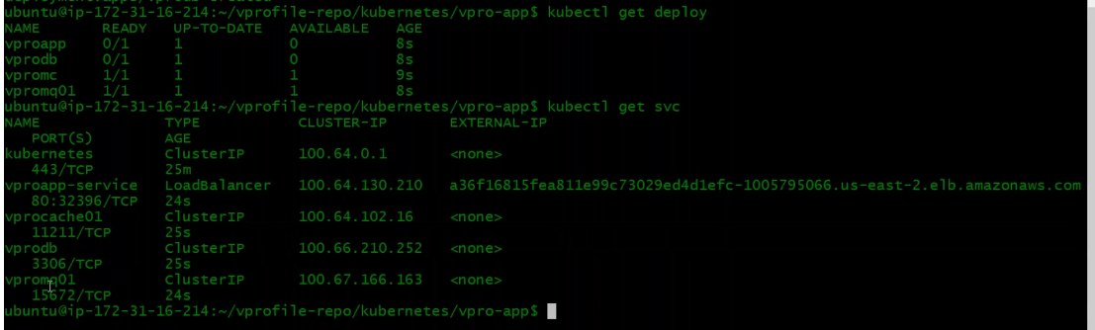

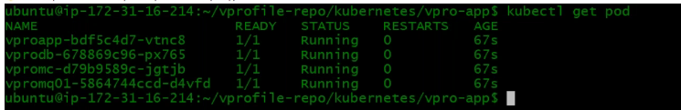



Lets now attach the tomcat pod to the /bin/bash – similar way we did for docker

And doing that am in the tomcat pod

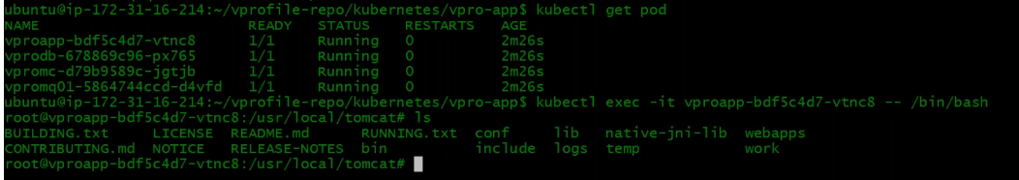

Let’s check tomcat log



Below is the configuration it is using

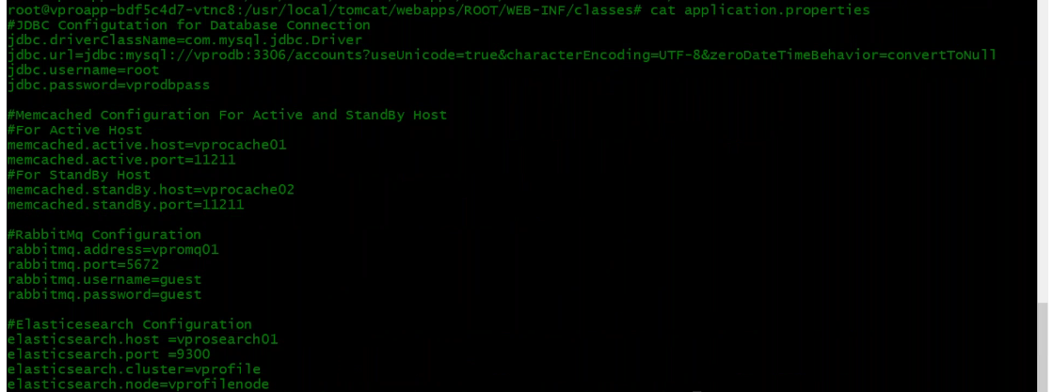

Lets ping vprodb and its able to resolve it to its cluster IP



Lets access the load balancer URL

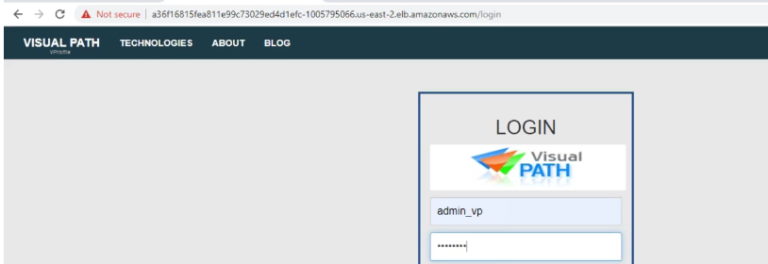

Logged in and db we are able to access that means db is tested. Let’s test Mcache

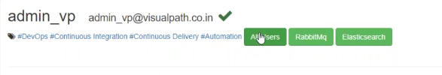

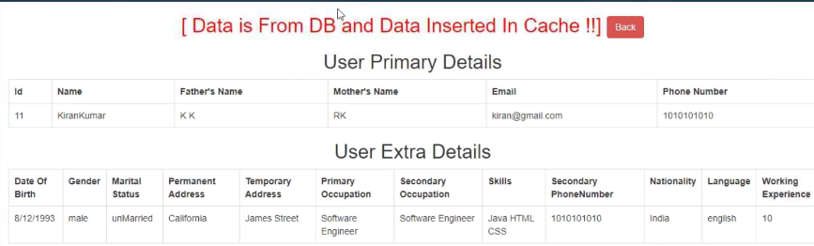

Again, lets click on same user and this time it should take from cache

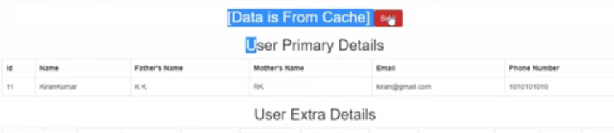

So, this is our Vprofile stack. Your project running on production grade kubernetes cluster.

For more to explore, go through documentation

**Namespaces –** Use this your project.. These are like grouping of resources. When you want to group your resources for your project, you create a name space with your project name and put all your resources like your containers, services, pods, config maps all of them you group them in to one name space. Upon which you use quota – you can control the security and many other things.

Namespaces will already there in the kubernetes. The below is the default one

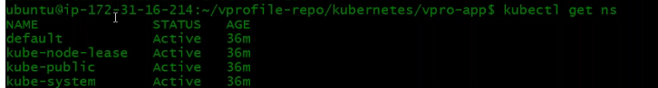

When you have multiple projects running on the same cluster, then its recommended you create namespace. Otherwise not required.

Below is one more definition file



Horizontal podautoscaler – Make sure you use this when using limits



limiting the resources - Doing it on a container is not desirable. But doing it in the pod which is running on a kubernetes cluster is something a real use case.

Like I want to limit my vproapp to use 1cpu and 200 milli CPU cpu request.

In the same line where you give name and ports, you say resources and set limits. You can set it for Ram and other .

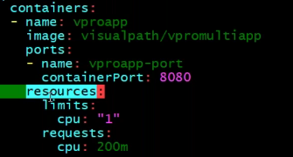

**Setting up Devops life cycle**

We will setup almost a devops life cycle but there is never complete devops lifecycyle.

We have already discussed – A devops life cycle starts when the developer push the code, we have used GIT to push our code then we have seen how Jenkins fetch the code and build the code with maven and store it in nexus repository. We have used Amazon – we have provisioned our environment , we have Ansible for deploying our artifact to your env.

We should not have a manual intervention, yes we know how to write playbook, execute playbook and do any kind of deployment, execute any kind of OS task but then we want to do it from devops life cycle. Automatically the playbook should gets executed, pick up the right thing, right version of the softwares and deploy it and we should be able to do it in different env.

We know that they could be OS related tasks that we can automate through Ansible, there are clould related tasks which we can do using Ansible but terraform would be a better option. So, the reason being doing all these is to setup a devops life cycle.

Automate and integrate is our Job. We can automate Continuous integration, we can automate delivery, we can automate OS tasks. We should also know how to integrate it.

In my AWS console I already have a Jenkins and a nexus sever. Already built it and kept.

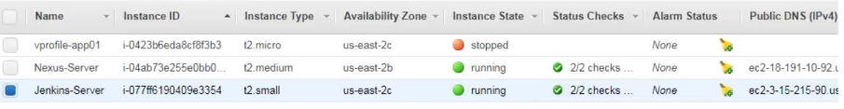

In this Jenkins server we already have CI job setup



We are using Jenkins as a CI tool to link everything together.

Your playbook or any kind of automation script should be already in the source code

Go to vp-rem branch →here along with my source code I have by playbooks here under ansible directory

We have a playbook site.yml which simply says that execute tomcat setup playbook first and then vpro-app playbook. We would be executing this playbook from Jenkins and it will call in an order. First setup tomcat and then deploy our artifact from nexus to tomcat server.

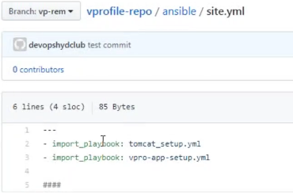

**Go through the tomcat setup playbook first (tomcat_setup.yml )**

This playbook will get executed on **appsrvgrp** so in the inventory you should be creating a group named appsrvgrp. There is vars – variable we are setting up giving tomcat URL which you can change based on your requirement. Its gonna use this URl to download tomcat application and use them.

Under tasks we are saying to install JDK depending on OS. Then its gonna download tomcat tar ball and here we have defined a variable get_url works same as wget and download and store it per defined location in playbook. We are not going to just download, extract and start tomcat but we are going to run it through system ctl command and for that we need to create a tomcat group, we need a user named tomcat without any login shell. We will create a directory /tmptomcat8 and we will extract tomcat tar ball into this directory. Remote source is yes that means the file is located remotely on the remote machine. If you don’t give this then it will look for the archive in your local machine your ansible machine. The we are saying list all the files and the out we are registering it to the variable **unarchive_info** which we will use. Then we have **debug** and here we have used method to get name of the directory that gets extracted. This is basically slicing (index number and key name). In the next step we are using **synchronize** module which will basically sync. When the directory gets extracted, its gonna sync the extracted directory with /usr/local/tomcat8 directory (tomcat home directory)– basically copy all data to here. Her it says one option delegate to **inventory_hostname**. Inventory_hostname is a magic variable and its value will be the hostname on which this playbook getting executed. If you don’t give **delegate_to** then it will look for the directory in local Ansible machine.

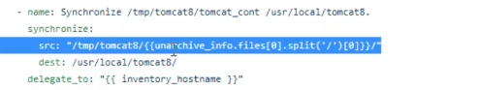

Then we are using **file module** here to give ownership to the the tomcat directory

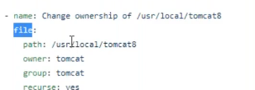

Then we have a **template module** to push systemctl startup file to dest as below

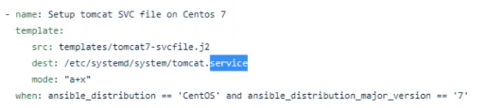

Below are few templates already created and can be used for different OS. These are called init scripts.

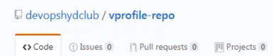

The tomcat that we are installing doesn’t have an option to run service through systemctl or service command. So we are creating it.

The same in our tomcat_setup.yml file is mentioned. If it is centos 6 then deploy the below highlighted file.

